School: ……………………………………….. | Date:……………………………………..
Class: ……………………………..................... | Period: …………………………….........

UNIT 6: LIFE ON OTHER PLANETS
Lesson 1.2 - Grammar (pages 55 & 56)

I. OBJECTIVES
By the end of the lesson, Ss will be able to:
1.1. Language knowledge and skills
- practice and use the Future Simple (will) for future predictions correctly.
- improve writing skill.
1.2. Competences
- improve Ss’ communication, collaboration and critical thinking skills.
1.3. Attributes
- be aware of what will happen in the future.
II. TEACHING AIDS AND LEARNING MATERIALS
1. Teacher’s aids: Student book and Teacher’s book, class CDs, Digital Book (DCR phần mềm tương tác SB, DHA (từ vựng/ cấu trúc) phần mềm trò chơi tương tác), projector/interactive whiteboard / TV (if any), PowerPoint slides, handouts.
2. Students’ aids: Student’s book, Workbook, Notebook.
III. ASSESSMENT EVIDENCE
Performance Tasks | Performance Products | Assessment Tools
- Listen and repeat.  - Fill in the blanks.  - Unscramble the sentences.  - Make predictions about the places (Tyson Station and Juba 5). | - Ss’ performance.  - Ss’ answers.  - Ss’ answers.  - Ss’ answers/ presentation. | - T’s feedback.  - T’s feedback/Peers’ feedback.  - T’s feedback/Peers’ feedback.  - T’s observation/ feedback/Peers’ feedback.
IV. PROCEDURES
A. Warm up: (5’)
a) Objective: Introduce the new lesson and set the scene for Ss to acquire new language; get students' attention at the beginning of the class by enjoyable and short activities as well as to engage them in the follow-up steps.
b) Content: Practicing the Future Simple tense.
c) Expected outcomes: Ss review the previous grammar point that will help them in the upcoming lesson.
d) Organization of the activity:
TEACHER’S ACTIVITIES | STUDENTS’ ACTIVITIES
Unscramble the words  - Use the activity “Word Search” – task b – page 32 - Workbook for the warm-up activity.  - Show the activity, have Ss look and search six more words they learned in unit 6 (in pairs).  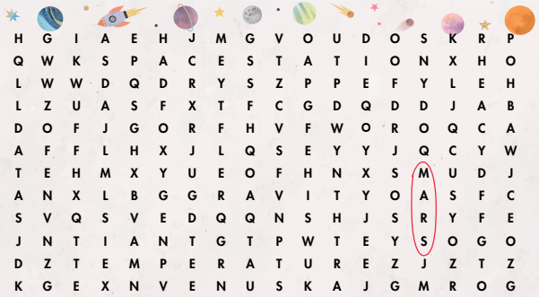  - Call Ss to give answers.  - Give feedback and show correct answers.  - Lead to the new lesson. | - Work in pairs to find words.  - Give answers.  Answer keys  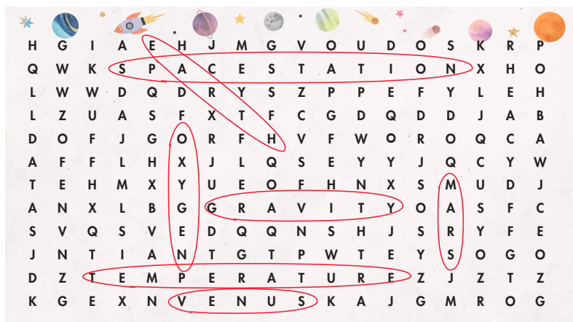

B. New lesson (35’)
- Activity 1: Presentation (10’)
a) Objective: Introduce the Future Simple used to make future predictions based on our own opinions and experiences.
b) Content: - Going over the grammar point through its meaning, use and form.
c) Expected outcomes: Ss practice and use will with future predictions in the upcoming exercises.
d) Organization of the activity:
TEACHER’S ACTIVITIES | STUDENTS’ ACTIVITIES
Task a. Read about Future Simple and fill in the blanks.  - Ask Ss to have a quick look at the picture and the grammar box on page 55.  - Have Ss predict what the boy and the girl are talking about the future.  What are they thinking of?  - Ask Ss share answers.  - Check answers.  Task b. Listen again and repeat.  - Play audio (CD2 – Track 2) and have Ss listen and read the speech bubbles. | - Look at the picture and the grammar box.  - Share the answers.  Answer keys  G: Where will people live in 2080?  B: I think that in 2080, people will live on the moon.  - Listen, then read.
- Play the audio again and have Ss listen and repeat.  GRAMMAR BOXES  - Have Ss look at the box of grammar meaning and use again.  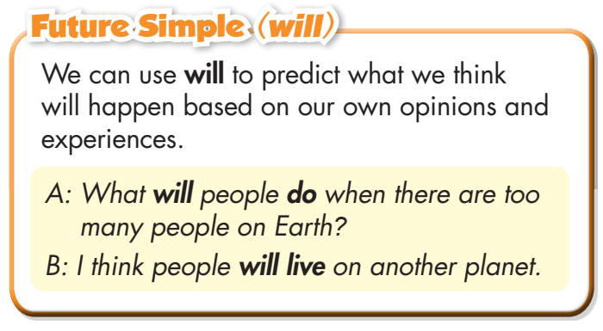  - Emphasize the use of will for future predictions.  - Ask Ss ‘What can you use will for?’  - Have Ss look at the grammar form box and read examples of different forms.  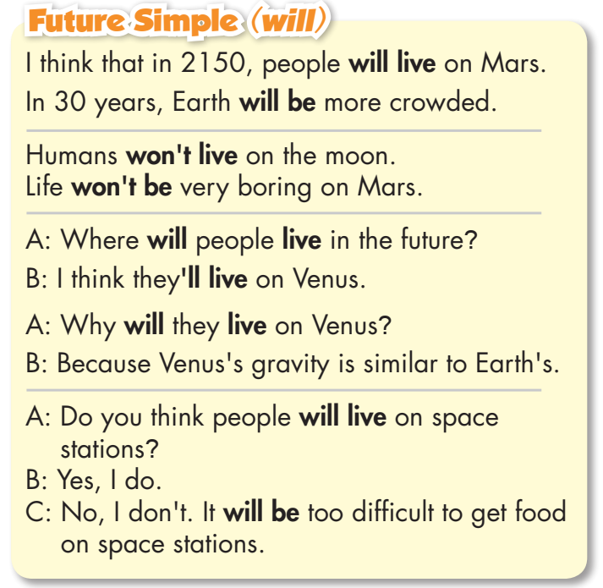  - Ask Ss to circle the bold words in the sentences, and elicit the affirmative, negative and interrogative forms.  - Elicit key words of the Future Simple:  KEY WORDS:  I think  I believe  probably…  - Ask Ss to give more examples using will/ won’t.  - Give feedback. | - Listen and repeat.  - Look and read.  - Read.  - Answer the question.  - Read examples of different forms.  - Circle the bold words.  - Give more examples.
- Activity 2: Practice (19’)
a) Objective: Students can use the Future Simple to do the exercises.
b) Content: Filling in the blanks and unscrambling the sentences.
c) Expected outcomes: Students can get used to the use of the Future Simple and use it correctly.
d) Organization of the activity:
TEACHER’S ACTIVITIES | STUDENTS’ ACTIVITIES
Task b. Fill in the blanks with the words from the  box.  - Demonstrate the activity, using the example.  - Have students fill in the blanks with the words from  the box.  - Have pairs check each other's work.  - Have some Ss share their answers with the class.  - Give feedback and correct Ss’ answers if necessary.  Task a. Read the examples and unscramble the  sentences.  - Demonstrate the activity, using the example (using DCR).  - Have Ss unscramble the sentences.  - Have pairs check each other's work.  - Have some students share their answers with the class on the board.  - Check Ss’ answers, give feedback and evaluation. | - Look and listen.  - Work individually.  - Work in pairs.  - Share the answers.  Answer keys  - will have  - won’t live  - will be  - won’t be  - Look and listen.  - Work individually.  - Work in pairs.  - Write the answers on the board.  Answer keys  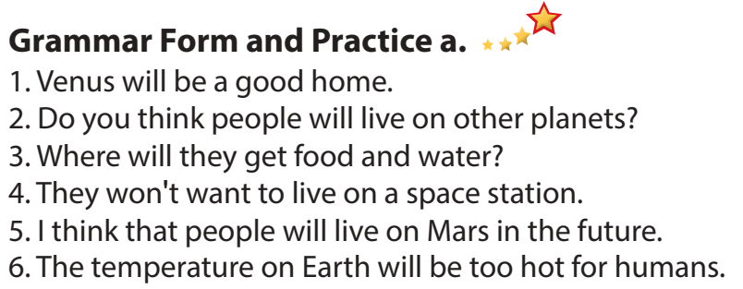
- Activity 3: Production (6’)
a) Objective: Students master the grammar point they have studied in the lesson.
b) Content: Encouraging communication in using the new language.
c) Expected outcomes: Ss produce the new language successfully, and they can the Future Simple in daily communication.
d) Organization of the activity:
TEACHER’S ACTIVITIES | STUDENTS’ ACTIVITIES
Task c. In pairs: Make predictions about the places. Use the prompts and your own ideas.  - Divide the class into pairs.  - Have students take turns making predictions using the prompts relating to Tyson Station and Juba 5.  - Have some students demonstrate the activity in front of the class.  - Give feedback and evaluation.  - For more practice, have Ss play the consolidation game, using DHA. | - Have conversation in pairs.  - Present.  - Listen.

C. Consolidation and homework assignments (5’)
* Consolidation:
- Find a mistake in each sentence below.
- Humans will live not on the moon.
- Where will live people in the future?
- I think will they live on Venus.
- Answer keys:
- Humans will not/ won’t live on the moon.
- Where will people live in the future?
- I think they will/ they’ll live on Venus.
* Homework:
- Make four sentences using will/ won’t.
- Do the exercises in WB: Grammar (page 33).
- Complete the grammar notes in Tiếng Anh 8 i-Learn Smart World Notebook (page 48).
- Play consolidation games in Tiếng Anh 8 i-Learn Smart World DHA App on www.eduhome.com.vn
- Prepare: Lesson 1 – Pronunciation and Speaking (pages 56 & 57 – SB).
V. Reflection
a. What I liked most about this lesson today:
…………………………………………………………………………………………
- What I learned from this lesson today:
…………………………………………………………………………………………
c. What I should improve for this lesson next time:
…………………………………………………………………………………………

