ĐỀ SỐ 19  FORM 2026 | ĐỀ THI HK2 MÔN TIẾNG ANH 7 GLOBAL SUCCESS  Thời gian: 60 phút
Mark the letter A, B, C or D on your answer sheet to indicate the word whose underlined part differs from the other three in pronunciation in each of the following questions.
Question 1. A. care B. bare C. are D. share
Question 2. A. area b. arena C. parent D. various
Mark the letter A, B, C or D on your answer sheet to indicate the word that differs from the other three in the position of primary stress in each of the following questions.
Question 3: A. fantastic B. amusing C. delicious D. gripping
Question 4: A. cartoon B. action C. shocking D. boring
Mark the letter A, B, C or D on your answer sheet to indicate the correct answer to each of the following questions.
Question 5: The ending of the film is __________. All audiences are very sad.
- Disappointed B. satisfying C. disappointing D. satisfied
Question 6: This is a ________film and it makes me cry a lot.
- Funny B. moving C. comdey D. excited
Question 7: She ______the Oscar Prize as the best actress this year.
- Wins B. acts C. performs D. directs
Question 8: She is hard-working. ________she isn’t lucky in examinations.
- Therefore B. But C. However D. So
Question 9. _____ they watch fireworks display last night?
- Will B. Did C. Can D. Are
Question 10. ______ the girl in the fitting room?
- Do B. Does C. Are D. Is
Question 11. _________ the cats in the garden? – Yes, ______.
- Is – it is B. Are – the cats are C. Are – they are D. Do – they do
Question 12. Mark: “ Did you go anywhere last weekend, Trang?”
Trang: “ ___________.”
- I don’t know C. I was busy
- I went to my uncle’s house D. Let’s go to the cinema
Read the following announcement and mark the letter A, B, C or D on your answer sheet to indicate the correct option that best fits each of the numbered blanks from 13 to 16.
CAR MODEL EXHIBITION
The city museum is hosting an exciting (13) ____ about car models.
Visitors can see (14) ____ cars, from classic vintage models to modern electric vehicles.
Volunteers are needed to:
- Help (15) ____ visitors find their way around the exhibition.
- Provide information about (16) ____ history of the displayed cars.
- Ensure the area is clean and safe for everyone.
Question 13. A. exhibition B. exhibit C. event D. fair
Question 14. A. a few B. various C. any D. much
Question 15. A. guiding for B. guiding C.to guide D. guided
Question 16. A. a B. an C. the D. some
Mark the letter A, B, C or D on your answer sheet to indicate the correct answer to each of the following questions 17.
Question 17. A local high school recentyly introduced a new computer course. It is popular among students. _____.
- The course teaches students about coding and digital design.
- Many students have signed up for the course
- The school added the course to prepare students for future jobs in technology.
- a-c-b B. c-a-b C. b-a-c D. c-b-a
Question 18. Choose the sentence that can end the text (in Question 17) most suitablely.
- The course has received good feedback from students and teachers
- Some students have started working on their tech projects
- The school is considering adding more technology-related courses
- There were some issues with the course schedule at first.
Read the following passage and mark the letter A, B, C or D on your answer sheet to indicate the correct option that best fits each numbered blank from 19 to 24.
When you are in Singapore, you can for about (19) _____ taxi, by bus, or by underground. I myself prefer the underground (20) _____ it is fast, early and cheap. There are (21) _____ buses and taxis in Singapore and one cannot drive along the road (22) _____ and withouht my stops, especially on Monday morning. The underground is therefore usually quicker (23) ____ Taxis or buses. If you do not know Singapore very well, it is difficult (24) _____ the bus you want. You can take a taxi, but it is more expensive than the underground or a bus. On the underground, you find good maps that tell you the names of station and show you how to get them, so that it is easy to find your way.
Question 19. A. buy B. in C. at D. on
Question 20. A. but B. because C. when D. so
Question 21. A. few B. a lot C. many D. some
Question 22. A. quickly B. quick C. quicker D. quickest
Question 23. A.so B. like C. than D. as
Question 24. A. find B. to find C. than D. found
Mark the letter A, B, C or D on your answer sheet to indicate the sentence that is closest in meaning to the original sentence in each of the following questions.
Question 25. Ben prepared carefully for the casting. He wasn’t chosen.
- Ben prepared carefully for the casting, however, he wasn’t chosen.
- Although Ben prepared carefully for the casting, but he wasn’t chosen
- Ben wasn’t chosen for the casting because he prepared carelessly.
- If Ben prepared more carefully for the casting, he would be chosen.
Question 26. The leading actor was famous. However, his performance in the film was poor.
- Though the leading actor was famous, but his performance in the film was poor.
- If he was a leading actor, he would perform better in the film.
- Even though the leading was famous, he performed in the film poorly.
- In spite of the leading actor, his film was poorly recognized.
Mark the letter A, B, C or D on your answer sheet to indicate the sentence that is made from the given cues in each of the following questions.
Question 27. Although/ film/ comedy/ send/ serious message/ teenagers/ peer pressure.
- Although the film is a comedy, but it sends serious message teenagers peer pressure
- Although the film is a comedy, it sends serious message about teenagers peer pressure
- Although the film is a comedy and sends a serious message about teenagers peer pressure
- Although the film is a comedy, it sends a serious message about teenagers peer pressure
Question 28. It’s/ cold/ wear/ heavy/ coat/.
- It’s very cold, so wear a heavy coat
- It’s very cold, but wear a heavy coat
- It’s cold so it’s not need to wear a heavy coat
- It’s cold because not wearing a heavy coat
Read the following sign or notice and mark the letter A, B, C or D on your answer sheet to indicate the correct answer to each of the following questions.
Question 29: What does the sign say?
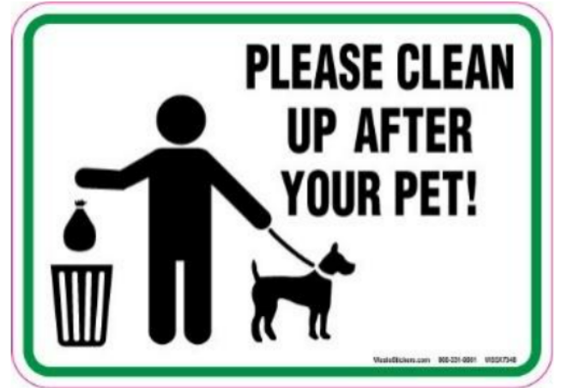 | - Leave pet waste as it is.  - Clean up any waste your pet leaves behind.  - Cleaning up pet waste is optional  - Only some pet waste needs cleaning
Question 30: What does the sign say?
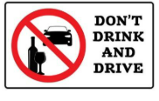 | - Drinking is not safe when you are driving vehicles  - You can drive a car if you drink only a little alcohol  - It is good to drink while driving  - You should only drive if you have not had alcohol
Read the following passage and mark the letter A, B, C or D on your answer sheet to indicate the correct answer to each of the following questions from 31 to 36.
The Pacific Rim Whale Festival
Every year, about 20,000 grey whales swim past the west coast of Vancouver Island. The whales travel from Mexico to the Arctic and back again. The whole trip is about 16,000 kilometres. Every March, the people who live around the Pacific Rim National Park have a festival to celebrate the whales’ journey. The festival is the Pacific Rim Whale Festival. The whales travel very close to the shore as they swim north. This allows people to gather together to watch the whales from land and from boats.
Nanaimo Bathtub Race
On the east coast of Vancouver Island, you can see people moving through the water in a strange type of boat. In the Nanaimo Bathtub Race, all the boats are made from bathtubs. The city of Nanaimo is home to the oldest and most famous bathtub boat race in the world. Today, Nanaimo World Championship Bathtub Race is a serious sport that attracts many racers and visitors from around the world.
Question 31. What is the main idea of the text?
A. Vancouver Island has many interesting tourist attractions.
B. The Pacific Rim Whale Festival celebrates the grey whales' journey.
C. Nanaimo is famous for its bathtub factories.
D. People in Vancouver enjoy festivals throughout the year.
Question 32. Which word is CLOSEST in meaning to “journey” in the text?
A. Adventure B. Voyage C. Game D. Goal
Question 33. Which word is OPPOSITE in meaning to “oldest” in the text?
A. Youngest B. Biggest C. Latest D. Shortest
Question 34. Which of the following is NOT true according to the text?
A. Grey whales swim about 16,000 kilometres every year.
B. The Nanaimo Bathtub Race involves boats made from bathtubs.
C. The Pacific Rim Whale Festival takes place in April.
D. The Nanaimo Bathtub Race attracts participants from around the world.
Question 35. According to the reading, why is it easy for people to see the whales?
- The people use binoculars.
- The whales swim close to land.
- The people are also swimming in the water
- They fly over the whales in helicopters.
Question 36. What is special about every boat in the race?
- Each boat can carry three people
- Every boat is made from a bathtub.
- Every boat gets a safety inspection
- All the boát have sails.
Four phrases/ sentences have been removed from the text below. For each question, mark the letter A, B, C or D on your answer sheet to indicate the correct option that best fits each of the numbered blanks from 37 to 40.
Traffic congestion is when vehicles travel slower because there is too much traffic on raods. This makes trip times longer and increase queueing. (37) _____. Congestion may result from a decrease in capacity, for example accidents on the road or roads being closed. (38) _______. Increased traffic, for example, by many cars leaving a sports stadium at the same time, can also cause congestion.
Where congestion is common, (39) _____. Cars may be banned in certain districts or certain times, or made to carry passengers or pay a fee, or people mey use public transport, (40) _____.
- Which travel independently of car traffic and are not affected by traffic jams.
- This is also know as a traffic jam.
- Bad road layouts can also restrict capacity.
- Serveral methods are used to relieve it.
Question 37 B Question 38 C Question 39 D Question 40 A

