**TIẾNG ANH 9 FRIENDS PLUS**

**BÀI KIỂM TRA ĐỊNH KÌ**

**REVIEW 4 – TEST 1**

**I. Pronunciation (1-4)**

**Câu 1.** Which word has the underlined part pronounced differently from that of the others?

**A.** celebrity  **B.** blogger  **C.** other  **D.** because

**Câu 2.** Which word has the underlined part pronounced differently from that of the others?

**A.** achieved  **B.** allowed  **C.** started  **D.** stayed

**Câu 3.** Which word has a different stress pattern from that of the others?

**A.** gadget  **B.** positive  **C.** consider  **D.** confident

**Câu 4.** Which word has a different stress pattern from that of the others?

**A.** perfect  **B.** potential  **C.** impact  **D.** expensive

**II. Choose the answer (A, B, C or D) that best fits the space in each question. (5-14)**

**Câu 5.** They plan to ________ the old theatre to restore its original beauty.

**A.** accommodate  **B.** renovate  **C.** bury  **D.** excavate

**Câu 6.** She has a ________ of spiders and cannot even look at pictures of them.

**A.** thrill  **B.** phobia  **C.** ward  **D.** sprain

**Câu 7.** The ________ of the building was beautifully decorated with sculptures.

**A.** interior  **B.** façade  **C.** cuisine  **D.** hoard

**Câu 8.** The artist painted a large ________ on the wall of the school.

**A.** hoard  **B.** arena  **C.** cuisine  **D.** mural

**Câu 9.** They decided to ________ the treasure in a secret location.

**A.** retract  **B.** bury  **C.** renovate  **D.** unearth

**Câu 10.** "I like pizza," Tom said.

Tom said that _____ pizza.

**A.** I like  **B.** I liked  **C.** he likes  **D.** he liked

**Câu 11.** "We went to the park yesterday," the girls said.

The girls said that they _____ to the park the day before.

**A.** had gone  **B.** were going  **C.** have gone  **D.** went

**Câu 12.** '_____ dinosaur fossils _____ in this area before?' - 'Yes, they have.'

**A.** Are ... found  **B.** Will ... be found  **C.** Have ... been found  **D.** Were ... found

**Câu 13.** They have _____ they need to hire more staff.

**A.** such a many customers  **B.** so many customers that

**C.** so many customers  **D.** such many customers

**Câu 14.** Has your truck been fixed, or is it still being worked on?

**A.** It was repaired today.  **B.** That truck is really modern.

**C.** Please use the truck.  **D.** Not very.

**III. Look at the signs. Choose the best answer (A, B, C or D). (15-16)**

**Câu 15.** What is the purpose of Sarah’s email to Katy?

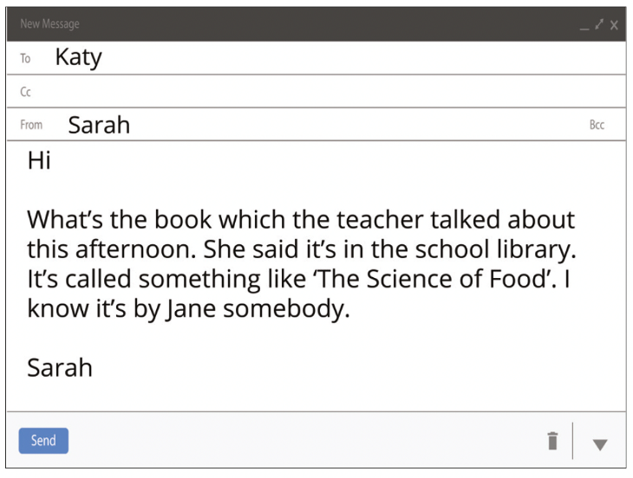

**A.** To inquire about homework assignments

**B.** To provide information on a book recommended by their teacher

**C.** To discuss a personal matter

**D.** To plan a meeting at the school library

**Câu 16.** What is being offered to students who register early for the IT course?



**A.** Extra tutoring sessions  **B.** A free textbook

**C.** Priority seating  **D.** A discount

**IV. Read the following passage and do as direct. (17-22)**

**France's Normandy Beach is a stunning location. It's in the country's north, by the sea. The beach stretches for around 80 kilometers.**

**World War II made Normandy Beach renowned. Thousands of soldiers arrived here to fight on June 6, 1944. We refer to this day as D-Day. You may still see artillery and other remnants of the conflict on the shore.**

**The beach is gorgeous. There are lovely sands and steep rocks. The blue water is always changing. There are little communities close to the seashore. These communities offer lodging and delicious seafood straight from the sea. There are lots of activities to do in Normandy Beach. You can swim in the sea or take a stroll on the sand. History is another subject you might study. The cuisine in the area is also well-known. Here, they create unique apple and cheese cocktails.**

**Normandy Beach is a worthwhile destination. By the water, you may relax, see historical sites, and relish French culture.**

**Câu 17.** Normandy Beach is located in the south of France.

**A.** True  **B.** False

**Câu 18.** Normandy Beach was the site of a major World War II battle on June 6, 1944.

**A.** False  **B.** True

**Câu 19.** The beach in Normandy stretches for about 80 kilometres.

**A.** True  **B.** False

**Câu 20.** Normandy Beach is known for its delicious seafood and unique local cuisine.

**A.** False  **B.** True

**Câu 21.** What is the main activity visitors can enjoy at Normandy Beach?

**A.** Hiking  **B.** Surfing  **C.** Skiing  **D.** Swimming

**Câu 22.** What historical event is Normandy Beach most associated with?

**A.** World War II  **B.** World War I

**C.** The Hundred Years' War  **D.** The French Revolution

**V. Choose the word (A, B, C or D) that best fits the blank space in the following passage. (23-28)**

**Effective time management is a crucial skill ____23_____ students to succeed in their academic and personal lives. It helps reduce stress, improve productivity, and create a better balance between study and leisure.**

**To start, students should create a _____24____ or use a planner. This tool helps organize tasks, deadlines, and commitments. Break larger projects into smaller, manageable tasks and assign specific times for each. For example, instead of "write essay," schedule "research for essay" on Monday, "create outline" on Tuesday, and so on.**

**_____25____ tasks is essential. Use methods like the Eisenhower Matrix to categorize tasks by importance and urgency. Focus on important and urgent tasks first, then move to important but less urgent ones.**

**Setting realistic goals is crucial. Be honest about how long tasks take and include breaks in your schedule. The Pomodoro Technique, which involves 25-minute focused work ____26_____ followed by short breaks, can be very effective.**

**Avoid procrastination by tackling difficult tasks when you're most alert. If you're a morning person, schedule challenging subjects early in the day.**

**Minimize distractions during study time. Put your phone on silent and use website blockers _____27____ necessary.**

**Lastly, don't forget self-care. Include time for exercise, hobbies, and socializing in your schedule. A well-rested, balanced student is more productive and focused.**

**Remember, good time management is a skill _____28____ improves with practice. Start implementing these strategies, and you'll see improvements in your academic performance and overall well-being.**

**Câu 23.** Choose the correct answer.

**A.** on  **B.** about  **C.** of  **D.** for

**Câu 24.** Choose the correct answer.

**A.** source  **B.** basis  **C.** root  **D.** schedule

**Câu 25.** Choose the correct answer.

**A.** Prioritizing  **B.** Priority  **C.** Prioritized  **D.** Priorities

**Câu 26.** Choose the correct answer.

**A.** equipment  **B.** device  **C.** sessions  **D.** things

**Câu 27.** Choose the correct answer.

**A.** as  **B.** if  **C.** while  **D.** unless

**Câu 28.** Choose the correct answer.

**A.** whose  **B.** what  **C.** whom  **D.** that

**VI. Supply the correct form of the word given in each sentence. (29-34)**

**Câu 29.** Our main ______________ just released a new product. (competition)

**Câu 30.** She (adventure) _________ tried skydiving for the first time.

**Câu 31.** I ______________ her determination and work ethic. (admiration)

**Câu 32.** Loud noises usually (fright) _________ my dog during thunderstorms.

**Câu 33.** He prepared a ______________ dish from his culture. (tradition)

**Câu 34.** Her work is ______________ different from others in her field. (distinctiveness)

**VII. Rearrange the groups of words in a correct order to make complete sentences. (35-36)**

**Câu 35.** we arrived, they / had already / By the time / finished dinner.

_______________________________________________________

**Câu 36.** later that / Tom promised / would call / that he / evening.

______________________________________________________

**VIII. Rewrite each of the following sentences in another way so that it means almost the same as the sentence printed before it. (37-40)**

**Câu 37.** I don't have enough money to buy a new car.

I wish...

**Câu 38.** I started learning English 5 years ago. (for)

I...

**Câu 39.** After we finished our assignments, we went for a walk. (had)

Before we …

**Câu 40.** "I will finish the project by next week," Tom said.

Tom said that...

**IX. Listening: listen to a passage about safety tips when playing sport and do as direct. (41-50)**

**Câu 41.** It's not important to stay safe when playing sports.

**A.** False  **B.** True

**Câu 42.** Wearing protective equipment like helmets and pads can help prevent injuries.

**A.** True  **B.** False

**Câu 43.** Warming up and stretching before playing does not get your muscles ready.

**A.** False  **B.** True

**Câu 44.** Listening to your coach and following their instructions is not important for safety.

**A.** False  **B.** True

**Câu 45.** Seeking medical attention quickly after an injury is not necessary.

**A.** False  **B.** True

***Listen again and choose the correct answer:***

**Câu 46.** What is the primary purpose of wearing protective equipment like helmets and pads?

**A.** To improve performance  **B.** To follow fashion trends

**C.** To look cool  **D.** To prevent injuries

**Câu 47.** Why is warming up and stretching important before playing sports?

**A.** It helps you win the game  **B.** It’s a tradition

**C.** It reduces the risk of sprains  **D.** It makes you more popular

**Câu 48.** Who knows the best techniques and rules to keep you safe during sports?

**A.** Your coach  **B.** Social media influencers

**C.** Your parents  **D.** Your friends

**Câu 49.** Why should you stay hydrated during games or practice?

**A.** To avoid dehydration  **B.** To show off

**C.** To win awards  **D.** To impress your teammates

**Câu 50.** What should you do if you get injured while playing sports?

**A.** Tell your coach or parents immediately  **B.** Post about it on social media

**C.** Ignore it  **D.** Keep playing

**----HẾT---**