UNITS | VOCABULARY | GRAMMAR
Unit 4  ALL THINGS HIGH-TECH | - Devices  - High-tech jobs  - Computers  - Video/PC/Mobile games | - Modals  - Infinitive (to-infinitive, infinitive without to)  - -ing form
Unit 5  TRAVEL & TRANSPORTATION | - Shops & Services  - Transportation in the future  - Travel & Transport  - Wonders of the world | - Comparative  - Superlative  - as … as, not so/as … as, much  - like/ the same as/ different from
Unit 6  BE GREEN | - The environment  - School green activities  - Recycling  - Volunteer tasks | - Tense revision (Simple Present, Present Continuous, Simple Past, will, be going to)  - and/ or/ but  - so/ because  - although/ however
Tiếng Anh 7 – RIGHT ON

SEMESTER 2 - FINAL TEST
Note: Each correct answer earns 0.2 points.

I. PRONUNCIATION (0.8 points)
A. Choose the word whose underlined part is pronounced differently.
1. A. donate B. grow C. yoghurt D. tower
2. A. decided B. managed C. protected D. created
B. Choose the word that has a different stressed syllable from the rest.
3. A. wonder B. engine C. advise D. damage
4. A. organise B. mechanic C. designer D. however

II. VOCABULARY AND GRAMMAR (2.4 points)
Choose the best option (A, B, C or D) to complete each of the following questions.
5. Nancy seldom travels by __________ because she’s scared of flying.
A. boat B. bus C. plane D. subway
6. In some parts of the world, animal transport is __________ as modern types of transport.
A. as popular B. more popular C. much popular D. most popular
7. I need a new __________ for my desktop computer. The ‘Enter’ key doesn’t work.
A. username B. keyboard C. mouse D. router
8. The train was late __________ there was a problem on the line.
A. however B. so C. although D. because
9. I’m getting up at 6:00 tomorrow because I don’t want __________ my bus. I can’t be late for the interview.
A. having B. taking C. to miss D. to catch
10. Nick __________ to Costa Rica tomorrow for six weeks to work on a turtle conservation project. Everything is ready.
A. goes B. is going C. will go D. went
11. David often ______ computer games in the evening, but he ______ out at the soup kitchen now.
A. plays / helps B. is playing / is helping
C. is playing / helps D. plays / is helping
12. My hometown isn’t __________ as it was five years ago. It’s much bigger and more modern.
A. the same B. like C. different D. similar
13. Energy-efficient light bulbs use __________ electricity than traditional bulbs, so they’re better for the environment.
A. more B. much C. less D. least
14. Student A: Governments should stop people from smoking in the parks.
Student B: _________
A. What can we do? B. That’s a great event.
C. Smoking is worse for your health. D. I think so, too.
15. What does the sign mean?
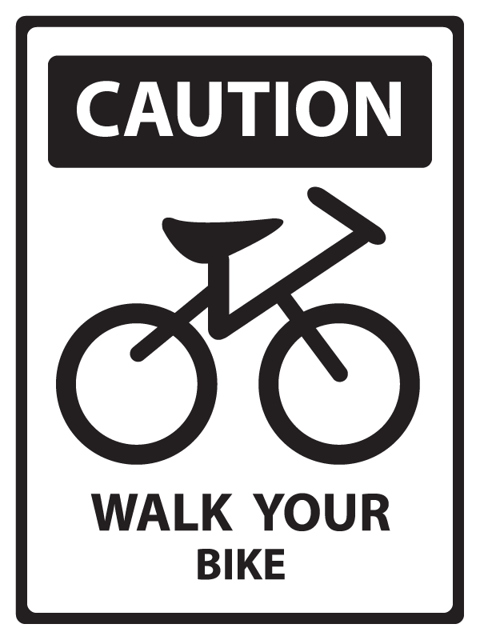 | A. You have to get off and walk your bike in this area.  B. You don’t have to use your bike here.  C. It’s dangerous for you to cycle here.  D. You must walk in this area without your bike.

16. What does the sign mean?
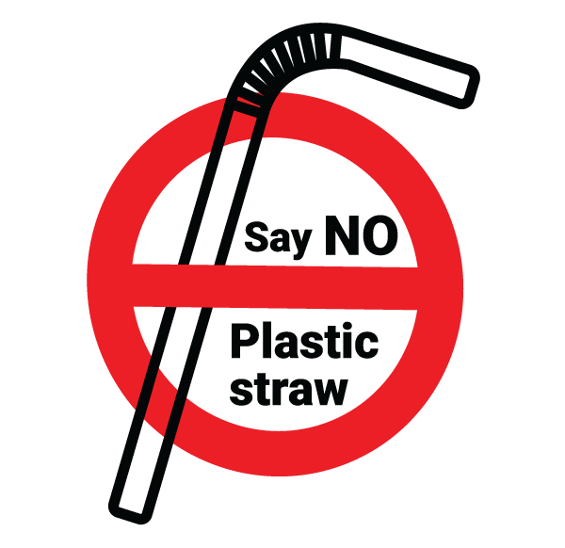 | A. There are no straws to use here.  B. You should stop using plastic straws.  C. You can’t make straws from plastic.  D. It’s necessary to say no when you use plastic straws.

III. WORD FORMATION (1.2 points)
Write the correct form of the words in brackets.
17. We can reduce air __pollution________ by taking public transport, walking or cycling instead of driving. (POLLUTE)
18. Dr. Jane Goodall is famous for her ____impressive______ work to protect chimpanzees. (IMPRESS)
19. People are cutting down trees, and this destroys the natural environment of many __endangered_________ animals. (DANGER)
20. One of the causes of global warming is __deforestation________. Humans are cutting down so many trees. (FOREST)
21. Yok Đôn is one of the biggest ___national_______ parks in Vietnam. It is also home to wild elephants and leopards. (NATION)
22. One of the most popular tourist __attractions________ in Scotland is the famous Edinburgh Castle. It’s the best place for sightseeing in the city. (ATTRACT)

IV. LISTENING (2 points)
A. You will listen to Rob and his mum talking about his birthday party. How will each person travel to the party? For each question, choose the correct letters from A-G. There are two extra letters.

People Transport
23. Brother C A. Motorbike
24. Grandma E B. Bike
25. Granddad D C. Bus
26. Aunt Julia F D. Subway
27. Uncle Ted B E. Car
F. Taxi
G. Train

B. You will hear a teacher making an announcement. For each question, listen and complete the notes. Write NO MORE THAN TWO WORDS AND / OR A NUMBER.

THE RIVER CLEAN-UP

Date: (28) _Saturday_________, 31st May.
Time: 9:00 – (29) __11:30/ 11.30 / 11.30 a.m. / 11.30 am / 11:30 a.m. / 11:30 am / eleven thirty / half past eleven_______
Need: (30) __Plastic gloves_________
Comfortable clothes
Hat
Activities: (31) __Pick up_________ litter
Repair fences and signs.
Lunch: Snacks, fruit juice, sandwiches and (32) __hamburgers_________

V. READING (2 points)
A. Read the following passage on a travelling blog. For each question, write T if the statement is TRUE, F if the statement is FALSE and NI if there is NO INFORMATION on it.

Swansea is the second largest city in Wales (after Cardiff). It is located on Britain’s west coast, and is home to the famous Swansea Festival. The hotels in Swansea are cheaper than those in many other British cities. They are also clean and safe. There are many interesting places you can visit. Swansea market is at the heart of the city. It is the largest indoor market in Wales with more than 100 stalls selling everything from jewelry to vegetables. Everyone can find something nice to take home. The market opens every day except Sunday. You can also buy fashionable clothes at the Quadrant and St David’s shopping centres. There, you can find big department stores and many smaller shops. The Swansea Museum – the oldest museum in Wales – is well worth a visit. There are six galleries with collections of different kinds of objects. If you have time, you should take a walk in Clyne Gardens, or visit the Grand Theatre, one of Britain’s oldest theatres. Swansea has got an excellent network of public transport, cycle routes and walking routes, so there are multiple ways to explore Swansea without the need for a car.

33. Swansea is as big as Cardiff. False
34. Visitors pay less for accommodation in Swansea than in many other places in Britain.
True
35. People can shop at Swansea market every day. False
36. You need a lot of time to visit Clyne Gardens. NG
37. Travelling by car is the only way to get around Swansea. False

B. Read the following email. For each question, choose the best option A, B, C or D.

Dear all students,
We want Saint Louis School to be greener. Therefore, we want all of you to follow these simple rules:
- Don’t (38) _________. Rubbish on the ground is unhealthy for people because it attracts animals like rats and flies and they spread diseases.
- Don’t throw away plastic bottles, paper, cardboard boxes and cans. Every class should sort the rubbish for recycling. Put all the plastic bottles and bags in the green bins. Batteries (39) _________ go in recycling bins or with normal rubbish. Place them in a separate box instead, and the school will collect them at the end of the month.
- Don’t throw away your food waste like banana (40) _________ or apple cores. Put them into the compost bin. We can use the compost to grow (41) _________ vegetables in our greenhouse.
- Bring your own reusable water bottles to school to get drinks and refill the water.
- Turn (42) _________ the lights when you leave the classroom. When the teacher isn’t using the computer or other electronic equipment, switch them off instead of leaving them on standby. You can save electricity this way.
Let’s make our school a greener place and help protect the environment. Our planet is in our hands!

38. A. waste B. garbage C. damage D. litter
39. A. cannot B. should C. needn’t D. have to
40. A. cover B. skins C. pot D. shell
41. A. natural B. fresh C. organic D. delicious
42. A. off B. on C. up D. down

VI. WRITING (1.6 points)
A. Rewrite the following sentences without changing their meaning.
43. Let’s install recycling bins in the school corridors.
→ Why don’t we install recycling bins in the school corridors?
44. It’s against the rules to use mobile phones during lessons.
→ Students can’t use mobile phones during lessons.
→ Students mustn’t use mobile phones during lessons.
45. The Burj Khalifa is taller than any other buildings in the world.
→ The Burj Khalifa is the tallest building in the world.
46. We know plastic bags damage the environment, but we continue using them every day. (ALTHOUGH)
→ Although we know plastic bags damage the environment, we continue using them every day.
→ We continue using plastic bags every day although we know they damage the environment.

B. Use the given words or phrases to make complete sentences.
47. you / prefer / travel / car / train?
→ Do you prefer travelling by car or by train?
48. My parents / agree / build / birdhouse / garden.
→ My parents agreed to build a birdhouse in the garden.
→ My parents agreed to build a birdhouse in our garden.
49. It / look / it / going / rain / so / let’s / take / taxi.
→ It looks like it’s going to rain, so let’s take a taxi.
→ It looks like it is going to rain, so let’s take a taxi.
50. Oxford / start / 11th century / so / it / be / one / oldest universities / the world.
→ Oxford University started in the 11th century, so it is one of the oldest universities in the world.
→ The University of Oxford started in the 11th century, so it is one of the oldest universities in the world.

***End – Of – Test***

Audio scripts:
Listening 1:
Rob: Mum, I’m home! Where are you?
Mum: Hi, Rob. I’m in the kitchen. Happy birthday, Rob!
Rob: Thanks, mum. But where is everybody else? Nobody has arrived yet!
Mum: Well, your brother is having a basketball practice. He finishes his practice at 5 p.m. Then, he will come home by bus.
Rob: Why doesn’t he take the subway? It’s much faster. And where’s Dad?
Mum: He phoned me ten minutes ago. Your grandma missed the half past four bus, so your dad is going to drive her.
Rob: Is Granddad coming in Dad’s car, too?
Mum: No, actually. He has to go to the baker’s to get the birthday cake first, and then he’s going to take the subway.
Rob: Alright, it’s probably quicker than the car. How about Aunt Julia?
Mum: She will take a taxi after she finishes her work. Her car broke down this morning.
Rob: Is Uncle Ted coming with her, too?
Mum: Uncle Ted is going to cycle from his office. At first, he said he would ride his new motorbike. Then, he decided to ride a bike because he wants to lose weight. Don’t worry, Rob. Everyone will be here in fifteen minutes.

Listening 2:
Alright, everyone. Listen up! Before we go home, I would like to make an announcement. Next weekend, our school is organizing an annual river clean-up. It’s usually on a Sunday, but this year it is on Saturday 31st May. It starts at nine o’clock and ends at about half past eleven. The school bus leaves at half past eight. Don’t be late. The school will provide bags and boxes for the rubbish, so just bring your own plastic gloves. You should wear comfortable clothes, and don’t forget to bring a hat. It might be very hot and sunny. We are going to pick up litter and repair the fences and signs. Last year, our school planted twenty trees along the river, and they all are really beautiful now. You can bring your cameras and take photos of them. After the clean-up, there will be a picnic in the park next to the river. The Cheese Café is going to provide snacks and fruit juice, and the Sammy Restaurant is going to prepare sandwiches and hamburgers for lunch, so you don’t have to bring any food. That’s all for now. Goodbye class, and see you tomorrow.

