Tiếng Anh 8 i-Learn Smart World - Luyện tập - Unit 8
Time allotted: 45

PART 1 PRONUNCIATION (5 questions)
Choose the word whose underlined part differs from the other three in pronunciation in the following question.
1. A. snow B. window C. flower D. flow
2. A. should B. thousand C. loudly D. house
3. A. open B. logic C. old D. wardrobe
Choose the word that differs from the other three in the position of the main stress in the following question.
4. A. culture B. highland C. language D. dessert
Choose the word whose primary stress is placed on the second syllable.
5. A. special B. peaceful C. complete D. ethnic

PART 2 USE OF ENGLISH (12 questions)
Choose the option that best completes the following sentence.
6. Sticky ______________ with fruit is a popular dish in Thailand.
A. vegetables B. rice C. corn D. fruit
7. Women from ethnic minorities in Vietnam often wear a ______________ around the head.
A. headscarf B. pottery C. basket D. necklace
8. The Kinh ethnic ______________ has the largest population in Viet Nam.
A. class B. team C. group D. school
9. Every chef in this restaurant has to wear an ______________ while cooking so they can keep their clothes clean.
A. apron B. blouse C. coat D. jacket
10. The ______________ in this hotel are expensive. All the forks, knives and spoons are made of silver.
A. pottery B. utensils C. baskets D. clothes
11. My mother is a vegetarian. She enjoys ______________ because they don't have any oil or fat.
A. hamburgers B. fast food C. steamed vegetables D. French fries
12. There is ______________ pen on my desk, but it's not mine.
A. Ø B. the C. an D. a
13. They are ______________ students that I told you about.
A. a B. the C. an D. Ø
14. He was just a kid from ______________ Vung Tau City, but now he is very successful.
A. Ø B. the C. an D. a
15. Trang asked me ______________ I was free that afternoon.
A. what B. how often C. did D. if
16. He told me that he was arriving ______________ hour ago.
A. Ø B. a C. an D. the
17. The reporter asked him ______________ best.
A. which team he liked B. which team did he like C. which team he likes D. which team does he like

PART 3 WORD FORMATION (3 questions)
Write the correct form of the given word.
18. Áo dài has been the ______________ clothes of Vietnamese people since the 18th century. (TRADITION)
19. Although I know about Kontum, I don't think I'm ______________ enough to be a tour guide for this place. (EXPERIENCE)
20. Many Vietnamese women are very good at ______________ . (EMBROIDER)

PART 4 ERROR RECOGNITION (2 questions)
Find the underlined part that needs correction in the following question.
21. When Mia went to a vacation in Hà Giang, she could experience local food as well as the tradition of people living there.
A. to B. in C. could D. food
22. We had the chance visit some famous Chăm buildings and watch a traditional Chăm dance performance in Nha Trang.
A. visit B. watch C. traditional D. in

PART 5 READING (5 questions)
Read part of an email from Shoo to an online English friend, Colin. Choose the best word or phrase for each space. (5 questions)
Dear Colin,
You asked for more information about my ethnic group.
There are only about 40 families in our group now, but at one time, we were the biggest in this country.
We are different in almost every way from the rest of the country, in language, in our (23) ___________ dances, and in our bright clothes. We wear the same clothes as our grandparents and great grandparents, with beautiful (24) ___________ on top of the cloth. On festival days, girls wear blouses and red skirts, while boys like me wear shirts and long (25) ___________, which are blue.
We eat the same foods as people from a hundred years ago, too – meat or fish with steamed (26) ___________. It’s delicious! You must try it when you come to stay with me.
There is another difference between us and other people in this country. We have our own (27) ___________ of the forest, the rivers, and the mountains. We pray to them every day.
Please write and tell me about your ethnic group. Do you all wear dark suits and hats every day and carry umbrellas?
Best wishes,
Shoo
(23) A. ceremony B. tradition C. custom D. folk
(24) A. sewing B. embroidery C. pattern D. knitting
(25) A. headscarves B. pants C. blouses D. skirts
(26) A. rice B. plant C. dessert D. food
(27) A. flowers B. trees C. gods D. animals

PART 6 LISTENING (5 questions)
Listen to five short texts. Choose the correct picture for each question. (5 questions)
28. (1) What are traditional products in the boy’s ethnic group?
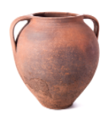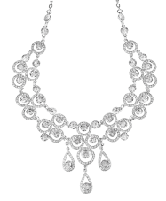
A. ☐ B. ☐ C. ☐
29. (2) What pattern often appears on traditional clothes in the girl’s ethnic group?
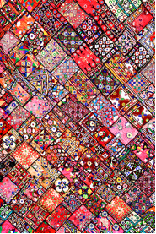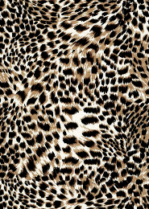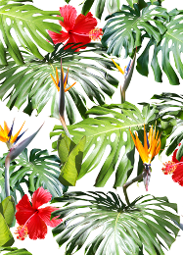
A. ☐ B. ☐ C. ☐
30. (3) What special food do people eat at the main festival in the boy’s culture?
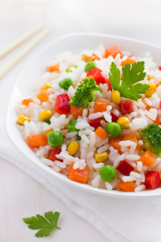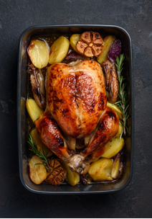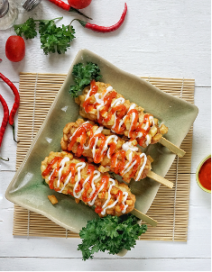
A. ☐ B. ☐ C. ☐
31. (4) Who makes important family decisions in the girl’s culture?
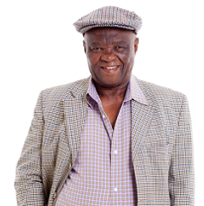
A. ☐ B. ☐ C. ☐
32. (5) What does Thanksgiving in the USA celebrate?
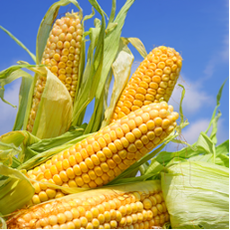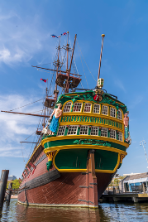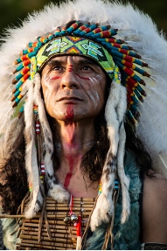
A. ☐ B. ☐ C. ☐

PART 7 WRITING (8 questions)
Rewrite the following sentence without changing its meaning. Use the given word(s) if any.
33. "What kind of food do you like best when you visit Mộc Châu?" asked the tour guide.
→ ASKED___________
34. My sister asked me, "Do you want to spend your holiday in an ethnic village in SaPa?"
→ ASKED___________
35. The little girl asked Sarah, "Would you like to try Ê-đê tradtional clothes on?"
→ ASKED___________
36. I asked my children, "What will you buy on the trip to Tràng An for your friends as souvenirs?"
→ ASKED___________
Use the given words or phrases to make a complete sentence.
37. He / ask / me / if / I / take part / the trip / Cao Bằng / his team / following week.
→ ___________
38. There / not any / hotels / mountainous area / so / we / had to stay / ethnic family's wooden house.
→ ___________
Put the words in the correct order to make a correct sentence.

39. Keywords: wear/./to carry/their backs/often/a basket/bamboo/The Thái women/produce/made of/on
→ .......................................
40. Keywords: to learn/want/more/what/I/to travel/Chăm people/about/do every day.
→ .......................................
---THE END---

