School: ……………………………………….. | Date: ………………………………
Class: ……………………………..................... | Period: ……………………….........

UNIT 7: TRANSPORTATION
Lesson 3.1 - Listening and Reading (page 58)

I. OBJECTIVES
By the end of the lesson, Ss will be able to:
1.1. Language knowledge and skills
- talk about transportation.
- practice listening and understanding a recording about two types of transportation (for general and specific information).
- read and understand an opinion paragraph about a mean of transportation (for gist and details).
1.2. Competences
- improve communication, collaboration, analytical and critical thinking skills.
1.3. Attributes
- be careful and safe road users.
- choose suitable means of transport for travelling.

II. TEACHING AIDS AND LEARNING MATERIALS
1. Teacher’s aids: Student book and Teacher’s book, class CDs, Digital Book (DCR phần mềm tương tác SB, DHA (từ vựng/ cấu trúc) phần mềm trò chơi tương tác), projector/interactive whiteboard / TV (if any), PowerPoint slides.
2. Students’ aids: Student’s book, workbook, notebook.

III. ASSESSMENT EVIDENCE
Performance Tasks | Performance Products | Assessment Tools
- Let’s Talk: Look at the pictures. What are the two kinds of transportation? Which would you most like to try? Why? | - Ss’ answers / presentation. | - T’s feedback/Peers’ feedback.
- Listening: Listen to Matt’s vlog about two types of transportation. Which is better for kids? | - Ss’ answers | - T’s feedback/Peers’ feedback.
- Listen and tick (✓ ) the advantages for each kind of transportation. | - Ss’ answers. | - T’s feedback/Peers’ feedback.
- Reading: Look at the opinion paragraph. Who wrote the paragraph? | - Ss’ answers. | - T’s feedback/Peers’ feedback.
- Now, read and write True or False. | - Ss’ answers. | - T’s feedback/Peers’ feedback.
-Speaking: Would the Wowscoot be convenient for where you live? Why (not)? | - Ss’ answers / presentation. | - T’s observation/ DCR and T’s feedback.

IV. PROCEDURES
A. Warm up: (5’)
a) Objective: Introduce the new lesson and set the scene for Ss to acquire new language; get students' attention at the beginning of the class by giving enjoyable and short activities as well as to engage them in the follow-up steps.
b) Content: Introduce the topic: Two kinds of transportation (monowheel and two wheels).
c) Expected outcomes: Ss have general ideas about the topic “transportation”, which they are going to listen and read in the new lesson.
d) Organization of the activity:
TEACHER’S ACTIVITIES | STUDENTS’ ACTIVITIES
- Option 1: Let’s Talk!  Look at the pictures. What are the two kinds of transportation? Which would you most like to try? Why?  - Use the “Let’s talk!” part in the textbook– page 58 for warm-up activity.  - Ask Ss to work in pairs to look at the pictures and answer the questions: What are the two kinds of transportation? Which would you most like to try? Why?  - Call Ss to share their answers with the whole class.  - Give feedback and evaluation.  - Lead to the new lesson.  - Option 2:  - Show 2 pictures.  - Have Ss look at the 2 pictures of 2 groups of vehicles.  - Have Ss find the basic difference between 2 groups of vehicles.  - Call Ss to give answers.  - Give feedback and lead to the new lesson: There are 2 kinds of transportation mentioned in the new lesson today.  *Illustration  Picture 1:  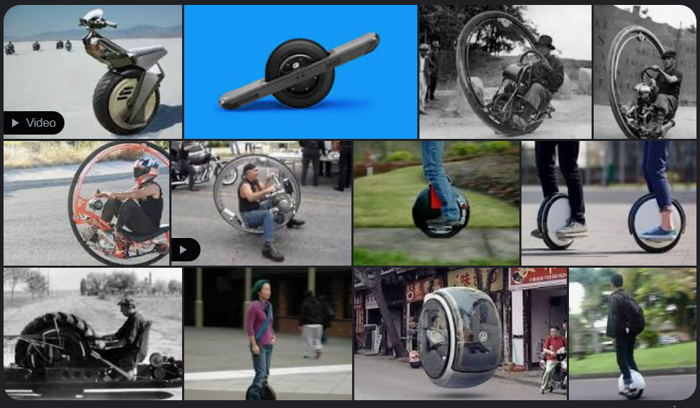  Picture 2:  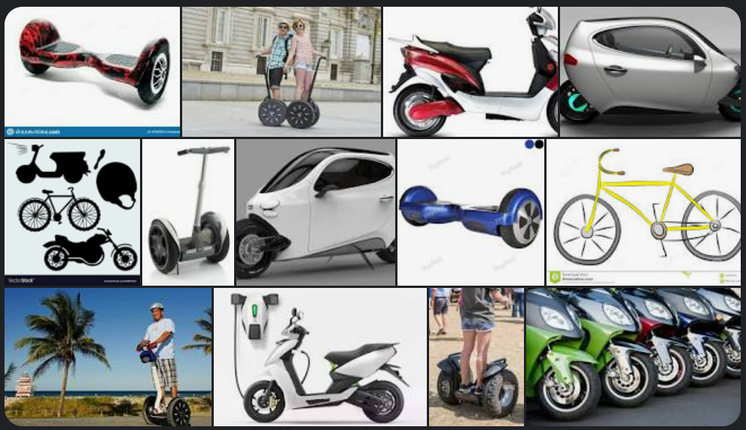 | - Work in pairs to discuss.  - Present.  - Look at the pictures and find the basic difference between 2 groups of vehicles.  - Give answers.  - Listen and answer.  Suggested answers  - Picture 1: Vehicles with only 1 wheel  - Picture 2: Vehicles with 2 wheels

B. New lesson (35’)
- Activity 1: Listening (17’)
a) Objective: Students can develop their listening skill.
b) Content:
- Listen to Matt’s vlog about two types of transportation. Which is better for kids?
- Listen and tick (✓ ) the advantages for each kind of transportation.
c) Expected outcomes: Students can practice listening and understanding general + specific information about transportation.
d) Organization of the activity:

TEACHER’S ACTIVITIES | STUDENTS’ ACTIVITIES
Task a. Listen to Matt’s vlog about two types of transportation. Which is better for kids?  - Have Ss read the question.  - Play audio (CD1 - Track 79).  - Have Ss listen and circle the correct answer.  - Call Ss to give answer, explain.  - Play the audio again and check the answer as a whole class using DCR.  Task b. Listen and tick (✓ ) the advantages for each kind of transportation.  - Have Ss read through the content in Task b first, underline the key words.  - Play the audio again (CD1 - Track 79).  - Have Ss listen and tick (✓ ) the advantages for each kind of transportation.  - Have Ss check answers with their partners.  - Call Ss to give answers, explain.  - Check answers as a whole class using DCR. | - Listen and guess the answer.  - Read.  - Listen and circle the correct answer.  - Give answer, explain.  Answer keys  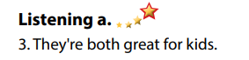  - Read, find and underline the key words.  - Listen and tick (✓ ) the advantages for each kind of transportation.  - Exchange answers.  - Give answers.  Answer keys  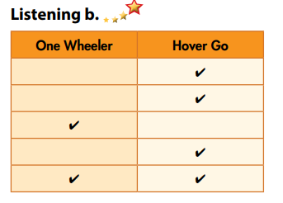

- Activity 3: Reading (18’)
a) Objective: Students can develop their reading skill.
b) Content:
- Look at the opinion paragraph. Who wrote the paragraph?
- Now, read and write True or False.
- Would the Wowscoot be convenient for where you live? Why (not)?
c) Expected outcomes: Students can read an opinion paragraph for gist and detail, and they can give their opinion about a type of transport.
d) Organization of the activity:
TEACHER’S ACTIVITIES | STUDENTS’ ACTIVITIES
Task a. Look at the opinion paragraph. Who wrote the paragraph?  - Have Ss read the content in Task a.  - Ask Ss to scan the paragraph to choose the correct answer.  - Have Ss underline the supporting ideas.  - Call a student to give answer.  - Check answers as a whole class using DCR.  Task b. Now, read and write True or False.  - Have Ss read the content in Task b and underline the key words.  - Have Ss read the article again and write True or False.  - Have Ss check their answers with a partner.  - Call Ss to give answers.  - Check answer as a whole class using DCR.  Task c. Speaking: In pairs: Would the Wowscoot be convenient for where you live? Why (not)?  - Have Ss discuss the questions in pairs.  - Call some Ss to share their answers with the whole class.  - Give feedback and evaluation. | - Scan the article to choose the correct answer.  - Underline the supporting ideas.  - Give answer.  Answer keys  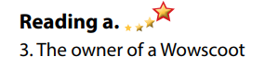  - Read and underline the key words.  - Read the article again for details.  - Exchange answers.  - Give answers.  Answer keys  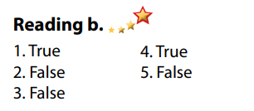  - Discuss in pairs.  - Present.

C. Consolidation and homework assignments (5’)
*Consolidation:
*Homework
- Do the exercises in WB: Listening and Reading (page 42).
- Do the vocabulary exercise in Tiếng Anh 7 i-Learn Smart World Notebook (page 46).
- Play consolation games in Tiếng Anh 7 i-Learn Smart World DHA App on www.eduhome.com.vn
- Prepare: Unit 7 - Lesson 3 – Writing and Speaking (page 59 – SB).

D. Reflection
a. What I liked most about this lesson today:
…………………………………………………………………………………………
- What I learned from this lesson today:
…………………………………………………………………………………………
c. What I should improve for this lesson next time:
…………………………………………………………………………………………

