Period
LESSON PLAN
TIẾNG ANH 10 FRIENDS GLOBAL
UNIT 3: ON SCREEN
LESSON 3G: SPEAKING – REACHING AN AGREEMENT
I. OBJECTIVES:
By the end of the lesson, Ss will be able to:
1. Knowledge:
- discuss and agree on an activity
- practice planning an activity to do with friends
2. Ability:
- main skills: listening and speaking skills
- sub skills: reading and writing skills
- use a simple structure to discuss and agree on an activity to do with friends
3. Quality:
- have positive attitude in English language learning so that they can participate enthusiastically in all classroom activities, especially with the topic conducted by the teacher
- keen on studying English
II. TEACHER AIDS AND LEARNING MATERIALS:
Lesson plan, PPT slides, student’s book, workbook, notebook, personal computer (if any), projector/TV, speakers, IWB software.
III. PROCEDURES:
A. Warm-up (5’)
a) Objective: Introduce the new lesson and set the scene for Ss to acquire new language; get students' attention at the beginning of the class by means of enjoyable and short activities as well as to engage them in the steps that followed.
b) Content: Game “MOVIE QUIZ”
c) Outcomes: Students can gain more confidence and interest in the lesson.
d) Competence: communication, collaboration, guessing
e) Organisation of the activity:
TEACHER’S ACTIVITIES | STUDENT’S ACTIVITIES | CONTENTS
WARM-UP. T-Ss/ S-S/ Indiv  Game “MOVIE QUIZ”  - Divide class into 2 groups  - Ask students to match the film in the poster with its genre  - Lead in the lesson: Reaching an agreement | - Play in groups  - With each correct answer, that group get one point.  - Open the course book page 42 | 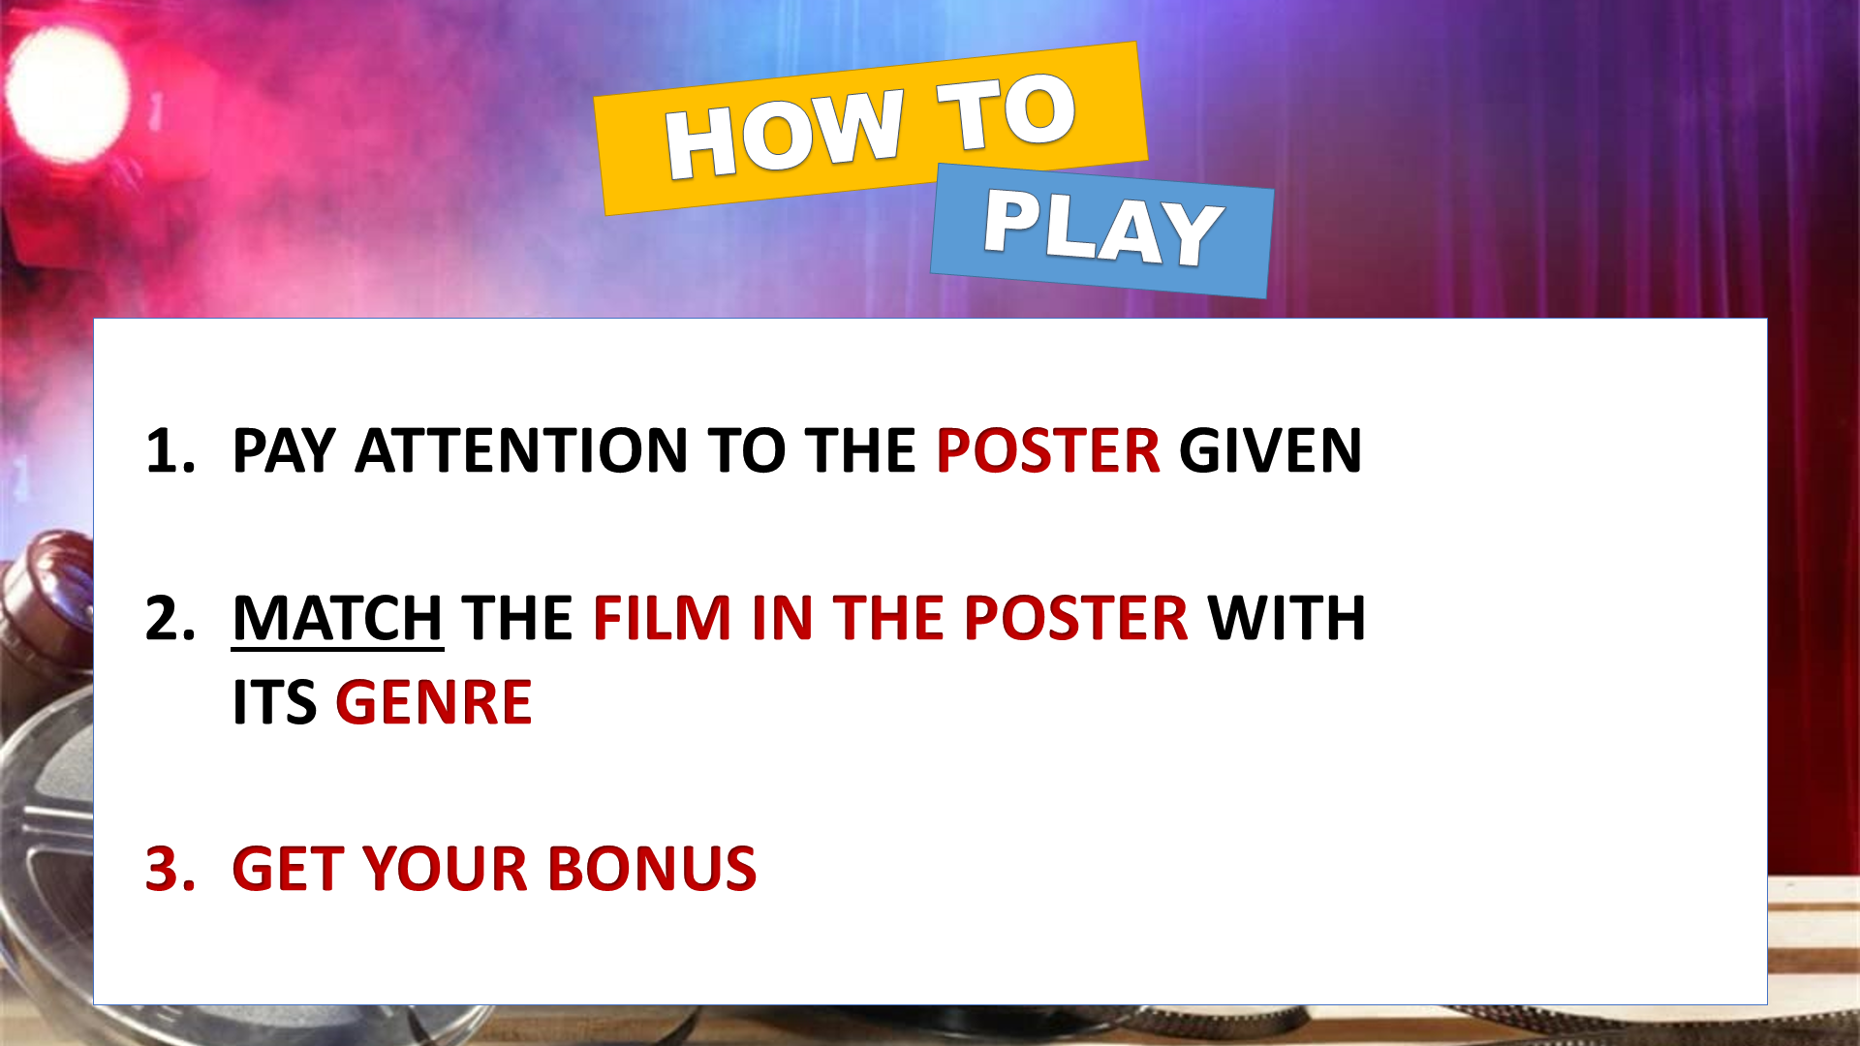  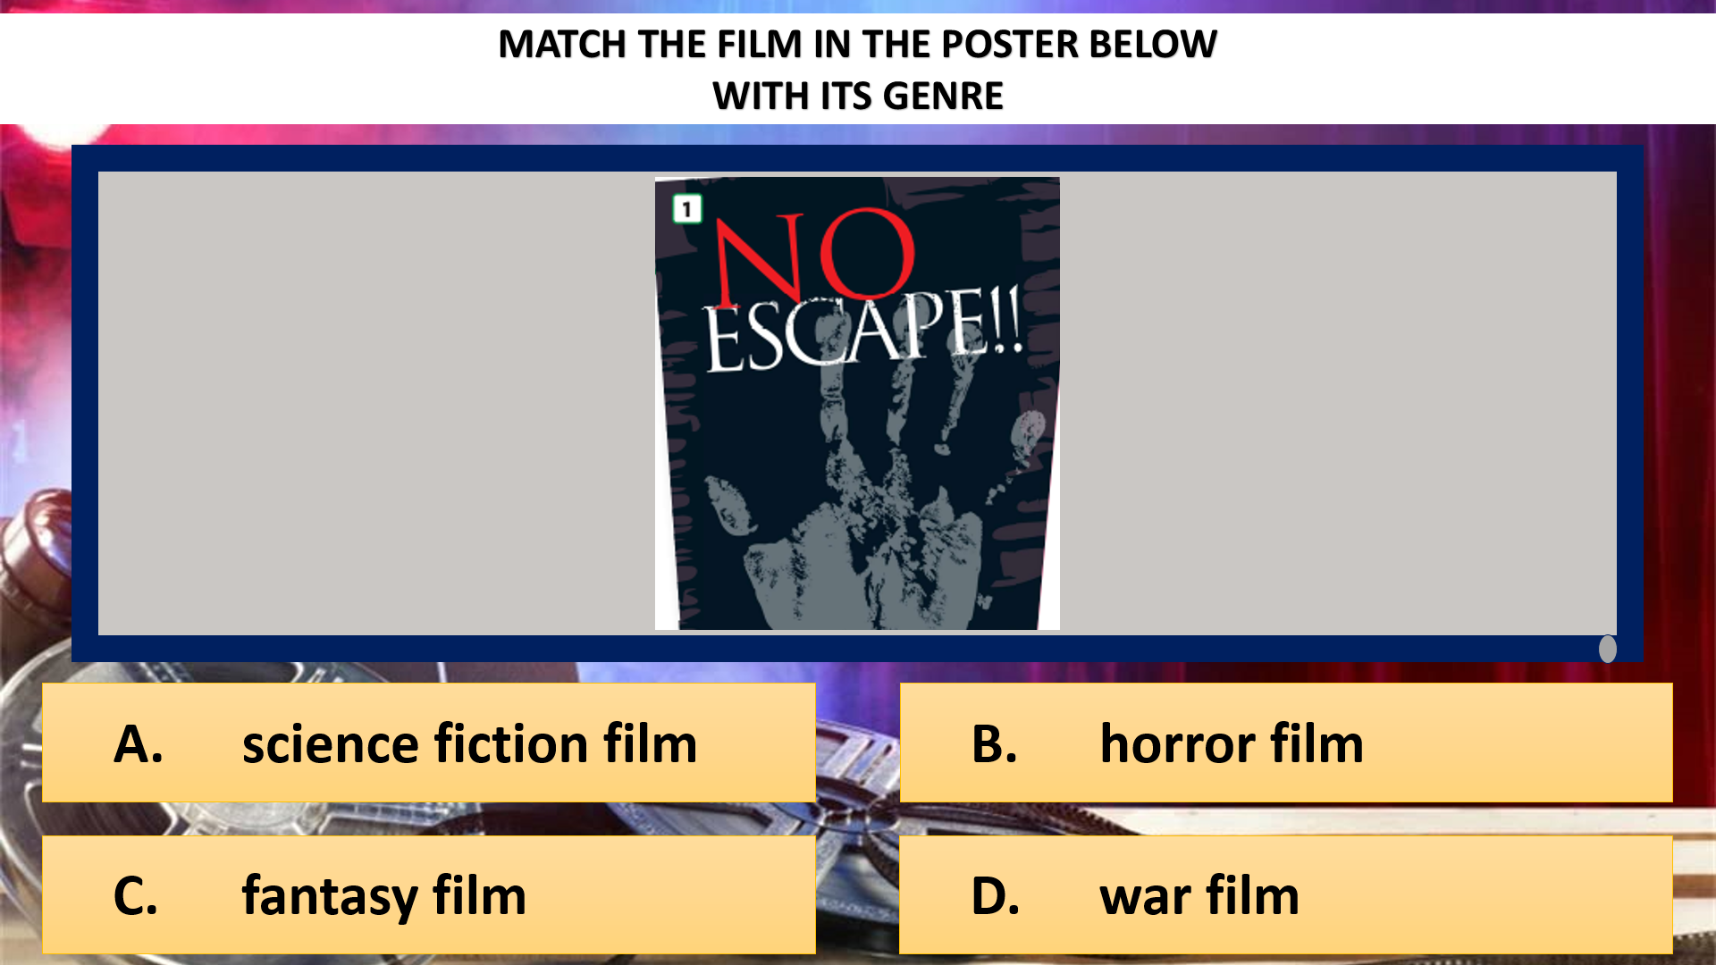  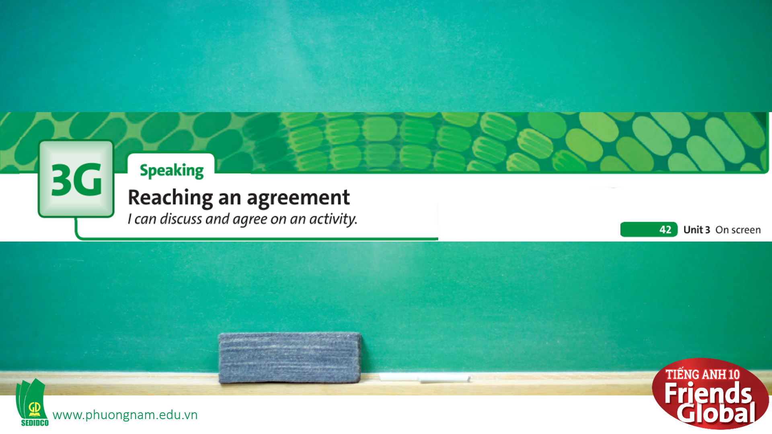

B. New lesson (35’)
- Activity 1: Presentation (2’)
a) Objective: Students get to know some new words in the lesson.
b) Content:
Speaking
Listening
c) Outcomes: Students know how to pronounce the new words precisely and use them in appropriate contexts.
d) Competence: communication, presentation, guessing
e) Organisation of the activity:

TEACHER’S ACTIVITIES | STUDENT’S ACTIVITIES | CONTENTS
PRESENTATION. T-Ss/ S-S/ Indiv.  Teach new vocabulary:  - Use pictures, gestures and explanation to present new words  - Have students practice their pronunciation drills  New words:  shrink (v)  scream (v)  adopt (v)  hop (v)  propose (v) | - Look, listen, and repeat in chorus and individuals | 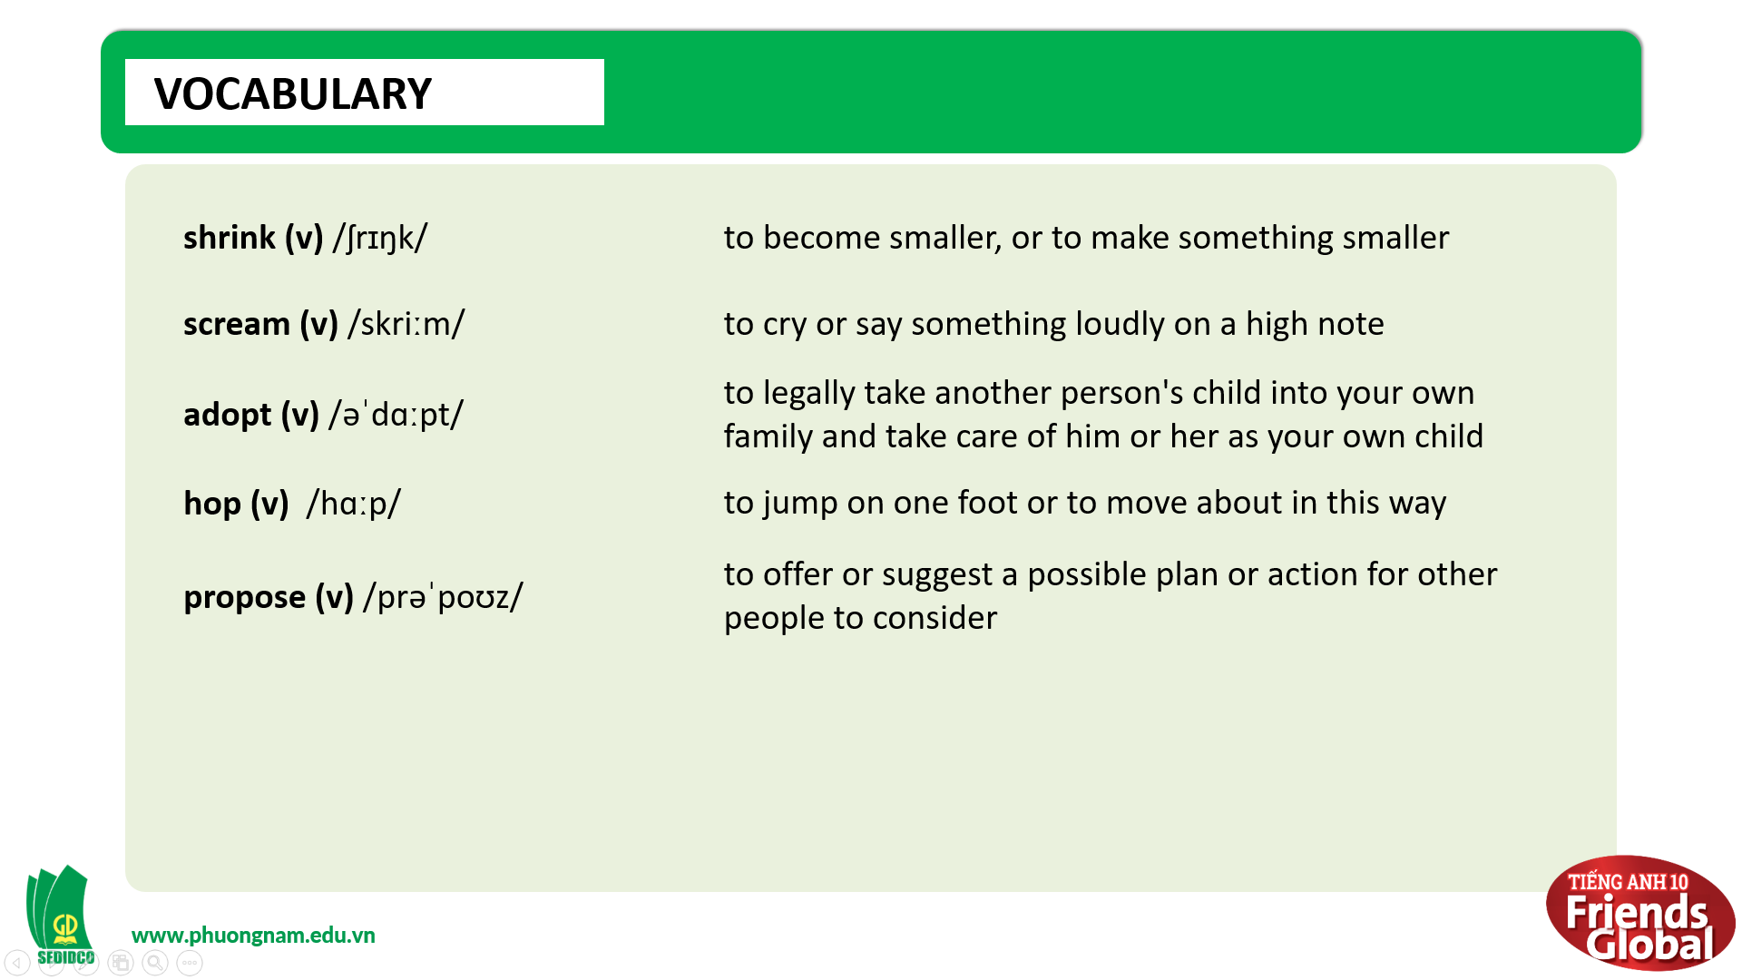
- Activity 2: Practice (18’)
a) Objective: Students can answer the questions to critical thinking, and they can finish the tasks in the textbook. Critical thing skills (guessing/ reasoning) and communication can also be practiced.
b) Content:
Reading
Speaking
c) Outcomes: Students can plan, discuss and agree on an activity to do with friends.
d) Competence: communication, collaboration, presentation
e) Organisation of the activity:
TEACHER’S ACTIVITIES | STUDENT’S ACTIVITIES | CONTENTS
PRACTICE. T-Ss/ S-S/ Indiv.  Activity 1 (3’): Task 2 page 42  - Ask students to read the Speaking Strategy and highlight the main ideas  - Then ask students to think about three nouns and three adjectives that they could use  - Give students a some hints of their upcoming tasks  Activity 2 (5’): Task 3 page 42  - Ask students to read the questions then listen to the audio  - Play the audio again and pause to check answers as a class  Activity 3 (5’): Task 4 page 42  - Ask students to work in pairs and complete the task  - Check answers as a class  - Then explain a little bit about these phrases (optional)  Activity 4 (5’): Task 5 page 42  - Go through the Learn this! box together and highlight main ideas  - Ask students to underline all the consonant clutters  - Then practice saying the words in pairs  - Check the answers | - Read the Writing Strategy and highlight the main ideas  - Take notes  - Listen to the teacher and take notes if needed  - Listen to the audio and complete the task  - Check answers with teacher and take notes  - Work in pairs and complete the phrases using the words given  - Check answers with teacher  - Listen and take notes  - Read the Reading Strategy and highlight main ideas  - Complete the task  - Practice pronunciation with their partners  - Check the answer with the teacher and take notes | 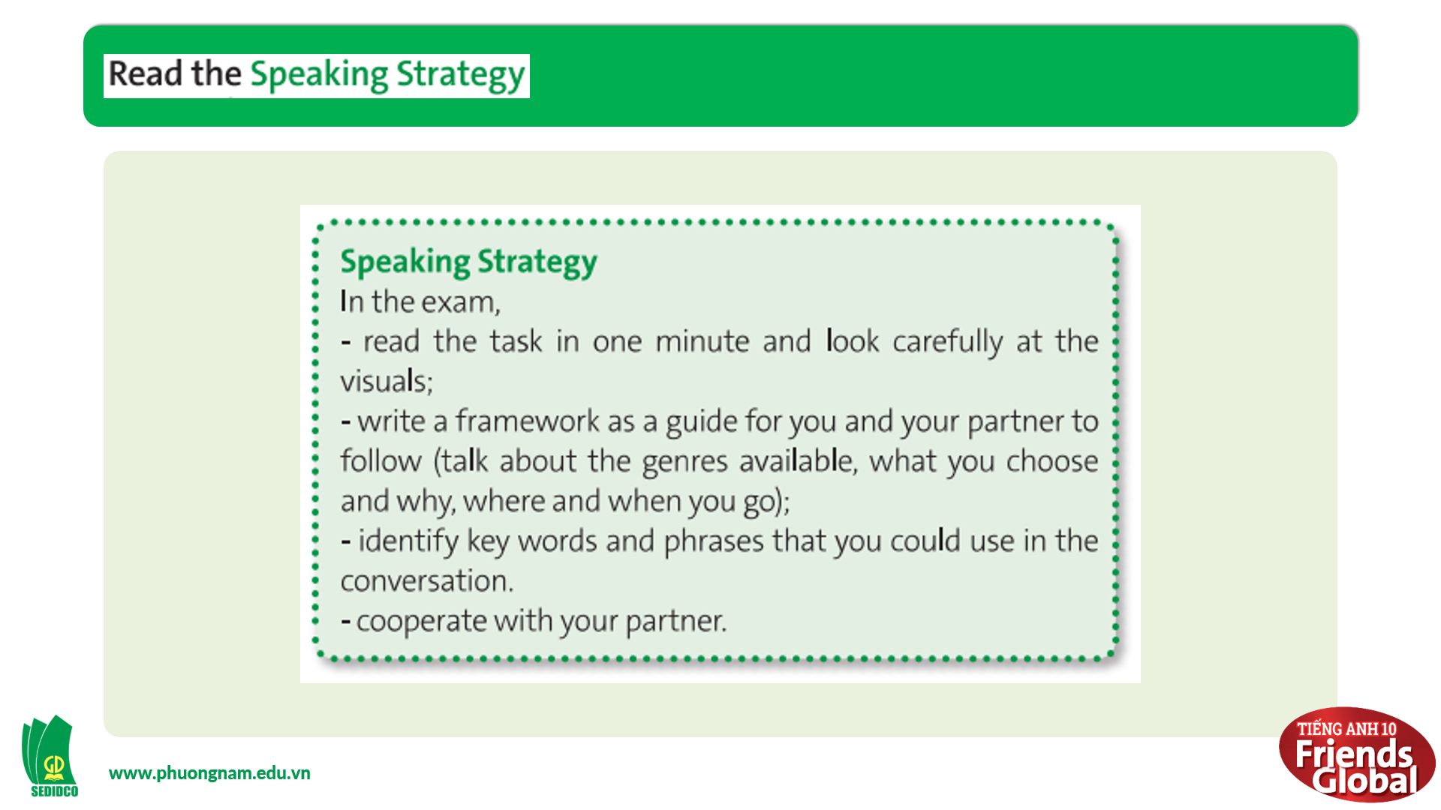  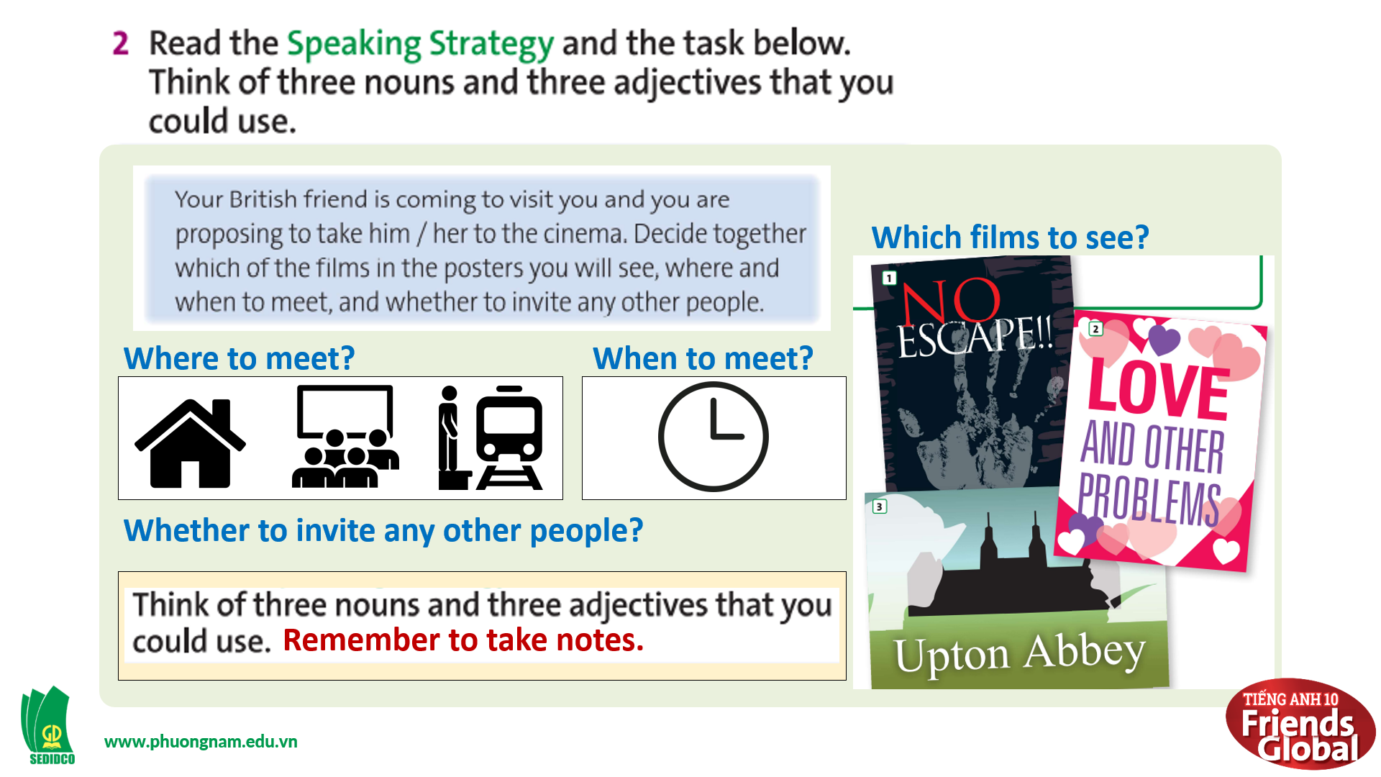  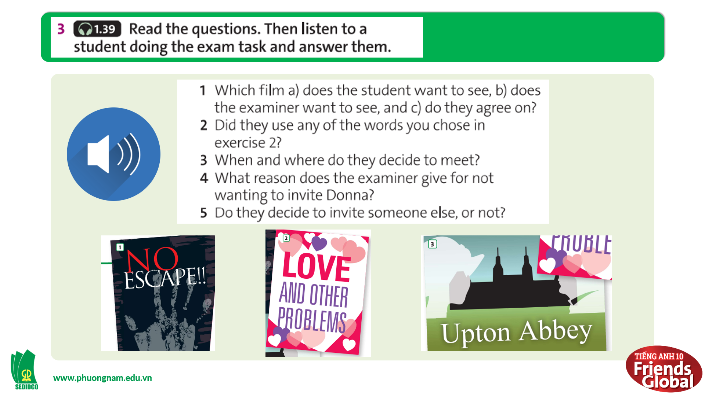  Answers:  1. a. NO ESCAPE  1. b. LOVE AND OTHER PROBLEMS  1. c. UPTON ABBEY  3. the cinema at 6.30  4. She doesn’t get on very well with Donna.  5. Yes. They decide to invite Tom.  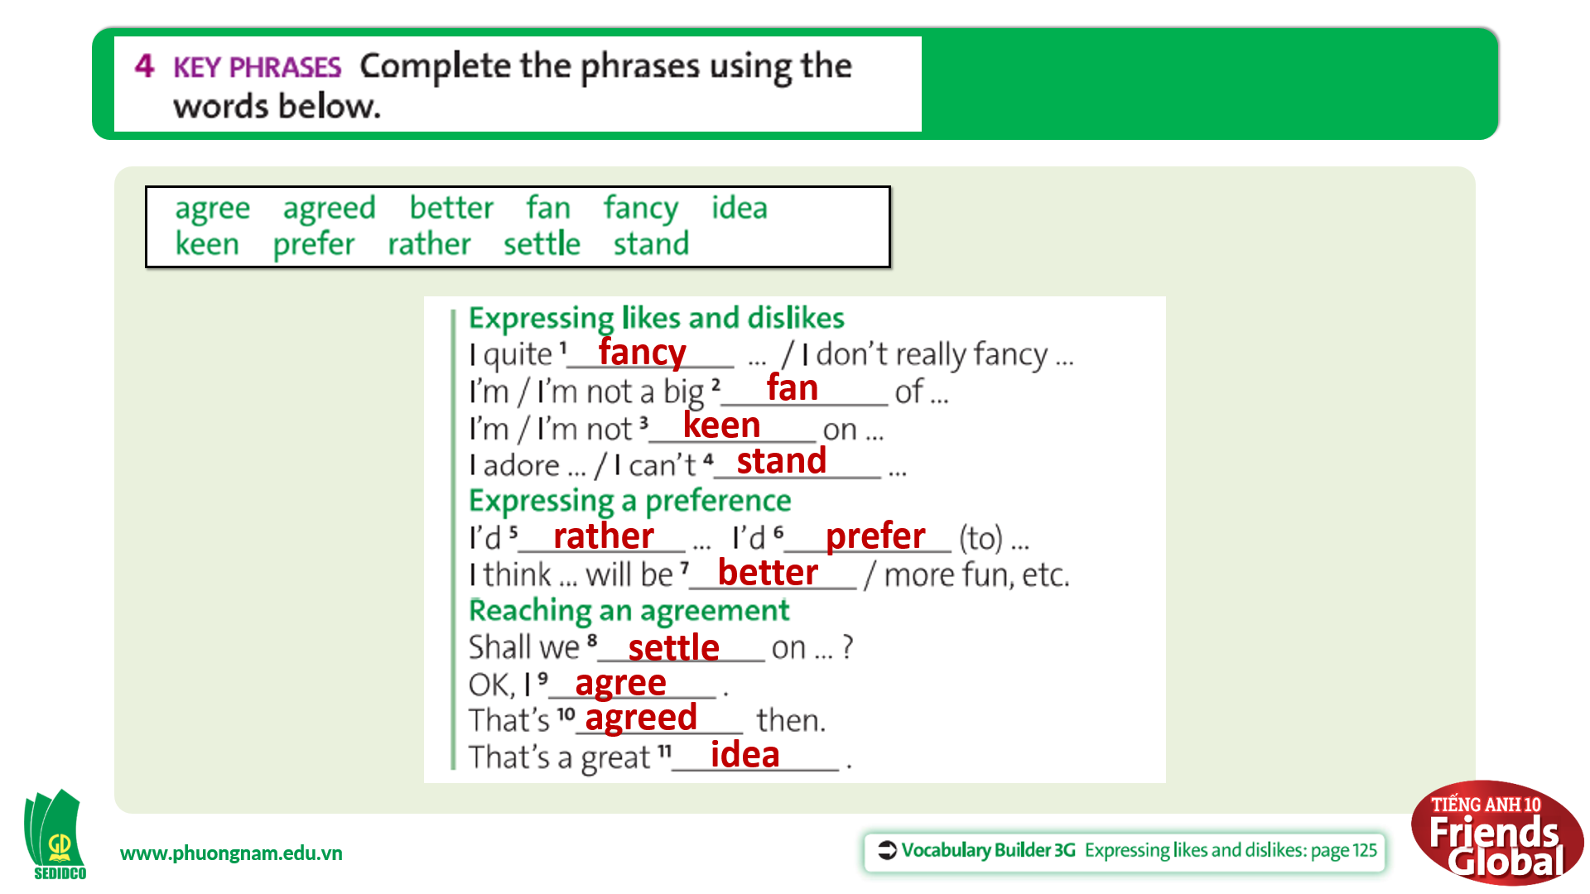  Answers:  fancy; fan; keen; stand; rather; prefer; better; agree; agreed; idea  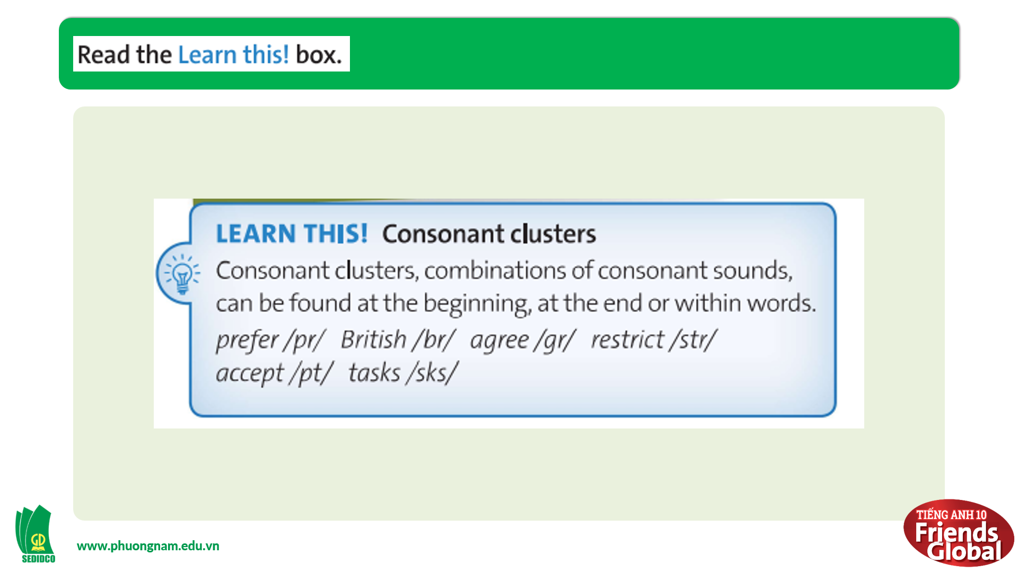  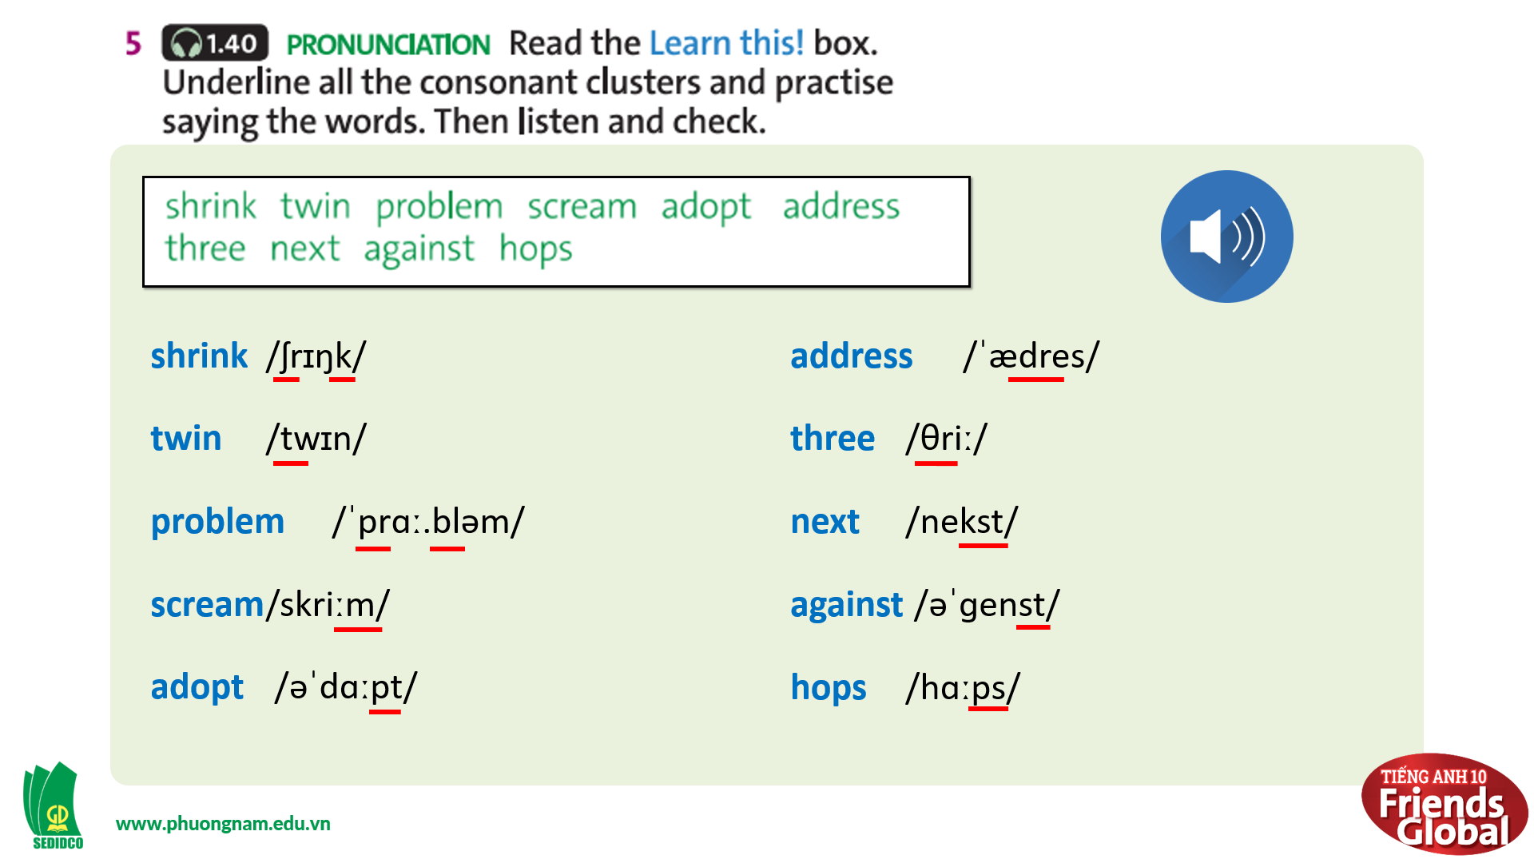

- Activity 3: Outcomes (10’)
a) Objective: Students plan, discuss and agree on some activities.
b) Content: Group discussion
c) Outcomes: Students can plan, discuss and agree on an activity to do with their friends.
d) Competence: Collaboration, communication, guessing
e) Organisation of the activity:
TEACHER’S ACTIVITIES | STUDENT’S ACTIVITIES | CONTENTS
PRODUCT. T-Ss/ S-S/ Indiv.  Activity 1 (5’): Task 6 page 42  - Go through the instructions together and make sure students understand what they have to do  - Monitor and help with grammar and vocabulary where necessary  - Give students some hints, sentences and examples to use while practice speaking  - Encourage students to speak  - Invite some students to share their ideas  Activity 2 (5’): Storytime  - Divide class into 4 groups (A, B, C & D)  - Each group will tell a story deciding what to do on the Saturday night after the last exam  - Each story is based on the clues depending on each situation  - Invite each group to share their story | - Listen to the teacher and take notes  - Work in pairs and practice speaking  - Volunteer to share ideas with the class  - Work in groups  - Discuss and note down some details of the story based on the clues given  - Tell the class about the upcoming activity | 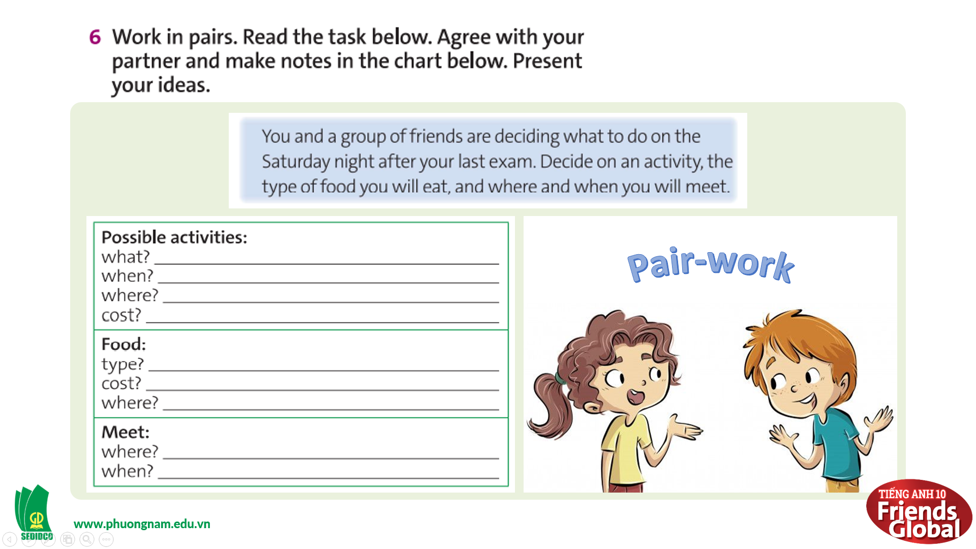  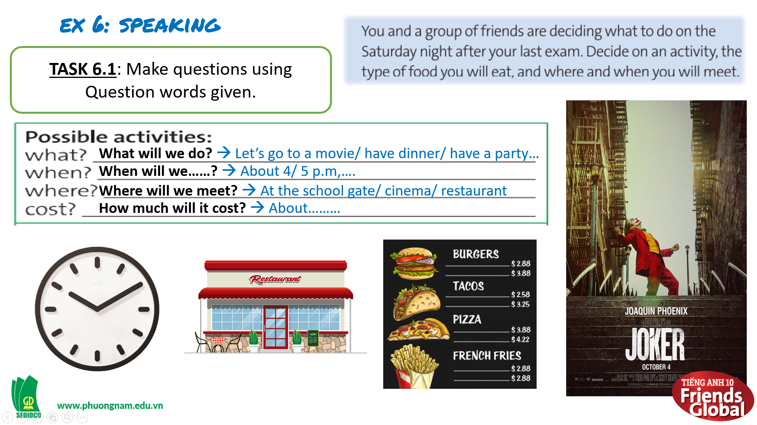  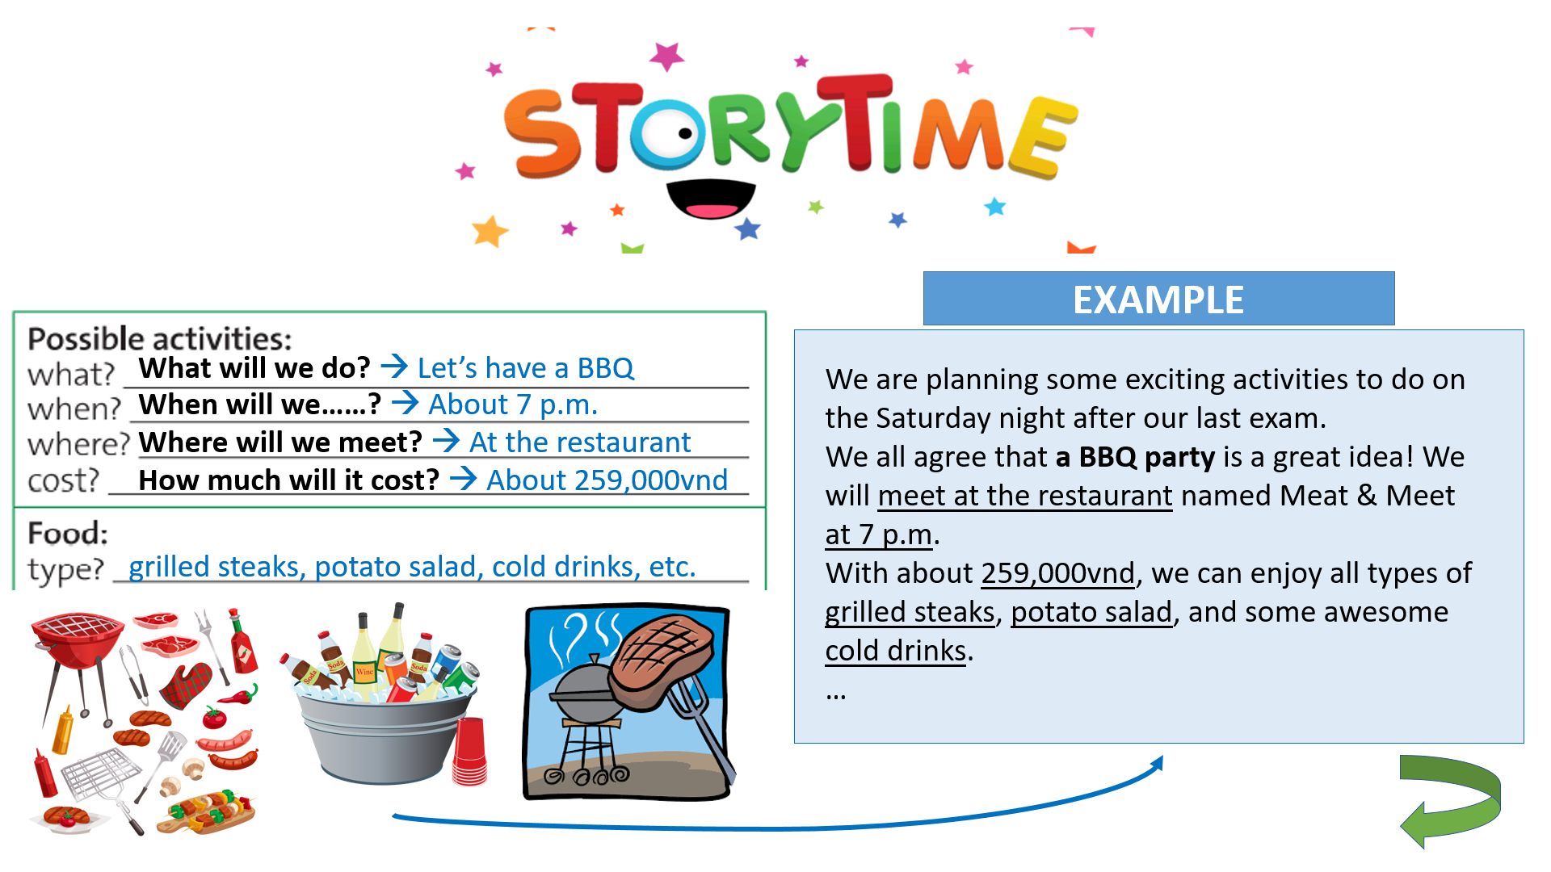  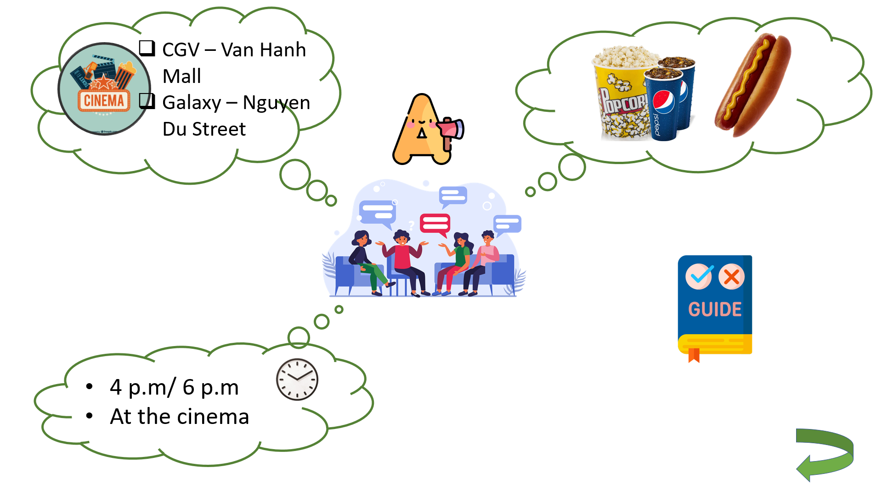
C. Consolidation (3’)
- Students can plan, discuss and agree on an activity to do with their friends.
D. Homework (2’)
- Practice discuss and agree on an activity with friends
- Do exercise
- Prepare: Unit 3H: Writing (page 43 – SB)

