|  |  |
| --- | --- |
| **Tiếng Anh 8 Friends Plus** | **FP 8 – REVIEW 2 - TEST 2**  **Test for Unit**  *-------------------------* |

**I. Pronunciation (1-4)**

**Câu 1.** Which word has the underlined part pronounced differently from that of the others?

**A.** convince  **B.** provide  **C.** driving  **D.** with

**Câu 2.** Which word has the underlined part pronounced differently from that of the others?

**A.** watched  **B.** wicked  **C.** laughed  **D.** helped

**Câu 3.** Which word has a different stress pattern from that of the others?

**A.** around  **B.** hockey  **C.** morning  **D.** language

**Câu 4.** Which word has a different stress pattern from that of the others?

**A.** informative  **B.** grandparents

**C.** minimize  **D.** underwater

**II. Choose the answer (A, B, C or D) that best fits the space in each question. (5-14)**

**Câu 5.** There are only a ______ cookies left in the jar.

**A.** lot of  **B.** enough  **C.** few  **D.** many

**Câu 6.** The Grand ______ in Arizona is one of the most famous natural landmarks in the United States.

**A.** ocean  **B.** cave  **C.** desert  **D.** valley

**Câu 7.** The Carlsbad Caverns National Park in New Mexico has over 119 ______ for visitors to explore.

**A.** oceans  **B.** deserts  **C.** caves  **D.** valleys

**Câu 8.** You'll be careful on the stairs, _______?

**A.** won't you  **B.** will you  **C.** do you  **D.** don't you

**Câu 9.** I'm _______ working on the project.

**A.** just  **B.** still  **C.** yet  **D.** already

**Câu 10.** He hasn't arrived _______.

**A.** already  **B.** still  **C.** just  **D.** yet

**Câu 11.** They don't like spicy food, _______?

**A.** did they  **B.** didn't they

**C.** do they  **D.** don't they

**Câu 12.** The Pacific ______ is the largest and deepest of Earth's oceanic divisions.

**A.** cave  **B.** valley  **C.** ocean  **D.** desert

**Câu 13.** I don’t have ______ money to buy a new car.

**A.** many  **B.** enough  **C.** few  **D.** lot of

**Câu 14.** Have you been doing anything special?

**A.** Yes, I have been learning a new musical instrument.

**B.** I enjoy eating ice cream.

**C.** I’ll have a trip to Nha Trang next summer.

**D.** No, nothing special about this food.

**III. Look at the signs. Choose the best answer (A, B, C or D). (15-16)**

**Câu 15.**

What is the purpose of the event mentioned in the notice?

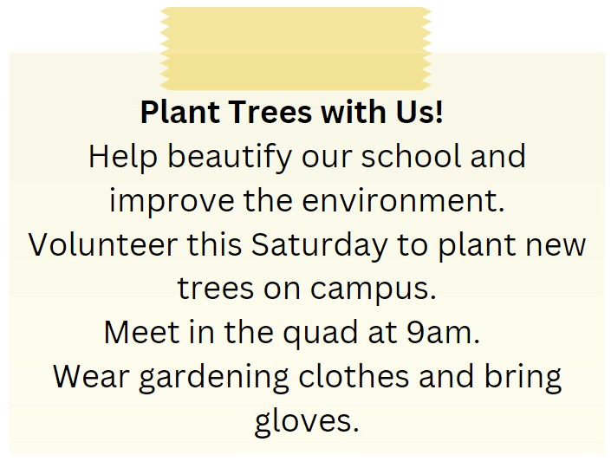

**A.** To clean the school  **B.** To collect donations for charity

**C.** To plant new trees on campus  **D.** To paint the school building

**Câu 16.**

What is the colour of the bin for composting according to the notice?

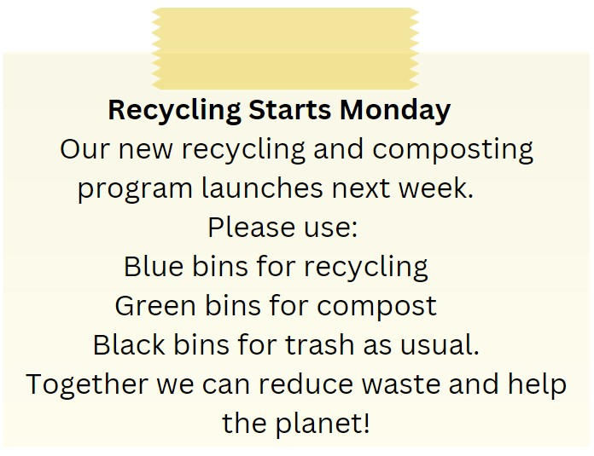

**A.** Green  **B.** Black  **C.** Blue  **D.** Red

**IV. Read the following passage and do as direct. (17-22)**

Smart furniture is an innovative and practical trend in home design. It refers to furniture that has multiple functions or incorporates technology to make life easier and more enjoyable. For example, a sofa that can easily transform into a bed, or a table that can adjust its height with the touch of a button. This type of furniture is especially useful in small homes where space is limited. Smart furniture can also include technological features such as built-in speakers, charging ports, or the ability to control lighting with a smartphone. Not only does smart furniture make life more convenient, but it is also environmentally friendly as it uses less space and resources. Investing in smart furniture is a great way to modernize your home and create a comfortable and functional living space.

**Câu 17.** Smart furniture refers to furniture that has multiple functions.

**A.** False  **B.** True

**Câu 18.** Smart furniture is not useful in small homes.

**A.** False  **B.** True

**Câu 19.** Smart furniture can include technological features such as built-in speakers.

**A.** False  **B.** True

**Câu 20.** Smart furniture is not environmentally friendly.

**A.** True  **B.** False

**Câu 21.** Which of the following is NOT an example of smart furniture mentioned in the passage?

**A.** A sofa bed  **B.** A height-adjustable table

**C.** A couch with built-in speakers  **D.** A dresser with built-in organizers

**Câu 22.** According to the passage, smart furniture is useful because it:

**A.** Is environmentally friendly  **B.** Uses less resources

**C.** Makes life more convenient  **D.** All of the above

**V. Choose the word (A, B, C or D) that best fits the blank space in the following passage. (23-28)**

Pizza is one of the most **___23____** dishes loved by people across the world. It originates from Italy but has become a global favourite enjoyed **____24___** people of all ages. Pizza consists of a flat round base of dough baked with a spread of tomato sauce and topped with cheese and a **___25____** of meats and vegetables. The most common pizza bases are made from wheat flour mixed with yeast, salt, olive oil and water. The versatility of toppings that can be added **____26___** the basic cheese and tomato sauce makes pizza a delicious and filling meal option. Pizza has also evolved over time with many regional variations emerging. Some popular styles **___27____** Neapolitan, New York, Sicilian and Chicago deep dish pizzas. People love to customize their pizzas by choosing different base types and an assortment of toppings like pepperoni, mushrooms, peppers, pineapple, olives and more. The **___28____** availability and affordability of pizza restaurants and takeaways have made this dish a popular choice for casual dining, parties and get-togethers.

**Câu 23.** Pizza is one of the most ___ dishes loved by people across the world.

**A.** dislike  **B.** popular  **C.** infamous  **D.** known

**Câu 24.** It originates from Italy but has become a global favourite enjoyed ____ people of all ages.

**A.** by  **B.** among  **C.** with  **D.** for

**Câu 25.** Pizza consists of a flat round base of dough baked with a spread of tomato sauce and topped with cheese and a ___ of meats and vegetables.

**A.** range  **B.** selection  **C.** variety  **D.** bag

**Câu 26.** The versatility of toppings that can be added ____ the basic cheese and tomato sauce makes pizza a delicious and filling meal option.

**A.** to  **B.** on  **C.** above  **D.** over

**Câu 27.** Some popular styles ____ Neapolitan, New York, Sicilian and Chicago deep dish pizzas.

**A.** exclude  **B.** include  **C.** is  **D.** have

**Câu 28.** The ___ availability and affordability of pizza restaurants and takeaways have made this dish a popular choice for casual dining, parties and get-togethers.

**A.** intensive  **B.** wide  **C.** narrow  **D.** famous

**VI. Supply the correct form of the word given in each sentence. (29-34)**

**Câu 29.** Can you give me a __________ of the person you saw? (describe)

**Câu 30.** It is __________ to predict the future with certainty. (possibility)

**Câu 31.** The audience watched in __________ as the magician performed his tricks. (amaze)

**Câu 32.** The __________ of social media has grown rapidly in recent years. (popular)

**Câu 33.** The beautiful scenery was a source of __________ for the artist. (inspire)

**Câu 34.** I __________ spilled coffee on my shirt. (accident)

**VII. Rearrange the groups of words in a correct order to make complete sentences. (35-36)**

**Câu 35.** late, but you / still haven’t / It’s very / homework. / done your

…

**Câu 36.** too many / films in / competition. / the / There are

…

**VIII. Rewrite each of the following sentences in another way so that it means almost the same as the sentence printed before it. (37-40)**

**Câu 37.** A lot of teenagers take an interest in environmental campaigns. (interested)

…

**Câu 38.** Lucy is saving money in order to buy a new laptop next month. (so that)

Lucy …

**Câu 39.** Do you think Liz will come to the party tomorrow? (Tag question)

Liz will …

**Câu 40.** Tom last went to the market 2 years ago. (for)

Tom …

**IX. Listening: listen and do as direct. (41-50)**

*Listen and fill in the blanks (one word for each sentence).*

**Câu 41.** Hardware refers to the ________ components of a computer.

**Câu 42.** Software instructs hardware to ________ tasks.

**Câu 43.** Examples of software include games, photo editors, and ________.

**Câu 44.** Hardware and software are distinct but ________.

**Câu 45.** Without software, our phones would not ________.

**Câu 46.** Without hardware, we would have programs but no ________ to run them on.

**Câu 47.** Software requires hardware to ________ its commands.

**Câu 48.** The combination of hardware and software enables us to do a lot on a ________.

**Câu 49.** As technology advances, hardware and software will continue to support it in the ________.

**Câu 50.** Hardware is the physical device, such as a phone, while software is its operating system and ________.

**----HẾT---**