School: ……………………………………….. | Date:……………………………………..
Class: ……………………………..................... | Period: …………………………….........

UNIT 2: HEALTH
Lesson 3.2 – Speaking and Writing (Page 19)

I. OBJECTIVES
By the end of the lesson, Ss will be able to:
1.1. Language knowledge and skills
- study format of a request letter.
- discuss healthy food (food which help Ss to study better).
- write a request letter to ask for better food in the school cafeteria.
1.2. Competences
- improve communication, collaboration, writing and critical thinking skills.
1.3. Attributes
- choose healthy food for themselves.
- lead a healthy life.
- make a polite request for better things in everyday life.

II. TEACHING AIDS AND LEARNING MATERIALS
1. Teacher’s aids: Student book and Teacher’s book, class CDs, Digital Book (DCR phần mềm tương tác SB, DHA (từ vựng/ cấu trúc) phần mềm trò chơi tương tác), projector/interactive whiteboard / TV (if any), PowerPoint slides.
2. Students’ aids: Student’s book, workbook, notebook.

III. ASSESSMENT EVIDENCE
Performance Tasks | Performance Products | Assessment Tools
- Speaking: Look at the pictures. Discuss which foods you think would help you study better. Why or why not? Can you buy any of these at your school?  - Complete the table about your school.  - Writing: Read about writing request letters. Then, read Tony’s letter again and fill in the labels.  - Number the sentences (1-7). Use the skill box.  - Write a letter to your school’s principal asking for better food in your cafeteria. | - Ss’ answers.  - Ss’ answers.  - Ss’ answers.  - Ss’ answers.  - Ss’ answers/ presentation. | - T’s feedback.  - T’s observation/ DCR.  - T’s feedback/Peers’ feedback.  - T’s feedback/Peers’ feedback.  - T’s observation and feedback.

IV. PROCEDURES
A. Warm up: (5’)
a) Objective: Introduce the new lesson and set the scene for Ss to acquire new language; get students' attention at the beginning of the class by enjoyable and short activities as well as to engage them in the follow-up steps.
b) Content: Food names / Introduce: Request.
c) Expected outcomes: Ss remember names of some food that they are going to talk about in the lesson.
d) Organization of the activity:
TEACHER’S ACTIVITIES | STUDENTS’ ACTIVITIES
Option 1:  - Divide class into groups.  - Give Ss a list of food.  - Have Ss work in groups to divide foods into 4 groups: vegetables, fruit, dairy and protein.  - Ask Ss in 4 groups to give answers.  - Ask Ss extra question: Which food is good for your brain?  - Have Ss give answers.  - Give feedback and evaluation.  - Lead to the new lesson.  *Suggested food list: lettuce, banana, cheese, apple, broccoli, yoghurt, egg, butter, ham, carrots, watermelon, milk, potatoes, beef, cream, pork, guava…  - Option 2: Game: Wheel of Fortune  - Have Ss play the game: Wheel of fortune.  - Design the game, have some voluntarily Ss spin the wheel and say a letter in English alphabet. If this letter is included in the key word, he / she will receive the thing in the wheel where the arrow stops. If he / she gets the wrong answer, T calls another one.  - Call Ss to spin and guess letters until the keyword is opened.  - The first S to give the right keyword will be the winner.  - Give feedback.  àLead to the new lesson: Introduce “REQUEST” à request letter.  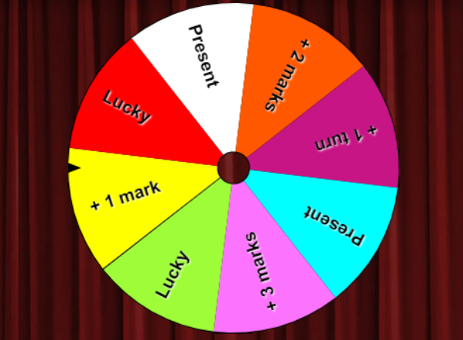 | - Take part the games in groups.  - Give answers.  - Listen.  Answer keys  - Vegetables: lettuce, broccoli, carrots, potatoes  - Fruit: banana, apple, watermelon, guava  - Dairy: cheese, yoghurt, butter, milk, cream  - Protein: egg, ham, beef, pork, …  - Take part in the game.  Keyword: REQUEST  - Listen.

B. New lesson (35’)
- Activity 1: Pre-Writing (Speaking) (10’)
a) Objective: Ss prepare for what they are going to write about.
b) Content:
- Speaking: Look at the pictures. Discuss which foods you think would help you study better. Why or why not? Can you buy any of these at your school?
- Complete the table about your school.
c) Expected outcomes: Ss know more vocabularies about food and apply the language from speaking to their writing.
d) Organization of the activity:
TEACHER’S ACTIVITIES | STUDENTS’ ACTIVITIES
Task a. Look at the pictures. Discuss which foods you think would help you study better. Why or why not? Can you buy any of these at your school?  - Use DCR to show the task.  - Have Ss observe the pictures, then work in pairs to which foods you think would help you study better, explain for their answers.  - Have some Ss share their ideas with the class.  - Give feedback and evaluation.  Task b. Complete the table about your school  - Use DCR to show the task.  - Have Ss complete the table about their school.  - Go round and give help if necessary.  - Have some pairs share their ideas with the class.  - Give feedback and evaluation. | - Look and discuss.  - Give answers.  - Complete the table.  - Present.
- Activity 2: While - Writing (20’)
a) Objective: Students can develop their writing skill.
b) Content: - Read about writing request letter. Read Tony’s letter (page 18) again and fill in the labels.
- Number the sentences of a request letter.
- Write a request letter to your school’s principal asking for better food in your cafeteria.
c) Expected outcomes: Students can write a request letter, using vocabulary about food and polite language.
d) Organization of the activity:
TEACHER’S ACTIVITIES | STUDENTS’ ACTIVITIES
Task a. Read about writing request letter. Read Tony’s letter (page 18) again and fill in the labels.  - Briefly explain the Writing skill box (using DCR).  - Have Ss read the Writing skill box and Tony’s letter again (page 18), then fill in the labels.  - Have Ss check their answers with a partner.  - Call Ss to give answers.  - Check answer as a whole class.  Task b. Number the sentences (1-7) of a request letter.  - Use DCR to show the task.  - Have Ss read the sentences, then number 1-7.  - Have Ss check their answers with a partner.  - Call Ss to give answers.  - Check answer as a whole class.  *Let’s Write: Now, write a request letter to your school’s principal asking for better food in your cafeteria. Use the feedback form to help you.  - Draw Ss’ attention to the feedback form (using DCR).  - Have Ss use their notes in speaking part and the form of the request letter to write a request letter to ask for better food in the school cafeteria.  - Have some Ss write their letter on the board. | - Listen.  -Work in pairs.  - Exchange their answers with a partner.  - Give answers.  Answer keys  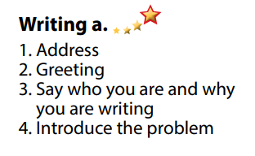  - Read and number the sentences.  - Exchange answers.  - Give answers.  Answer keys  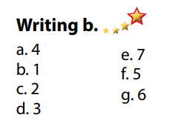  - Look and listen.  - Do the writing part.  -Write.  Suggested writing  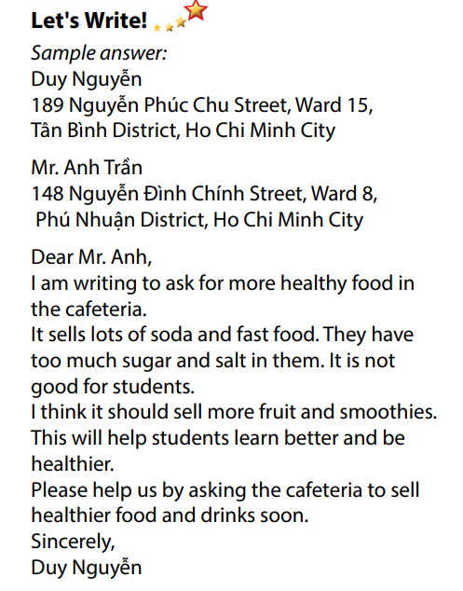

- Activity 3: Post - Writing (5’)
a) Objective: Help Ss realize their mistakes in writing and correct them.
b) Content: Correcting Ss’ writings.
c) Expected outcomes: Students know whether their letters follow the model and use the correct structures and language, whether their writings are interesting and understandable or not.
d) Organization of the activity:
TEACHER’S ACTIVITIES | STUDENTS’ ACTIVITIES
- Give feedback, correct Ss’ mistakes.  - Use the feedback form to give evaluation. Focus on:  + the format, the structures.  + the understandability.  + the coherence and cohesion. | - Look, listen and correct mistakes.

C. Consolidation and homework assignments (5’)
* Consolidation:
- Format of a request letter:
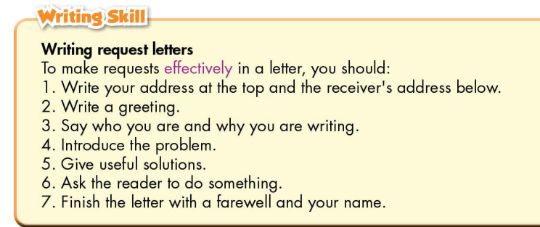

* Homework
- Remember how to write a request letter.
- Finish the writing part.
- Do the exercises in WB: Writing (page 13).
- Complete the grammar notes in Tiếng Anh 7 i-Learn Smart World Notebook (page 15).
- Play consolation games in Tiếng Anh 7 i-Learn Smart World DHA App on www.eduhome.com.vn
- Prepare: Unit 2 – Review.

D. Reflection
a. What I liked most about this lesson today:
…………………………………………………………………………………………
- What I learned from this lesson today:
…………………………………………………………………………………………
c. What I should improve for this lesson next time:
…………………………………………………………………………………………

