## **Tiếng Anh 8 i-Learn Smart World_Unit 5.3 Time allotted: 45**

**PART 1**  **PRONUNCIATION (4 questions)**

**Choose the word whose underlined part differs from the other three in pronunciation in the following question.**

1. A. safe B. danger C. tablet D. space

2. A. great B. steak C. break D. search

**Choose the word that differs from the other three in the position of the main stress in the following question.**

3. A. navigate B. exactly C. digital D. battery

**Choose the word that differs from the other three in the position of the main stress in the following question.**

4. A. machine B. image C. rescue D. robot

**PART 2**  **USE OF ENGLISH (13 questions)**

**Choose the option that best completes the following sentence.**

5. The tablet's ______________ is so large and bright that I can easily watch movies on it.

A. webcam B. screen C. keyboard D. mouse

6. The new tablet has a very light ______________, so you can easily hold it in one hand.

A. gigabyte B. price C. inch D. weight

7. Robear is a robot which is designed to ______________ elderly people from their beds into a wheelchair.

A. increase B. lighten C. lift D. improve

8. During the Covid-19 pandemic, some hospitals used robots to pick ______________ and transport test samples.

A. up B. at C. off D. on

9. The robot can ______________ the faces and voices of different people and respond to their commands.

A. listen B. react C. recognize D. create

10. The Tokyo Fire Department has used robots to ______________ trapped people from the burning building.

A. research B. rescue C. prevent D. nagivate

11. Samsung Bot Care is able to ______________ many tasks around the home.

A. make B. have C. get D. complete

12. I'm excited that the iPhone 15 has a longer battery life, ______________ I can use it all day.

A. so B. or C. also D. but

13. The new model runs______________ than the old model; you can barely hear it running.

A. more quiet B. quieter C. quietly D. more quietly

14. The old model may work ______________, but the new model is more efficient.

A. hardier B. harder C. more hardly D. more hard

15. Lucas: "______________ "   
Kate: "To read online materials and do school projects."

A. When do you use your tablet?

B. How do you use your tablet?

C. What do you use your tablet for?

D. Why do you use your tablet?

16. Jamie: "Dad, ______________ might the iPhone 15 cost?"   
Dad: "More than 800 dollars, I guess."

A. how many B. how much C. how D. what

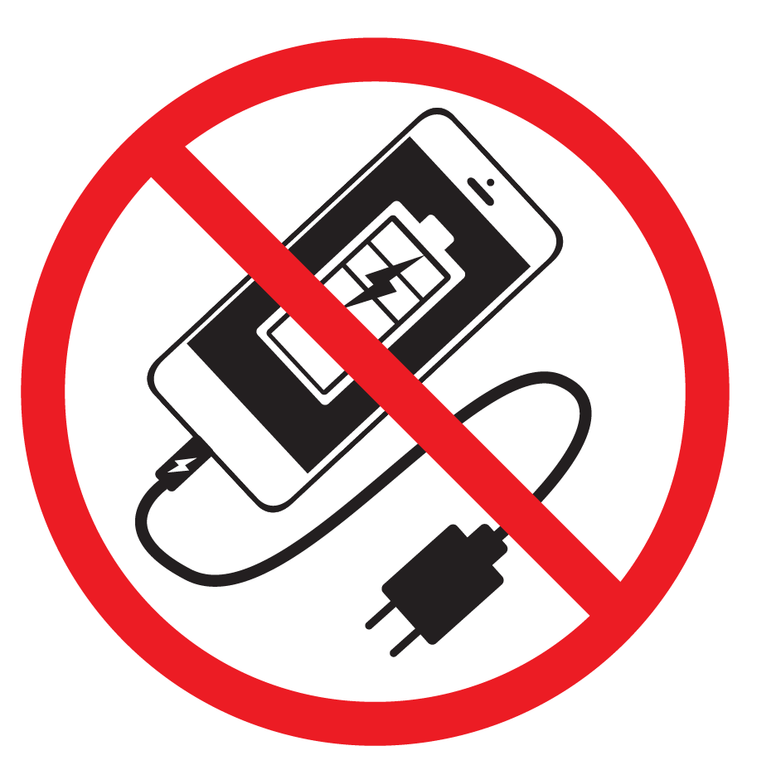

17. What does the sign mean?

A. Please do not charge your phone here.

B. Please do not use smartphones here.

C. There is no electricity for your phone here.

D. Your phone is not safe here.

**PART 3**  **WORD FORMATION (6 questions)**

**Write the correct form of the given word.**

18. The new smartphone has 128 GB of ______________, which is plenty of space for my needs. ***(STORE)***

19. My computer is ______________ enough for me to play the latest games. ***(POWER)***

20. We were amazed at the ______________ of robots at the exhibition. ***(PERFORM)***

21. More and more robots are used in ______________ jobs, as it can help to protect human workers.

***(DANGER)***

22. Robots can ______________ navigate through natural disasters and search for survivors. ***(SAFE)***

23. I will lend you my tablet, but you must promise to use it ______________. ***(CARE)***

**Find the underlined part that needs correction in the following question.**

24. The new robot design allows it to travel further in one charge, making it more suitable for difficult tasks.

A. allows B. further C. in one charge D. suitable for

**PART 5**  **READING (5 questions)**

**Read an article in a school magazine from a young inventor, Jess, and choose the best answer for each question. (5 questions)**

My mother is a computer programmer and my father is a computer engineer. He loves repairing computers in the garage. My sister and I enjoyed helping him from an early age, always seeing who could be more helpful. He wasn’t an inventor, but he showed us inventions all the time which made computers work better. I learned then that technology must help people do something better.   
When I was 10, I had an idea for a robot which could make tea in the morning and then wake you up. But my mother said people already had that kind of machine. I realized then that an inventor has to find answers to new problems.   
When I was 12, I built a robot for a competition. It could climb stairs. I won first prize in my age group. The judges said that I had solved a problem which took robot engineers years to solve. Climbing is easy for humans, but it is hard for robots.   
I’m working on a robot now which can do lots of different things. Robots which can do one thing very well are everywhere, in car factories, for example. We don’t really think of them as robots, because they can’t navigate around a room or talk to us. But each one only has one job. It is expensive to build robots **like this**, because each one contains hundreds of parts which are the same. It costs less if each robot can do many things, like a human being.

25. The writer probably started inventing things because ______________.

A. her parents both work with new technology

B. her father invented things for computing

C. she saw her father solving problems

D. she wanted to do better than her sister

26. What does the writer feel now about her first robot?

A. It didn’t solve a new problem.

B. It wasn’t a very good idea.

C. It wouldn’t really work.

D. Robots can’t make tea.

27. Why did the writer’s robot win a prize when she was 12?

A. Because she was the first person to make a robot that could climb stairs

B. Because she had solved a difficult problem

C. Because her robot could make tea

D. Because there was a category for her age

28. What does **like this** mean in the final paragraph?

A. In a good way

B. With only one job

C. Which can navigate around a room

D. Which can talk

29. Why is it better to have robots which can do many things, according to the writer?

A. They are cheaper.

B. They are like humans.

C. They can work better in car factories.

D. They can walk around and talk.

**PART 6**  **LISTENING (5 questions)**

**You will hear an advertisement for a new computer. Complete the summary. Write ONE WORD AND / OR A NUMBER in each numbered space. (5 questions)**

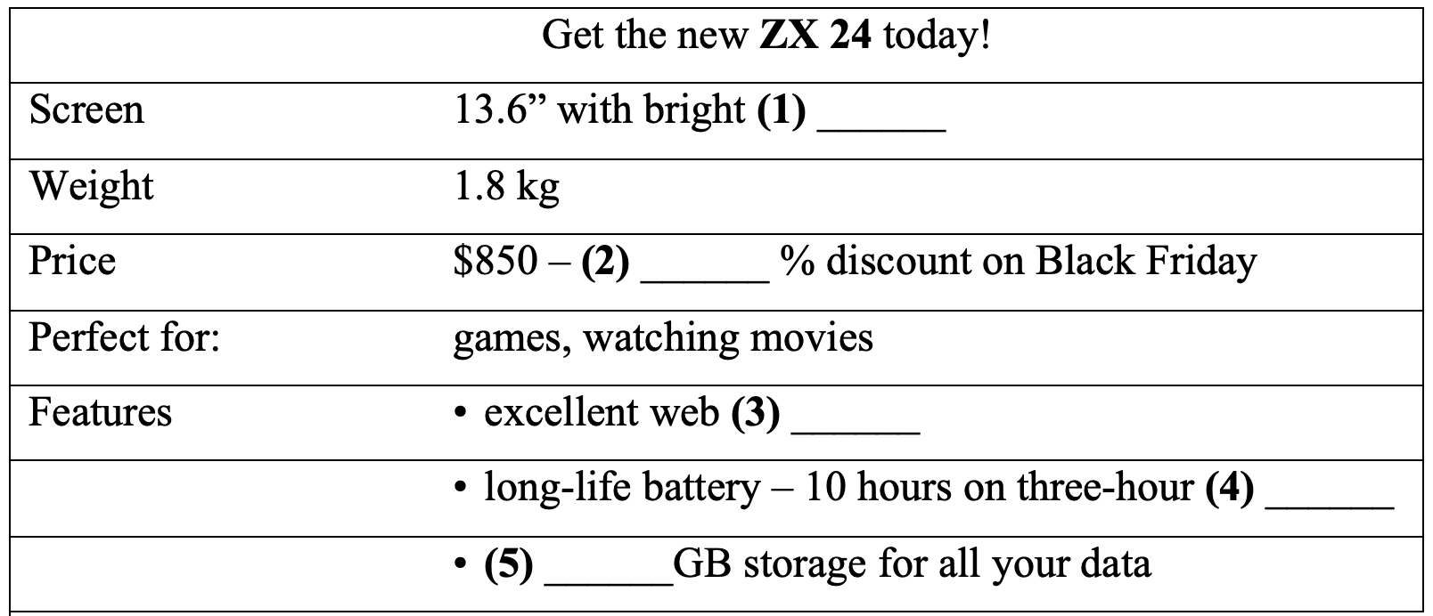

(30)___________________  
(31)___________________  
(32)___________________  
(33)___________________  
(34)___________________

**PART 7**  **WRITING (6 questions)**

**Rewrite the following sentence without changing its meaning. Use the given word(s) if any.**

35. The new model is thinner and lighter, but it has a smaller battery.

→ BUT___________

36. The new model's battery lasts longer than the old one.

→ LASTS___________

37. I think this robot cleans better than I do.

→ CLEANS___________

38. The robot worked more slowly than I had thought.

→ SLOWLY___________

**Put the words in the correct order to make a correct sentence.**

39. it has/./this tablet/I prefer/it is/a great camera/because/and/easy to use

→ .......................................

40. ./which/UC Santa Barbara/higher than/a robot/30 meters/has developed/can jump

→ .......................................

**---THE END---**

## **Tiếng Anh 8 i-Learn Smart World_Unit 5.3 Time allotted: 45**

## **ANSWER KEY**

**PART 1**  **PRONUNCIATION (4 questions)**

**Choose the word whose underlined part differs from the other three in pronunciation in the following question.**

1. A. safe B. danger C. tablet D. space

2. A. great B. steak C. break D. search

**Choose the word that differs from the other three in the position of the main stress in the following question.**

3. A. navigate B. exactly C. digital D. battery

**Choose the word that differs from the other three in the position of the main stress in the following question.**

4. A. machine B. image C. rescue D. robot

**PART 2**  **USE OF ENGLISH (13 questions)**

**Choose the option that best completes the following sentence.**

5. The tablet's ______________ is so large and bright that I can easily watch movies on it.

A. webcam B. screen C. keyboard D. mouse

6. The new tablet has a very light ______________, so you can easily hold it in one hand.

A. gigabyte B. price C. inch D. weight

7. Robear is a robot which is designed to ______________ elderly people from their beds into a wheelchair.

A. increase B. lighten C. lift D. improve

8. During the Covid-19 pandemic, some hospitals used robots to pick ______________ and transport test samples.

A. up B. at C. off D. on

9. The robot can ______________ the faces and voices of different people and respond to their commands.

A. listen B. react C. recognize D. create

10. The Tokyo Fire Department has used robots to ______________ trapped people from the burning building.

A. research B. rescue C. prevent D. nagivate

11. Samsung Bot Care is able to ______________ many tasks around the home.

A. make B. have C. get D. complete

12. I'm excited that the iPhone 15 has a longer battery life, ______________ I can use it all day.

A. so B. or C. also D. but

13. The new model runs______________ than the old model; you can barely hear it running.

A. more quiet B. quieter C. quietly D. more quietly

14. The old model may work ______________, but the new model is more efficient.

A. hardier B. harder C. more hardly D. more hard

15. Lucas: "______________ "   
Kate: "To read online materials and do school projects."

A. When do you use your tablet?

B. How do you use your tablet?

C. What do you use your tablet for?

D. Why do you use your tablet?

16. Jamie: "Dad, ______________ might the iPhone 15 cost?"   
Dad: "More than 800 dollars, I guess."

A. how many B. how much C. how D. what



17. What does the sign mean?

A. Please do not charge your phone here.

B. Please do not use smartphones here.

C. There is no electricity for your phone here.

D. Your phone is not safe here.

**PART 3**  **WORD FORMATION (6 questions)**

**Write the correct form of the given word.**

18. The new smartphone has 128 GB of ______________, which is plenty of space for my needs. ***(STORE) =>storage***

19. My computer is ______________ enough for me to play the latest games. ***(POWER) => powerful***

20. We were amazed at the ______________ of robots at the exhibition. ***(PERFORM)***

***=> performances/ performance***

21. More and more robots are used in ______________ jobs, as it can help to protect human workers.

***(DANGER) => dangerous***

22. Robots can ______________ navigate through natural disasters and search for survivors. ***(SAFE)***

***=> safely***

23. I will lend you my tablet, but you must promise to use it ______________. ***(CARE) => carefully***

**Find the underlined part that needs correction in the following question.**

24. The new robot design allows it to travel further in one charge, making it more suitable for difficult tasks.

A. allows B. further C. in one charge D. suitable for

**PART 5**  **READING (5 questions)**

**Read an article in a school magazine from a young inventor, Jess, and choose the best answer for each question. (5 questions)**

My mother is a computer programmer and my father is a computer engineer. He loves repairing computers in the garage. My sister and I enjoyed helping him from an early age, always seeing who could be more helpful. He wasn’t an inventor, but he showed us inventions all the time which made computers work better. I learned then that technology must help people do something better.   
When I was 10, I had an idea for a robot which could make tea in the morning and then wake you up. But my mother said people already had that kind of machine. I realized then that an inventor has to find answers to new problems.   
When I was 12, I built a robot for a competition. It could climb stairs. I won first prize in my age group. The judges said that I had solved a problem which took robot engineers years to solve. Climbing is easy for humans, but it is hard for robots.   
I’m working on a robot now which can do lots of different things. Robots which can do one thing very well are everywhere, in car factories, for example. We don’t really think of them as robots, because they can’t navigate around a room or talk to us. But each one only has one job. It is expensive to build robots **like this**, because each one contains hundreds of parts which are the same. It costs less if each robot can do many things, like a human being.

25. The writer probably started inventing things because ______________.

A. her parents both work with new technology

B. her father invented things for computing

C. she saw her father solving problems

D. she wanted to do better than her sister

26. What does the writer feel now about her first robot?

A. It didn’t solve a new problem.

B. It wasn’t a very good idea.

C. It wouldn’t really work.

D. Robots can’t make tea.

27. Why did the writer’s robot win a prize when she was 12?

A. Because she was the first person to make a robot that could climb stairs

B. Because she had solved a difficult problem

C. Because her robot could make tea

D. Because there was a category for her age

28. What does **like this** mean in the final paragraph?

A. In a good way

B. With only one job

C. Which can navigate around a room

D. Which can talk

29. Why is it better to have robots which can do many things, according to the writer?

A. They are cheaper.

B. They are like humans.

C. They can work better in car factories.

D. They can walk around and talk.

**PART 6**  **LISTENING (5 questions)**

**You will hear an advertisement for a new computer. Complete the summary. Write ONE WORD AND / OR A NUMBER in each numbered space. (5 questions)**



30. images

31. 20/twenty

32. camera

33. charge

34. 512

**PART 7**  **WRITING (6 questions)**

**Rewrite the following sentence without changing its meaning. Use the given word(s) if any.**

35. The new model is thinner and lighter, but it has a smaller battery.

→ The new model is thinner and lighter, but it has a smaller battery.

36. The new model's battery lasts longer than the old one.

→ The new model's battery lasts longer than the old one.

37. I think this robot cleans better than I do.

→ I think this robot cleans better than I do.

38. The robot worked more slowly than I had thought.

→ The robot worked more slowly than I had thought.

**Put the words in the correct order to make a correct sentence.**

39. it has/./this tablet/I prefer/it is/a great camera/because/and/easy to use

→ I prefer this tablet because it is easy to use and it has a great camera ./I prefer this tablet because it has a great camera and it is easy to use .

40. ./which/UC Santa Barbara/higher than/a robot/30 meters/has developed/can jump

→ UC Santa Barbara has developed a robot which can jump higher than 30 meters.

**---THE END---**