School: ……………………………………….. | Date: ………………………………….
Class: ……………………………..................... | Period: ………………………….........

UNIT 6: EDUCATION
Lesson 3.2 – Speaking and Writing (page 51)

I. OBJECTIVES
By the end of the lesson, Ss will be able to:
1.1. Language knowledge and skills
- use conjunctions “however”, “although” to show contrast.
- talk about positive and negative experiences of studying abroad.
- write a paragraph about studying abroad.
1.2. Competences
- improve communication, collaboration, writing and critical thinking skills.
1.3. Attributes
- overcome studying pressure and negative feelings.
- be independent and know how to take care of themselves when studying away from home.

II. TEACHING AIDS AND LEARNING MATERIALS
1. Teacher’s aids: Student book and Teacher’s book, class CDs, Digital Book (DCR phần mềm tương tác SB, DHA (từ vựng/ cấu trúc) phần mềm trò chơi tương tác), projector/interactive whiteboard / TV (if any), PowerPoint slides, handouts.
2. Students’ aids: Student’s book, workbook, notebook.

III. ASSESSMENT EVIDENCE
Performance Tasks | Performance Products | Assessment Tools
- Speaking: You just finished a year studying abroad. In pairs: Ask and answer the questions below. | - Ss’ answers / presentation. | - T’s feedback/Peers’ feedback.
- Talk about two positive and two negative experiences when you studied abroad. Then, fill in the table. | - Ss’ answers / presentation. | - T’s feedback/Peers’ feedback.
- Writing: Read about using conjunctions. Then, read Anna's paragraph again and underline the ideas linked with conjunctions. | - Ss’ answers. | - T’s feedback/Peers’ feedback.
- Read and circle Yes or No. | - Ss’ answers. | - T’s feedback/Peers’ feedback.
- Underline and correct the mistakes. Then, rewrite the correct sentences with however and although in your notebook. | - Ss’ answers. | - T’s feedback/Peers’ feedback.
- Now, write a paragraph about studying abroad. Use the Feedback form to help you. Write 60 to 80 words. | - Ss’ answers. | - T’s observation and feedback.

IV. PROCEDURES
A. Warm up: (5’)
a) Objective: Introduce the new lesson and set the scene for Ss to acquire new language; get students' attention at the beginning of the class by enjoyable and short activities as well as to engage them in the follow-up steps.
b) Content: Introduce “however” and “Although” / adjectives of feelings.
c) Expected outcomes: Ss know about the topic that they are going to talk and write about in new the lesson.
d) Organization of the activity:
TEACHER’S ACTIVITIES | STUDENTS’ ACTIVITIES
Option 1: Introduce “however” and “although”  - Give 3 sets of letters.  - Have Ss use the letters given in each set to make a meaningful English word.  - Have Ss give answers. The first student to give a right answer will be given a small present.  - Give feedback and evaluation.  - Lead to the new lesson: However and although to show contrast.  Set 1 Set 2  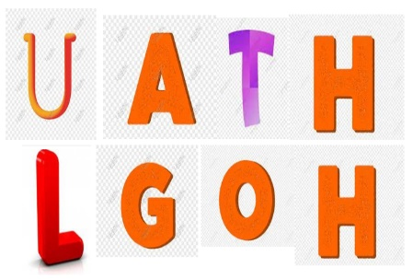    Set 3  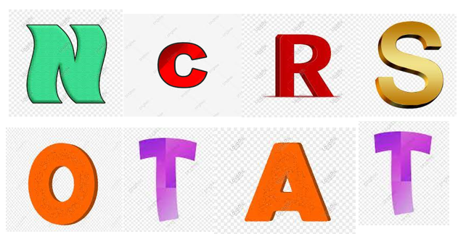  - Option 2: Adjectives of feelings / activity  - Have Ss close books.  - Give Ss some adjectives of feelings / activities.  - Have Ss put them into 2 categories: negative and positive (in 2 minutes).  - Have Ss give answers.  - Check Ss’ answers, give feedback and evaluation  - Lead to the new lesson.  *Suggested adjectives: bored, annoyed, delighted, happy, lonely, independent, lazy, sociable, active, fantastic, tired, pleased, homesick… | - Do the task.  - Give answers.  - Listen.  Answer keys  1. HOWEVER  2. ALTHOUGH  3. CONTRAST  - Close all books and notebooks.  - Do the task in pairs.  - Read answers.  - Listen.  Answer keys  - Adjectives of positive feelings / activities: delighted, happy, independent, sociable, active, fantastic, pleased  - Adjectives of negative feelings / activities: bored, annoyed, lonely, lazy, tired, homesick

B. New lesson (35’)
- Activity 1: Pre-Writing (Speaking) (8’)
a) Objective: Ss prepare for what they are going to write about.
b) Content:
- Speaking: You just finished a year studying abroad. In pairs: Ask and answer the questions below.
- Talk about two positive and two negative experiences when you studied abroad. Then, fill in the table.
c) Expected outcomes: Ss have more ideas and language for their writing.
d) Organization of the activity:
TEACHER’S ACTIVITIES | STUDENTS’ ACTIVITIES
Task a. In pairs: You just finished a year studying abroad. In pairs: Ask and answer the questions below.  - Divide the class into pairs.  - Have students discuss in pairs using the questions.  - Go round and support Ss if necessary.  - Have some students share their ideas with the class.  - Give feedback and evaluation.  Task b. Talk about two positive and two negative experiences when you studied abroad. Then, fill in the table.  - Have students continue to work in pairs to talk about two positive and two negative experiences when they studied abroad. Then, fill in the table.  - Go round and give help if necessary.  - Have Ss exchange their answers with another pair.  - Have some pairs read their answers.  - Give feedback and evaluation. | - Work in pairs.  - Present.  - Discuss and fill in the table.  - Exchange.  - Present.
- Activity 2: While - Writing (22’)
a) Objective: Students can develop their writing skill.
b) Content: - Read about using conjunctions. Then, read Anna's paragraph again and underline the ideas linked with conjunctions.
- Read and circle Yes or No.
- Underline and correct the mistakes. Then, rewrite the correct sentences with however and although in your notebook.
- Now, write a paragraph about studying abroad. Use the Feedback form to help you. Write 60 to 80 words.
c) Expected outcomes: Students can write a paragraph about good and bad sides of studying abroad, using right format and rich vocabulary.
d) Organization of the activity:
TEACHER’S ACTIVITIES | STUDENTS’ ACTIVITIES
Task a. Read about using conjunctions. Then, read Anna's paragraph again and underline the ideas linked with conjunctions.  -Briefly explain the Writing skill box and have some Ss read it aloud.  - Have Ss read Anna’s paragraph again (page 50) and underline the ideas linked with conjunctions.  - Have Ss check their answers with a partner.  - Call Ss to give answers.  - Check answers as a whole class using DCR.  Task b. Read and circle Yes or No.  - Have students read the prompts.  - Have students read the questions and circle Yes or No.  - Have students check their answers with a partner.  - Check answer as a whole class using DCR.  Task c. Underline and correct the mistakes. Then, rewrite the correct sentences with however and although in your notebook.  - Have students read the sentences.  - Have students underline and correct the mistakes.  - Have students check their answers with a partner.  - Call Ss to read their answers and explain.  - Check answers as a whole class using DCR.  - Then, have Ss rewrite the correct sentences with “however” and “although” in their notebook.  *Let’s Write: Write a paragraph about studying abroad. Use the Feedback form to help you. Write 60 to 80 words.  - Draw Ss’ attention to the feedback form.  - Have Ss use their notes in speaking part and the instruction in the Writing box to write a paragraph about studying abroad.  - Go round, observe and give help if necessary.  - Have some Ss write their paragraph on the board. | - Listen and read.  -Work in pairs.  - Exchange their answers with a partner.  - Give answers.  Answer keys  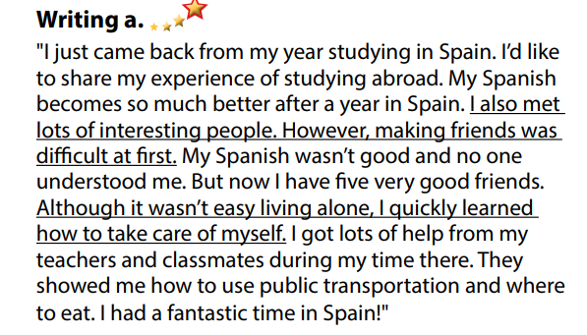  - Read the prompts and circle Yes or No.  - Exchange answers.  - Read answers.  Answer keys  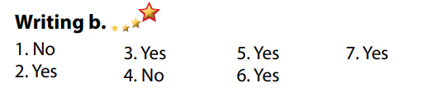  - Read, underline and correct the mistakes.  - Give answers.  - Rewrite the correct sentences with “however” and “although” in the notebook.  Answer keys  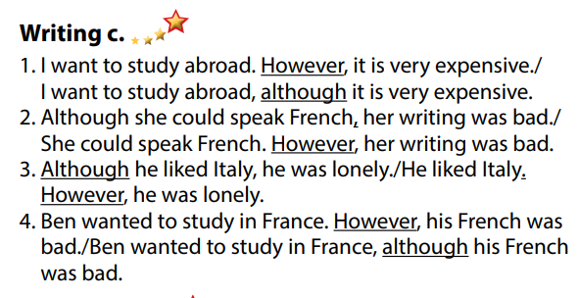  - Do the writing part.  -Write.

- Activity 3: Post - Writing (5’)
a) Objective: Help Ss realize their mistakes in writing and correct them.
b) Content: Correcting Ss’ writings.
c) Expected outcomes: Students know whether their writings follow the model and use the correct structures and language, whether their writings are interesting and understandable or not.
d) Organization of the activity:
TEACHER’S ACTIVITIES | STUDENTS’ ACTIVITIES
- Give feedback, correct Ss’ mistakes.  - Use the feedback form to give evaluation. Focus on:  + the format, the structures, the punctuation  + the understandability  + the coherence and cohesion  + the spelling | - Look, listen and correct mistakes.  Suggested writing  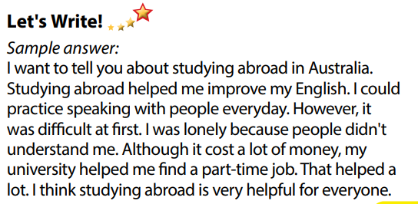

C. Consolidation and homework assignments (5’)
* Consolidation:
- Writing Skill:
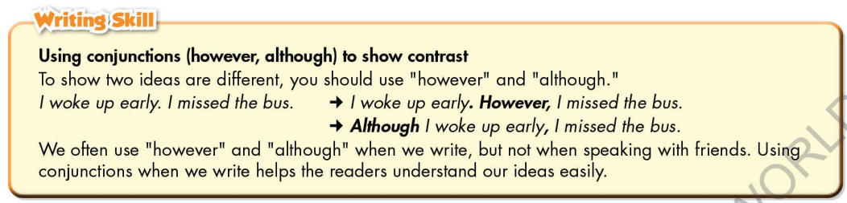

* Homework
- Remember how to write a paragraph about benefits and drawbacks of studying abroad.
- Finish the writing part.
- Do the exercises in WB: Writing part, page 37.
- Complete grammar notes in Tiếng Anh 7 i-Learn Smart World Notebook (pages 41).
- Play consolation games in Tiếng Anh 7 i-Learn Smart World DHA App on www.eduhome.com.vn
- Prepare: Unit 6 – Review, pages 100, 101.

D. Reflection
a. What I liked most about this lesson today:
…………………………………………………………………………………………
- What I learned from this lesson today:
…………………………………………………………………………………………
c. What I should improve for this lesson next time:
…………………………………………………………………………………………

