Name:____________________ ENGLISH GRADE 5
Giaoandethitienganh.info có rất nhiều tài liệu tiếng anh file word hay, chất lượng, mời bạn đăng ký tài khoản ( chỉ 100k/ năm) để chủ động tự tải tài liệu khi cần!
Class: ____________________ UNIT 2: OUR HOMES
- LISTENING

Task 1: Listen and put the stressed syllable of the following words. There is one example.
- fif’teen
- thirteen 5. sixteen
- bamboo 6. ninety
- twenty 7. seventeen
- kangaroo 8. eighty
Task 2: Listen and tick or cross.
-  2. 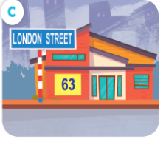 3. 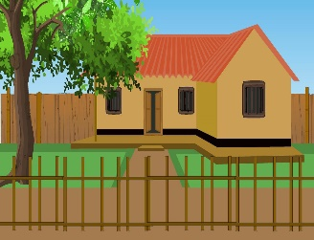 4. 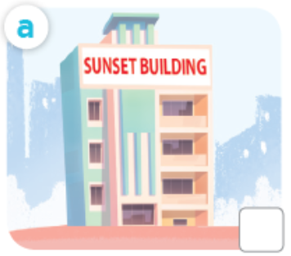

Task 3: Listen and circle. There is one example.
- Ben lives / doesn’t live near the school.
- He lives five / four kilometres from the school.
- He lives in a flat / house.
- His address is 14 / 15 River Street.
- It’s a noisy / quiet street.
- VOCABULARY AND GRAMMAR
Task 1: Look and write. There is one example.
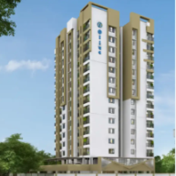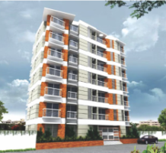

0. a h_______ 1. a b_______ 2. a f_______ 3. a t______

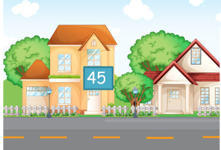
- a________ 6. c__________ 7. c_________ 8. f______ _____

Task 2: Choose the best answer. There is one example.
- Do you live in _____ house? Yes, I do. 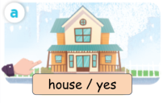
A. this B. that C.an
- Do you live in this _____? No, I don’t. 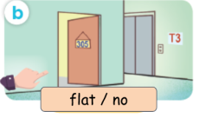
A. house B. building C. flat
2. Do you live in _____ building? Yes, I do. 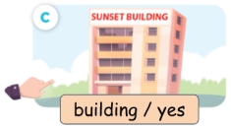
A. this B. that C.an

3. Do you live in a house? ____________
A. Yes, I live. B. Yes, I do. C. Yes, I don’t.
4. I live in that house.
A. 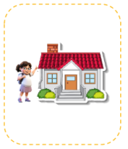 B. 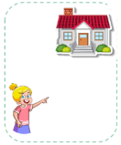 C. 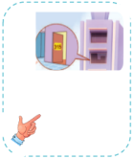
5. I live in _________. 
A. this building B. that building C. this house

III. READING
Task 1: Read and match. There is one example.
- Does she live in this house? | - It’s 25 Nguyen Du Street. | 0. b
- What’s your address? | - Yes, she does. | 1.
- Is it far from here? | - No. I live in that flat. | 2.
- Where do you live? | - Yes, it is. | 3.
- Do you live in this flat? | - I live at 93 Oxford Street. | 4.
Task 2: Read and complete. There is one example.
- A: What’s your address?
B: It’s___________________.
A: _________ you live in a big house?
B: Yes, I do. My house is big and beautiful.

- A: Where do you live?
B: I live at_________________.
A: Is it near the _____________?
B: Yes, it is.
Task 3: Read and answer.
Mai is my pen friend. She is from Ha Noi, Viet Nam. She lives with her parents in a flat in Ha Noi Tower. Her address is Flat 9, 79 Nguyen Du Street. In her flat, there are three bedrooms, three bathrooms, a kitchen, and a living room. Mai likes her flat because it is pretty and comfortable. She also likes her city because it is modern and pretty.
0. What’s her name? Her name’s Mai Linh.
- Where does Mai live?
- …………………………………………………………………
- What is her address?
- …………………………………………………………………
- Does she live in a big house?
- …………………………………………………………………
- How many rooms are there in her flat?
- …………………………………………………………………
Task 4: Read and answer.
James lives in a tower in Sydney. His address is Flat 5, Sunshine Tower, 29 Hill Street. He lives about five kilometres from school. His flat is large and quiet. He lives with his mum, his dad and his sister. Thanh lives in a small house in Da Nang. Her house is very close to school. She lives with her mum and dad. She has a dog. Her address is 116 Doc Lap Street. The street is busy. It has many shops. Dan lives in London with his parents. He lives in a small flat in a building. It’s one kilometre from school. His address is Flat 12, 76 King Road. Dan likes living in London.
- Who lives in a large flat? _______________________________________________
- Who lives in a house? __________________________________________________
- Which city does James live in? ___________________________________________
- Does Thanh live far from school? _________________________________________
- What’s Dan’s address? __________________________________________________
IV. WRITING
Task 1. Look and write. There is one example.

0. Do you live in a house?  No. I live in a flat. | 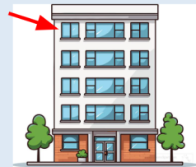
1. What’s your address?  It’s ………………………………………………….. | 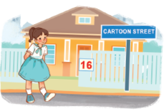
2. Do you live in a big city?  ..............……………………………………………….. | 
3. Where does she live?  ………………………………………………………….. | 
4. Does he live in that house?  ………………………………………………………….. | 
Task 2. Reorder the words/ phrases to complete the sentences. There is one example. (1)
- Where/ live/ do/ you/?
- Where do you live?
- live/ I/ 15 / Hoa Binh/ at/ Street/.
- …………………………………………………………………
- I/ building/ that/ live/ in/.
- …………………………………………………………………
- is/ What/ address/ your/ ?
- …………………………………………………………………
- is/ It/ Nguyen Van Cu/ 25/ Street/.
- …………………………………………………………………
Task 3. Write about you!

• your name
• where you live (village / town / city)
• what kind of building you live in
• your address
• who you live with

Giaoandethitienganh.info có rất nhiều tài liệu tiếng anh file word hay, chất lượng, mời bạn đăng ký tài khoản ( chỉ 100k/ năm) để chủ động tự tải tài liệu khi cần!

