ĐỀ VIP 9+ - ĐỀ SỐ 4
Read the following advertisement and mark the letter A, B, C, or D to indicate the correct option that best fits each of the numbered blanks from 1 to 6.

Join Our Eco-Volunteers Programme!
Are you passionate about making a difference in the environment? Our Eco-Volunteers Programme allows individuals (1) to sustainable projects that protect nature and promote biodiversity. Offering a wide (2) of activities – from planting trees to educating communities – this programme has (3) opportunities for you to explore and engage in environmental preservation. Working alongside dedicated professionals, you’ll gain hands-on experience (4) real-
world challenges, helping communities in need and learning valuable skills. Volunteers (5) in this programme enjoy outdoor adventures, meeting like-minded individuals, and making a meaningful impact on the planet. By the end, you’ll feel both accomplished and (6) , knowing you played a role in preserving the environment for future generations.
Sign up today and be part of a programme designed to make a difference.
Chỉ 100k/12 tháng, bạn tải rất nhiều tài liệu tiếng anh file word hay tại: Giaoandethitienganh.info Mong bạn ghé ủng hộ !
Question 1. | A. to contributing | B. to contribute | C. contribute | D. contributing
Question 2. | A. range | B. degree | C. volume | D. amount
Question 3. | A. each | B. another | C. many | D. others
Question 4. | A. putting up | B. taking over | C. dealing with | D. carrying out
Question 5. | A. participated | B. to participate | C. participating | D. participate
Question 6. | A. refreshingly | B. refreshing | C. refreshed | D. refresh
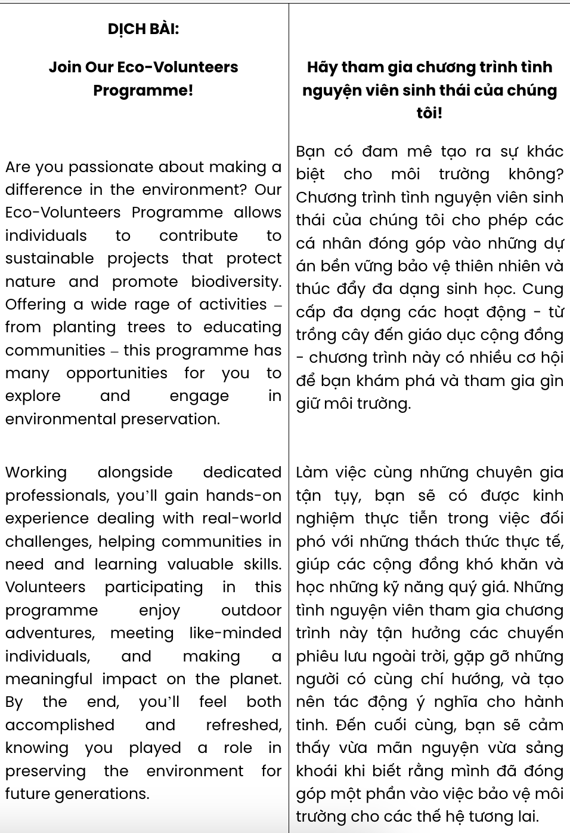
GIẢI CÂU 1:
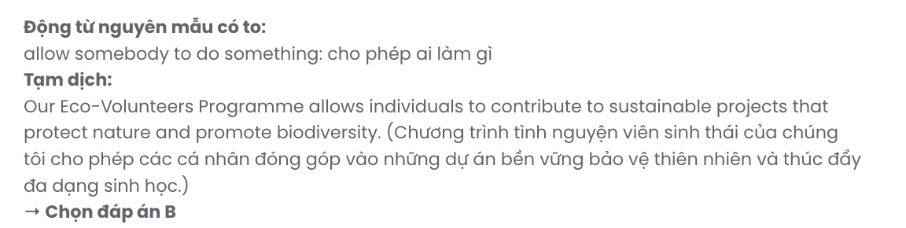
GIẢI CÂU 2:
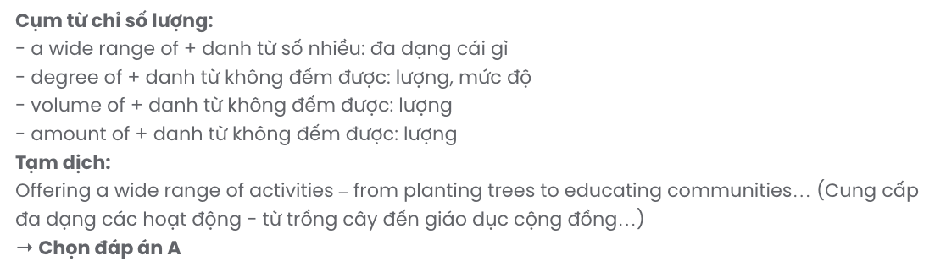
GIẢI CÂU 3:
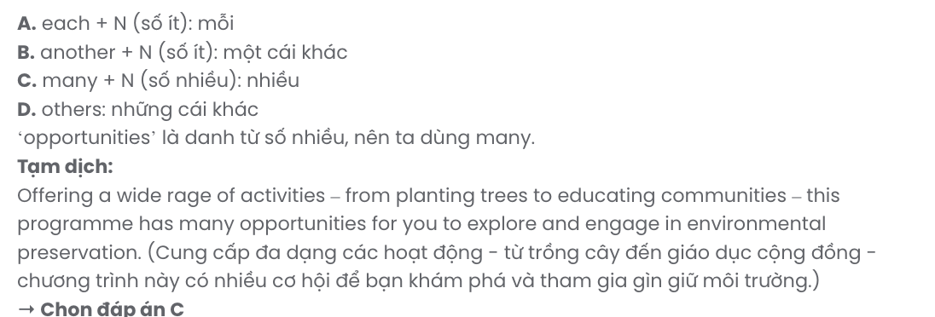
GIẢI CÂU 4:
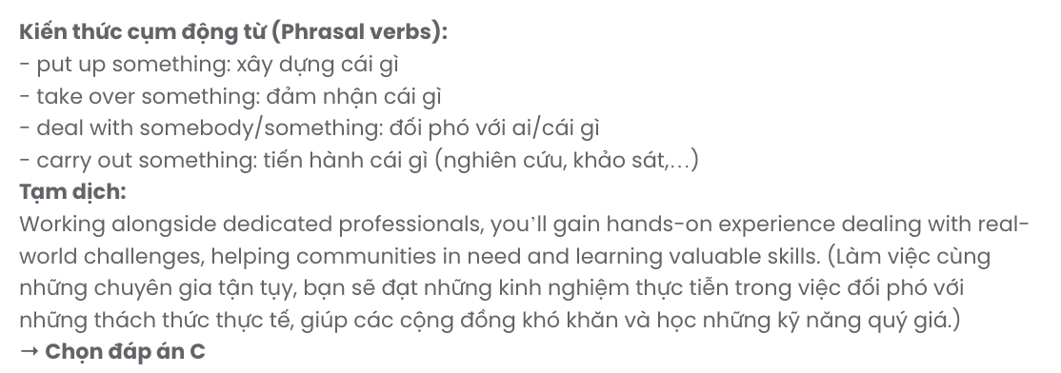
GIẢI CÂU 5:
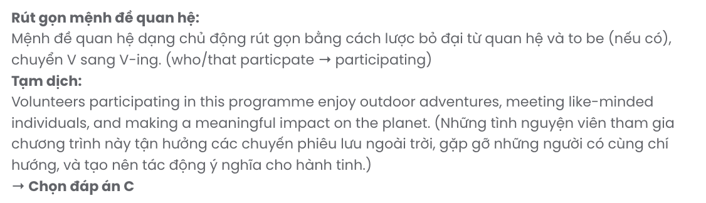
GIẢI CÂU 6:
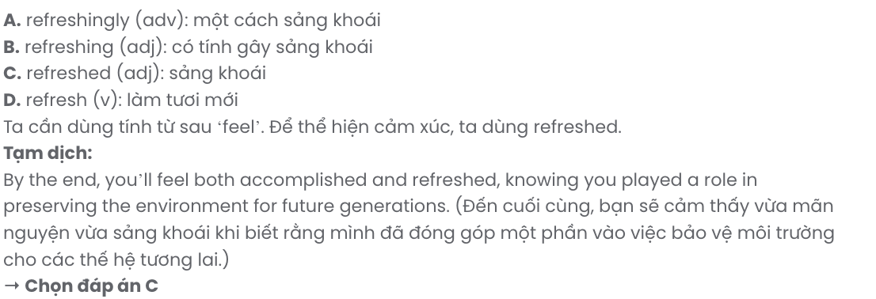
Read the following leaflet and mark the letter A, B, C, or D to indicate the correct option that best fits each of the numbered blanks from 7 to 12.

ASEAN Young Leaders Conference 2024
Join us for the ASEAN Young Leaders Conference 2024 – an inspiring event that brings together future leaders from across Southeast Asia. This year’s theme, Innovative Solutions for Sustainable Development, will explore creative (7) to tackle today’s challenges.
Engage with passionate (8) from diverse ASEAN countries, building a strong leadership network that strengthens regional partnerships and fosters shared growth. The conference offers a valuable platform (9) critical topics like sustainability, economic development, and cultural exchange.
Held at the ASEAN Cultural Centre, the event includes interactive workshops, dynamic keynote speeches, and a (10) . Don’t miss this chance to take part in a truly impactful journey, connecting
(11) like-minded individuals and developing practical skills.
Mark your calendar – (12) the first step toward a sustainable future in ASEAN!
Question 7. | A. journeys | B. strategies | C. routines | D. lifestyles
Question 8. | A. representatives | B. dwellers | C. inhabitants | D. peers
Question 9. | A. with regard to | B. regardless of | C. in contrast to | D. in place of

Question 10. | A. transformative experience networking  C. experience transformative  networking |  | B. networking transformative experience  D. transformative networking  experience
Question 11. | A. at | B. for | C. in | D. with
Question 12. | A. make | B. lead | C. put | D. take
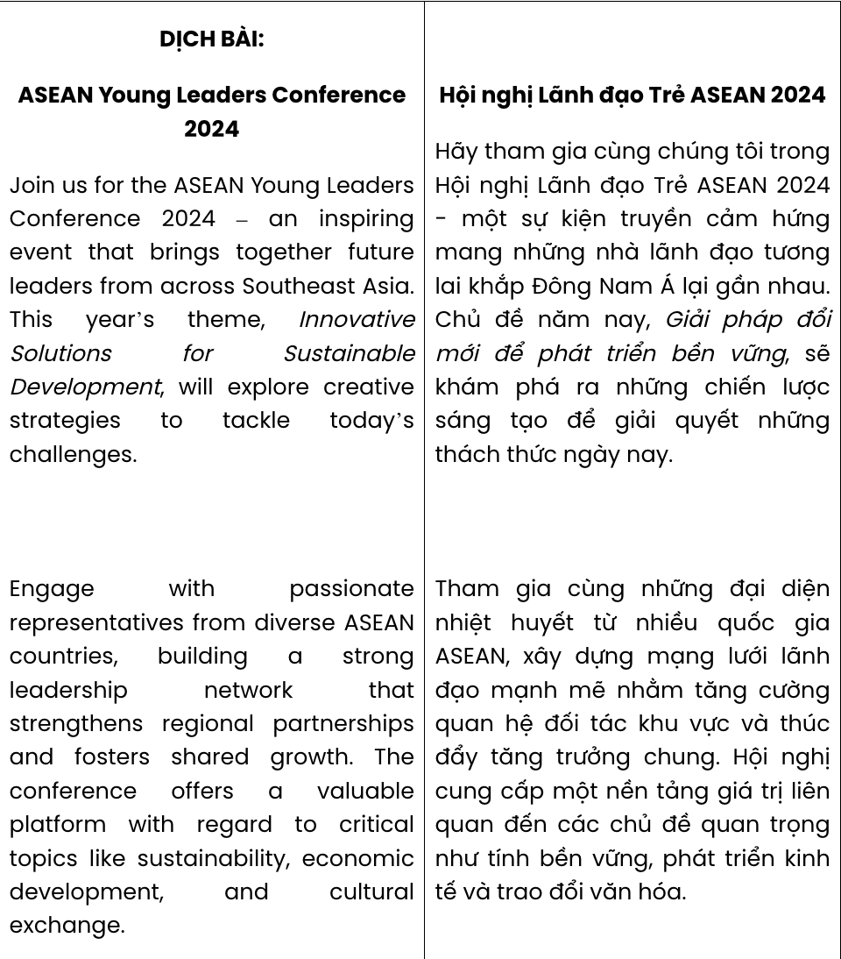
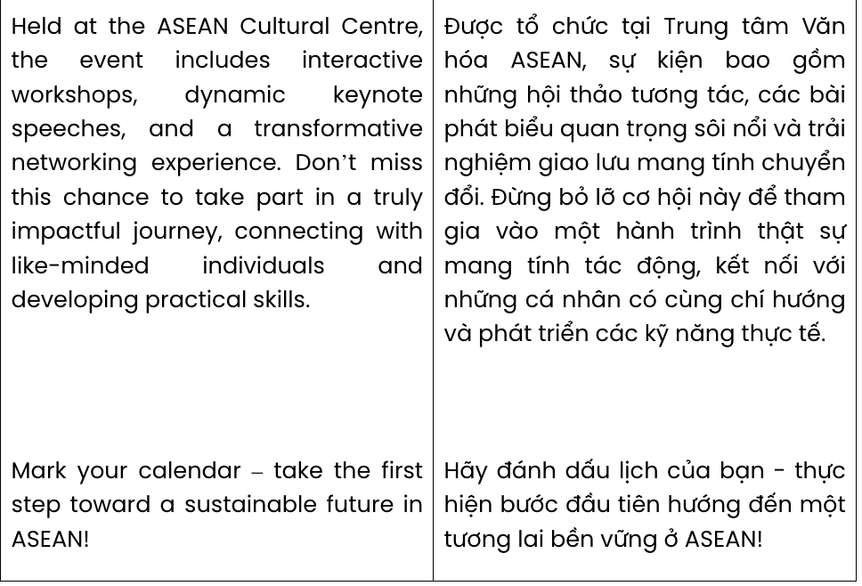
GIẢI CÂU 7: GIA SƯTẠI HUẾ (079.3833.272)
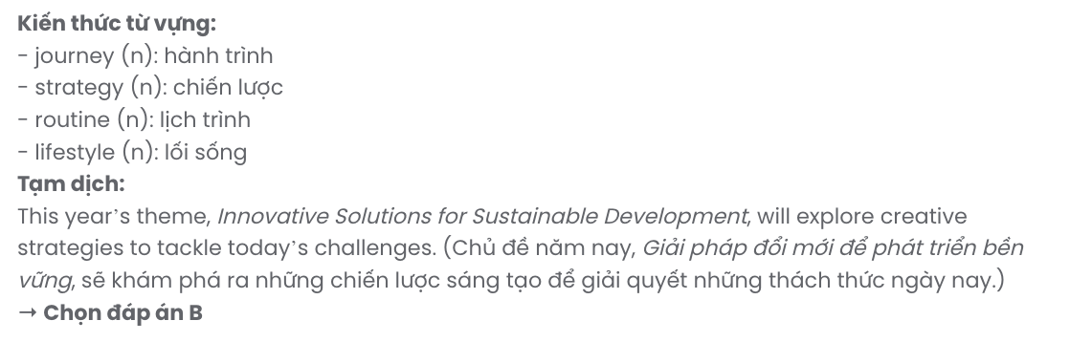
GIẢI CÂU 8:
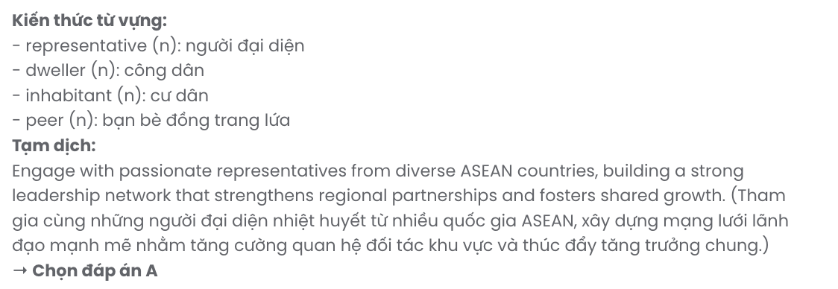
GIẢI CÂU 9:
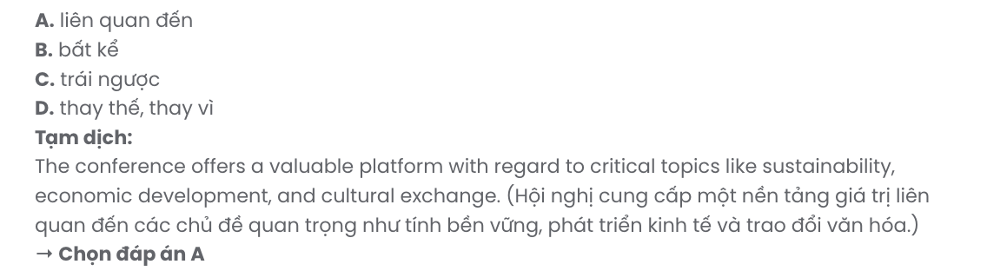
GIẢI CÂU 10:
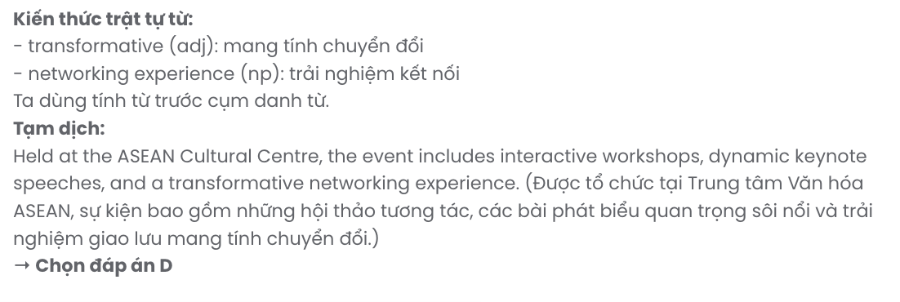
GIẢI CÂU 11:
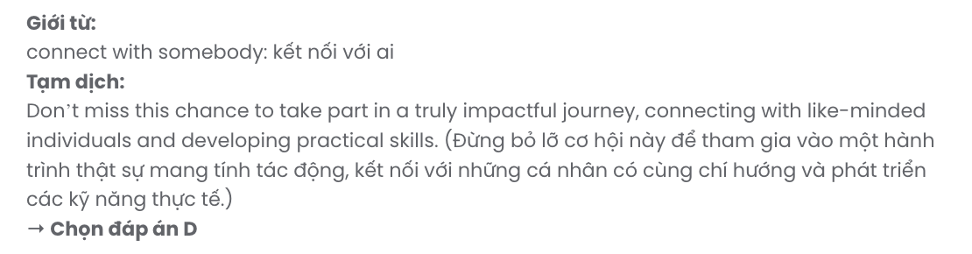
GIẢI CÂU 12:
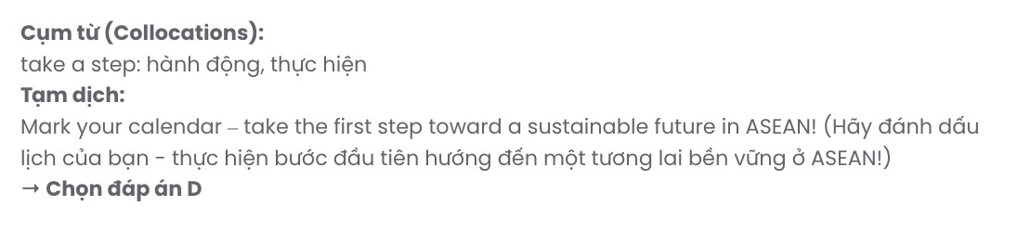
Mark the letter A, B, C or D to indicate the best arrangement of utterances or sentences to make a meaningful exchange or text in each of the following questions from 13 to 17.

Question 13.
Hi Sarah,
- Spending time with the kids has been both challenging and incredibly rewarding, especially seeing the impact even small activities can have.
- I really appreciate your suggestion to volunteer at the local orphanage - it’s been such a meaningful experience.
- Maybe we could volunteer together sometime? Let me know what you think!
- Your tips on engaging them with fun activities were a huge help! The kids loved them.
- Although my schedule is tight, I’ve been able to visit once a week, and it’s become something I really look forward to.
Write back soon. Jamie
A. a – b – e – c – d B. d – b – e – a – c C. b – a – d – e – c D. e – a – b – d – c

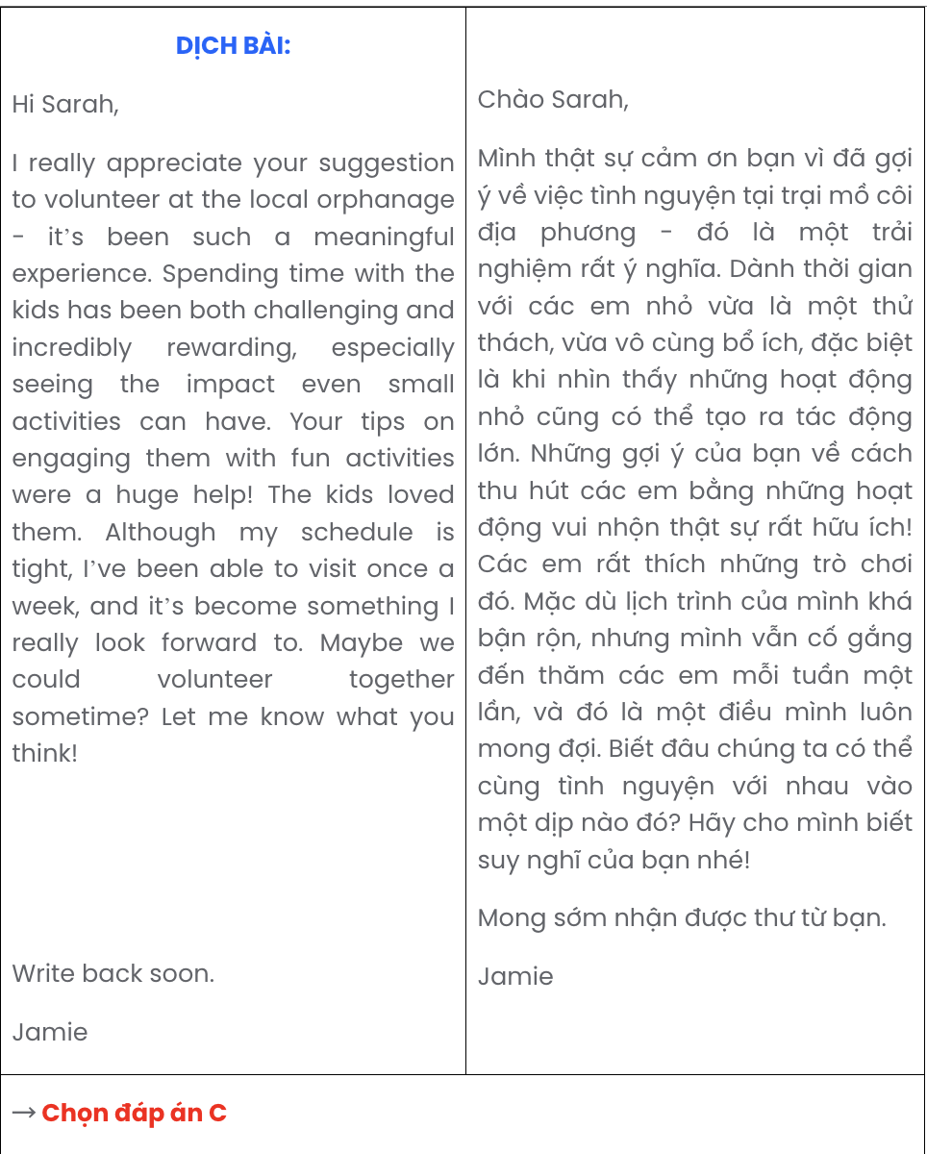

Question 14.
- Quang: Hi, Peter! Yes, I am! I’ve heard it’s going to be a lot of fun. Have you been on a field trip like this before?
- Peter: Hi, Quang! Long time no see. Are you excited about the field trip?
- Peter: Yes, I have. Last year, we went to a similar place, and it was amazing! I'm sure this one will be even better.

A. c – a – b B. a – b – c C. b – a – c D. b – c – a

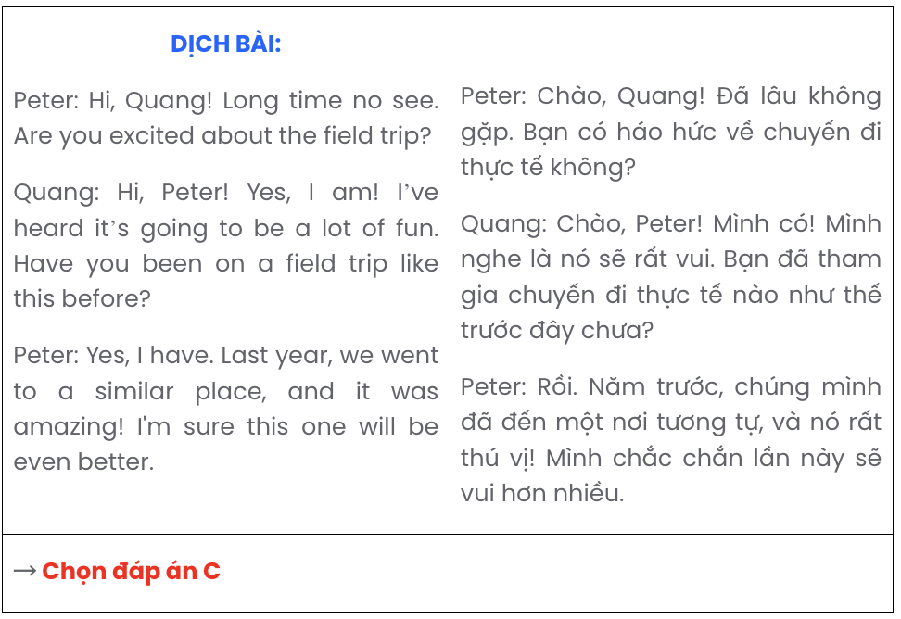

Question 15.
- Martin: It’s a fantastic way to meet people from various backgrounds, and it’s super convenient!
- Martin: I thought I’d try connecting with people on social media.
- Kim: What’s your plan for meeting new people?
- Kim: I get it, but I still prefer meeting people in person - it feels more genuine to me.
- Kim: What makes social media so appealing for that?
A. c – a – d – b – e B. e – b – d – a – c C. e – a – c – b – d D. c – b – e – a – d
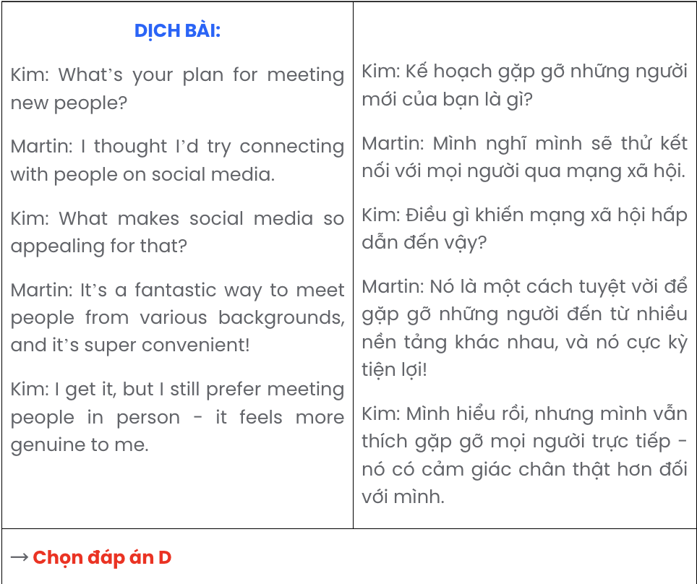

Question 16.
- However, despite these efforts, fake news persists, partly due to the ease with which content is shared online.
- Trusted news sources are increasingly questioned, as sensationalism often overshadows accuracy to attract readers.
- This rise in misinformation has prompted responses from tech companies, governments, and activists, all working to address the problem.

- Over the past few years, fake news has become a widespread issue.
- The shift toward sensationalism has fuelled the spread of fake news, leaving people uncertain about which sources to trust.
A. d – b – e – c – a B. d – c – a – b – e C. d – a – c – b – e D. d – e – b – a – c

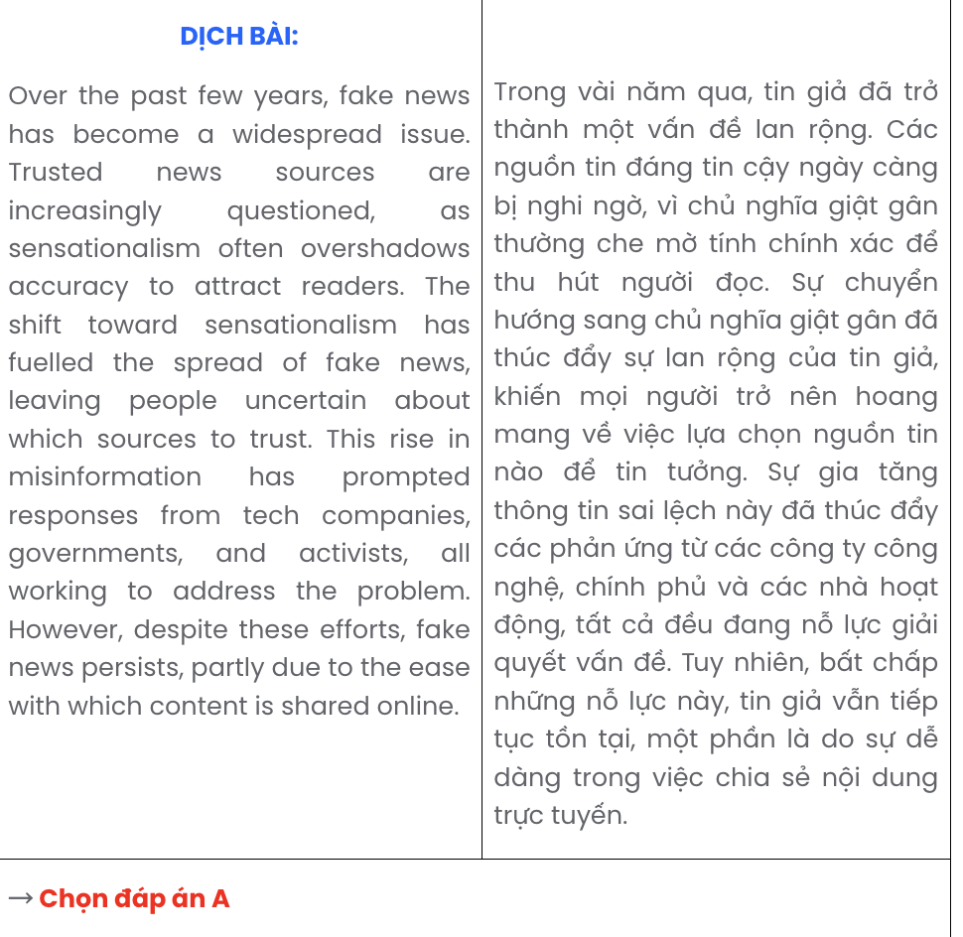

Question 17.
- Engaging in these movements online connects me with a diverse community and fosters a sense of purpose.
- In conclusion, I find hashtag activism incredibly rewarding as it aligns with my passion for advocacy and digital outreach.
- Over the past year, I’ve actively participated in online campaigns, where I use targeted hashtags to raise awareness and rally support.
- While maintaining momentum and visibility can be challenging, the chance to influence positive change is worth the effort.
- My dedication to social issues and digital engagement naturally led me to explore the power of hashtag activism.
A. a – c – d – e – b B. c – e – a – d – b C. e – c – a – d – b D. d – a – c – e – b
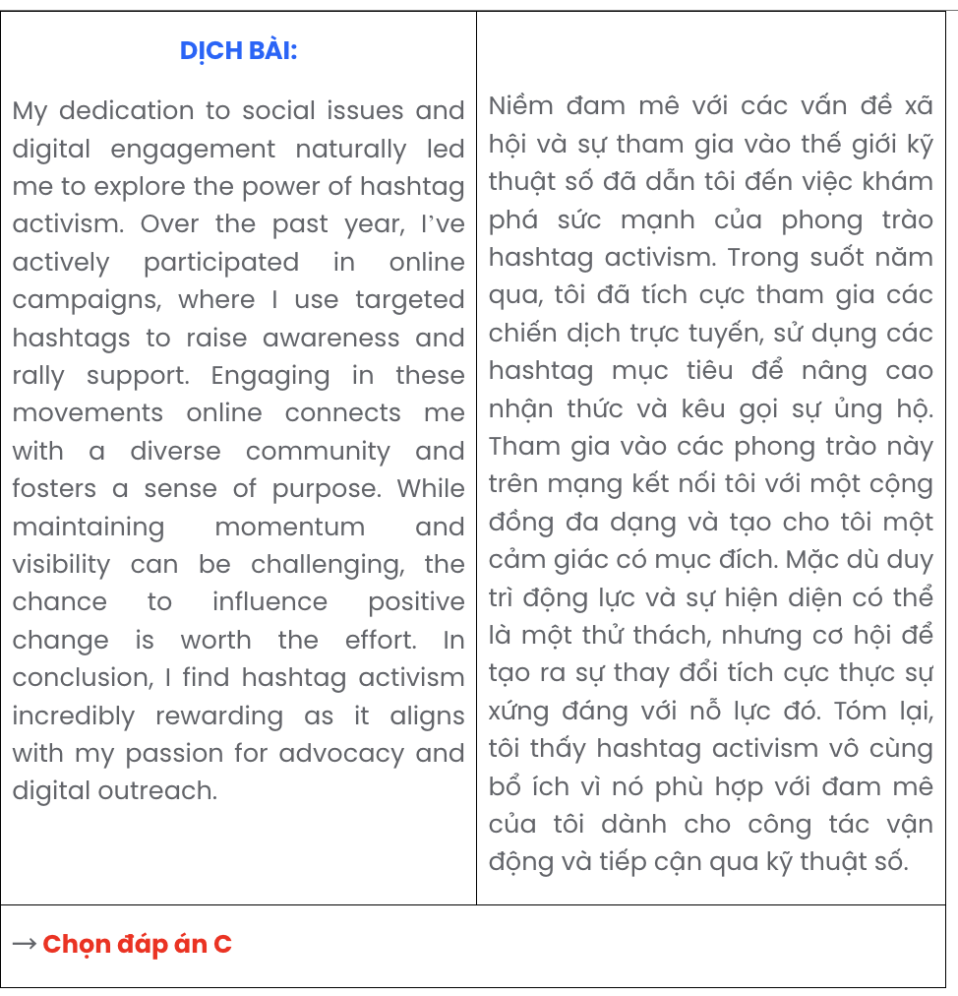
Read the following passage about Vietnamese customs and cultures and mark the letter A, B, C, or D to indicate the correct option that best fits each of the numbered blanks from 18 to 22.
Vietnamese customs and traditions, deeply rooted in cultural history and values, (18) . One such example is the celebration of Tet, or the Lunar New Year, which marks the beginning of spring. Traditionally, families gather to pay respects to their ancestors and to welcome the new year with hopes of prosperity and happiness. During this time, people decorate their homes with kumquat trees and peach blossoms, symbols of luck and longevity.
Vietnam’s rich cultural heritage includes a wide array of unique rituals and practices (19) . At festivals such as the Mid-Autumn Festival, children parade with lanterns, and families share mooncakes, expressing unity and joy. These traditions highlight the importance of family bonds and respect for older generations, core values of Vietnamese culture.
Vietnamese attire also reflects a deep cultural symbolism. The ao dai, a traditional long dress with side slits, has become a national symbol and is worn on special occasions to show elegance and pride. In recent years, (20) .
Vietnam’s cultural practices extend to communication and interaction. (21) . Visitors are often amazed by these small yet meaningful gestures, which showcase the courtesy ingrained in Vietnamese society. The preservation of Vietnamese customs and traditions remains a priority in modern society. Passed down through generations, (22) .

Question 18.
  - having played a vital part in defining the lives of its people
  - which have had a major impact on the lives of its people
  - play a significant role in shaping the lives of its people
  - that have greatly contributed to the development of its people's lives
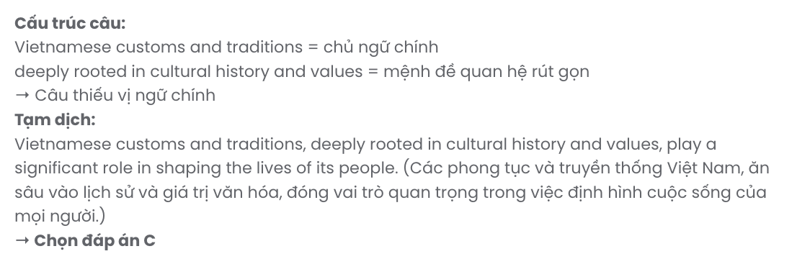

Question 19.
- had origins tracing back to centuries-old beliefs and philosophies
- is rooted in beliefs and philosophies that date back centuries
- whose origins stem from centuries-old beliefs and philosophies
- of which close ties with beliefs and philosophies dating back centuries

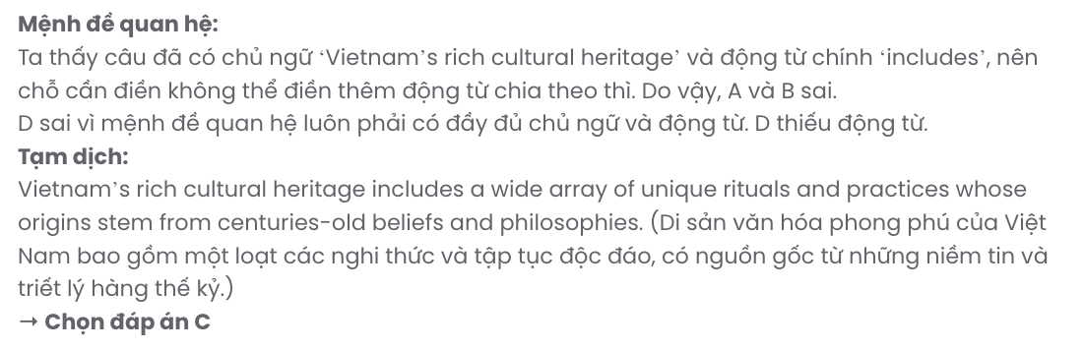

Question 20.
- the evolutionary style of the ao dai has made the younger generation popularise it
- evolving the ao dai in style, they have made it popular among the younger generation
- the style of the ao dai gained in popularity in evolving the younger generation
- the ao dai has evolved in style, making it popular among the younger generation
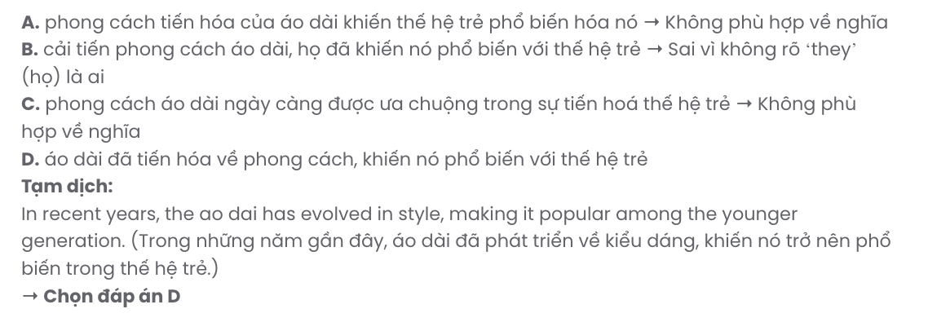

Question 21.
- Bowing and using respectful terms show Vietnamese respect and humility
- Wanting to show Vietnamese respect and humility, bowing and respectful terms are used
- Vietnamese respect and humility shows how to bow and use respectful terms
- Using respectful terms when bowing shows respect and humility for the Vietnamese
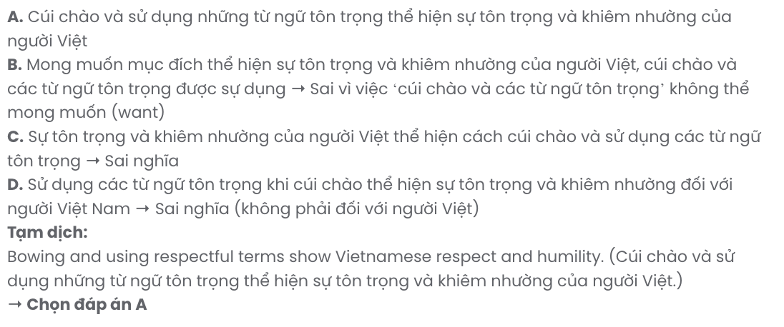

Question 22.
- Vietnamese identity is the key to these customs
- they make these customs vital to Vietnamese identity
- the value of these customs to Vietnamese identity is less clear
- these customs are integral to Vietnamese identity GIASƯ TẠI HUẾ (079.3833.272)
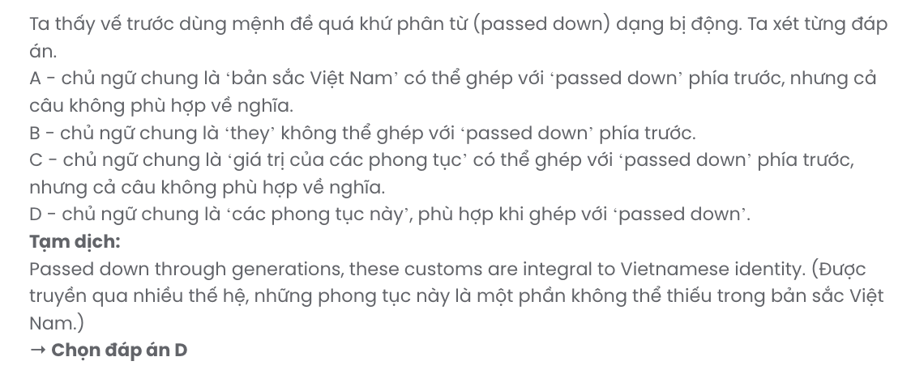
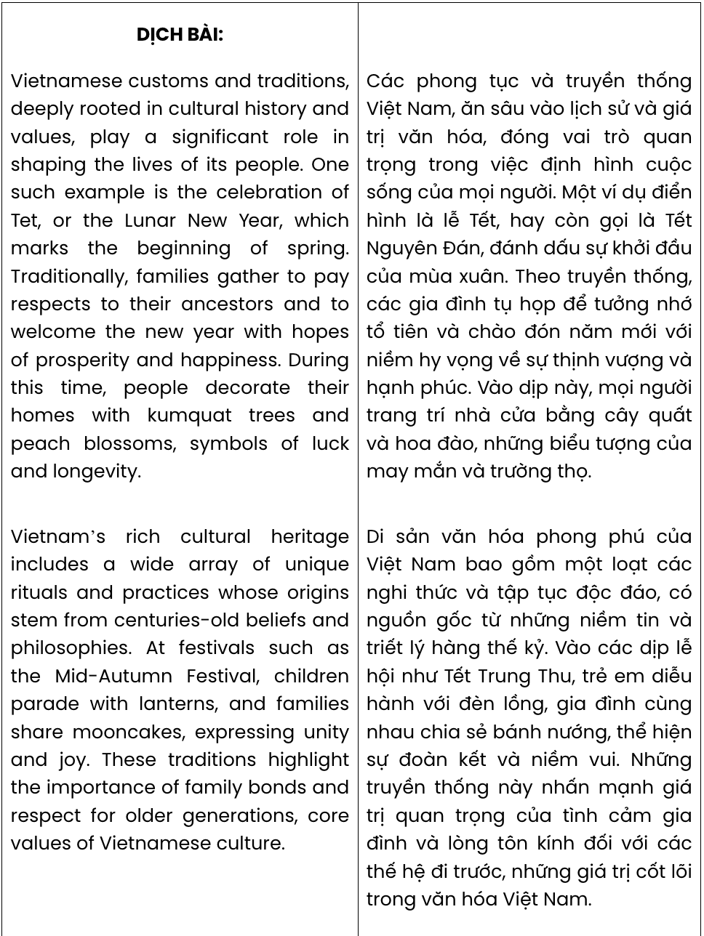
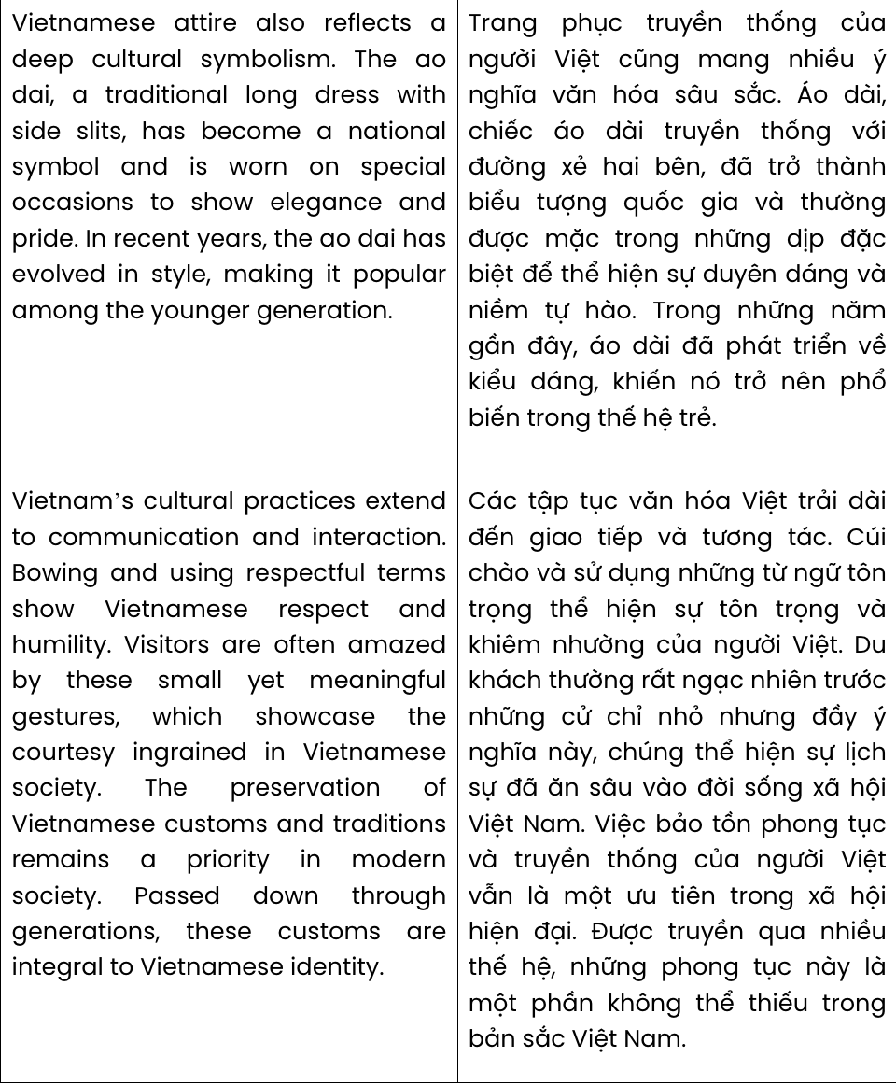
Read the following passage about a male nursery school teacher and mark the letter A, B, C, or D on your answer sheet to indicate the correct answer to each of the questions from 23 to 30.
ToddlerWorld Nursery was delighted to employ a trainee - twenty-two-year-old Jonathan Brown - as their first male nursery school teacher. He was also the only man who applied for the job, but, insists Margery Bowman, head teacher of ToddlerWorld, by far the best applicant. 'Both boys and girls will benefit from the experience of having a male role model in the nursery,' says mother of two, Marjory.
Jonathan has always been interested in childcare. His own mother is a childminder and his father is a teacher. 'I've always helped Mum with looking after all the children,' he says. 'I'm used to changing nappies, feeding babies, reading stories and playing with Lego.'
But Jonathan is a rare male in a female world. Only 2% of nursery teachers are men and this hasn't changed for ten years. Roger Olsen of the National Nursery Trust said, 'Men are often viewed with anxiety and suspicion in a children's environment. Or they are expected to do things the way women would do them. But men bring different things into childcare and this has to be recognised.' Jonathan agrees. He is a qualified under-7s football coach, and plans to introduce football lessons to the nursery for boys and girls.
What do Jonathan's friends think of his choice of career? 'Actually, most of them are pretty cool about it now,' he says, though they do make jokes about nappies. 'And I've found that girls are actually quite impressed - so that's good!'
(Adapted from Solutions 2nd Edition)

Question 23. Which of the following best paraphrases the underlined sentence in paragraph 1?
- Having a male teacher in the nursery will allow both boys and girls to develop important skills equally.
- Boys and girls can learn valuable things from interacting with a male figure in the nursery.
- The nursery benefits from employing a man because he is a great role model for everyone.
- Both boys and girls will learn specific skills from observing how a man teaches in the nursery.
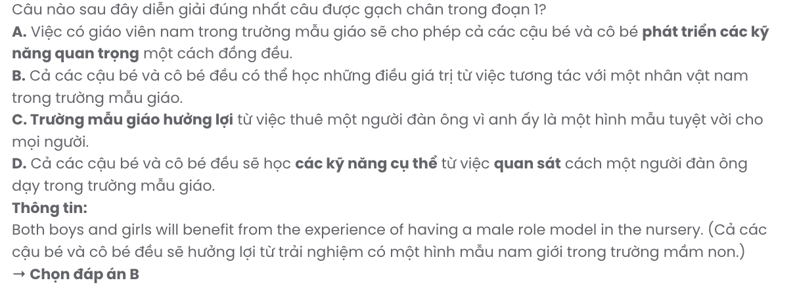
Question 24. Which of the following is NOT mentioned as an activity that Jonathan Brown is familiar with?
A. feeding babies B. inventing tales C. changing nappies D. playing with Lego

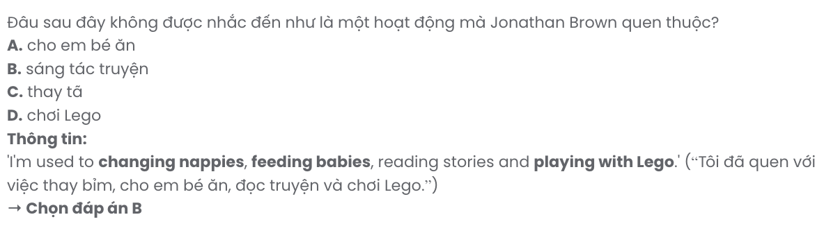
Question 25. The word rare in paragraph 3 could be best replaced by .
A. helpful B. unusual C. encouraging D. common
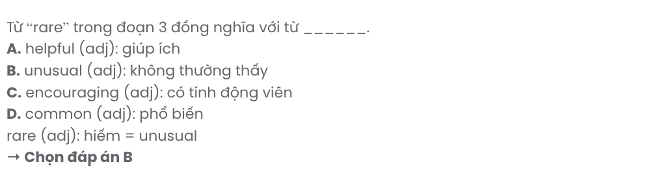
Question 26. The word suspicion in paragraph 3 is OPPOSITE in meaning to .
A. approval B. trust C. attention D. interest
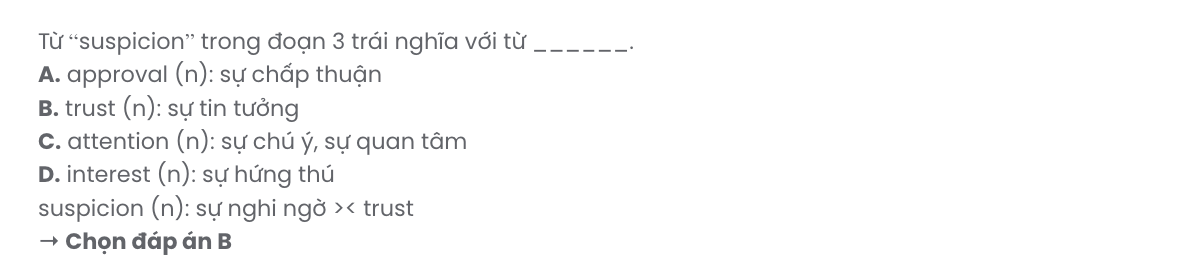
Question 27. The word they in paragraph 4 refers to .
A. Johathan’s friends B. girls C. children D. parents
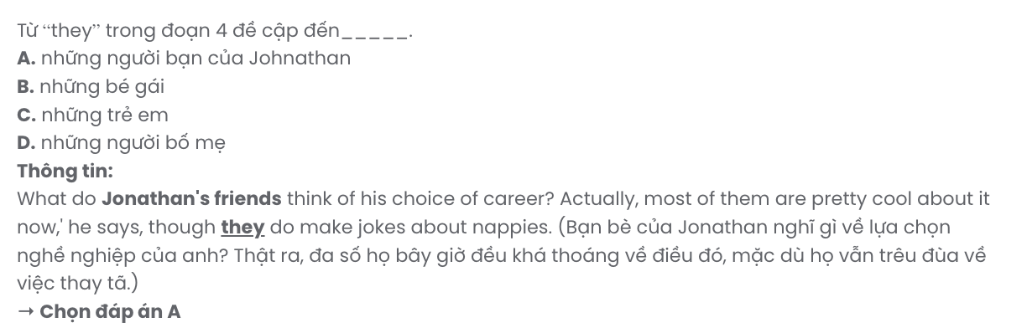
Question 28. Which of the following is TRUE according to the passage?
- Jonathan was the first person to apply for the teaching position at the nursery.
- Jonathan plans to introduce football lessons at the nursery for all children.
- Margery Bowman was initially against hiring Jonathan as a nursery teacher.
- Jonathan’s parents inspire him to pursue a teaching career at the nursery.
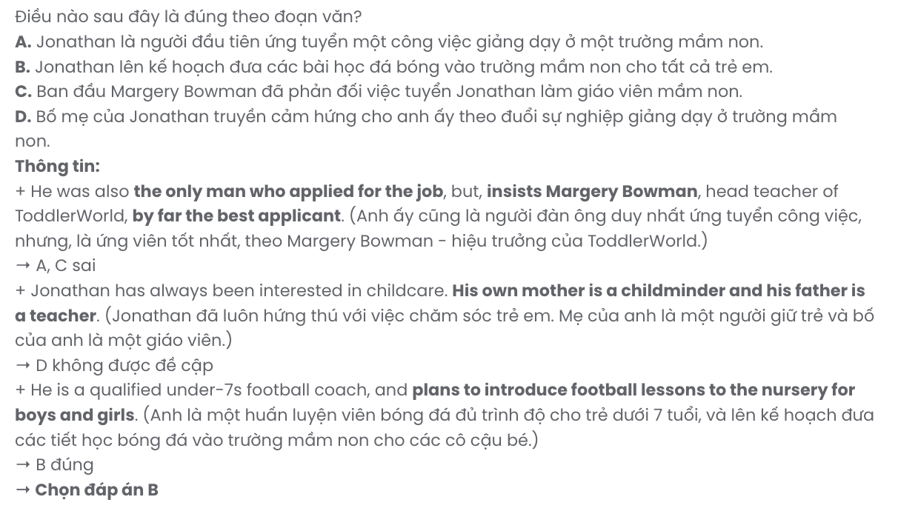
Question 29. In which paragraph does the writer mention Jonathan’s personal background in childcare?
A. Paragraph 1 B. Paragraph 2 C. Paragraph 3 D. Paragraph 4

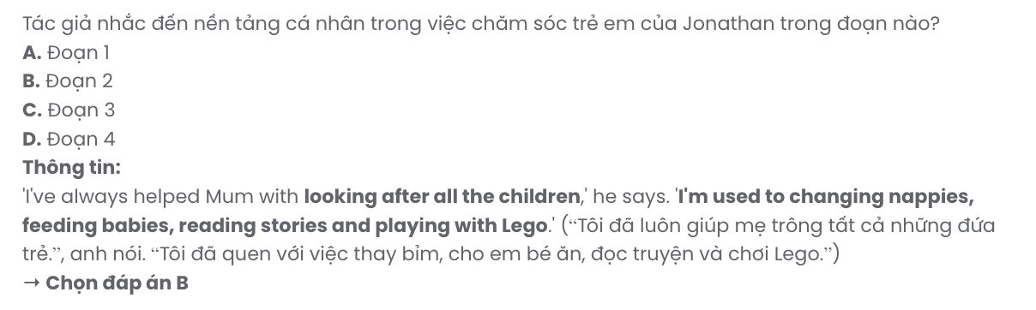Question 30. In which paragraph does the writer describe prejudices faced by male nursery teachers?
A. Paragraph 1 B. Paragraph 2 C. Paragraph 3 D. Paragraph 4

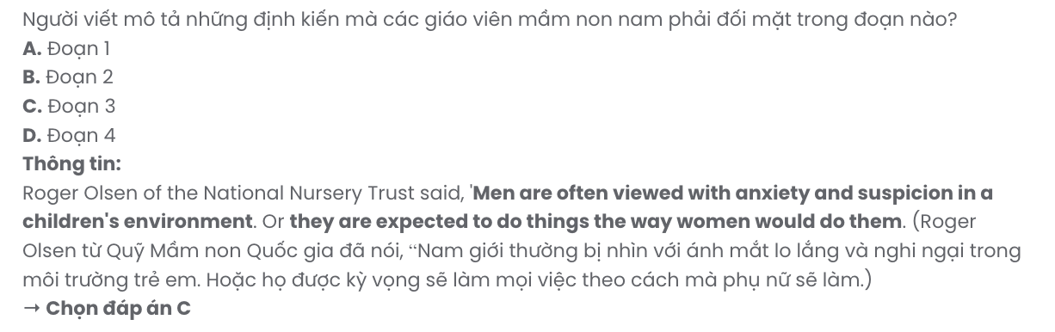
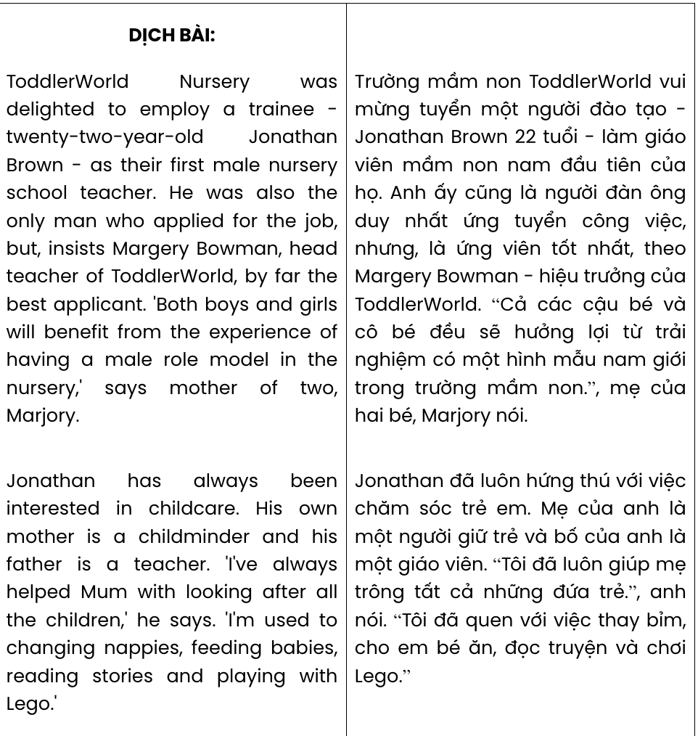
Chỉ 100k/12 tháng, bạn tải rất nhiều tài liệu tiếng anh file word hay tại: Giaoandethitienganh.info Mong bạn ghé ủng hộ !
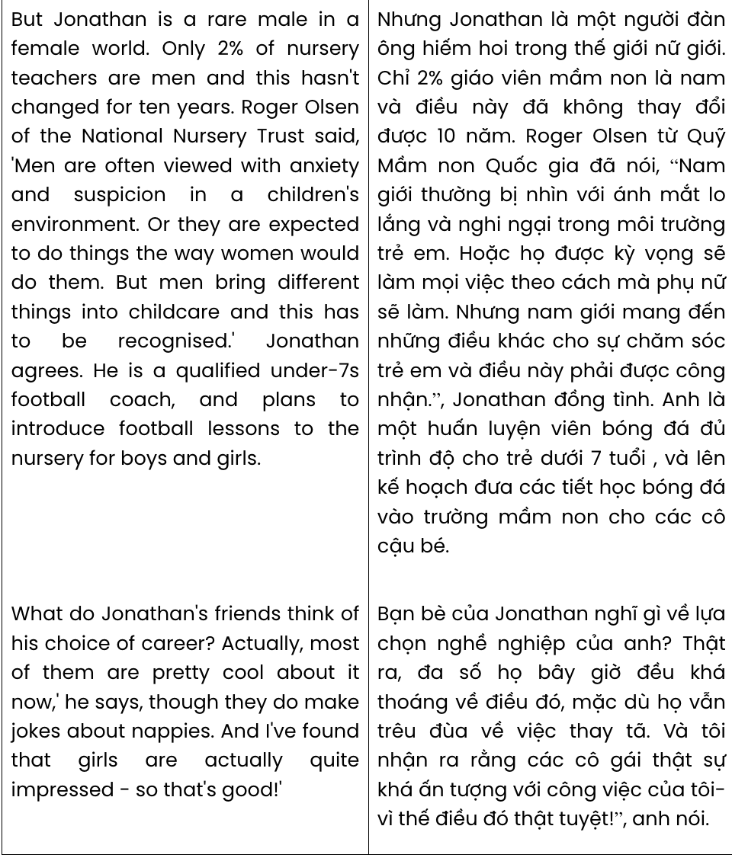
Read the following passage about ugly fruits and vegetables and mark the letter A, B, C, or D on your answer sheet to indicate the correct answer to each of the questions from 31 to 40.
When buying fresh fruit and vegetables, would you select a very curly cucumber, a carrot with two 'legs', or a potato with three heads? For many people, the answer is 'no' - they look for perfect produce when they go to the supermarket.
Not anymore! In France, a large supermarket chain, Intermarché, has started a marketing campaign to put ugly fruit and vegetables back on the shelves. And British TV chef Jamie Oliver has followed their lead, together with a large UK supermarket. Both the French and British supermarkets are selling their funny-shaped fruit and veg at a huge discount as an incentive for shoppers to opt for the less attractive versions.
Over the years, supermarkets have trained their customers to expect perfect fruit and veg, with many customers discarding produce that isn't 'perfect'. And until recently, there were numerous, very strict rules for supermarkets about the size and shape of fresh produce. Fortunately, there are now fewer rules, but customers need encouragement to change their shopping habits.
There is a good reason for this change in attitude. The rejection of misshapen produce results in a huge amount of waste: around 20-40% of food is thrown away before it even reaches the shops. Yet at the same time, we know that world food shortages are soon going to be a real and serious problem.
[I] Fortunately, it looks like these brave, but common-sense supermarket campaigns are working. It seems that these campaigns are going to be profitable, as well as environmentally friendly. [II] Other supermarkets have already experimented with the same idea, both within and outside Europe. [III] After all, it's the taste that counts. [IV]
(Adapted from Gateway)
Question 31. According to paragraph 1, when going shopping, people tend to .
A. choose ugly produce that is cheaper B. buy fresh and expensive fruits
C. opt for perfect fruit and vegetables D. look for bargain prices
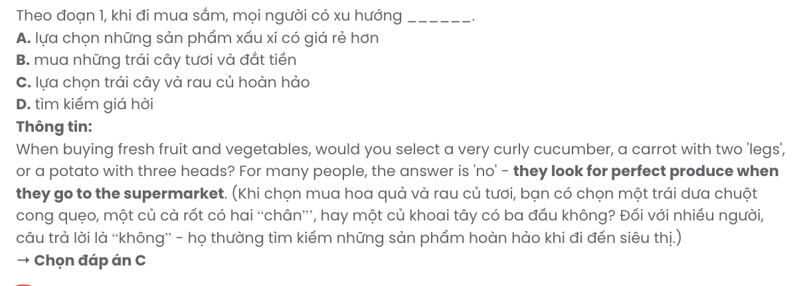
Question 32. The word their in paragraph 2 refers to .
A. shelves B. versions C. shoppers D. Intermarché

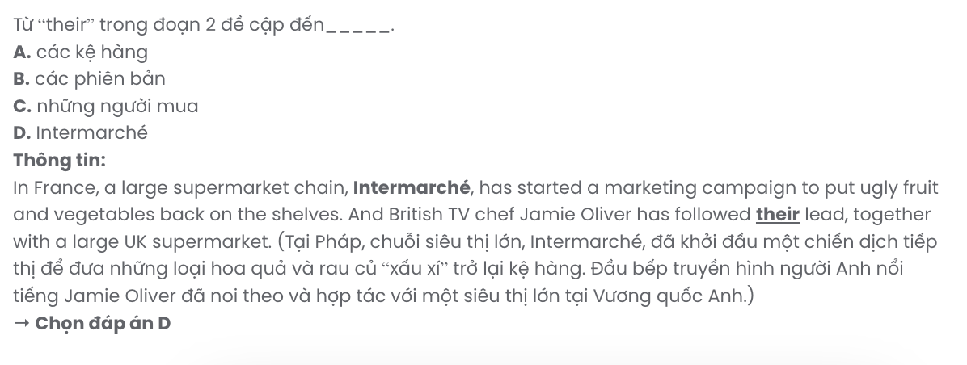
Question 33. Which of the following best summarises paragraph 2?
A. Intermarché and a UK supermarket are encouraging people to buy imperfect produce by offering it at a discount.
B. Supermarkets in France and the UK are only selling funny-shaped fruits and vegetables to reduce food waste.
C. Jamie Oliver and UK supermarkets are now working together to improve the quality of produce sold.
D. Intermarché started a campaign to sell all unattractive produce at a normal price, inspiring others to do the same.
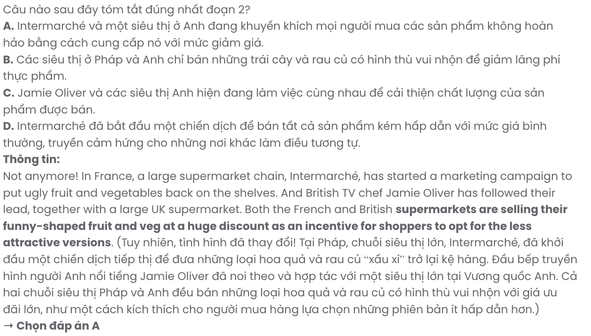
Question 34. The word discarding in paragraph 3 is closest in meaning to .
A. demanding B. rejecting C. accepting D. purchasing
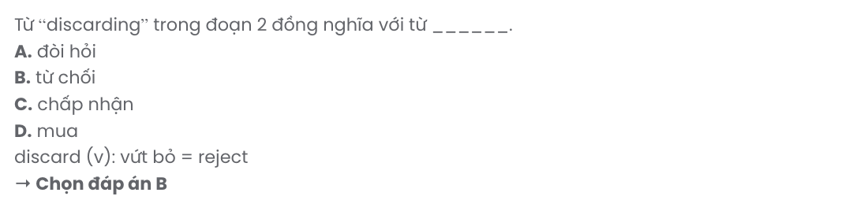
Question 35. Which of the following best paraphrases the underlined sentence in paragraph 3?
A. Rules have become less stricter, so customers require more support in changing how they shop.
B. Fortunately, few rules are now in place, which encourages customers to alter their shopping habits.
C. Thankfully, rules have been relaxed, but customers still need motivation to adjust their shopping practices.
D. Thankfully, customers now shop differently because of the recent reduction in rules.
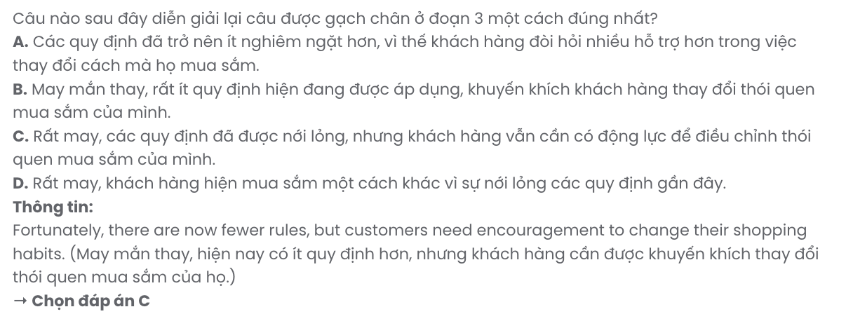

Question 36. The word misshapen in paragraph 4 is OPPOSITE in meaning to .
A. expensive B. normal C. affordable D. complimentary
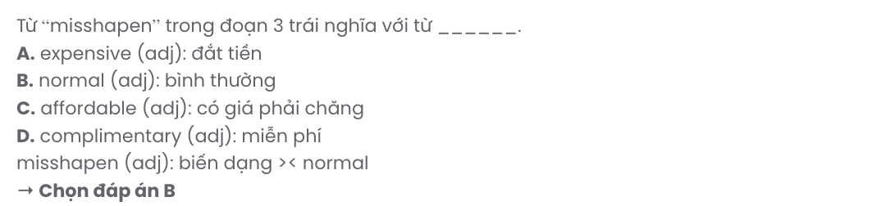
Question 37. Where in paragraph 5 does the following sentence best fit?

So, next time, when you go shopping, think before you buy.
A. [I] B. [II] C. [III] D. [IV]
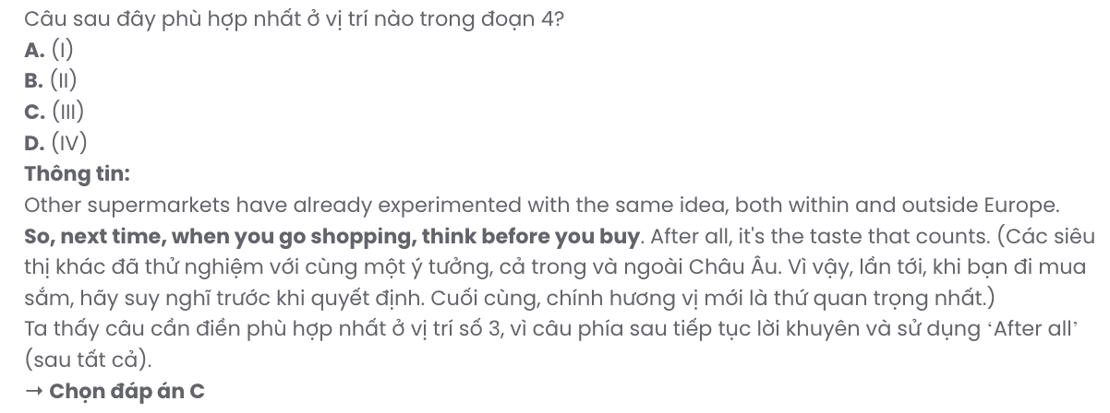
Question 38. Which of the following is NOT true according to the passage?
A. Regulations for supermarkets about the size and shape of produce have been eased.
B. The French and British supermarkets are selling ugly produce at a cheaper price.
C. Intermarché has launched a campaign to encourage shoppers to buy ugly produce.
D. Around 20-40% of fresh produce is thrown away after it is sold at supermarkets.
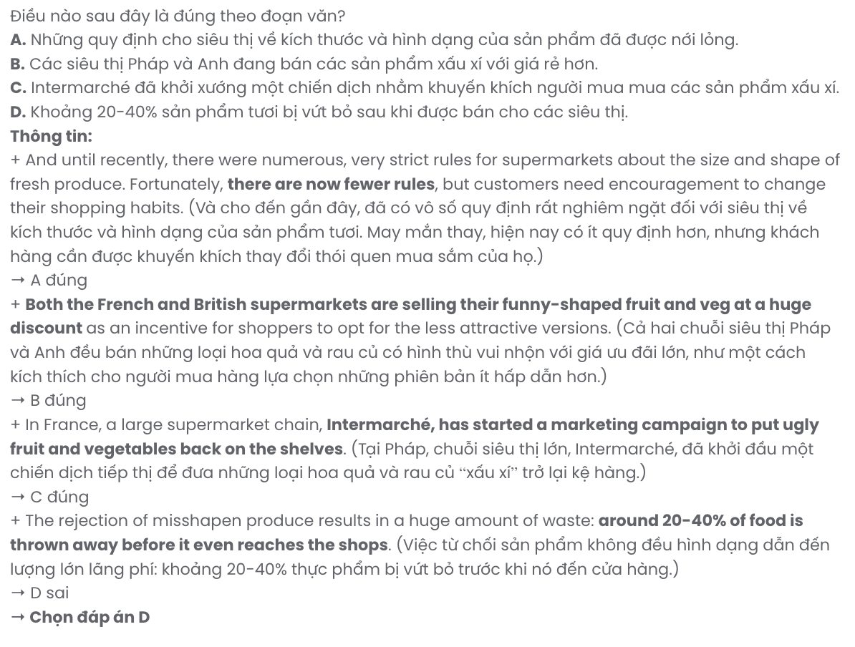
Question 39. Which of the following can be inferred from the passage?
A. The supermarket campaigns for ugly produce haven’t been popular in other nations.
B. Eliminating food waste can be helpful in solving global food shortages.
C. The supermarket campaigns benefit the environment but are not quite profitable.
D. Promoting the sale of imperfect produce helps shoppers reconsider what is important.
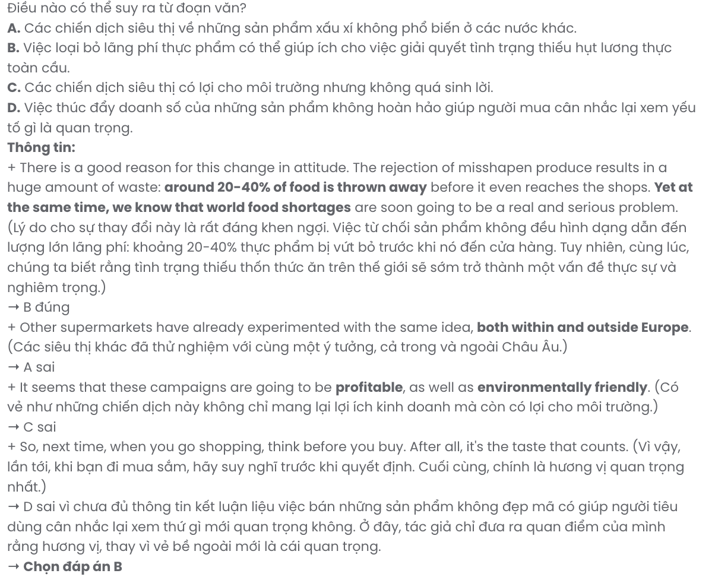
Question 40. Which of the following best summarises the passage?
A. Supermarkets are increasingly discounting misshapen produce to encourage shoppers to choose imperfect fruit and vegetables, but strict rules on produce appearance remain a major obstacle.
B. Campaigns by supermarkets in France and the UK aim to reduce food waste by selling imperfect produce, showing a shift in customer habits towards appreciating quality over appearance.
C. The rejection of oddly shaped produce creates substantial waste, but supermarkets like Intermarché are now selling misshapen fruit and veg at discounts to change customer habits and reduce food waste.
D. Intermarché’s campaign has led to a trend in Europe where only local supermarkets try selling less attractive produce at lower prices, resulting in improved customer preferences for appearance.
GIA SƯ TẠI HUẾ (0793833272)
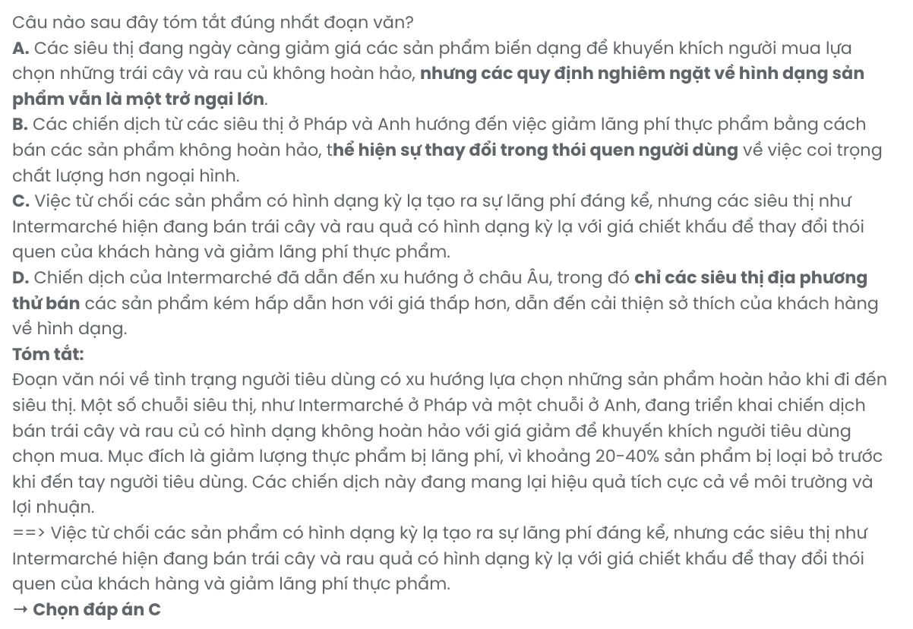
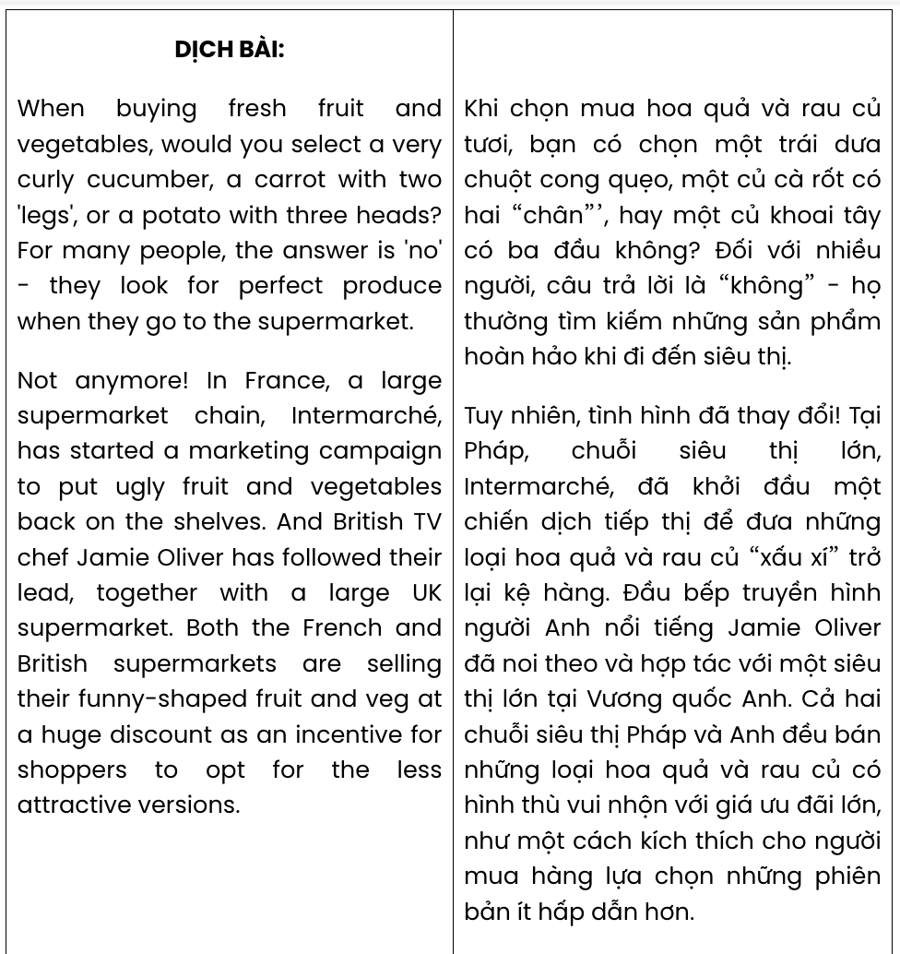

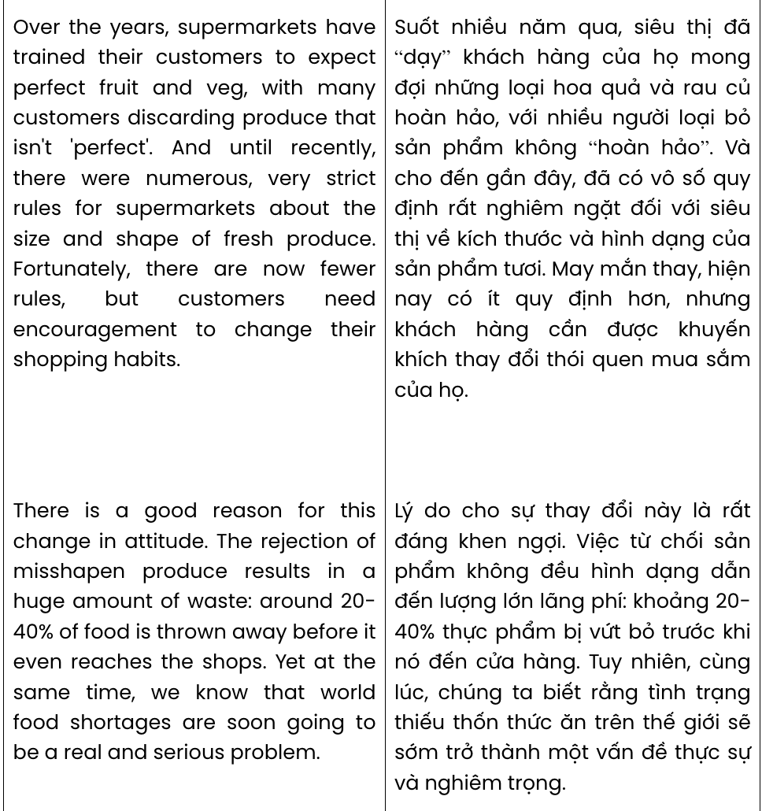

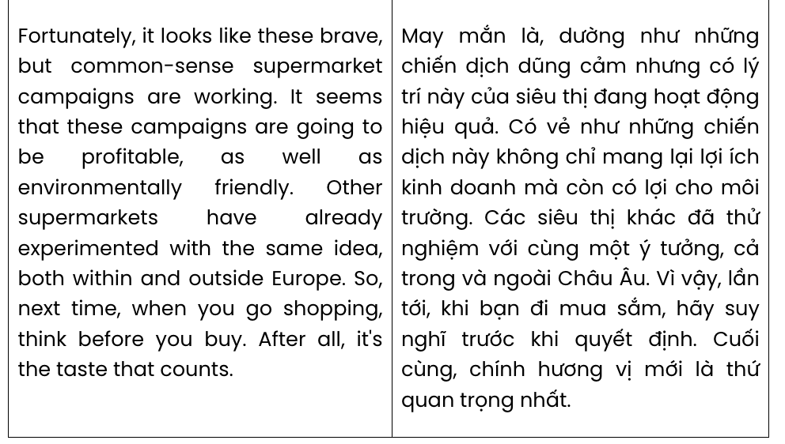

BẢNG TỪ VỰNG
STT | Từ vựng | Từ loại | Phiên âm | Nghĩa
1 | cucumber | n | /ˈkjuː.kʌm.bər/ | dưa chuột
2 | produce | n | /ˈprɒdjuːs/ | sản phẩm
3 | chain | n | /tʃeɪn/ | chuỗi
4 | chef | n | /ʃef/ | đầu bếp
5 | incentive | n | /ɪnˈsen.tɪv/ | phần thưởng, ưu đãi để tạo động lực
6 | version | n | /ˈvɜː.ʃən/ | phiên bản
7 | discard | v | /dɪˈskɑːd/ | vứt bỏ
8 | rejection | n | /rɪˈdʒek.ʃən/ | sự từ chối
9 | common-sense | adj | /ˌkɒm.ən ˈsens/ | hợp lý
10 | brave | adj | /breɪv/ | dũng cảm
11 | bargain | n | /ˈbɑː.ɡɪn/ | hời, rẻ
12 | purchase | v | /ˈpɜː.tʃəs/ | mua
13 | misshapen | adj | /mɪsˈʃeɪ.pən/  /mɪʃˈʃeɪ.pən/ | biến dạng
14 | eliminate | v | /iˈlɪm.ɪ.neɪt/ | loại bỏ
15 | nursery | n | /ˈnɜː.sər.i/ | nhà trẻ
16 | suspicion | n | /səˈspɪʃ.ən/ | sự nghi ngờ
17 | coach | n | /kəʊtʃ/ | huấn luyện viên
18 | nappy | n | /ˈnæp.i/ | tã
19 | integral | adj | /ˈɪn.tɪ.ɡrəl/ | không thể thiếu
20 | sustainable | adj | /səˈsteɪ.nə.bəl/ | bền vững
21 | effort | n | /ˈef.ət/ | nỗ lực
22 | passionate | adj | /ˈpæʃ.ən.ət/ | đam mê
23 | dedicated | adj | /ˈded.ɪ.keɪ.tɪd/ | tận tâm
24 | valuable | adj | /ˈvæl.jə.bəl/ | quý giá
25 | refreshed | adj | /rɪˈfreʃt/ | sảng khoái
26 | refresh | v | /rɪˈfreʃ/ | làm tươi mới
27 | conference | n | /ˈkɒn.fər.əns/ | hội nghị
28 | dynamic | adj | /daɪˈnæm.ɪk/ | sôi động
29 | peer | n | /pɪə(r)/ | người bạn cùng trang lứa
30 | transformative | adj | /trænsˈfɔː.mə.tɪv/ | mang tính chuyển đổi
31 | rewarding | adj | /rɪˈwɔː.dɪŋ/ | xứng đáng
32 | genuine | adj | /ˈdʒen.ju.ɪn/ | chân thật
33 | appealing | adj | /əˈpiː.lɪŋ/ | hấp dẫn
34 | sensationalism | n | /senˈseɪ.ʃən.əl.ɪ.zəm/ | chủ nghĩa giật gân
35 | overshadow | v | /ˌəʊ.vəˈʃæd.əʊ/ | làm lu mờ
36 | accuracy | n | /ˈæk.jə.rə.si/ | tính chính xác
37 | advocacy | n | /ˈæd.və.kə.si/ | sự ủng hộ
38 | momentum | n | /məˈmen.təm/ | động lực
39 | align | v | /ˈæk.jə.rə.si/ | phù hợp
40 | ancestor | n | /ˈæn.ses.tər/ | tổ tiên
41 | prosperity | n | /prɒsˈper.ə.ti/ | sự thịnh vượng
42 | heritage | n | /ˈher.ɪ.tɪdʒ/ | di sản
43 | ritual | n | /ˈrɪtʃ.u.əl | nghi thức, nghi lễ
44 | symbolism | n | /ˈsɪm.bəl.ɪ.zəm/ | tính biểu tượng

45 | attire | n | /əˈtaɪər/ | trang phục
46 | reflect | v | /rɪˈflekt/ | phản ánh
47 | gesture | n | /ˈdʒes.tʃər/ | cử chỉ
48 | priority | n | /praɪˈɒr.ə.ti/ | sự ưu tiên
49 | courtesy | n | /ˈkɜː.tə.si/ | sự lịch sự
50 | elegance | n | /ˈel.ə.ɡəns/ | sự thanh lịch

BẢNG CẤU TRÚC
STT | Cấu trúc | Nghĩa
1 | look for somebody/something | tìm ai/cái gì
2 | result in something | dẫn đến cái gì
3 | apply for something | ứng tuyển vị trí gì
4 | look after somebody/something | chăm sóc ai/cái gì
5 | allow somebody to do something | cho phép ai làm gì
6 | put up something | xây dựng cái gì
7 | take over something | đảm nhận cái gì
8 | deal with somebody/something | đối phó với ai/cái gì
9 | carry out something | tiến hành cái gì (nghiên cứu, khảo sát,…)
10 | take part in something | tham gia cái gì
11 | connect with somebody | kết nối với ai
12 | take a step | hành động, thực hiện
Chỉ 100k/12 tháng, bạn tải rất nhiều tài liệu tiếng anh file word hay tại: Giaoandethitienganh.info Mong bạn ghé ủng hộ !

