School: ……………………………………….. | Date:……………………………………..
Class: ……………………………..................... | Period: ………………………………….

UNIT 1: FREE TIME
Lesson 1: Vocabulary and Reading (Pages 4 & 5)

1. Objectives
By the end of this lesson, students will be able to…
1.1. Language knowledge/ skills
- learn and use vocabulary for leisure activities.
- practice reading for specific information.
- present their ideas about hobbies.
- improve reading skills.
1.2. Competences
- improve Ss’ communication, collaboration, analytical, and critical thinking skills.
1.3. Attributes
- have healthy lifestyles.
- spend free time in a good way.
2. Teaching aids and materials
- Teacher’s aids: Student’s book and Teacher’s book, class CDs, DCR– Phần mềm tương tác trực quan, DHA – Ứng dụng trò chơi tương tác, projector / interactive whiteboard /TV (if any), PowerPoint slides.
- Students’ aids: Student’s book, Workbook, Notebook.
3. Assessment Evidence
Performance Tasks | Performance Products | Assessment Tools
- Match the pictures with new words.  - Complete the table with the correct new words to form collocations.  - Talk about leisure activities.  - Read the text and choose the best answer.  - Read the text and match the names with the correct phrases.  - Say who (in the text) you are most like. | - Ss’ answers.  - Ss’ answers.  - Ss’ answers/presentation.  - Ss’ answers.  - Ss’ answers.  - Ss’ answers/presentation. | - Observation.  - Observation.  - Observation.  - Observation.  - Observation.  - Observation.
4. Procedures
A. Warm up: 5 minutes
a. Objectives: to introduce the topic.
b. Content: Let’s talk.
c. Expected outcomes: Ss can talk about free time activities based on the title and the picture.
d. Organization
Teacher’s activities | Students’ activities
Let’s talk: Look at the title of the unit and the picture. What do the girls like doing in their free time? What do you do in your free time? How often do you do it?  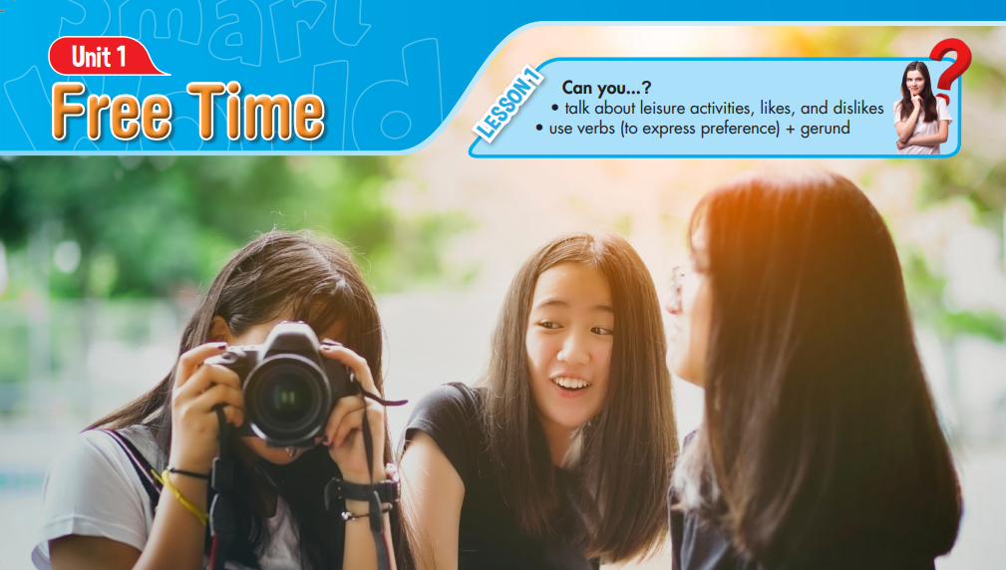  - Ask Ss to work in pairs, look at the title and the picture and answer the questions (using the DCR/ PPTs slides).  - Call some pairs to give their answers.  - Give feedback. | - Work in pairs, look at title and the picture and answer the questions.  Answer Keys  The girls like taking pictures in their free time.  Ss’ own answers

B. New Lesson (35’)
1. Pre-Reading (Vocabulary - 15’)
a. Objectives: to help Ss improve their vocabulary about leisure activities and their collocations.
b. Content: tasks a and b.
c. Expected outcomes: Ss can learn some new free time activities and the verbs that go with them.
d. Organization
Teacher’s activities | Students’ activities
Task a: Number the pictures. Listen and repeat.  - Ask Ss to work in pairs and number the pictures (using the DCR).  - Check Ss’ answers around the class.  - Ask Ss to listen and repeat. | - Work with a partner and number the pictures.  - Listen and repeat.  Answer Keys:  - C  - H  - A  - G  - B  - E  - D  - F
Task b: In pairs: Write the new words into the table and add more words you know. Which activities do you do?  - Explain and model the activity.  - Ask Ss to work in pairs, writing the new words into the table.  - Check Ss’ answers around the class.  - Ask Ss to work with their partner, adding more words they know.  - Check Ss’ answers around the class.  -Get Ss to ask their partner what activities they do.  -Pick some Ss to talk about their partner. | - Work in pairs, writing the new words into the table.  Answer Keys:  Play … Go … Make … Design … … with friends  board games handball rock climbing jogging fishing jewelry jewelry chat online hang out  -Work with their partner, adding more words they know.  - Ask their partner what activities they do.

2. Pre & While-Reading (Reading – 15’)
a. Objectives: to help Ss read for details.
b. Content: tasks a, b, and c.
c. Expected outcomes: Ss can read for specific information and know some popular hobbies of teenagers around the world.
d. Organization:
Teacher’s activities | Students’ activities
Task a: Read the passages. Circle the name of the person who prefers indoor activities: Will, Jess, or Peter.  - Ask Ss to name some indoor activities they know.  - Ask Ss to read the passages and circle the name of the person who prefers indoor activities according to what they read.  - Pick some Ss to give the answer and show the evidence to justify their answer.  - Check Ss’ answers. | -Expected answers: reading, drawing, cooking, playing chess, playing board games, …  - Read the passages, underline the evidence and circle the correct name.  Answer Keys: Jess  (Passage 2: I like reading books, chatting with my friends online, and doing crafts in my bedroom.)
Task b: Now, read and draw lines to match the phrases and the person they describe.  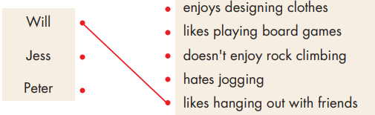  - Ask Ss to read the phrases and underline the key words.  - Get Ss to scan the text to find the key words.  - Ask Ss to match the names with the correct phrases.  - Set the time and monitor the class.  - Check Ss’ answers (using the DCR). | - Read the phrases and underline the key words.  - Scan the text to find the key words.  - Match the names with the correct phrases.  Answer Keys  Will-likes hanging out with friends.  Will-doesn’t enjoy rock climbing.  Jess-likes playing board games.  Jess-hates jogging.  Peter-enjoys designing clothes.
Task c: Listen and read.  - Play the CD and ask Ss to listen and read along.  - Pick three Ss to read the three passages aloud and correct their pronunciation if necessary. | -Listen and read along.

3. Post – reading (5’)
a. Objectives: to help Ss to use the language and information in the real situation.
b. Content: similarity and difference in hobbies of the Ss and people in the passages.
c. Expected outcomes: Ss can compare and contrast their hobbies with those of the people in the passages.
d. Organization

Teacher’s activities | Students’ activities
Pair work: Which person are you most like? How are you similar? How are you different?  - Ask Ss to work in pairs to answer the questions.  - Monitor the class and help them if necessary.  - Ask some Ss to share their ideas. | - Work in pairs to answer the questions.  - Share their ideas.

C. Consolidation and homework assignments (5’)
- Vocabulary: chat, fishing, hang out, jogging, jewelry, handball, rock climbing, board games.
- Do exercises in workbook on pages 2 & 3.
- Prepare the next lesson: Lesson 1.2 – Grammar, pages 5 & 6.
- Do the exercises in Tiếng Anh 8 i-Learn Smart World notebook (pages 4 & 5).

5. Reflection

a. What I liked most about this lesson today:
…………………………………………………………………………………………
b. What I learned from this lesson today:
…………………………………………………………………………………………
c. What I should improve for this lesson next time:
…………………………………………………………………………………………

