Mã đề 6.2.71 | BÀI KIỂM TRA CUỐI HỌC KÌ II  NĂM HỌC 2021-2022  MÔN: TIẾNG ANH 6 (Right on!)  Thời gian làm bài: 60 phút
A. LISTENING: (2.0 points)
I. Listen to five short recordings and for each recording you have to choose the best of three pictures (Circle A, B or C). (1.0 point)
1. What is Sarah’s dad going to give her?
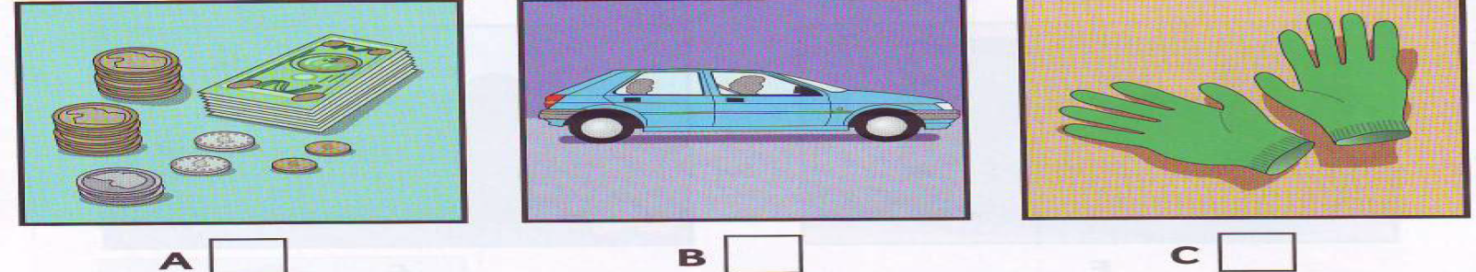
A B C
2. How many friends is Sarah going to go out with?
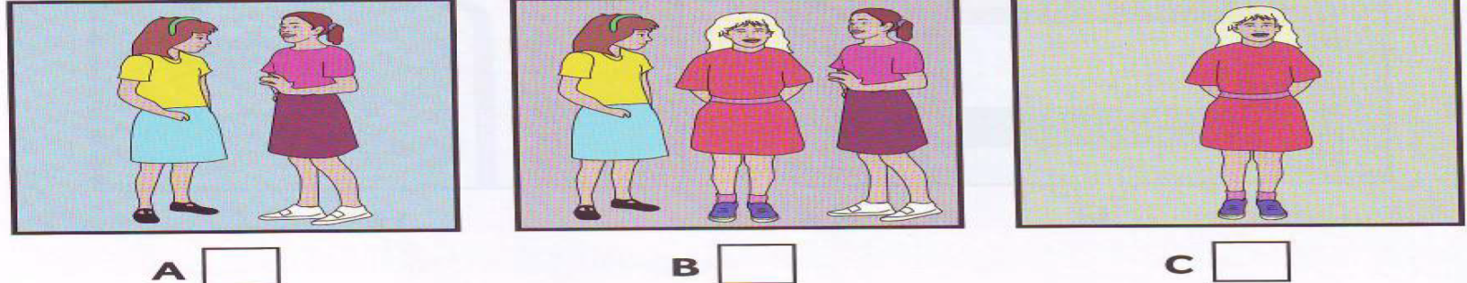
A B C
3. What’s the film about?
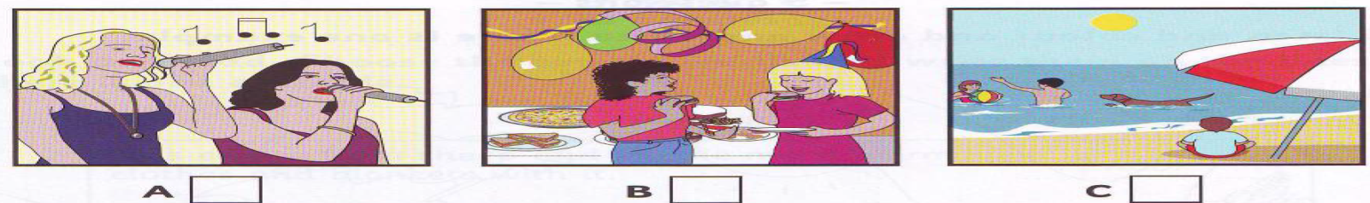
A B C
4. What will Sarah have for dinner?
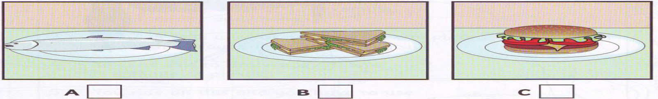
A B C
5. What’s Betty’s phone number?
A B C
II. Listen and write no more than one words or number. (1.0 point)
OUR NEW TEACHER
Will start on: Tuesday
6. Will teach us: …………………………
7. Name: Mrs. ……………………
8. Classroom number: …………………………
9. Classroom is next to: School……………….…
10. Colour of teacher’s car: …………………….……

B. LANGUAGE (2.0 points)
I. Pronunciation: Choose the word that has underlined part pronounced differently from other words.
1. A. meal B. meat C. bread D. reason
2. A. looked B. watched C. stopped D. carried
II. Vocabulary: Choose the best option to complete each of the following sentences.
3. Harry can do ________ very well.
A. martial arts B. basketball C. tennis
4. It’s very grey and ________ today. I can’t see the sun.
A. cloudy B. sunny C. snow
5. In the _________, I like to make snowmen with my friends.
A. spring B. winter C. autumn
6. Game shows are _________ programs. They can be both entertaining and educational.
A. interested B. tired C. exciting
III. Grammar: Choose the best option to complete each of the following sentences.
7. This is ____ jumper. It is blue.
A. me B. mine C. my
8. - Peter: “It’s hot.” - John: “I ____ open the window.”
A. is going to B. am going to C. will
9. Bridget _______ to the cinema last night.
A. didn’t went B. didn’t go C. doesn’t go
10. If it _______, we ________ to the zoo tomorrow.
A. doesn't rain / will go B. will rain / go C. don't rain / go

C. READING (2 points)
I. Read the following passage and choose the word or phrase that best fits the blank space in each sentence. (1 point)
I am Lan and this writing is about my best friend, Mai. We go to the same school and we’ve been together (1) _____ three years. Mai is very pretty. She has (2) ______ and big brown eyes. She is clever and hard-working but she is also (3) ______ She often makes jokes and we all laugh. She loves reading and writing short poems. I like being with her. We often do our homework together and she helps me a lot. I also like her (4) ______ she knows a lot about astronomy and we can chat about it for hours. At the moment we are making a Space minibook. We’re doing a lot of research on the Internet. This Saturday we are going to the National Museum to (5) ______ some photos for the project. Then we’re watching a new film on the Disney channel together. It’s going to be fun.
1. A. in B. for C. since
2. A. short black hair B. black short hair C. hair short black
3. A. friendly B. kind C. funny
4. A. and B. because C. but
5. A. take B. do C. make
II. Read the following passage and choose the best answer for each question. (1 point)
My name is Karen and I’m from Britain. The weather in Britain is often rainy, but in the winter it’s also very cold and snowy. You can’t imagine how cold it is here. Yesterday it rained a lot but it is snowing heavily today. We have to wear heavy jackets and gloves to keep us warm. My sisters are making a snowman in the garden at the moment. I am in the living room with my parents. They are decorating the Christmas tree. In the autumn and spring, it can be quite windy but it’s not very cold. The summer can be warm. My favourite season is spring because the trees are green and there are many flowers. I often go for a walk in the park.

6. In Britain, the weather is very cold in ______________.
A. the spring B. the summer C. the winter
7. Karen’s sisters are in ____________.
A. the garden B. the park C. the living room
8. ___________ decorating the Christmas tree.
A. Karen is B. Karen’s sister is C. Karen’s parents are
9. Karen’s favourite season is _______.
A. spring B. summer C. autumn
10. The passage is mainly about ____________.
A. the weather in Britain B. Karen’s favourite season C. what Karen’s family are doing

D. WRITING (2 points)
I. Choose the underlined word or phrase which is not correct in standard English. (0.4 point)
1. We are usually play football at break time.
A B C D
2. The student favourite subject is science.
A B C D
II. Rearrange words or phrases to make meaningful sentences. (0.4 point)
3. We / visit / our / are / this / grandparents / going / weekend / to /.
…………….……………………………..……………………………………..………………………………………
4. can / music / You / classical / to / hall / at / concert / a / listen /.
…..…….…………………………………..……………………………………..……………………………………..
III. Complete the second sentence, keep the meaning the same as the first. (0.4 point)
5. I have a desktop and a bookcase in my bedroom.
There is _______________________________________________________________.
6. No one in my class is taller than Linh.
Linh is ________________________________________________________________.

IV. Write meaningful sentences, using suggested words or phrases. (0.8 point)

7. I / not / send / email / parents / while / I / on holiday
_______________________________________________________________________.
8. Linda / prepare / lunch / the moment?
_______________________________________________________________________.
9. Which place / you / going / visit / summer vacation?
_______________________________________________________________________.
10. Ho Chi Minh City / big / and / interesting / than / Hue City.
_______________________________________________________________________.

----- THE END ----

