Tiếng Anh 8 i-Learn Smart World_Unit 4.1
Time allotted: 45

PART 1 PRONUNCIATION (5 questions)
Choose the word whose underlined part differs from the other three in pronunciation in the following question.
1. A. volcanic B. fire C. disaster D. tsunami
2. A. emergency B. email C. battery D. escape
3. A. flood B. school C. moon D. tool
Choose the word whose primary stress is NOT placed on the second syllable.
4. A. tornado B. earthquake C. typhoon D. tsunami
Choose the word whose primary stress is NOT placed on the first syllable.
5. A. volcano B. forest C. wooden D. safer

PART 2 USE OF ENGLISH (12 questions)
Choose the option that best completes the following sentence.
6. Air ______________ is often seen as a major environmental result of modern living.
A. pollution B. smoke C. fume D. sewage
7. Tornadoes – very strong winds that move in a circle – can suck up anything that is in their ______________.
A. road B. line C. eye D. path
8. ______________, the sky became very dark, and the storm came with strong winds and heavy rain.
A. Logically B. Luckily C. Normally D. Suddenly
9. Jane’s mom: Stay inside in case of earthquakes. - Jane: ______________.
A. OK. It’s empty outside.
B. I know. Earthquakes can cause trees, electricity poles, and buildings to collapse.
C. I agree. We can get under a desk or table.
D. I disagree. We cannot run away from the danger made by earthquakes.
10. During an earthquake, you should get ______________ a desk because something could fall on you.
A. on B. for C. into D. under
11. You ______________ open the windows when there is a storm.
A. shouldn’t B. don’t have to C. should D. must
12. Make sure your phone has enough ______________ in case of a terrible storm.
A. space B. air C. battery D. electricity
13. Thousands of lives were ______________ thanks to the timely warning.
A. stored B. saved C. reserved D. limited
14. Please, pay attention to the ______________ announcements from the National Weather Service.
A. main B. emergency C. frequently D. week
15. Although Tom’s grandmother doesn’t ______________ weather forecasts, she likes watching them.
A. experience B. trust C. expect D. predict
16. It was the world’s ______________ volcanic eruption in more than 50 years.
A. large B. larger C. the largest D. largest
17. Jack: What shouldn’t we do when there is a typhoon?
Sue: We shouldn’t ______________.
A. have an escape plan
B. have emergency items ready to go
C. keep enough supplies for at least five days
D. stay near windows

PART 3 WORD FORMATION (3 questions)
Write the correct form of the given word.
18. The ______________ typhoon last year made thousands of people homeless. (DISASTER)
19. During a typhoon, be ______________ to leave your home and follow your escape plan.
(PREPARATION)
20. Emergency ______________ from the National Weather Service are very important to local people during disasters. (ANNOUNCE)

PART 4 ERROR RECOGNITION (2 questions)
Find the underlined part that needs correction in the following question.
21. People should keep a fire extinguish in a safe place.
A. should B. keep C. fire extinguish D. in
22. If you are in danger, calling the emergency service, they can help you.
A. are | B. in | C. calling | D. can help

PART 5 READING (5 questions)
Read the email from Chris to his friend, Luke. Choose the best word or phrase for each space. (5 questions)
Hi Luke,
Did you watch that program about natural disasters last night? It was excellent! I was a bit bored at the beginning, because the first disaster was snow coming down a mountainside. I’m not sure that (23)___________ are really disasters, but they are horrible for skiers.
After the first break, there was a sad story about a (24)___________ in a part of India. It didn’t rain for nine months, and there was no water in any of the lakes or rivers. All the food plants died, and people brought things into the area by truck every day.
Next, we had a story about a kind of storm. It turns very fast over water and sometimes causes a lot of damage when it goes over land. It’s called a (25)___________.
There’s another program next week about other natural disasters, but this program ended with some advice. The presenter said people need to be ready, but that is strange, because he also said there is often no (26)___________ that a natural disaster will happen.
Next week, we will learn about the (27)___________ of natural disasters, which will be very interesting. Do you want to come and watch it with me?
Best wishes,
Chris
(23) A. blizzards B. avalanches C. landslides D. earthquakes
(24) A. heat wave B. drought C. wildfire D. fire
(25) A. typhoon B. tsunami C. wave D. wind
(26) A. extinguisher B. kit C. plan D. warning
(27) A. expects B. informs C. causes D. supplies

PART 6 LISTENING (5 questions)
Listen to five short texts. Choose the correct picture for each question. (5 questions)
28. Which natural disaster was the man in?
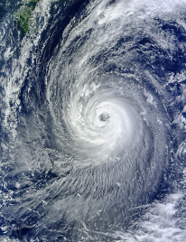 | 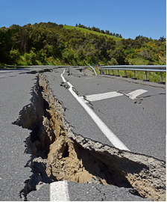 | 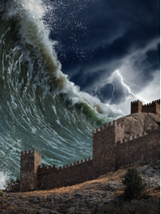
A. ☐ | B. ☐ | C. ☐
29. What happened to the man?
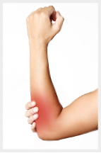 | 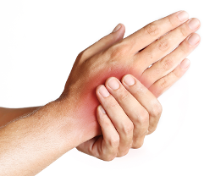 | 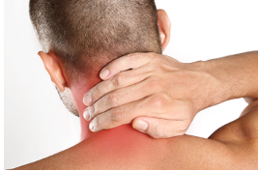
A. ☐ | B. ☐ | C. ☐
30. Which natural disaster was the woman in?
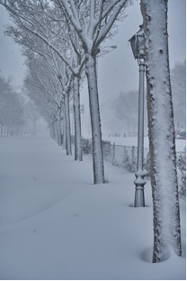 | 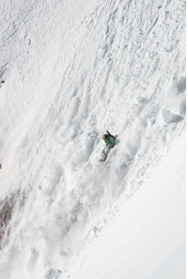 | 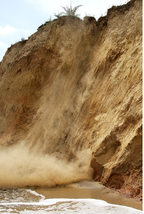
A. ☐ | B. ☐ | C. ☐
31. What did the woman do?
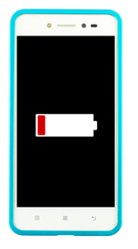 | 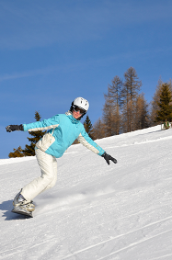 | 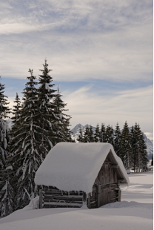
A. ☐ | B. ☐ | C. ☐
32. What is the warning telling people to do?
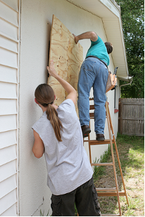 | 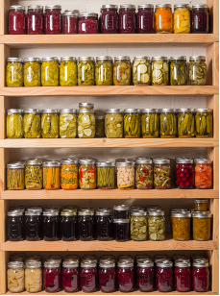 | 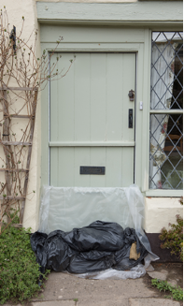
A. ☐ | B. ☐ | C. ☐
PART 7 WRITING (8 questions)
Rewrite the following sentence without changing its meaning. Use the given word(s) if any.
33. You shouldn’t go outside of the house during disasters. (INSIDE)
→ You___________
34. Everybody in my neighborhood is well-prepared for the coming typhoon.
→ (HAS)___________
35. I suggest keeping a first aid kit in every bathroom.
→ I think___________
36. Watching local TV or listening to the radio for more information is very useful.
→ It is___________
Use the given words or phrases to make complete sentence.
37. We / have / escape plan / save / ourselves / disasters /.
→ ___________
38. Disasters / can take / a lot / live / and make / people / homeless / .
→ ___________
Put the words in the correct order to make correct sentence.

39. Keywords: get outside/how to/and go to/An escape plan/will help/you know/a safe place/.
→ .......................................
40. Keywords: ./tsunami/undersea/started a/earthquake/A large
→ .......................................
---THE END---

Tiếng Anh 8 i-Learn Smart World_Unit 4.1
Time allotted: 45

ANSWER KEY

PART 1 PRONUNCIATION (5 questions)
Choose the word whose underlined part differs from the other three in pronunciation in the following question.
1. A. volcanic B. fire C. disaster D. tsunami
2. A. emergency B. email C. battery D. escape
3. A. flood B. school C. moon D. tool
Choose the word whose primary stress is NOT placed on the second syllable.
4. A. tornado B. earthquake C. typhoon D. tsunami
Choose the word whose primary stress is NOT placed on the first syllable.
5. A. volcano B. forest C. wooden D. safer

PART 2 USE OF ENGLISH (12 questions)
Choose the option that best completes the following sentence.
6. Air ______________ is often seen as a major environmental result of modern living.
A. pollution B. smoke C. fume D. sewage
7. Tornadoes – very strong winds that move in a circle – can suck up anything that is in their ______________.
A. road B. line C. eye D. path
8. ______________, the sky became very dark, and the storm came with strong winds and heavy rain.
A. Logically B. Luckily C. Normally D. Suddenly
9. Jane’s mom: Stay inside in case of earthquakes. - Jane: ______________.
A. OK. It’s empty outside.
B. I know. Earthquakes can cause trees, electricity poles, and buildings to collapse.
C. I agree. We can get under a desk or table.
D. I disagree. We cannot run away from the danger made by earthquakes.
10. During an earthquake, you should get ______________ a desk because something could fall on you.
A. on B. for C. into D. under
11. You ______________ open the windows when there is a storm.
A. shouldn’t B. don’t have to C. should D. must
12. Make sure your phone has enough ______________ in case of a terrible storm.
A. space B. air C. battery D. electricity
13. Thousands of lives were ______________ thanks to the timely warning.
A. stored B. saved C. reserved D. limited
14. Please, pay attention to the ______________ announcements from the National Weather Service.
A. main B. emergency C. frequently D. week
15. Although Tom’s grandmother doesn’t ______________ weather forecasts, she likes watching them.
A. experience B. trust C. expect D. predict
16. It was the world’s ______________ volcanic eruption in more than 50 years.
A. large B. larger C. the largest D. largest
17. Jack: What shouldn’t we do when there is a typhoon?
Sue: We shouldn’t ______________.
A. have an escape plan
B. have emergency items ready to go
C. keep enough supplies for at least five days
D. stay near windows

PART 3 WORD FORMATION (3 questions)
Write the correct form of the given word.
18. The ______________ typhoon last year made thousands of people homeless. (DISASTER) => disastrous
19. During a typhoon, be ______________ to leave your home and follow your escape plan.
(PREPARATION) => prepared
20. Emergency ______________ from the National Weather Service are very important to local people during disasters. (ANNOUNCE) => announcements

PART 4 ERROR RECOGNITION (2 questions)
Find the underlined part that needs correction in the following question.
21. People should keep a fire extinguish in a safe place.
A. should B. keep C. fire extinguish D. in
22. If you are in danger, calling the emergency service, they can help you.
A. are B. in C. calling D. can help

PART 5 READING (5 questions)
Read the email from Chris to his friend, Luke. Choose the best word or phrase for each space. (5 questions)
Hi Luke,
Did you watch that program about natural disasters last night? It was excellent! I was a bit bored at the beginning, because the first disaster was snow coming down a mountainside. I’m not sure that (23)___________ are really disasters, but they are horrible for skiers.
After the first break, there was a sad story about a (24)___________ in a part of India. It didn’t rain for nine months, and there was no water in any of the lakes or rivers. All the food plants died, and people brought things into the area by truck every day.
Next, we had a story about a kind of storm. It turns very fast over water and sometimes causes a lot of damage when it goes over land. It’s called a (25)___________.
There’s another program next week about other natural disasters, but this program ended with some advice. The presenter said people need to be ready, but that is strange, because he also said there is often no (26)___________ that a natural disaster will happen.
Next week, we will learn about the (27)___________ of natural disasters, which will be very interesting. Do you want to come and watch it with me?
Best wishes,
Chris
(23) A. blizzards B. avalanches C. landslides D. earthquakes
(24) A. heat wave B. drought C. wildfire D. fire
(25) A. typhoon B. tsunami C. wave D. wind
(26) A. extinguisher B. kit C. plan D. warning
(27) A. expects B. informs C. causes D. supplies

PART 6 LISTENING (5 questions)
Listen to five short texts. Choose the correct picture for each question. (5 questions)
28. Which natural disaster was the man in?
A. ☐ | B. ☐ | C. ☐
29. What happened to the man?
A. ☐ | B. ☐ | C. ☐
30. Which natural disaster was the woman in?
A. ☐ | B. ☐ | C. ☐
31. What did the woman do?
A. ☐ | B. ☐ | C. ☐
32. What is the warning telling people to do?
A. ☐ | B. ☐ | C. ☐
PART 7 WRITING (8 questions)
Rewrite the following sentence without changing its meaning. Use the given word(s) if any.
33. You shouldn’t go outside of the house during disasters. (INSIDE)
→ You should stay inside the house during disasters.
34. Everybody in my neighborhood is well-prepared for the coming typhoon.
→ Everybody in my neighborhood has a good preparation for the coming typhoon./Everybody in my neighborhood has good preparation for the coming typhoon./Everybody in my neighborhood has good preparations for the coming typhoon.
35. I suggest keeping a first aid kit in every bathroom.
→ I think we should keep a first aid kit in every bathroom./I think you should keep a first aid kit in every bathroom.
36. Watching local TV or listening to the radio for more information is very useful.
→ It is very useful to watch local TV or listen to the radio for more information./It is very useful to watch local TV or to listen to the radio for more information./It is very useful to listen to the radio or watch local TV for more information./It is very useful to listen to the radio or to watch local TV for more information.
Use the given words or phrases to make complete sentence.
37. We / have / escape plan / save / ourselves / disasters /.
→ We should have escape plans to save ourselves from disasters./We should have an escape plan to save ourselves from disasters.
38. Disasters / can take / a lot / live / and make / people / homeless / .
→ Disasters can take a lot of lives and make people homeless./Disasters can take a lot of lives and make a lot of people homeless./Disasters can take a lot of lives and make many people homeless.
Put the words in the correct order to make correct sentence.

39. Keywords: get outside/how to/and go to/An escape plan/will help/you know/a safe place/.
→ An escape plan will help you know how to get outside and go to a safe place .
40. Keywords: ./tsunami/undersea/started a/earthquake/A large
→ A large undersea earthquake started a tsunami .
---THE END---

