Mã đề 9.1.2 | ĐỀ KIỂM TRA ĐÁNH GIÁ GIỮA KÌ I  NĂM HỌC 2022 - 2023  Môn: Tiếng Anh - Lớp 9  Thời gian làm bài: 45 phút  (Đề bài gồm 02 trang)
A. LISTENING
I. Part 1. Listen and circle the correct answer or picture. (1.0pt)
1. What is it?
a. yoyo b. doll c. ball
2. Can you throw a ball?
a. Yes, I cannot. b. Yes, I can. c. Yes, I do.
3. How’s the weather?
a. It’s rainy. b. It’s windy. c. It’s sunny.
4. How many flowers are there?
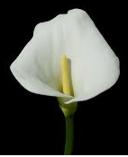
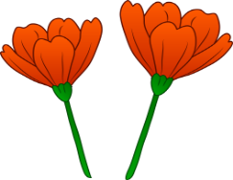
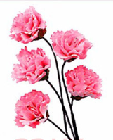
a. b. c.

II Part 2.Listen and write the words or numbers. There is one example. (1pt)
NEW STREET SCHOOL LIBRARY
- Example Full name: Sarah Tanner
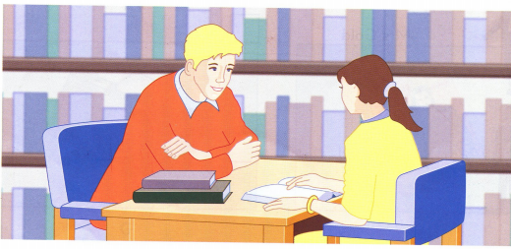
- Age: _________________________________________
- Teacher’s name:________________________________
- Favourite books:________________________________
- Hobby(ies):_______________________________________
- How many books:________________________________
B. VOCABULARY + GRAMMAR + LANGUAGE FUNCTION
I. Choose the best option to complete each sentence. (2.0 pts)
1. They _________ in Ha Noi ten years ago.
A. live B. have lived C. lived
2. My brother isn't here. I wish he _________ here.
A. is B. be C. were
3. Mr. Smith _________ play volleyball when he was young.
A. use to B. doesn't use to C. used to
4. I ______ English since 1993.
A. learnt B. was learning C. have learnt
5. Greeting cards are big business in Britain. Millions of cards_____ every year.
A. send B. are sent C. has sent
6. The material used to make jeans was very ______ and it didn’t wear out easily.
A. plain B. difficult C. strong
7. Now fashion _______ want to modernize the traditional Ao dai.
A. designers B. workers C. makers
8. He may be from a rich family. His clothes look very modern and _______.
A. fashion B. fashionable C. cheap
9. They really enjoy the peaceful_______ in Viet Nam.
A. impression B. atmosphere C. expression
10. John likes……….……….a member of our club.
A. Being B. to being C. is
C. READING
I. Read the passage then Fill in the table with the right information about Vietnam (1,5pts).
Vietnam is a member country of ASEAN. The area is 331.690 sq km. Hanoi is the capital city but it is not the largest city. The largest city is Ho Chi Minh city. Viet Nam has the population of around 87 million. The Vietnamese unit of currency is dong. Vietnam enjoys tropical climate. There are many religions in Vietnam but Buddhism accounts greater number. There are 54 ethnic groups . The Kinh people account for 87% of the total population. Vietnam is famous for its picturesque landscapes. Many visitors come to Vietnam every year.
0/ Unit of currency
1/ Capital city
2/ Area
3/ Population
4/ Climate
II. Choose the on option (a, b, c or d ) that best complete the passage. (1,5 pts)
Vietnames’s New Year is (1)_________ according to the Lunar calendar. It is (2) _____________ known as the Lunar New Year or Tet. It occurs in (3) __________ January or early February. The exact date changes (4) __________ year to year. Vietnamese people usually make (5) ___________ for Tet holiday several weeks beforehand. They clean and decorate their homes, cook special food such as (6) ________ rice cakes, and make (7) _______ on the family altars. On the New Year’s Ever, the whole family (8) _________ together for the reunion dinner in which many different kinds of dishes are served. On Tet, people usually (9) ______ their new clothes, give one another the Tet season’s greetings, and pay (10) _______ visits.
1. a. made b. organized c. celebrated
2. a. officially b. hardly c. exactly
3. a. later b. late c. lately
4. a. in b. for c. from
5. a. decoration b. expression c. preparation
6. a. sticky b. cream c. milky
7. a. offers b. offerings c. fruit
8. a. meets b. takes c. gets
9. a. take on b. get off c. put on
10. a. mutual b. regular c. annual
D. WRITING
I. Finish each of the following sentences in such a way that it means the same as the sentence printed before. (1.5 point)
A. Rewrite the sentences with the words given keep the same meaning. (10 pts)
1. I don’t have enough time to finish this work.
→ I wish ………………………………………………………………………………..
2. People plant rice in tropical countries.
→ Rice …………………………………………………………………………………..
3. I like reading books. Books tell us about different people and their cultures.
→ I like reading …………………………………………………………………………
4. Let’s put garbage bins around the school yard.
→ I suggest …………………………………………………………………………….
5. “Do you like learning English?” she said to me.
→ She asked me ………………………………………………………………………
II. Imagine that you have recently visited a place of interest. In about 80 – 100 words, write a paragraph about your trip (1.5 point). Your paragraph may include:
⬧ When and where you went  How you got there Who you went with
⬧ What the place was like What you did there
HƯỚNG DẪN CHẤM
KIỂM TRA ĐÁNH GIÁ GIỮA KÌ I
NĂM HỌC 2022 - 2023
Môn:Tiếng Anh - Lớp 9
Thời gian làm bài: 02 phút
(Hướng dẫn chấm gồm 02 trang)
A. LISTENING:
I. Part 1. Listen and circle the correct answer or picture.(1pt)
Each correct answer = 0.25(0.25 x 4 = 1pt)
1. What is it? a. yoyo
2. Can you throw a ball? b. Yes, I can.
3. How’s the weather? c. It’s sunny.
4. How many flowers are there? d. five
II. Part 2. Listen and write the words or numbers. There is one example. (1pt)
Each correct answer = 0.2 (0.2 x 5 = 1,0pt)
1. 8/eight 2. (Mrs) Drummond 3. Animal stories
4. Riding (horses) 5. 5/five

(5 items x 0.2 = 1.0 pt)
B. VOCABULARY + GRAMMAR + LANGUAGE FUNCTION
I. Choose the best answer to complete the sentences.
Each correct answer = 0.2 (0.2 x 10 = 2,0pts)
1. C 2. C 3.C 4.C 5.B 6.C 7.A 8.B 9.B 10.A
C. READING:
I. Read the passage then Fill in the table with the right information about Vietnam(1,5pts).
Each correct answer = 0.3 (0.3 x 5 = 1,5pt)
0/ Unit of currency | Dong
1/ Capital city | Hanoi
2/ Area | 331.690 sq km
3/ Population | around 87 million
4/ Climate | tropical climate
II. Choose the on option (a, b, c or d ) that best complete the passage. (1,5 pts)
Each correct answer = 0.15 (0.15 x 10 = 1,5pt)
1. c | 2. a | 3.b | 4. c | 5. c
6. a | 7. c | 8.c | 9. c | 10. a
D. WRITING
I. Rewrite each of the following sentences so that it means the same or do as directed.
Each correct answer = 0.3(0.3 x 5 = 1,5pt)
1. I wish I had enough time to finish this work.
2. Rice is planted in tropical countries.
3. I like reading books which tell us about different people and their cultures.
4. I suggest putting garbage bins around the school yard.
5. She asked me if I liked learning English
II. Imagine that you have recently visited a place of interest. In about 80 – 100 words, write a paragraph about your trip (1.5 pt).
* Form: (0.5 pt) | * Task fulfillment: (0.5 pt) | *Language: (0.5 pt)
- correct form of a passage. | - complete the passage with all relevant information  - well-organized. | - accurate grammar  - appropriate vocabulary

