SPEAKING TEST ENGLISH 7
UNIT 2: HEALTHY LIVING
A. Introduction - 0.4 pt (~3 ideas):
Share something about your hobbies/ school/ friends/
B. Cue pictures (Vocabulary) – 1.0 pt (~5 questions):
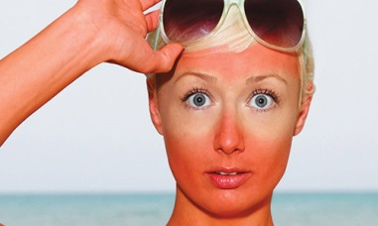  1 | 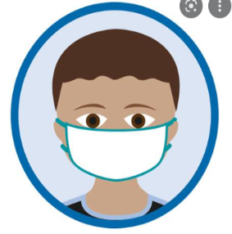  2 | 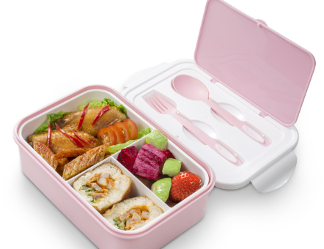  3 |   4
  12 | 1. What is her/ his problem? 1/5/8/10  2. What problem does he/ she get? 1/5/8/10  3. It is an activity that helps you keep fit. 6/9  4. It’s one of the ways to protect you from COVID-19. 2/12  5. What happens when you go out without hat and suncream? 1  6. This food helps you have a good health. 4 |  | 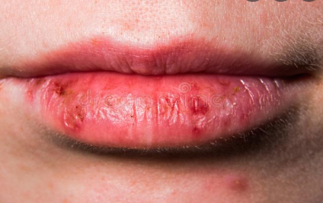  5
  11 |  |  |   6
  10 |   9 | 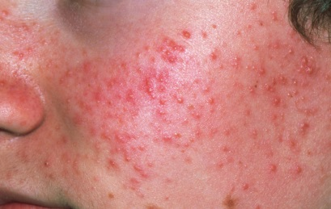  8 |   7

