UNIT 5: FOOD AND DRINK
Lesson 7: Looking back & Project
I. OBJECTIVES
By the end of this lesson, Ss will be able to:
1. Knowledge
- Review the vocabulary and grammar of Unit 5
- Apply what they have learnt (vocabulary and grammar) into practice through a project
2. Core competence
- Develop communication skills and creativity
- Develop presentation skill
- Develop critical thinking skill
- Be collaborative and supportive in pair work and team work
- Actively join in class activities
3. Personal qualities
- Be more creative when doing the project
- Develop self-study skills

II. PREPARATIONS
1. Teacher
- Grade 7 textbook, laptop, TV/Projector/ pictures and cards, speakers, lesson plan, sachmem.vn…
2. Students
- Grade 7 textbook, notebooks, school things….
III. TEACHING PROCEDURES
ACTIVITY 1 – WARM – UP & INTRODUCTION (5’)
a) Aims:
- To create an active atmosphere in the class before the lesson
b) Contents: Play the game “What can you make?”
c) Products: Ss’ answers
d) Teaching steps:
Teacher’s and students’ activities | Content
Deliver the task  - Teacher puts Ss in small groups, shows some ingredients on the screen and gives thorough instructions.  Implement the task  - Ss work in their teams to decide what food they can cook, using the ingredents provided.  Discuss  - Students then share their ideas with other groups.  Giving comments or feedback  - Teacher corrects students’ answers if they make any mistakes and suggests some food, they can make using the given ingredients. | What can you make?  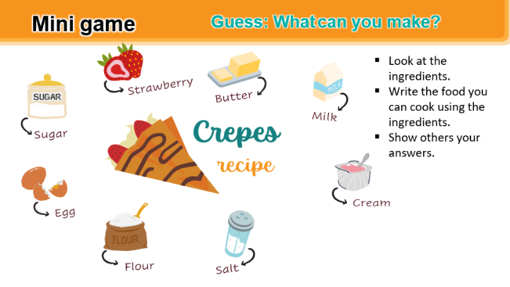
ACTIVITY 2 – PRESENTATION (5’)
a) Aims:
- To revise the language that students have learnt in Unit 5
b) Content: Complete the chart about language learnt in Unit 5
c) Products: the chart about language learnt in Unit 5
d) Teaching steps:
Teacher’s and students’ activities | Content
Deliver the task  - Teacher shows an unfinished chart which summarizes the language that students have learnt in Units 1, 2, 3.  - Teacher asks Ss to complete the chart individually.  Implement the task  - Ss do the task and complete the chart  Discuss  - Teacher calls some Ss share their answers.  - Ss give their answers  Giving comments or feedback  - Teacher checks and corrects | 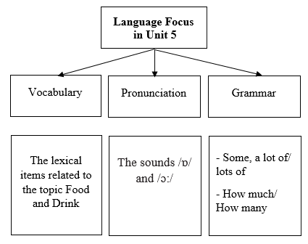
ACTIVITY 3 – PRACTICE (15’)
a) Aims:
- To help Ss revise the vocabulary items they have learnt in the unit.
- To help Ss revise the use of some, any, much and a lot of / lots of
- To help Ss revise the use of How much and How many.
b) Contents:
- Add the words and phrases in the correct columns.
- Read the recipe and write sentences.
- Complete the sentences. Write some, any, much, or a lot of/ lots of.
- Make questions with How many/ How much for the underlined words in the following sentences.
c) Products:
- Answer key
d) Teaching steps:
Teacher’s and students’ activities | Content
Deliver the task  -Teacher encourages students to find as many words or phrases as possible to add to the columns individually.  Implement the task  -Students do the task individually.  Discuss  -Ss compare with their partners to find out who has more words and add any words they haven’t had into their tables.  Giving comments or feedback  -Teacher gives feedback as a class discussion.  Deliver the task  -Teacher has Ss do this activity individually.  Implement the task  - Ss read the recipe and write about 7 sentences.  Discuss  -Ss then compare their answers with their partners. Some strong ones are nominated to read out their answers in front of the class.  Giving comments or feedback  -Teacher gives feedback as a class discussion.  Deliver the task  -Teacher gives instructions.  Implement the task  - Ss do the exercise individually first.  Discuss  -Then they can swap and check their answers with a partner before discussing the answers as a class. Remind Ss to record their original answers so they can use that information in their Now I can … statement.  Giving comments or feedback  -Teacher gives feedback as a class discussion.  Deliver the task  - Teacher gives instructions.  Implement the task  - Ss do the exercise individually first.  Discuss  - Then they can swap and check their answers with a partner before discussing the answers as a class. Remind Ss to record their original answers so they can use that information in their Now I can … statement.  Giving comments or feedback  - Teacher gives feedback as a class discussion. | VOCABULARY  Task 1: Add the words and phrases in the correct columns.  Task 2: Read the recipe and write sentences.  Suggested answers:  We need 5 eggs. We need 2 tomatoes.  We need 2 tablespoons of cold water.  We need 40 grams of butter.  We need 5 grams of onion.  We need 1 teaspoon of salt.  We need 1 teaspoon of pepper.  GRAMMAR  Task 3: Complete the sentences. Write some, any, much, or a lot of/ lots of.  Key:  1. any 2. some 3. a lot of/ lots of 4. a lot of/ lots of  Task 4: Make questions with How many/ How much for the underlined words in the following sentences.  Key:  1. How many bottles of juice are there in the fridge?  2. How much butter do you need for your pancakes?  3. How many bottles of fish sauce do you / we have?  4. How many chairs do you / we need (for the party)?  5. How much sugar did she put in her lemonade?
ACTIVITY 4 – PRODUCTION (13’)
a) Aims:
- To allow students to apply what they have learnt (vocabulary and grammar) into practice through a project.
- To develop teamwork skills
- To give students authentic practice in using target language
b) Contents:
- Work in pairs. Think about your favourite food and drink. Then ask your partner about his/her favourite food and drink.
c) Products:
- Answer key
d) Teaching steps:
Teacher’s and students’ activities | Content
Deliver the task  Posters exhibition:  * Teacher has students display all or some of the posters on the wall or notice board and ask each group to present their poster to the whole class. When all groups have presented their posters, T may have the whole class vote for the best poster.  - Choose eating habits in Ha Noi or in another area or country and design a poster for it, including:  - what typical food they eat for the meals  - what ingredients they need to cook  - how they cook  - how they serve the meals  - pictures or photos for illustration  - Organise an exhibition.  - Vote for the best poster.  Implement the task  ** Students do the project in groups before and present during lesson 7  Discuss  *** Students listen to the others, vote for the best poster and finally complete the self-assessment by completing the statement Now I can … so that they can identify any difficulties and weak areas and provide further practice as the whole groups and individuals.  Giving comments or feedback   Teacher gives feedback. | PROJECT  Task 1: Work in groups. Design a poster about eating habits.  Task 2: Present your poster to the class.
IV. WRAP-UP & HOMEWORK (2’)
- Teacher asks students to talk about what they have learnt in the lesson.
- Prepare for the next lesson: Unit 6 – Lesson 1. Getting started.
V. FEEDBACK

……………………….…, ngày………….tháng…………..năm 2022
Duyệt của Tổ chuyên môn

