Week 31 Preparing date: April ……., 2023
Period 121 Teaching date: April………, 2023

Unit 18: Playing and doing
Lesson 2 (4, 5, 6)
A. OBJECTIVES:
By the end of the lesson, Ss will be able to:
1. Knowledge:
- listen to and understand two communicative contexts in which pupils talk about the quantity of toys that some people have and tick the correct pictures.
- complete four sentences with the help of picture cues.
- review vocabulary words for toys by playing Kim’s game.
- Vocabulary: Review
- Skills: speaking, listening, reading and writing.
2. Competences:
- Critical Thinking: talk about toys
- Co-operation: ready to help friends in pair work/ group work.
- Self-control and independent learning: perform listening tasks.
3. Attitude/ Qualities:
- Kindness: Help partners to complete learning tasks.
- Honesty: tell the truth about feelings and emotions.
- Diligence: complete learning tasks.
B. TEACHING AIDS:
- Teacher: Teacher’s guide Pages 215, 216; audio Tracks 70; website sachmem.vn, posters, laptop, pictures, textbook, lesson plan, TV or projector.
- Students: Pupil’s book Page 49, notebooks, workbooks, school things.
C. PROCEDURES:
Stages/Time | Teacher’s activities | Students’ activities
1.Warm- up:  (5’)  2.Practice: (27’)  3. Homework. (3’) | Sing a song: “What is missing?”  *Aims: to create a friendly and active atmosphere in the class to beginning the lesson.  *Procedure:  - Divide class into 4 teams.  - Set rules: Look at the pictures and find out what is missing (kite, car, plane, train, truck, ship, bus, teddy bear)  + Invite Ss to find out which one is missing.  + The fastest have correct answer get points for the team.  - Encourage Ss to join in the game.  - Give point for Ss.  - Say “Open your book page 43” and look at “Unit 17, Lesson 2 (4,5,6)”.  Activity 1. Listen and tick:  *Aims: Ss will be able to listen to and understand two communicative contexts in which pupils talk about the quantity of toys that some people have and tick the correct pictures.  *Procedure:  - Elicit the quantity of toys that the boys have in each picture 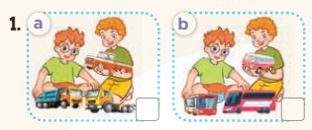  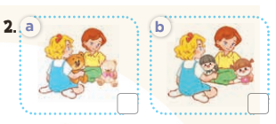  - T ask Ss to guess the answers.  + T writes Ss’guessing on the board.  - Listen to the tape:  + Play the recording  + Play the recording again and get Ss to swap books with their partners.  + Play the recording again to check answers together as a class.  + Write the answers on the board for Ss to correct their answers. Then checks Ss’ guessing.  - Play the recording, sentence by sentence, for the class to listen and repeat in chorus.  Key: 1.b 2. a  Activity 2. Look, complete and read.  *Aims: Ss will be able to complete four sentences with the help of picture cues.  *Procedure:  - Have Ss look at the pictures and identify the quantity of toys in the picture.  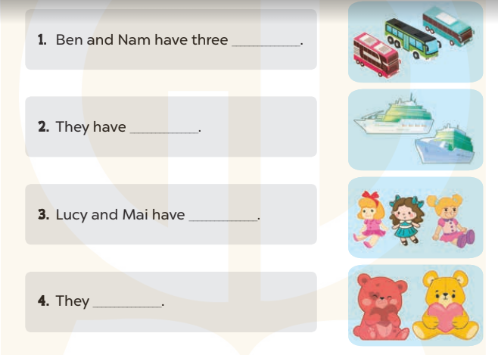  - T models with sentence 1.  + Have Ss look at the sentence.  + Ask them what is missing in the answer (buses).  + Have Ss complete the gap.  + Have Ss read the completed sentence in chorus.  -Have Ss work in pairs and complete the sentences 2, 3 and 4.  - Invite pairs of pupils to stand up and read aloud the sentences.  - T gives feedbacks.  Key: 1. buses 2. two ships  3. three dolls 4. have two teddy bears  Activity 3. Let’s play.  *Aims: Ss will be able to review vocabulary words for toys by playing Kim’s game.  *Procedure:  - Elicit the language that pupils need to name the toys.  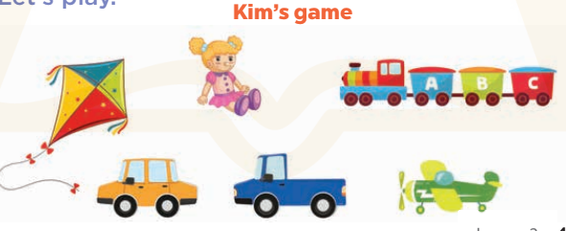  - Tell the Ss the goal of the game and how to play it: Ss should look at the cards carefully and recall their names and positions successfully.  - Divide the class into two teams.  - Display both sets of cards face up on the board. Give Ss two minutes to memorise their set. Turn the cards face down on the board.  + Explain that when you say a word, a nominated pupil from each team must run to their set, try to remember which card shows the relevant picture and turn it over to show to their team.  + A correct card scores one point. When the Ss’ turn is over, they must put the cards back on the board and return to their seats.  + Remember to nominate a pupil from each team before saying the word.  - Count the points for each team and announce the winner.  + The team with the most points wins.  + The winning team must then correctly pronounce all of the words.  *Consolidation  *Aims: Ss will be able consolidate and wrap up the content of the lesson.  *Procedure:  - T asks ss to answer the following questions:  + What have you learnt from the lesson today?  +What are the core values of the lesson? (if the teacher can take from the lesson).  - T praises some Ss who are hardworking / active/ good…. as well as encourage others to try more.  - Prepare the new lesson: Unit 17, Lesson 3 (1,2,3). | - Ss listen and play the game  - Ss open their books  -Look at the pictures and say:  + Picture a: Ben and Bill playing with three trucks  + Picture b: Ben and Bill playing with three buses  + Picture c: Lucy and Mary playing with two teddy bears  + Picture d: Lucy and Mary playing with two dolls  -Ss guess the answers  - Ss listen to the tape and tick  - Ss listen again, tick and swap books with their partners.  - Ss check their answers and guessing  -Ss listen and repeat.  -Ss look at the pictures and say  -Ss listen and answer  -Ss read and complete  -Ss work in pairs and do the task  -Ss read aloud  - Ss look and listen.  -Ss play the game  -Ss play the game  -Ss play the game  -Ss listen and answer  -Ss listen and take note

D. ADJUSTMENTS (if necessary):
………………………………………………………………………………………….…..……………………………………………………………………………...………………………………………….…..……………………………………………………………………………….……………………………………………………………………...

Week 31 Preparing date: April ……., 2023
Period 122 Teaching date: April………, 2023

Unit 18: Playing and doing
Lesson 3 (1, 2, 3)
A. OBJECTIVES:
By the end of the lesson, Ss will be able to:
1. Knowledge:
- correctly repeat the sounds of the letters i and oy in isolation, the words kite and toy and the sentences She has a kite.? and He has a toy. with the correct pronunciation and intonation.
- identify the target words painting and running while listening.
- say the chant with the correct rhythm and pronunciation.
- Vocabulary: Review
- Skills: speaking, listening, reading and writing.
2. Competences:
- Co-operation: ready to help friends in pair work/ group work.
- Self-control and independent learning: perform listening tasks.
3. Attitude/ Qualities:
- Kindness: Help partners to complete learning tasks.
- Honesty: tell the truth about feelings and emotions
B. TEACHING AIDS:
- Teacher: Teacher’s guide Pages 217, 218; audio Tracks 71, 62, 63; website sachmem.vn, posters, laptop, pictures, textbook, lesson plan, TV or projector.
- Students: Pupil’s book Page 50, notebooks, workbooks, school things.
C. PROCEDURES:
Stages/Time | Teacher’s activities | Students’ activities
1.Warm- up:  (5’)  2. Presentation  (9’)  3.Practice: (19’)  4. Homework. (2’) | Game: Find and circle the words  *Aims: to create a friendly and active atmosphere in the class to beginning the lesson.  *Procedure:  - Divide class into 2 groups  - Ask Ss to find and circle the words that they learnt.  - Which groups find the best correct words is winner.  - Give Ss time to play the game.  Rows: bike, toy  Columns: kite, boy  -T checks who’s winner?  - Say “Open your book page 50” and look at “Unit 17, Lesson 3 (1,2,3)”.  Activity 1. Listen and repeat:  *Aims: Ss will be able to correctly pronounce the sounds of the letters i and oy in isolation, the words kite and toy and the sentences She has a kite.? and He has a toy. with correct pronunciation and intonation.  *Procedure:  - T gives instruction to the letters i and oy in isolation, the words kite and toy and the sentences She has a kite.? and He has a toy.  - Play the recording for the letter i and oy  - Encourage Ss to point at the letter/ word/ sentence while listening.  - Play the recording again and encourage Ss to listen and repeat.  - Do this several times until Ss feel confident.  - T calls some Ss to practice.  - T gives feedbacks.  Activity 2. Listen and circle.  *Aims: Ss will be able to identify the target words kite and toy while listening.  *Procedure:  - Elicit the sentences and explain that they have to listen.  - T ask Ss to guess the answers.  + T writes Ss’guessing on the board.  - Listen to the tape:  + Play the recording  + Play the recording again and get Ss to swap books with their partners.  + Play the recording again to check answers together as a class.  + Write the answers on the board for Ss to correct their answers. Then checks Ss’ guessing.  - Play the recording, sentence by sentence, for the class to listen and repeat in chorus.  - Invite one or two Ss to stand up and read the completed sentences.  Key: 1.c 2.b  Activity 3. Let’s chant  *Aims: Ss will be able to say the chant with the correct rhythm and pronunciation.  *Procedure:  - Introduce the title and lyrics of the chant.  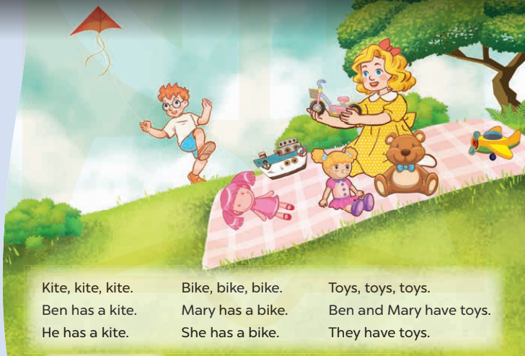  - Play the recording for Ss to listen to the whole chant.  + Have them repeat the title and lyrics line by line.  + Ask Ss to attend to the sounds of the letters i and oy and the words kite and toy.  - Play the recording all the way through for Ss to listen to pronunciation and melody.  - Play the recording line by line for Ss to listen and repeat  - Play the recording for Ss to chant and clap along.  - Ask Ss to practice chant and clap along in pairs or groups.  - Invite groups to the front of the classroom to perform the chant  -T gives feedback.  *Consolidation  *Aims: Ss will be able consolidate and wrap up the content of the lesson.  *Procedure:  - T asks ss to answer the following questions:  + What have you learnt from the lesson today?  +What are the core values of the lesson? (if the teacher can take from the lesson).  - T praises some Ss who are hardworking / active/ good…. as well as encourage others to try more.  - Practice the chant more.  - Prepare the new lesson: Unit 17, Lesson 3 (4,5,6). | - Ss listen  -Ss play game  - Ss open their books  - Ss recognize the differences about color of letter  - - Ss listen  - Ss listen and point  - Ss listen again and repeat  -Ss listen again and repeat  -Ss practice  -Ss listen  -Ss listen and say:  + Number 1: She has a…..  + Number 2: He has a…..  -Ss guess the answers  - Ss listen to the tape and circle  - Ss listen again, circle and swap books with their partners.  - Ss check their answers and guessing  -Ss listen and repeat.  -Ss read the sentences  - Ss look and listen.  -Ss listen to the chant  - Ss listen and repeat line by line without clap their hands  -Ss note the sounds, words  -Ss listen to melody of the chant  - Ss listen and chant line by line.  - Ss chant and clap along.  - Ss work in groups (two groups) to chant  -Ss perform in front of the class.  -Ss listen  -Ss listen.  -Ss answer the questions  -Ss listen and clap their hands  -Ss listen and take note
  D | B | K | K | E | P | S | C | P | T
  G | E | I | E | E | D | D | B | Z | H
  G | E | T | O | Y | E | C | O | Y | I
  R | A | E | M | F | C | C | Y | R | N
  T | A | B | N | N | N | L | S | O | K
  G | L | Y | D | F | I | I | W | T | B
  S | R | O | W | R | C | V | T | A | H
  M | M | B | I | K | E | S | T | A | Y
  D | P | P | R | E | S | E | R | S | M
  A | C | E | B | F | A | Z | Y | W

D. ADJUSTMENTS (if necessary):
………………………………………………………………………………………….…..……………………………………………………………………………...………………………………………….…..……………………………………………………………………………….……………………………………………………………………...

Week 31 Preparing date: April ……., 2023
Period 123 Teaching date: April………, 2023

Unit 18: Playing and doing
Lesson 3 (4, 5, 6)
A. OBJECTIVES:
By the end of the lesson, Ss will be able to:
1. Knowledge:
- read and understand a passage about toys.
– read, understand and complete a paragraph about toys that Lucy has.
– revise the target language by making paper toys and talking about them to the class.
- Vocabulary: Review
- Skills: speaking, listening, reading and writing.
2. Competences:
- Co-operation: ready to help friends in pair work/ group work.
- Self-control and independent learning: perform reading tasks.
3. Attitude/ Qualities:
- Kindness: Help partners to complete learning tasks.
- Honesty: tell the truth about feelings and emotions.
- Diligence: complete learning tasks.
B. TEACHING AIDS:
- Teacher: Teacher’s guide Pages 219, 220, website sachmem.vn, posters, laptop, pictures, textbook, lesson plan, TV or projector.
- Students: Pupil’s book Page 51, notebooks, workbooks, school things.
C. PROCEDURES:
Stages/Time | Teacher’s activities | Students’ activities
1.Warm- up:  (5’)  2.Practice: (8’)  3.Production: (19’)  4. Homework. (3’) | Game: What’s in the box?  *Aims: to review the vocabulary and structure about greet and respond to greetings.  *Procedure:  - Divide class into 4 teams.  - Set rules: invite 1 pupil from each team go to the board look at the toy  (kite, plane, doll, train, bus, car, ship) then unscramble the words by writing on the board and say aloud what the toy is. The fastest will get more points than the rest.  - Encourage Ss join in the game.  - Give points for the teams.  - Say “Open your book page 51” and look at “Unit 17, Lesson 3 (4,5,6)”.  Activity 1. Read and circle a, b, or c:  *Aims: Ss will be able to read and understand a passage about toys.  *Procedure:  - Tell Ss attend to the passage about Linh’s and Lucy’s toys and read it together as a class.  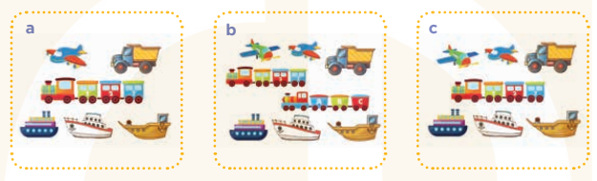  - Have Ss spot the differences between the pictures (the quantity of toys in each picture) and check comprehension.  - Get Ss to read and circle the correct letter.  - Get Ss to swap books with a partner, then check answers together as a class.  - Invite Ss to read the complete text aloud  -T gives feedbacks.  Key: c  Activity 2. Let’s write  *Aims: Ss will be read, understand and complete a paragraph about toys that Lucy has.  *Procedure:  - Tell the class the goal of this activity: Ss read the passage about Lucy’s toys and fill in the gaps.  - Have Ss fill in the first gap together as an example.  - Ask Ss to look at the gap and guess what is missing (the word She).  - Let Ss write down the word in the gap.  - Repeat the same procedure with the other incomplete sentences.  - If time allows, invite a few Ss to read aloud the paragraph they have completed in front of the class.  Key: Pupils’ own answers  Activity 3. Project.  *Aims: Ss will be able to revise the target language by making paper toys and talking about them to the class.  *Procedure:  - Elicit the language needed to do the task: He / She has ___. and ask Ss to repeat it several times  - Ask Ss to work in groups of six.  + Ask Ss to show the paper toys that they have made at home, then tell the group about them and check comprehension.  - Give Ss time to do the task.  - Invite some Ss to show and tell the class about the toys they have made using the language learnt.  - Have Ss display their toys on the classroom walls.  *Consolidation  *Aims: Ss will be able consolidate and wrap up the content of the lesson.  *Procedure:  - T asks ss to answer the following questions:  + What have you learnt from the lesson today?  - T praises some Ss who are hardworking / active/ good…. as well as encourage others to try more.  - Prepare the new lesson: Unit 18- Lesson 1 (1,2,3). | - Ss listen  -Ss play game  - Ss open their books  -Ss listen and answer  + Picture a: a plane, a truck, a train, three ships  + Picture b: two planes, a truck, two trains, three ships  + Picture c: two planes, a truck, a train, three ships  -Ss read and answer  -Ss read and circle  -Ss swap books and check  -Ss read aloud  -Ss listen  -Ss listen  -Ss read and answer  -Ss listen and answer  -Ss write down  Lucy is my friend. She has a doll………is my friend. She/ He has……………. ………and  ………..are my friends. They have…………..  -Ss read aloud  -Ss listen and repeat  -Ss work in groups  -Ss work in groups  -Ss perform in front of the class.  -Ss display their toys on the classroom walls.  -Ss answer the questions  -Ss listen and clap their hands  -Ss listen and take note
D. ADJUSTMENTS (if necessary):
………………………………………………………………………………………….…..……………………………………………………………………………...…………
Week 31 Preparing date: April ……., 2023
Period 124 Teaching date: April………, 2023

Unit 19: Outdoor activities
Lesson 1 (1, 2, 3)
A. OBJECTIVES:
By the end of the lesson, Ss will be able to:
1. Knowledge:
- understand and correctly repeat the sentences in two communicative contexts to talk about an action in progress.
- correctly say the words and use I’m …… to identify an action in progress.
- enhance the correct use of I’m……… to identify an action in progress in a freer context.
- Vocabulary: writing, dancing, singing, reading, song.
- Model sentences:
I’m dancing.

- Skills: speaking and listening
2. Competences:
- Co-operation: ready to help friends in pair work/ group work.
- Sociability: Talk to each other, say good words to others.
3. Attitude/ Qualities:
- Kindness: Help partners to complete learning tasks.
- Honesty: tell the truth about feelings and emotions
B. TEACHING AIDS:
- Teacher: Teacher’s guide Pages 221, 222, audio Tracks 74, 75, website sachmem.vn, posters, laptop, pictures, textbook, lesson plan, TV or projector.
- Students: Pupil’s book Page 52, notebooks, workbooks, school things.
C. PROCEDURES:
Stages/Time | Teacher’s activities | Students’ activities
1.Warm- up:  (3’)  2. Presentation  (16’)  3.Practice: (7’)  4.Production: (7’)  5. Homework. (2’) | Sing: Head, shoulders, knees and toes  *Aims: to create a friendly and active atmosphere in the class to beginning the lesson.  *Procedure:  - Show the song on the screen.  https://www.youtube.com/watch?v=WX8HmogNyCY  - Ask Ss to listen, sing and dance the song.  - Say “Open your book page 52” and look at “Unit 18, Lesson 1 (1,2,3)”.  Activity 1. Vocabulary.  *Aims: Ss will be able to know the vocabulary in front of starting the new lesson.  *Procedure:  -T elicits the new words  + writing : viết (mime)  + dancing : nháy múa (mime)  + singing :hát (mime)  + reading : đọc (mime)  + song :bài hát (translation)  - T models (3 times).  - T writes the words on the board.  - Checking: Matching  Activity 2. Look, listen and repeat:  *Aims: Ss will be able to understand and correctly repeat the sentences in two communicative contexts to talk about an action in progress.  *Procedure:  - Have Ss look at Pictures a and b and identify names of the speakers in the pictures.  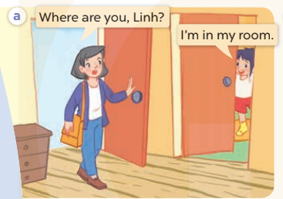  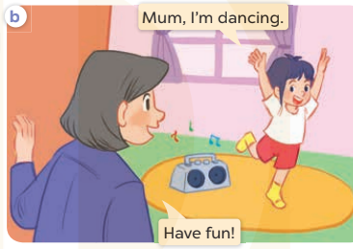  - Play the audio twice (sentence by sentence). Correct their pronunciation where necessary.  - Have Ss to practice the dialogue  - T invites a few pairs to the front of the class to practice.  - T checks pronunciation for ss.  Activity 3 Listen, point and say.  *Aims: Ss will be able to correctly say the words and use I’m ……. to identify an action in progress  *Procedure:  * Model sentences:  - T asks Ss look at picture b and helps Ss know the structure from the dialogue.  - T introduces new structure for Ss.  - T explains, models and gives meaning.  -Have Ss repeat the model sentences.  I’m dancing.  *Drill pictures  - Elicit the character and the quantity of toys in each picture.  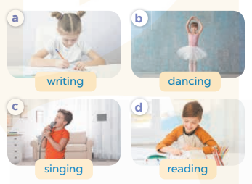  - Run through all the pictures.  - Run through model sentences.  - Have Ss to practise:  - Ask Ss to work in pairs.  - T controls and corrects.  - Invite a few pairs to come to the front of the classroom and point at the pictures and say the questions and answers in front of the class.  - T gives feedbacks.  Activity 4. Let’s talk.  *Aims: Ss will be able to enhance the correct use of I’m ….. to identify an action in progress in a freer context.  *Procedure:  - Have Ss look at the picture and tell them about the activity.  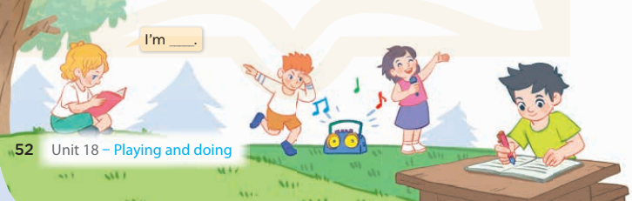  - Put Ss into groups of four.  - Ask Ss to say using I’m…..  - Invite some Ss to the front of the class to say about the activity.  *Consolidation  *Aims: Ss will be able consolidate and wrap up the content of the lesson.  *Procedure:  - T asks ss to answer the following questions:  + What have you learnt from the lesson today?  +What are the core values of the lesson? (if the teacher can take from the lesson).  - T review the vocabulary and model sentences.  - T praises some Ss who are hardworking / active/ good…. as well as encourage others to try more.  - Learn the vocabulary and model sentences by heart  - Prepare the new lesson: Unit 18, Lesson 1 (4,5,6). | - Ss listen  - Ss sing a song  - Ss open their books  -Ss listen and answer  - - Ss listen and repeat  + Choral repetition (3 times).  + Individual repetition (3 ss)  - Ss take note  - Ss look, remember and match  -Look at the pictures and say  + In picture a: Mum asks: Where are you, Linh? Linh answers: I’m in my room.  + In picture b: Linh says: Mum, I’m dancing and Mum says: Have fun!  -Ss listen and repeat in chorus (twice)  -Ss work in pairs to practice  -Ss practice the dialogue  -Ss listen  -Ss look at the picture and answer.  -Ss listen  -Ss listen and repeat  -Ss repeat  - Ss look, listen and answer  + Picture a: a girl is writing + Picture b: a girl is dancing + Picture c: a boy is singing  + Picture d: a boy is reading  -Ss listen and repeat  -Ss practice in chorus  -Ss work in pairs to practice  -Ss point and say  -Ss listen.  -Ss look at the picture and listen  -Ss look and answer  -Ss perform in front of the class.  -Ss answer the questions  - Ss listen  -Ss listen and clap their hands  -Ss listen and take note
D. ADJUSTMENTS (if necessary):
………………………………………………………………………………………….…..……………………………………………………………………………...………………………………………….…..……………………………………………………………………………….……………………………………………………………………...

