School: …………………………………….. | Date: ……………………………..
Class: …………………………..................... | Period: …………………….........

UNIT 9: ENGLISH IN THE WORLD
Lesson 2.2 - Grammar (page 72)

I. OBJECTIVES
By the end of the lesson, Ss will be able to:
1.1. Language knowledge and skills
- use Past Simple with regular verbs correctly.
- talk about their last holiday.
1.2. Competences
- improve speaking, listening and writing skills.
- improve the use of English.
1.3. Attributes
- love studying English, love travelling.
- have good preparation for any trip.

II. TEACHING AIDS AND LEARNING MATERIALS
1. Teacher’s aids: Student book and Teacher’s book, class CDs, Digital Book (DCR phần mềm tương tác SB, DHA (từ vựng/ cấu trúc) phần mềm trò chơi tương tác), projector/interactive whiteboard / TV (if any), PowerPoint slides, handouts.
2. Students’ aids: Student’s book, workbook, notebook.

III. ASSESSMENT EVIDENCE
Performance Tasks | Performance Products | Assessment Tools
- Listen and repeat. | - Ss’ performance. | - T’s feedback.
- Study the grammar box. | - Ss’ task. | - T’s observation.
- Fill in the blanks with the correct form of the verbs in the box. | - Ss’ answers. | - T’s feedback/Peers’ feedback.
- Fill in the blanks with the correct Past Simple form of the verbs. | - Ss’ answers. | - T’s feedback/Peers’ feedback.
- Speak: Ask your partner about their last holiday. Use the prompts to ask the questions. | - Ss’ performance/ presentation. | - T’s observation, T’s feedback/Peers’ feedback.

IV. PROCEDURES
A. Warm up: (5’)
a) Objective: Introduce the new lesson and set the scene for Ss to acquire new language; get students' attention at the beginning of the class by enjoyable and short activities as well as to engage them in the follow-up steps.
b) Content: Review words / Introduce: Past simple with irregular verbs.
c) Expected outcomes: Ss review old knowledge and have general ideas about the grammar points they are going to study in the new lesson.
d) Organization of the activity:
TEACHER’S ACTIVITIES | STUDENTS’ ACTIVITIES
- Option 1: Matching  - Have Ss close all books.  - Have Ss work in pairs to match verbs in A with words / phrases in B.  - Call Ss to give answers, have Ss read the verb phrases again, tell the meaning.  - Lead to the new lesson.  *Illustration:  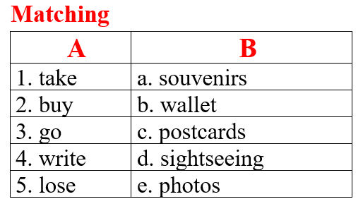  - Option 2: Introduce: Past simple with irregular verbs.  - Show the irregular verb lists, briefly introduce this to Ss.  - Lead to the new lesson.  *Illustration:  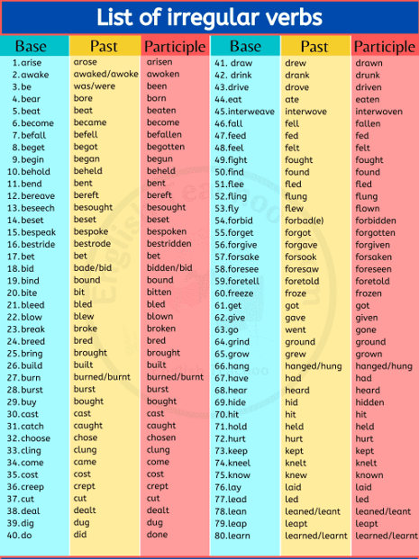 | - Close books.  - Do the matching.  - Give answers.  - Listen.  Answers keys  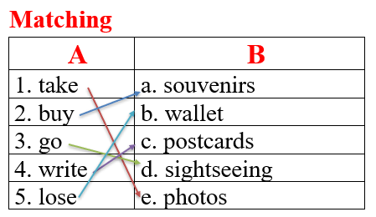  - Listen.

B. New lesson (35’)
- Activity 1: Presentation (10’)
a) Objective: Introduce: Past Simple with regular verbs.
b) Content:
- Listen and repeat.
- Introduce the grammar point: Past Simple with regular verbs.
c) Expected outcomes: Ss know how to use Past Simple with regular verbs to do some following exercises.
d) Organization of the activity:
TEACHER’S ACTIVITIES | STUDENTS’ ACTIVITIES
Task a. Listen and repeat  - Have Ss look at the picture using DCR.  - Play audio (CD2 – Track 19) and have Ss listen and read the speech bubbles.  - Play the audio again and have Ss listen and repeat.  Grammar box  - Have Ss look at the grammar explanation, examples and read: Past Simple with regular verbs.  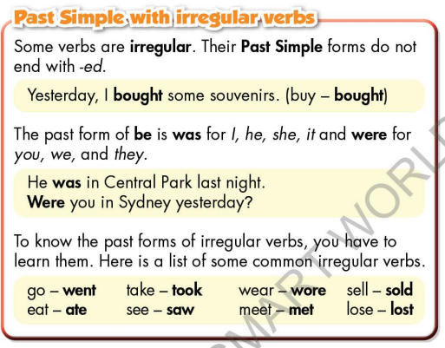  - Briefly explain the grammar point.  - Ask Ss to make sentences with Past Simple with regular verbs.  - Give feedback and evaluation. | - Look.  - Listen, then read.  - Listen and repeat.  - Look and read.  - Listen and take notes.  - Make sentences.
- Activity 2: Practice (19’)
a) Objective: Students can use Past Simple with regular verbs correctly.
b) Content:
- Fill in the blanks with the correct form of the verbs in the box.
- Fill in the blanks with the correct Past Simple form of the verbs.
c) Expected outcomes: Students can use Past Simple with regular verbs to talk about holidays in their speaking.
d) Organization of the activity:

TEACHER’S ACTIVITIES | STUDENTS’ ACTIVITIES
Task b. Fill in the blanks with the correct form of the verbs in the box.  - Demonstrate the activity using DCR.  - Have students fill in the blanks.  - Have pairs check each other's work.  - Have some students share their answers with the class.  - Check Ss’ answers, give feedback.  Task c. Fill in the blanks with the correct Past Simple form of the verbs.  - Demonstrate the activity using the example.  - Have students read the message and the fill in the blanks with the correct Past Simple form of the verbs. - Have students check their answers with a partner.  - Check answers as a whole class using DCR. | - Look and listen.  - Work individually.  - Work in pairs.  - Write answers on the board.  Answer keys  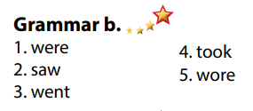  - Look and listen.  - Work individually.  - Work in pairs.  - Give answers.  Answer keys  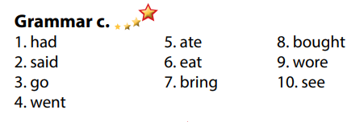

- Activity 3: Production (6’)
a) Objective: Students master the grammar point they study in the lesson.
b) Content: Speaking: Ask your partner about their last holiday. Use the prompts to ask the questions.
c) Expected outcomes: Ss produce the new language successfully, and they can apply the grammar point they have learnt in speaking and writing.
d) Organization of the activity:
TEACHER’S ACTIVITIES | STUDENTS’ ACTIVITIES
Task d. Ask your partner about their last holiday. Use the prompts to ask the questions.  - Divide class into pairs.  - Have Ss ask each other questions using the prompts.  - Have some pairs demonstrate the activity in front of the class.  - Give feedback and evaluation. | - Have conversation in pairs.  - Present.  - Listen.

C. Consolidation and homework assignments (5’)
*Consolidation
- Past Simple with regular verbs
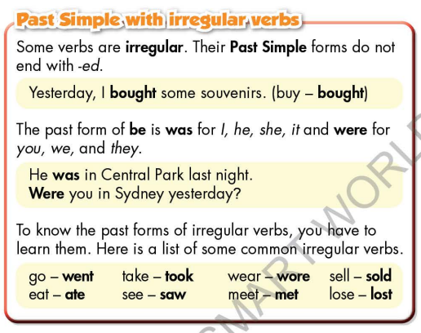

* Homework:
- Make 3 sentences using Past Simple with regular verbs.
- Lean by heart Past Simple with regular verbs: go-went, eat-ate, take-took, see-saw, sell-sold, lost-lost, wear-wore, meet-met, be-was/were, buy-bought.
- Do the exercises in WB: Grammar & Writing (page 53).
- Complete the grammar notes in Tiếng Anh 7 i-Learn Smart World Notebook (page 57).
- Play consolation games in Tiếng Anh 7 i-Learn Smart World DHA App on www.eduhome.com.vn
- Prepare: Lesson 2.3 – Pronunciation and Speaking (page 73 – SB).

D. Reflection
a. What I liked most about this lesson today:
…………………………………………………………………………………………
- What I learned from this lesson today:
…………………………………………………………………………………………
c. What I should improve for this lesson next time:
…………………………………………………………………………………………

