UNIT 8: SPORTS AND GAMES
A - TRỌNG TÂM KIẾN THỨC
I. Từ vựng
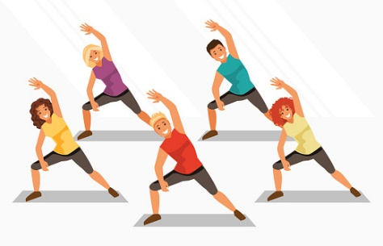 | 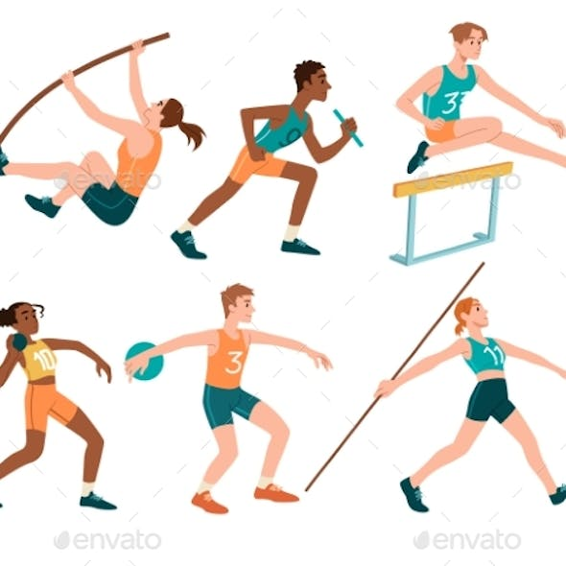 | 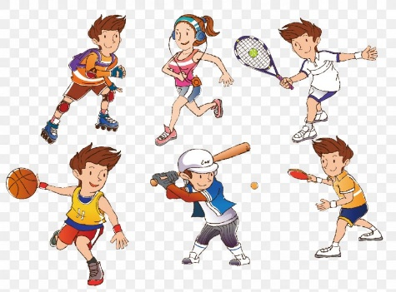
aerobics | athletics | athlete
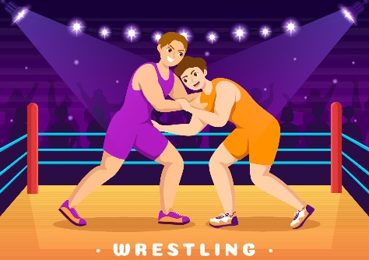 | 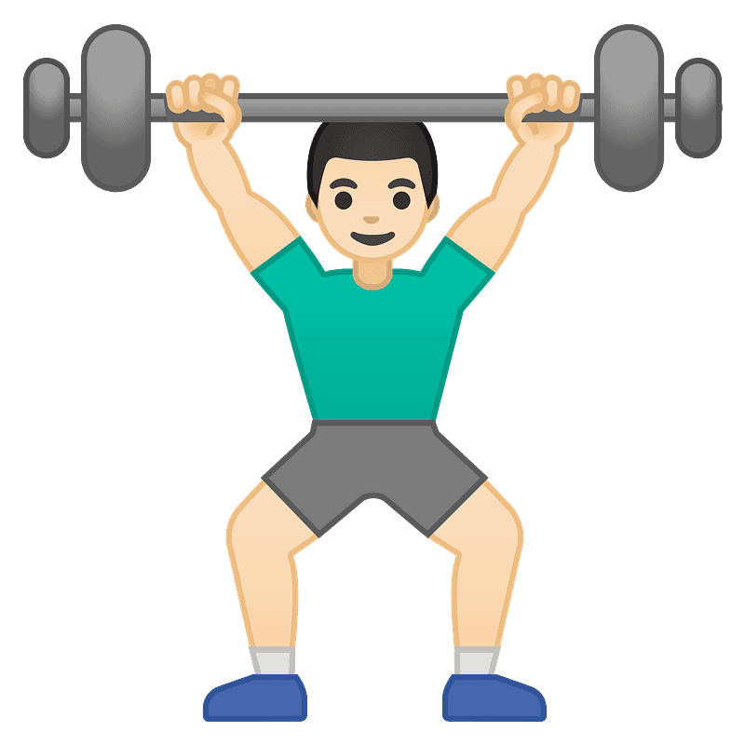 | 
wrestling | weightlifting | surfing
 | 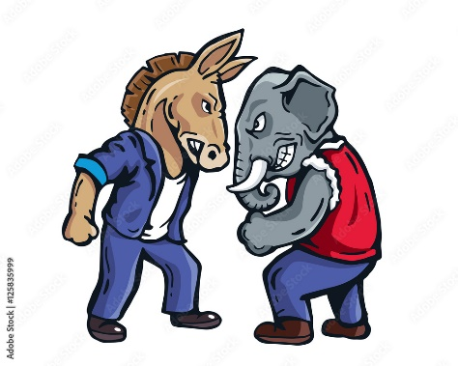 | 
spectator | opponent | achievement

Sports and Games
Do | Go | Play
altheletics, aerobics, yoga, judo, ballet | fishing, cycling, camping, horse-riding | the guitar, football, chess, rugby
❖ Lưu ý
- do kết hợp với các danh từ chỉ các hoạt động giải trí hoặc các môn thể thao trong nhà, không liên quan tới trái bóng, thường mang tính cá nhân và không mang tính chiến đấu, ganh đua.
- play kết hợp với các danh từ chỉ môn thể thao liên quan đến trái bóng hoặc một vật tương tự trái bóng như trái cầu/ quả cầu, có tính chất ganh đua với đối thủ khác.
- go kết hợp với cấu trúc V_{-ing}, mang tên một môn thể thao hay hoạt động giải trí.
II. Ngữ âm
1. Phát âm: /eə/ vs. /ɪə/
/eə/ | /ɪə/
Là âm đôi, chuyển từ âm /e/ sang âm /ə/; chuyển từ vị trí miệng mở rộng, hàm dưới di chuyển xuống, về vị trí môi và lưỡi thả lỏng | Là âm đôi, chuyển từ âm /ɪ/ sang âm /ə/; chuyển từ vị trí đầu lưỡi nâng lên về vị trí môi và lưỡi thả lỏng
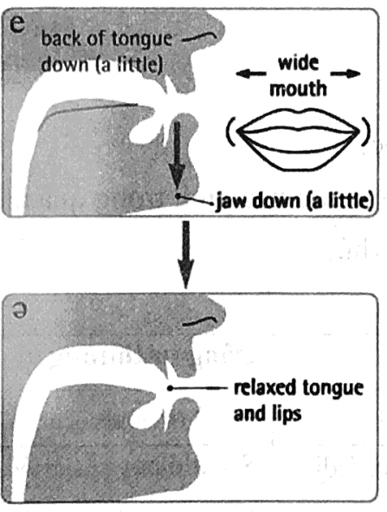 | 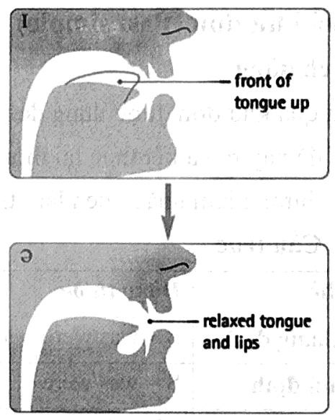
• Âm /eə/ thể được nhận diện trong từ có chứa các nhóm chữ cái sau:
- are: | care
- air: | air | chair | hair | fair | stair
- ear: | wear
- ere: | where
- aer: | aeroplane
• Âm /ɪə/ thể được nhận diện trong từ có chứa các nhóm chữ cái sau:
- ea: | real
- ear: | ear | beard | clear | hear | nearly
- eer: | beer | cheer
- ere: | here | we’re
2. Hậu tố nhận trọng âm
Các từ có hậu tố sau có trọng âm luôn rơi vào chính nó:
-oo bamboo, kangaroo
-ee teenager, refugee
-eer engineer, volunteer
-ese Vietnamese, Japanese
-ette cigarette, novelette
-esque picturesque
-self themselves, herself
-ect effect, correct
-fer prefer, refer
III. Ngữ pháp
1. Quá khứ đơn (Past simple)
a. Cách dùng
Thì quá khứ đơn được dùng để nói về việc:
- đã xảy ra và kết thúc tại một thời điểm được xác định trong quá khứ;
- thường làm hoặc quen làm trong quá khứ;
b. Cấu trúc
Thể | Động từ be | Động từ thường
Khẳng định | S + was/were + noun/adj. | S + Vpast simple (+ O).
Phủ định | S + was/were + not + noun/adj. | S + did not + V (+ O).
Nghi vấn | Was/ Were + S + noun/adj?  Yes, S + was/were.  No, S + wasn’t/weren’t. | Did + S + V (+ O)?  Yes, S + did.  No, S + didn’t.
c. Dấu hiệu nhận biết
Trong câu ở thì quá khứ đơn thường xuất hiện các trạng từ chỉ thời gian như:
- yesterday, last night/week/month!...;
- two hours/two weeks ago',
- in + thời gian trong quá khứ (e.g.: in 1990),
- when + S + Ved.
d. Cách thêm -ed vào sau động từ theo quy tắc
Quy tắc | Ví dụ
Ta thêm “ed” vào đằng sau hầu hết các động từ | want - wanted
 | look - looked
Động từ kết thúc bằng đuôi "e” hoặc ”ee” ta chỉ thêm -d và cuối động từ. | live - lived
 | love - loved
Động từ tận cùng là một phụ âm + “y”, ta chuyển “y” thành “i” và thêm -ed. | cry - cried
 | study - studied
Động từ một âm tiết, tận cùng bằng một nguyên âm + một phụ âm (trừ những từ kết thúc bằng h, w, x, y), ta phải gấp đôi phụ âm trước khi thêm “ed”. | stop - stopped
 | plan - planned
2. Câu mệnh lệnh (Imperatives)
- Câu mệnh lệnh là câu dùng để sai khiến, ra lệnh hoặc đề nghị một người khác làm một việc gì đó. Chủ ngữ của câu mệnh lệnh được ngầm hiểu là you.
- Câu mệnh lệnh luôn được dùng ở thì hiện tại đơn và dạng thức nguyên thể của động từ.
Dạng | Khẳng định | Phủ định
Cấu trúc | Verb + object (tân ngữ) | Don’t verb + object/preposition
 | Verb + prepositional (giới từ)
Ví dụ | Open the door.  Come in.  Sit down. | Don’t open the window.  Don’t cry.  Don’t stand up.
Lưu ý | Có thể dùng please (làm ơn, xin mời) trong câu mệnh lệnh làm cho câu nhẹ nhàng hơn và lịch sự hơn, có thể đặt ở đầu hoặc ở cuối câu.
3. Một số động từ theo sau bởi to V và V_{-ing}
+ to V | + V_{-ing}
remember: nhớ phải làm  forget: quên phải làm  try: cố gắng  learn: học  promise: hứa  dare: dám  allow: cho phép | avoid: tránh, hạn chế làm  give up: từ bỏ try: thử làm  consider: cân nhắc  look forward to: mong chờ  stop: dừng lại  keep: tiếp tục, duy trì

B - BÀI TẬP VẬN DỤNG
I. Từ vựng
Exercise 1: Put the word in the correct box.
wrestling | horse-riding |  | basketball | sailing |  | gymnastics
mountain-climbing | yoga |  | karate | ice-skating |  | volleyball
baseball | crossword |  | hide-and-seek | golf |  | darts
diving | cricket |  | martial arts | aerobics |  | chess
table tennis | bowling |  | exercise | riding |  | board games
do |  | play |  |  | go
Exercise 2: Fill in the blank with given words or phrases.
spectators | audience | viewers | athletes | athletics
achievement | opponent | participation | competitive | weightlifting
1. Being the Olympic champion at such a young age was a remarkable _________________.
2. The theatre is trying to attract a wider _________________ to come and see their latest play.
3. They wanted to build a stadium that could hold a million _________________.
4. Romantic movies are losing their _________________ to more captivating series like Sherlock or Brooklyn Nine-Nine.
5. You have to be trained carefully before you can do _________________.
6. A back injury will prevent your active _________________ in any sports for a while.
7. I cannot go jogging for more than 15 minutes. _________________ is not the kind of sports that I can take part in.
8. Over 45,476 _________________ from 11 nations competed in the 31st edition of the Southeast Asian Games.
9. Liverpool is a tough _________________, competing against Manchester City to be this year’s champion.
10. _________________ sports encourage children to work together as a team.
II. Ngữ âm
Exercise 1: Put the words in the correct groups.
career | dearly | secretarial | fear | share | hare
clear | near | upstairs | year | fairy | airport
beer | interior | superior | smear | premier | garish
weary | various | engineer | prepare | librarian | heir
/eə/ |  |  | /ɪə/
Exercise 2: Choose the word whose underline part is pronounced differently from others.
1. A. hair | B. stare | C. lair | D. weary
2. A. bear | B. deer | C. fear | D. steer
3. A. bearish | B. peer | C. smear | D. queer
4. A. tear | B. beer | C. airport | D. mere
5. A. sphere | B. clear | C. shear | D. swear
6. A. aeroplane | B. parent | C. nearly | D. area
7. A. cheer | B. steer | C. engineer | D. wear
8. A. head | B. instead | C. breast | D. wheat
9. A. bang | B. latter | C. slang | D. fang
10. A. where | B. leer | C. heir | D. theirs
Exercise 3: Choose the word whose main stress is different from the others.
1. A. lefty | B. hungry | C. alive | D. harmful
2. A. sporty | B. service | C. hunter | D. embrace
3. A. suspend | B. football | C. tennis | D. seldom
4. A. prevalence | B. disturbance | C. limited | D. conquering
5. A. galaxy | B. addition | C. insistence | D. related
6. A. policeman | B. national | C. dependence | D. decision
7. A. maximum | B. video | C. collection | D. cultural
8. A. ensure | B. credit | C. shower | D. cruel
9. A. tropical | B. motorist | C. formula | D. approval
10. A. candidate | B. arrogant | C. parachute | D. solution
III. Ngữ pháp
Exercise 1: Choose the correct answer.
1. Mozart _________________ more than 600 pieces of music.
A. writes B. wrote C. have wrote D. written
2. ‘How did you learn to drive?’ My father _________________ me.
A. teaches B. taught C. teaches D. teached
3. We couldn’t afford to keep our car, so we _________________ it.
A. sell B. selled C. sold D. has sell
4. Dave _________________ down the stairs this morning and _________________ his leg.
A. falling/breaks B. fall/breaks C. fell/breaked D. fell/broke
5. Ann _________________ a lot of money yesterday. She _________________ a dress which costed $100.
A. spent/bought B. spends/buys C. spent/buy D. spent/buyed
6. I _________________ to go into the woods for the picnic this weekend.
A. plan B. am planning C. planned D. planning
7. Marry used to _________________ swimming every Thursday.
A. go B. goes C. went D. going
8. _________________ did you learn to play the piano?
A. When B. Did C. Were D. Who
9. Marry is still _________________ whether to join the music or the baking club.
A. consider B. considers C. considering D. considered
10. She _________________ me her money, and I promise to pay her back soon.
A. borrows B. lending C. lends D. borrowing
Exercise 2: Write a question for the underlined part in each sentence.
1. ___________________________? She was a doctor before retiring.
2. ___________________________? I watched TV all day yesterday.
3. ___________________________? I used to go to school 5 days a week.
4. ___________________________? She learned to play the piano at six.
5. ___________________________? I was at school yesterday morning.
6. ___________________________? She used to be a part time engineer.
7. ___________________________? I couldn’t swim when I was 12.
8. ___________________________? She had to study all day so she couldn’t go play with us.
9. ___________________________? I used to go to the cinema with my mother when I was younger.
10. ___________________________? She wasn’t a good student then.
Exercise 3: Complete the sentences using the following verbs in the correct form.
hurt | catch | buy | spend | teach
fall | cost | go | import | retire
1. Mark _____________ himself badly when he was climbing a tree last week.
2. That nation didn’t _____________ anything in the past, but now products from other countries can be found nearly wherever people go.
3. I _____________ the entire morning trying to fix the projector.
4. Did you arrive early enough to _____________ the 7 a.m. train?
5. Although I really liked that shirt, I didn’t buy it. It _____________ too much.
6. He promised to _____________ me how to play sudoku.
7. There wasn’t enough food for the dinner, so I went and _____________ some more.
8. Mark _____________ to Leeds for two years to get his MSc degree.
9. She couldn’t derive any satisfaction from her work, so she chose to _____________.
10. He wasn’t looking where he was going so, he tripped and _____________.
Exercise 4: Complete the sentences using the following verbs in the correct form.
1. Don’t forget (turn) _____________ off all the lights before you leave the classroom.
2. Allow me (help) _____________ you. I have experience with broken computer.
3. Promise (finish) _____________ your homework next time, or I will punish you.
4. Avoid (travel) _____________ during rush hours. You can save a lot of time.
5. Remember (wake) _____________ up at 7 o’clock. We have to catch an early flight.
6. Look forward to (visit) _____________ the museum next week. They have installed 3D models of dinosaurs and many extinct animals.
7. Dare (be) _____________ different. Nobody is exactly the same.
8. Try (revise) _____________ carefully. We are having a Maths exam on Wednesday.
9. If you have a lot of free time, try (learn) _____________ to speak another language.
10. If you want to have a better health, give up (smoke) _____________.
11. Consider (look) _____________ for another job. You look exhausted these days.
12. Stop (talk) _____________ so loudly! I’m trying to memorise new English words.
13. Keep (work) _____________ hard, and you will get your promotion soon.
14. Don’t dare (cross) _____________ the red light. You might cause an accident.
15. Try (finish) _____________ the exercise yourself. You have done it before.
Exercise 5: Use imperatives to make sentences suitable for each situation.
1. Your little brother is playing music loudly. You want him to stop.
‘Stop ____________________________________________________________________________’
2. You want your children to be careful when they cross the streets.
‘Remember ______________________________________________________________________’
3. Your kid spends too much time playing video games. You want her to stop.
‘Don’t dare _______________________________________________________________________’
4. You need a car to travel from Hanoi to Bac Ninh. You borrow it from your father.
‘Allow ___________________________________________________________________________’
5. Your children often stay up late. You don’t want them to do that.
‘Stop ____________________________________________________________________________’
6. You want your child to finish his homework before you get home from work.
‘Don’t forget ______________________________________________________________________’
7. Your friend is wearing a dress that is too tight. You want to give her some advice.
‘Try _____________________________________________________________________________’
8. Your friend’s car is not reliable. It breaks down often. You want to give some advice.
‘Consider ________________________________________________________________________’
9. Going sailing can be dangerous for children without adults. You tell your children:
‘Avoid ___________________________________________________________________________’
10. You hope your boyfriend will tell you first when he has any problems.
‘Promise _________________________________________________________________________’

C - BÀI TẬP LUYỆN TẬP
Exercise 1: Choose the word whose underlined part is pronounced differently from others.
1. A. clear | B. tear | C. real | D. fear
2. A. bare | B. care | C. merely | D. air
3. A. dare | B. career | C. deer | D. smear
4. A. fare | B. chair | C. square | D. engineer
5. A. beard | B. vegetarian | C. cheer | D. gear
Exercise 2: Choose the word whose main stress is different from the others.
1. A. badminton | B. always | C. volleyball | D. aerobics
2. A. karate | B. swimming | C. running | D. tennis
3. A. equipment | B. skateboard | C. favourite | D. racket
4. A. stadium | B. football | C. sailing | D. event
5. A. popular | B. sportsman | C. competition | D. marathon
Exercise 3: Fill in the blank with the given words.
illnesses | beneficial | essential | join | have
Sports is one of the most (1) _____________ activities that a person should pursue in his/her life. It is a tool to (2) _____________ a healthful body and an active brain. A person who follows sports is less likely to expose to (3) _____________ and bodily problems. Sports is an activity that everyone of any age and gender can (4) _____________. Schools should make it compulsory because it is as (5) _____________ as education.
Exercise 4: Provide the correct tense of the verbs.
1. I (see) _____________ a talk show last night. It was really informative.
2. First, we (do) _____________ some work, and then we (drink) _____________ some orange juice when we were too tired.
3. Suddenly, the dog lunged at me and (bite) _____________ my hand.
4. The Wright brothers (fly) _____________ the first airplane in 1903.
5. I think I (just/ hear) _____________ someone open the front door.
6. I tripped on my way down the stairs and (break) _____________ my arm.
7. The police finally (catch) _____________ the robbers after a long car chase.
8. How many times (you/ read) _____________ that brochure?
9. It was so embarrassing that I (forget) _____________ to bring my money.
10. If I meet him tomorrow, I (tell) _____________ him about the change in the schedule.
11. The last time I (meet) _____________ Mark was two weeks ago.
12. I (not see) _____________ Mark since he moved to Manchester.
13. She (make) _____________ a birthday cake for her son in the kitchen now.
14. We (waste) _____________ too much electricity at the moment.
15. When the phone rang, I (water) _____________ the flowers in the garden.
Exercise 5: Complete these sentences using one of the verbs in the correct form.
talk | do | have | use | be x 3 | buy | see | cook
1. _____________ the working condition ideal when you were employed by Google?
2. My mother taught me how to _____________ a fax.
3. My best friend _____________ a dog when he was younger.
4. My visit to Google headquarter _____________ wonderful.
5. What time _____________ he _____________ the housework yesterday?
6. My parents _____________ very tired after the trip.
7. I _____________ a lot of gifts for my little sister.
8. Lan and Mai _____________ sharks, dolphins and turtles at Star aquarium yesterday.
9. Trung _____________ chicken and rice for dinner in the kitchen.
10. They _____________ about their holiday in Hoi An when I came in.
Exercise 6: Provide the correct form of the word given.
1. I couldn’t find any _____________ between the two pictures. DIFFERENT
2. I am going to have a _____________ check-up next Monday. MEDICINE
3. What is the correct _____________ of this word? PRONOUNCE
4. It is _____________ to eat too much sugar and fatty food. HEALTH
5. Every day, there are many _____________ from Da Nang to Ho Chi Minh city. FLY
6. He didn’t win the championship, so he felt very _____________. HOPE
7. The government is trying very hard to deal with the problem of _____________. POOR
8. Don’t be so _____________. I’m not going to give you $1000. RIDICULE
9. I think everyone wants to _____________ at whatever they do. EXCELLENT
10. She wasn’t _____________ prepared for the bad news. MENTAL
Exercise 7: Identify the mistake in each of the following sentences and correct it.
1. How many students is there in this class? _____________
2. Michael can play different musical instrument. _____________
3. Peter was boring, so he played hockey on his PS5. _____________
4. Avoid arrive at 5 p.m. There won’t be anyone home. _____________
5. Phong often goes bowl with his dad in his free time. _____________
6. Mary reads that interesting story when she was small. _____________
7. The shop closed ten minutes last. _____________
8. I can’t speak French, neither can’t my brother. _____________
9. You have to wake up early every day, have you? _____________
10. I can’t stand this. Stop to leave the dishes until the next day. _____________
Exercise 8: Choose the best answer.
1. Last weekend, my friends and I _____________ a football match.
A. watch B. watching C. watched D. watches
2. My _____________ sports are badminton and basketball.
A. fantastic B. favourite C. exhausted D. sporty
3. You should buy a new _____________ to play badminton.
A. pedal B. table C. racket D. shoes
4. _____________ is a running race of over 26 miles.
A. Marathon B. Weightlifting C. Boxing D. Athletics
5. Annie love doing sports. She’s _____________.
A. hungry B. happy C. funny D. sporty
6. It’s fantastic to _____________ gymnastics.
A. have B. make C. get D. do
7. The sports _____________ in London lasted for 2 weeks.
A. compete B. competition C. competing D. competitive
8. What _____________ do we need to go swimming? - A swimsuit and goggles.
A. equipment B. skateboard C. baseball D. regatta
9. They _____________ the fencing competition last year.
A. win B. won C. wins D. will win
10. He adores _____________ football with his friends.
A. doing B. making C. playing D. getting
11. Table tennis is _____________ difficult for him to play.
A. too B. so C. enough D. such
12. _____________ games such as chess is a good exercise for our brain.
A. Indoor B. Outdoor C. Healthy D. Easy
13. Yesterday, he _____________ judo for 3 hours.
A. went B. did C. got D. played
14. Please stop _____________ noise.
A. make B. made C. making D. to make
15. Playing sports is _____________ good way to stay away from stress.
A. a B. an C. the D. 0
Exercise 9: Read the passage and answer questions that follow.
Watching television is an interesting and fun activity. The first television broadcast in Australia was in 1956. Back then, the pictures on a TV were black and white only. Television has changed a lot since then. There are several channels, and they show different TV programmes. In Western Australia, the main channels are ABC, Seven, Nine, Ten, and SBS. TV guides tell us what programmes are showing on which channel, and at what time on a day. Many programmes on television are episodes. They are parts of a series. These episodes usually last for either 30 minutes or a full hour. At the weekend there are interesting films. You can watch them instead of going to the cinema.
1. When was the first Australian TV broadcast?
A. In 1986 B. In 1956 C. In 1965
2. How were the pictures on a TV then?
A. colour B. black only C. black and white only
3. Are there any TV channels in Western Australia?
A. Yes, there is B. Yes, there are C. No, they aren’t
4. How can one find the broadcast schedules for their favourite TV show?
__________________________________________________________________________________
5. What is the usual length of TV episodes?
__________________________________________________________________________________
Exercise 10: Rewrite the following sentences so that the meaning does not change.
1. How long is the Red River?
What
2. How much did that concert ticket cost you?
How much
3. I did judo every Tuesday and Thursday when I was a kid.
I used
4. What is the height of that building?
How
5. I used to go to the mall with my parents every weekend.
I remember
6. Jenny was sick, she couldn’t go to school this morning.
Because of
7. The last time I met him was 5 years ago.
I last
8. Lan went out, but she didn’t finish her homework.
Although
9. He says he has retirement in mind.
He is
10. Her music is always played too loud.
She is

