|  |  |
| --- | --- |
| **School: ………………………………………..** | **Date:……………………………………..** |
| **Class: …………………………….....................** | **Period: …………………………….........** |

**UNIT 3: MUSIC AND ARTS**

**Lesson 1.3 – Pronunciation and Speaking (Page 22)**

**I. OBJECTIVES**

By the end of the lesson, Ss will be able to:

**1.1. Language knowledge and skills**

- pronoun the sounds /s/ and /z/ of “s” at the end of the verbs.

- ask and answer about whether a person likes a type of music or not.

- conduct a music survey.

**1.2. Competences**

- improve listening and speaking skills.

**1.3. Attributes**

- love music.

- relax with music.

**II. TEACHING AIDS AND LEARNING MATERIALS**

**1. Teacher’s aids:** Student book and Teacher’s book, class CDs, Digital Book (DCR phần mềm tương tác SB, DHA (từ vựng/ cấu trúc) phần mềm trò chơi tương tác), projector/interactive whiteboard / TV (if any), PowerPoint slides, handouts.

**2. Students’ aids:** Student’s book, workbook, notebook.

**III. ASSESSMENT EVIDENCE**

|  |  |  |
| --- | --- | --- |
| **Performance Tasks** | **Performance Products** | **Assessment Tools** |
| - Listen to the words and focus on the underlined letters.  **-** Listen and cross out the word with the different sound.  - Read the words with the correct sound to a partner.  - Point, ask and answer.  - Practice with their own ideas.  - Carry out a survey in groups of 4: Fill in the table with your own information. Put a ✓ if you like the music or a cross (x) if you don’t, and add an adjective to give your opinion. Then, ask 3 friends and complete the table. | **-** Ss’ performance and answers.  - Ss’ answers.  **-** Ss’ performance.  **-** Ss’ performance.  **-** Ss’ performance.  - Ss’ performance /  Presentation. | - T’s observation.  - T’s feedback/Peers’ feedback.  - T’s feedback/Peers’ feedback.  - T’s feedback/Peers’ feedback.  - T’s feedback/Peers’ feedback.  - T’s observation, T’s feedback/Peers’ feedback. |

**IV. PROCEDURES**

**A. Warm up: (5’)**

**a) Objective:** Introduce the new lesson and set the scene for Ss to acquire new language; get students' attention at the beginning of the class by enjoyable and short activities as well as to engage them in the follow-up steps.

**b) Content:** Review adjectives to describe films / review “s” or “es” after verbs spelling.

**c) Expected outcomes:** Ss remember old knowledge and use them in other speaking activities.

**d) Organization of the activity:**

|  |  |
| --- | --- |
| **TEACHER’S ACTIVITIES** | **STUDENTS’ ACTIVITIES** |
| * **Option 1:**   - Give Ss a list of adjectives, have Ss work in pairs to divide them into 2 groups: positive and negative.  - **Suggested adjective list**: *boring, interesting, fun, terrible, exciting, beautiful, frightening, amazing, incredible, bad, cool, romantic, tragic, violent, great.*  - Call Ss to read answers.  - Give feedback.  àLead to the new lesson.   * **Option 2: “s” / “es” ending spelling**   - Give Ss a list of verbs, have Ss work in pairs to put “s” or “es” after these verbs, using correct spelling.  - **Suggested verb list**: *learn, study, play, touch, miss, watch, listen, wash, go, get, do, like, sing, walk, eat, reply, teach.*  - Call Ss to read answers.  - Give feedback.  àLead to the new lesson. | - Work in pairs, then give answers.  **Answer keys**  ***- Positive adjectives to describe films****: interesting, fun, exciting, beautiful, amazing, incredible, cool, romantic, great*  *-* ***Negative adjectives to describe******film****s: boring, terrible, frightening, bad, tragic, violent*  - Listen.  - Work in pairs, then give answers.  **Answer keys**  *learns, studies, plays, touches, misses, watches, listens, washes, goes, gets, does, likes, sings, walks, eats, replies, teaches.*  - Give answers.  - Listen. |

**B. New lesson (35’)**

* **Activity 1: Pre-Speaking: Pronunciation (10’)**

**a) Objective:** Introduce the sound /s/, /z/ of “s” at the end of verbs.

**b) Content:**

**-** recognize the sound /s/, /z/ of “s” at the end of verbs.

**-** listen and check, find mistakes.

- practice.

**c) Expected outcomes:** Ss distinguish and use the sound /s/, /z/ of “s” at the end of verbs correctly in their speaking.

**d) Organization of the activity:**

|  |  |
| --- | --- |
| **TEACHER’S ACTIVITIES** | **STUDENTS’ ACTIVITIES** |
| **Task a + b. Listen to the words and focus on the underlined letters.**  - Play the recording (CD1, track 26) using DCR.  - Ask Ss to listen and focus on the underlined letters  - Play the recording again, have Ss listen and repeat with a focus on the pronunciation feature.  - Explain more about the tips how to pronounce the sound /s/, /z/ of “s” at the end of verbs.  \**The pronunciation of the final “s” in plural words and verbs in the third person singular depends on the final consonant sound before that “s”. The ending is pronounced /s/ after a voiceless sound, it is pronounced /z/ after a voiced sound.*      **Task c + d. Listen and cross out the word with the different sound, then read the words with the correct sound to a partner.**  - Play the recording (CD 1 – Track 27) using DCR, have Ss listen and cross out the option that doesn’t follow the sound feature in “a”.  - Call Ss to give answers.  - Play the recording again and check answers as a whole class.  - Then have Ss practice saying the examples with a partner, using the correct pronunciation feature.  - Call some Ss to read the words in front of the class.  - Ask Ss to find some more English words with an “s” ending which contains /s/ and /z/ sound.  - Give feedback and evaluation. | - Listen.  - Listen again and repeat.  - Listen again and take notes.  - Listen and cross out.  - Give answers.  - Listen again and check.  **Answer keys**    - Work in pairs.  - Read.  - Give answers. |

* **Activity 2: While-speaking (20’)**

**a) Objective:** Students can talk about whether a person likes a type of music or not, using adjectives to describe it.

**b) Content:**

- point to the pictures, ask and answer.

- do a music survey about favorite type of music, fill in the table with your own information , then ask 3 friends to complete the table.

**c) Expected outcomes:** Ss produce the new language successfully.

**d) Organization of the activity:**

|  |  |
| --- | --- |
| **TEACHER’S ACTIVITIES** | **STUDENTS’ ACTIVITIES** |
| **PRACTICE**  **\*Point, ask and answer**  - Use DCR to introduce the task.  - Demonstrate the activity by asking and answering with a student.  - Have pairs take turns pointing, asking, and answering using the pictures and words in the box.  - Remind Ss to pay attention to the adjectives to describe film types in the box.  - Have some pairs demonstrate the activity in front of the class.  **SPEAKING: Music Survey**  **Task a. In fours: Fill in the table with your own information. Put a tick (✔) if you like the music or a cross (✘) if you don't, and add an adjective to give your opinion. Then, ask three friends and complete the table**  - Demonstrate the activity by practicing the activity with a student.  - Divide the class into groups of 4.  - Have students fill in the table for themselves.  - Have students ask three friends and complete the table.  - Observe, give help if necessary. | - Observe, listen.  - Work in pairs.  - Present.  - Observe and listen.  - Work in groups of 4.  - Complete the survey. |

* **Activity 3: Production (5’)**

**a) Objective:** Students report to the class about the survey results.

**b) Content:**  Answer: What is the most popular kind of music in your group?

**c) Expected outcomes:** Ss produce the new language successfully in everyday speaking and writing.

**d) Organization of the activity:**

|  |  |
| --- | --- |
| **TEACHER’S ACTIVITIES** | **STUDENTS’ ACTIVITIES** |
| **SPEAKING: Music Survey**  **Task b. Answer the question:** What is the most popular kind of music in your group?  - Have students decide which is the most popular kind of music in their group.  - Have some Ss share their findings with the class.  - Give feedback and evaluation. | - Discuss.  - Present.  - Listen. |

**C. Consolidation and homework assignments (5’)**

**\* Consolidation:**

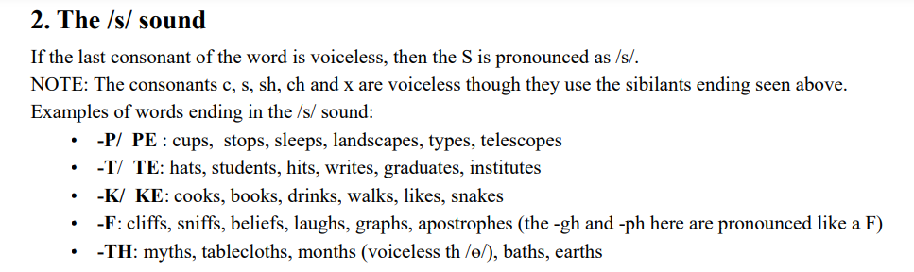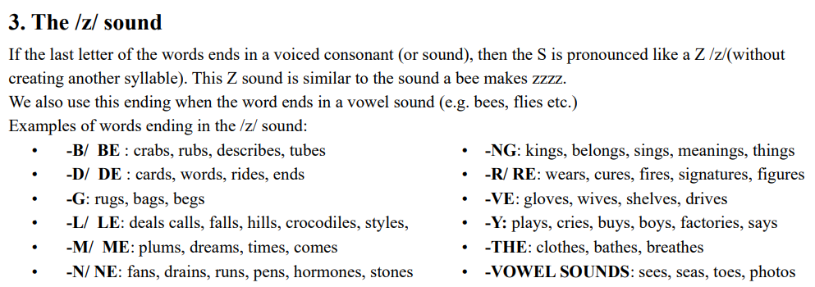

**\* Homework:**

- Practice pronouncing words with “s” endings.

- Complete the survey for those who haven’t finished it in class.

- Prepare: Unit 3 - Lesson 2 – New words and Listening (page 23 – SB).

- Review the vocabulary and grammar notes in Tiếng Anh 7 i-Learn Smart World Notebook

(pages 16 & 17).

- Play consolation games in Tiếng Anh 7 i-Learn Smart World DHA App on [www.eduhome.com.vn](http://www.eduhome.com.vn)

**D. Reflection**

a. What I liked most about this lesson today:

…………………………………………………………………………………………

1. What I learned from this lesson today:

…………………………………………………………………………………………

c. What I should improve for this lesson next time:

…………………………………………………………………………………………