**UNIT 12. ENGLISH-SPEAKING COUNTRIES**

**PART 1. THEORY**

**I. VOCABULARY**

|  |  |  |  |  |
| --- | --- | --- | --- | --- |
| **No.** | **English** | **Type** | **Pronunciation** | **Vietnamese** |
| **1** | fantastic | adj | /fæn'tæstɪk/ | *tuyệt vời* |
| **2** | ask for direction | Vphr | /æsk fɒr də'rekʃn/ | *hỏi đường* |
| **3** | take a tour | Vphr | /teɪk ə tʊr/ | *đi dạo một vòng* |
| **4** | wonderful | adj | /'wʌndəfl/ | *tuyệt vời* |
| **5** | island | n | /'aɪlənd/ | *hòn đảo* |
| **6** | sunset | n | /'sʌnset/ | *cảnh mặt trời lặn* |
| **7** | landscape | n | /'lænd.skeɪp/ | *khung cảnh* |
| **8** | Australia | n | /ɒ'streɪljə/ | *thuộc nước úc, người úc* |
| **9** | Australian | adj, n | /ɒ'streɪlɪən/ | *người úc* |
| **10** | penguin | n | /'peηgwɪn/ | *chim cánh cụt* |
| **11** | tattoo | n | /tə'tu:/ | *hình xăm* |
| **12** | kangaroo | n | /.kæηgə'ru:/ | *con chuột túi* |
| **13** | Scottish | adj, n | /'skɒtɪʃ/ | *(thuộc) xứXcốt-len; người Xcốt-Ien* |
| **14** | kilt | n | /kɪlt/ | *váy kilt (váy của đàn ông Xcốt-len)* |
| **15** | castle | n | /'kɑ:sl/ | *lâu đài* |
| **16** | coastline | n | /'kəʊst.laɪn/ | *bờ biển* |
| **17** | native | adj | /'neɪtɪv/ | *bản xứ* |
| **18** | unique | adj | /ju'ni:k/ | *độc đáo, duy nhất* |
| **19** | amazing | adj | /ə'meɪzɪη/ | *kì thú, kì lạ* |
| **20** | ancient | adj | /'eɪnʃənt/ | *CỔ xưa* |
| **21** | local | adj | /'ləʊkl/ | *thuộc về địa phương* |
| **22** | symbol | n | /'sɪmbl/ | *biểu tượng* |
| **23** | capital | n | /'kæpɪtl/ | *thủ đô* |
| **24** | tower | n | /'taʊər/ | *tòa tháp* |
| **25** | tourist | n | /'tʊrəst/ | *du khách* |
| **26** | country | n | /'kʌntrɪ/ | *đất nước* |
| **27** | royal | adj | /'rɔɪəl/ | *thuộc hoàng gia* |
| **28** | famous | adj | /'feɪməs/ | *nổi tiếng* |
| **29** | (the) Pacific Ocean | n | /pə’sɪfɪk 'əʊʃən/ | *Thái Bình Dương* |
| **30** | industry | n | /'ɪndəstrɪ/ | *nên công nghiệp* |
| **31** | culture | n | /'kʌltʃər/ | *văn hóa* |
| **32** | attraction | n | /ə'trækʃn/ | *sự hấp dẫn* |
| **33** | traditional | adj | /trə'dɪʃənl/ | *thuộc truyền thống* |
| **34** | palace | n | /'pæləs/ | *lâu đài, dính thự* |
| **35** | boat ride | n | /bəʊt raɪd/ | *sự đi thuyên* |

**II. GRAMMAR**

**❄ ARTICLES (MẠO TỪ)**

**1. Cách dùng mạo từ bất định *a, an.***

**• *A/ an*** được sử dụng trước một danh từ số ít đếm được.

***Ex:*** We need a book. *(Chúng tôi cần 1 cuốn sách.)*

✓ Mạo từ "a" đứng trước một phụ âm (trong cách phát âm).

***Ex:***

- a game (một trò chơi); a boat (một chiếc tàu thủy).

- Chú ý: a university (một trường đại học); a year (một năm).

- a European (một người Âu); a one-legged man (một người thọt chân).

✓ Mạo từ "an" đúng trước từ bắt đầu bằng một nguyên âm (a, e, i, o, u) hoặc n cam

***Ex:***

- an egg (một quả trứng); an ant (một con kiến)

- Chú ý: an honour (một niềm vinh dự); an hour (một giờ đồng hồ)

**2. Cách dùng mạo từ xác định *“the”***

**• The** được dùng khi danh từ chỉ đối tượng được cả người nói lẫn người nghe biết rõ: đối tượng đó là ai, cái gì. Cụ thể mạo từ ***“the”*** thường gặp nhất trong các trường hợp sau:

|  |  |
| --- | --- |
| **•** Khi vật thể hay nhóm vật thể là duy nhất hoặc được xem là duy nhất | The Sun (mặt trời), the world (thế giới), the Earth (Trái đất) |
| **•** Trước một danh từ nếu danh từ này vừa được đê' cập trước đó | I see a dog. **The dog** is chasing a cat. **The cat** is chasing a mouse. (Tôi thấy 1 chú chó. Chú chó đó đang đuổi theo 1 con mèo. Con mèo đó đang đuổi theo 1 con chuột.) |
| **•** Trước một danh từ nếu danh từ này được xác bằng 1 cụm từ hoặc 1 mệnh đê' | **The teacher** that I met yesterday is my sister in law. (Cô giáo tôi gặp hôm qua là chị dâu tôi.) |
| **•** Đặt **the** trước một tính từ để chỉ một nhóm người nhất định | the old (người già), the poor (người nghèo), the rich (người giàu) |
| **• The** được dùng trước những danh từ riêng chỉ biển, sông, quần đảo, dãy núi, tên gọi số nhiều của các nước, sa mạc, miền,... | The Pacific Ocean (Thái Bình Dương), The United States (Hợp chủng quốc Hoa Kỳ), the Alps (Dãy An pơ) |

**iii. PHONETICS**

**Rising and falling intonation for questions (Giọng điệu lên và xuống trong câu hỏi). ❄ Track 16**

**1. Khi câu hỏi đó là dạng câu *wh-question,* giọng điệu của câu sẽ đi xuống**

***Examples with falling intonation***

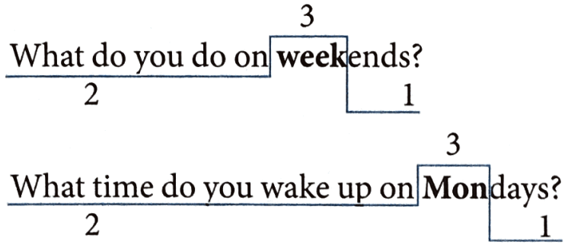

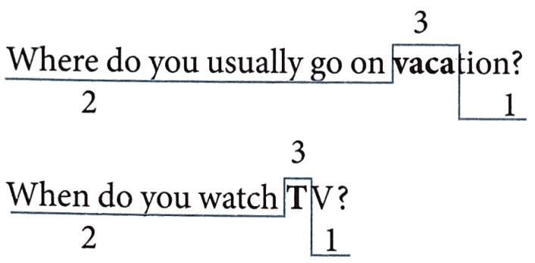

**2. Khi câu hỏi đó là dạng câu Yes/ No question, giọng điệu của câu sẽ đi lên**

***Examples with rising intonation***

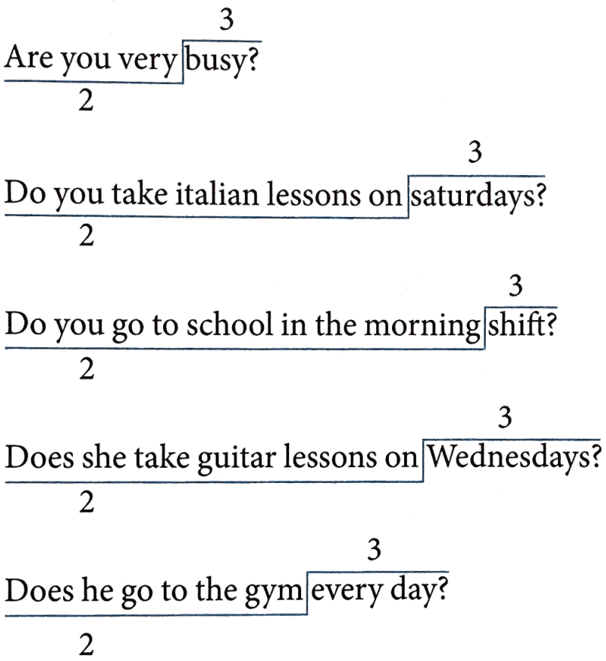

**PART 2. LANGUAGE**

**I. VOCABULARY**

**Exercise 1. Look at the photo and put the correct words/ phrases under them.**

|  |  |  |  |
| --- | --- | --- | --- |
| kilt | tourist | penguin | tower |
| sunset | tattoo | kangaroo | castle |

|  |  |  |  |
| --- | --- | --- | --- |
| King penguin – Australian Antarctic Program | Kilt and More - You'll Love Our Kilts - Kilt Makers | 39 Most Beautiful Castles in the World: Royal Palaces, Estates + More | Daruma Sunset: Where to See Kochi's Lucky Sunsets ｜Highlights｜VISIT KOCHI  JAPAN |
| **1.** | **2.** | **3.** | **4** |
| 15 essential things to know about the Eiffel Tower | Style Guides: Blackwork Tattoos • Tattoodo | Red Kangaroo - The Australian Museum | 5 Helpful Tips to Market Your Tourist Destination |
| **5.** | **6.** | **7.** | **8.** |

**Exercise 2. Choose the correct option A, B, C or D to complete the sentences.**

**1.** Singapore is famous for its ______________ and green trees.

A. cleanliness B. cleanly C. cleaning D. clean

**2.** On Christmas Eve, most big cities, especially London are ______________ with coloured lights across the streets and enormous Christmas trees.

A. decorated B. hang C. put D. Made

**3.** In the United State, there are 50 ______________ and six different time zones across the country.

A. states B. nations C. towns D. Countries

**4.** I once tried to ______________ an apple pie when I was in London. It was really delicious.

A. do B. cook C. make D. show

**5.** You should go to Canada in summer because it is the most popular time for visitors to ______________ Niagara Falls and see the beautiful sights there.

A. stay B. look C. tour D. Visit

**6.** Nowadays you still see the ______________ men wear kilts (skirts) to wedding or other formal occasions.

A. Scottish B. Scotland C. Scots D. Scot

**7.** The USA has a population of about 304 million, and it’s the third ______________ country in the world.

A. smallest B. largest C. narrowest D. highest

**8.** In some English speaking countries, turkey and pudding are ______________ food at Christmas.

A. national B. historical C. traditional D. Possible

**9.** New Zealand ______________ lovers of nature and fans of dangerous sports.

A. attracts B. keeps C. calls D. Asks

**10.** Queenstown in New Zealand has got beautiful ______________ and a dry climate, so its ideal for outdoor activities.

A. look B. viewing C. atmosphere D. scenery

**Exercise 3. Complete the sentences with the words in the box.**

|  |  |  |  |  |
| --- | --- | --- | --- | --- |
| brigade | cattle | symbol | native | igloo |
| loch | accent | monument | fence | football |

**1.** The silver fern is a national ______________ of New Zealand.

**2.** Mount Rushmore is a national ______________ carved into a mountain in South Dakota, USA.

**3.** Trung speaks English like a ______________ though he comes from Viet Nam.

**4.** I sometimes thought John’s ______________ sounded English, sometimes American.

**5.** In Scotland, the word “______________” is used to describe any large, enclosed expanse of water.

**6.** It took six years to build the rabbit-proof ______________ in Australia.

**7.** England is the original home of ______________ because the sport was invented there.

**8.** Edinburgh, Scotland was the first city in the world to have its own fire ______________ in 1824.

**9.** Anna Creek Station in South Australia is the worlds largest ______________ with an area of 24,000 km2.

**10.** An ______________ is a type of shelter built of snow by the Inuit, the Aboriginal peoples in Canada.

**Exercise 4. Give the correct form of the words given to complete the sentences.**

**1.** Both French and English are ______________ languages in Canada. **(office)**

**2.** NSW is the ______________ of New South Wales, the most populous state in Australia. (abbreviate)

**3.** The Gold Coast is famous for its most ______________ theme parks in Australia such as Dreamworld and White Water World. **(icon)**

**4.** Do you know that the telephone, the television and penicillin are Scottish ______________**? (invent)**

**5.** Visitors can spend ______________ days exploring amazing natural beauty of New Zealand. **(end)**

**6.** There are different kinds of ______________ provided throughout Disneyland. **(entertain)**

**7.** Scotland is a ______________ land and this is noted for its rich and interesting history. (legend)

**8.** We’ll take the early ______________ from Sydney to Wellington. **(fly)**

**9.** Niagara Falls, on the border of the USA and Canada, is one of the most ______________ sceneries in the world. **(spectacle)**

**10.** There are many tourist ______________ in London such as British Museum, London Eye and Tower of London. **(attract)**

**II. GRAMMAR**

**Exercise 1. Put in a correct article: *a/an.***

|  |  |
| --- | --- |
| **1.** ______ unreasonable decision | **2.** ______ universal problem |
| **3.** ______ unit of work. | **4.** ______ eucalyptus tree |
| **5.** ______ honorable man. | **6.** ______ X- ray |
| **7.** ______ UFO | **8.** ______ T-shirt |
| **9.** ______ happy girl | **10.** ______ H-bomb |
| **11.** ______ elephant | **12.** ______ hospital |
| **13.** ______ BBC programme | **14.** ______ UNESCO worker |

**Exercise 2. Put in a correct article: *a/an.* Write (🗶) if it’s not necessary.**

**1.** Have you got ______ camera?

**2.** Would you like to be ______ actor?

**3.** Bill's got ______ umbrella.

**4.** Do you collect ______ stamps?

**5.** Tom always gives Ann ______ flowers on her birthday.

**6.** Those are ______ really nice trousers. Where did you get them?

**7.** What ______ beautiful garden!

**8.** What ______ lovely children!

**9.** Jack has got very long legs, so he's ______ fast runner.

**10.** You need ______ visa to visit our country.

**11.** Jane is ______ teacher. Her parents were ______ teachers, too.

**12.** When I was ______ child, I used to be very shy.

**Exercise 3. Put in a correct article: a/ an/ the.**

**1.** Can you recommend me ______ luxury restaurant?

**2.** I saw ______ accident this morning.

**3.** My friend lives in the city. It is ______ most developed region of Vietnam.

**4.** This house is very beautiful. Do you have ______ garden?

**5.** We ate dinner at ______ luxury restaurant in the city.

**6.** There isn’t ______ airport near where we live.

**7.** There are two cars in the parking lot: ______ black one and a white one. My neighbor’s black one.

**8.** Today is a fine day. Let’s sit in ______ garden.

**9.** Are you going for business next week? - No, ______ week after next.

**10.** ______ teacher is Lan’s aunt.

**Exercise 4. Put in a correct article: a/ an/ the. Write (🗶) if it’s not necessary.**

**1.** I have ______ cat.

**2.** We have ______ breakfast at 6:00 a.m.

**3.** ______ girl wearing ______ red dress is beautiful.

**4.** He is ______ most galant boy I have ever met.

**5.** She often goes to ______ church to pray in spring.

**6.** ______ Taylor Swift is my favorite singer.

**7.** ______ government should build more nursing homes for ______ old.

**8.** Would you like to play ______ football with me?

**9.** Do you want to study in ______ United States?

**10.** Have you ever traveled to ______ Canada?

**Exercise 5. Put in a correct article: a/ an/ the. Write (🗶) if it’s not necessary.**

**1.** Which one do you prefer, ______ red car or ______ green car?

**2.** She is ______ first person to own this bag.

**3.** Do you know ______ boy sitting next to Lan?

**4.** I travel to ______ Ho Chi Minh City by ______ plane.

**5.** He lives on ______ Brown Street.

**6.** ______ patience plays ______ important role in everyone’s ______ success.

**7.** This is ______ first time she has traveled to ______ Europe.

**8.** I have ______ beautiful pen.

**9.** ______ milk is my favorite drink.

**10.** ______ Viet Nam is ______ developing country.

**Exercise 6. Choose the best article to complete the sentence.**

**1.** Mrs. Lan went to ______ school to meet her son's teacher.

A. no article B. a C. an D. the

**2.** The workmen went to ______ church to repair the roof.

A. no article B. the C. a D. an

**3.** Carol went to prison to meet her brother.

A. the B.a C. an D. no article

**4.** This morning I bought a newspaper and a magazine. ______ newspaper is in my bag but I don't know where ______ magazine is.

A. A/ a B. A/ the C. The/ the D. The/ a

**5.** My parents have ______ cat and ______ dog. The dog never bites the cat.

A. a/ a B. a/ the C. the/ the D. the/ a

**6.** We live in ______ big house in ______ middle of the village.

A. a/ a B. a/ the C. the/ the D. the/ a

**7.** I'm looking for ______ job. Did Mary get ______ job she applied for?

A. a/ the B. the/ a C. a/ a D. the/the

**8.** Did ______ police find ______ person who stole your bicycle?

A. a/ a B. the/ the C. a/ the D. the/ a

**9.** We went out for ______ meal last night. ______ restaurant we went was excellent.

A. a/ A B. the/ The C. a/ The D. the/ A

**10.** As I was walking along the street, I saw ______ $10 note on ______ pavement.

A. a/ a B. the/ the C. a/ the D. the/ a

**11.** The Soviet Union was ______ first country to send a man into ______ space.

A. the/ the B. no article *I* no article

C. no article / the D. the/ no article

**12.** Did you watch "Titanic" on ______ television or at ______ cinema?

A. the/ the B. no article/ no article

C. no article/ the D. the/ no article

**13.** After ______ lunch, we went for a walk by ______ sea.

A. the/ the B. no article/ no article

C. no article/ the D. the/ no article

**14.** Peru is ______ country in south America. ______ capital is Lima.

A. a/ A B. a/ The C. the/ The D. the/ A

**15.** I never listen to ______ radio. In fact I haven't got ______ radio.

A. a/ a B. a/the C. the/ the D. the/ a

**16.** It was a beautiful day. ______ sun shone brightly in ______ sky.

A. a/ A B. a/ The C. the/ The D. the/ A

**17.** It is said the Robinhood robbed ______ rich and gave the money to ______ poor.

A. a/ a B. a/ the C. the/ the D. the/ a

**18.** Life is not so easy for ______ unemployed.

A. the B. a C. an D. no article

**19.** Many people were killed in the accident. The bodies of ______ dead were taken away.

A. the B. a C. an D. no article

**20.** Lan has been a nurse all her life. She has spent her life caring for ______ sick.

A. the B. a C. an D. no article

**III. PHONETICS**

**Listen and mark the rising intonation (🡭) or falling intonation (🡮). ❄ Track 17**

**1.** Do you like pop music?

**2.** When do you go shopping?

**3.** What do you do in your free time?

**4.** Is Mary a basketball player?

**5.** What time does she go to school?

**6.** Do you brush your teeth three times a day?

**7.** What do you watch on Netflix?

**8.** Does she play in a famous orchestra?

**9.** Are you a talented boy?

**10.** What do they do in the morning?

**PART 3. COMMUNICATION SKILLS**

**I. LISTENING**

**☞ Listen and do the tasks followed. ❄ Track 18**

**Exercise 1. Listen and decide if each statement is True (T) or False (F).**

|  |  |
| --- | --- |
| **Statement** | **True/ False** |
| **1.** Kiwis live in Australia and New Zealand. |  |
| **2.** A kiwi has a tail but no wings. |  |
| **3.** It sleeps during the day because light hurts its eyes. |  |
| **4.** People in New Zealand do not want the kiwis to live. |  |
| **5.** The kiwi is a strange New Zealand bird. |  |

**Exercise 2. Listen again and complete the sentences.**

**1.** The kiwi (1) ______________ only in New Zealand.

**2.** A kiwi does not have any (2) ______________ like other birds.

**3.** The kiwi can (3) ______________ better than most birds do.

**4.** The kiwi’s (4) ______________ are very big.

**5.** There is a picture of a kiwi on New Zealand (5) ______________.

**II. SPEAKING**

**Match the questions to the answers.**

|  |  |
| --- | --- |
| **1.** What is the national flower of Wales? | **A.** Glasgow |
| **2.** What is the national symbol of the USA? | **B.** The beaver |
| **3.** What country has a dragon on their flag? | **C.** In 1492 |
| **4.** What is the capital of New Zealand? | **D.** Canada |
| **5.** Where do Aborigines live? | **E.** Daffodil |
| **6.** Which is the national mascot of Canada? | **E.** Wales |
| **7.** How many countries have English as an official language? | **G.** Wellington |
| **8.** When was America discovered? | **H.** In Australia |
| **9.** Which country has two official languages? | **I.** The bald eagle |
| **10.** Which is Scotland’s biggest city? | **J.** Seventy-five |

**Your answer:**

|  |  |  |  |  |
| --- | --- | --- | --- | --- |
| **1.** | **2.** | **3.** | **4.** | **5.** |
| **6.** | **7.** | **8.** | **9.** | **10.** |

**III. READING**

**Exercise 1. Read the text and answer the questions below.**

In Canada and the United States, one of the most popular days in the year is Halloween. Halloween occurs on October 31st. It's a day when some people wear in strange or unusual costumes. For example, they may dress to look like an animal, a person from a book or movie or a famous person from history. After dark, many young children put on their costumes and visit their neighbors. They knock on the door and shout "Trick or treat". Then the neighbors give them some candy, and the children go on to the next house. Adults also enjoy dressing up for Halloween. There are usually Halloween parties in the evening and usually there is a prize for the best or most unusual costume.

**1.** Is Halloween one of the most popular days in Canada and the USA?

__________________________________________________________________________________

**2.** When does Halloween happen?

__________________________________________________________________________________

**3.** What do young children do after dark?

__________________________________________________________________________________

**4.** Who also enjoy dressing up for Halloween?

__________________________________________________________________________________

**5.** What are children given when they knock on their neighbors' door?

__________________________________________________________________________________

**Exercise 2. Fill each blank with a correct word to finish the passage.**

Australia is the 6th biggest country in the world. Only Russia, China, Canada, USA and Brazil are (**1**) _____________. It is the world’s largest island.

Even though the country is so big, it only has about 23 million inhabitants. 88% of all Australians (**2**) _____________ in the big cities or smaller towns, which makes big areas of the country empty.

Australia lies in the (**3**) _____________ hemisphere which means that the more South you go, the cooler it gets. In the north parts of the country, it is always hot. The (**4**) _____________ of the country has really hot summers and mild winters. Snow only falls in the Australian Alps and in Tasmania, when we have (**5**) _____________ in Europe and Asia, the Australians have summer. So they celebrate Christmas in the (**6**) _____________ of the summer!

Australia is famous for its wildlife. The most famous (**7**) _____________ is probably the kangaroo. The kangaroo, or roo for short, has (**8**) _____________ Australia’s national Symbol. The word “kangaroo” was the first Aboriginal (**9**) _____________ in the English language. There are several spices of kangaroos. The red kangaroos (**10**) _____________ the biggest ones and they are found in the middle of the country.

**Exercise 3. Read the follow passage and answer the questions.**

New Zealand is a small country in the southern Pacific Ocean. There are two main islands, the North Island and the South Island, as well as many smaller islands. New Zealand is 268,000 square kilometres, about the same size as the United Kingdom.

Maori people arrived from the Pacific in the 10th century, and by the 12th century there were many Maori settlements along the coasts of New Zealand. The Maori name for New Zealand is Aotearoa, which means ‘The land of the long white cloud'. Seven hundred years later, large numbers of Europeans started to settle in New Zealand. According to Government figures, the population of New Zealand in 2015 was over four million, and of these, about 75 percent lived in the North Island.

There are four main cities. Auckland, in the north, is the largest city with a population of over one million people. Auckland's population includes many different nationalities. For example, there are large groups of European, Maori, Pacific Island, Chinese and Indian people. Together with other smaller groups, they make Auckland an interesting and exciting place to live.

Although Wellington is the capital, the centre of government, it is smaller and quieter than Auckland with a population of350,000. The main cities in the South Island are Christchurch, known as the Garden City, and Dunedin, which is often compared to a small Scottish city.

**1.** Where is New Zealand located?

__________________________________________________________________________________

**2.** When did Maori people first come to New Zealand?

__________________________________________________________________________________

**3.** What does “Aotearoa” mean?

__________________________________________________________________________________

**4.** Where do most New Zealanders live?

__________________________________________________________________________________

**5.** Why is Auckland an interesting city?

__________________________________________________________________________________

**IV. WRITING**

**Exercise 1. Make up sentences using the words and phrases given.**

**1.** USA/enormous/country.

__________________________________________________________________________________

**2.** This country/ both/ one of/ hot/ and cold/ places/ the world.

__________________________________________________________________________________

**3.** about/ half/ of/ Australia’s population/ go/ this event/ on Australia Day/.

__________________________________________________________________________________

**4.** Kangaroo/ the unique/ animal/ Australia.

__________________________________________________________________________________

**5.** Big Ben Tower/ one/ most famous/ symbol/ England.

__________________________________________________________________________________

**Exercise 2. Rewrite the sentences without changing the meaning of the original sentences.**

**1.** There is a big library in Lan’s school.

🡪 Lan’s school

**2.** Lan learns Math very well.

🡪 Lan is very

**3.** Which subject do you like best?

🡪 What is your

**4.** Why don’t we go swimming?

🡪 What about

**5.** The birthday cake is very delicious.

🡪 What

**6.** When is her birthday?

🡪 What

**7.** Nam works more hours than Lan.

🡪 Lan works

**8.** Nile River is longer than any rivers in the world.

🡪 Nile River is

**9.** The school library has over five thousand books.

🡪 There are

**10.** Ha Noi has many interesting places.

🡪 There are