Mã đề 6.1.17 | ĐỀ KIỂM TRA GIỮA HỌC KÌ I  NĂM HỌC 2022-2023  MÔN : Tiếng Anh LỚP 6- GLOBAL SUCCESS
A. LISTENING
Part I. There are 5 questions in this part, for each question there are 3 pictures and a short recording. (1.0pt)
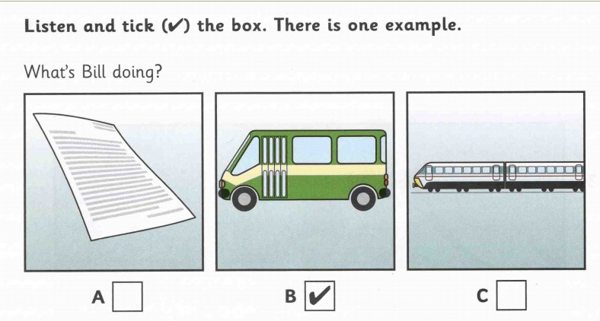 | 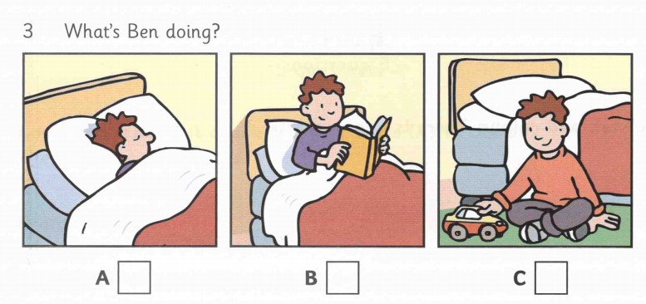
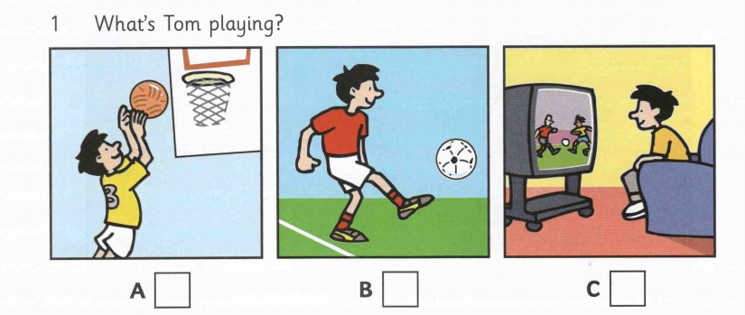 | 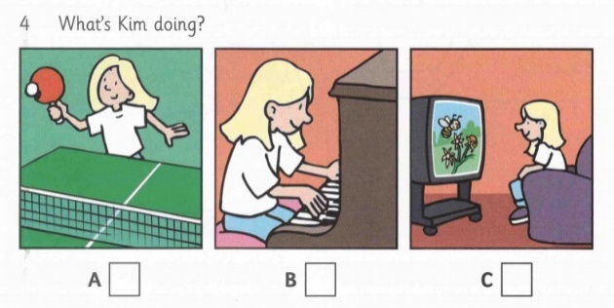
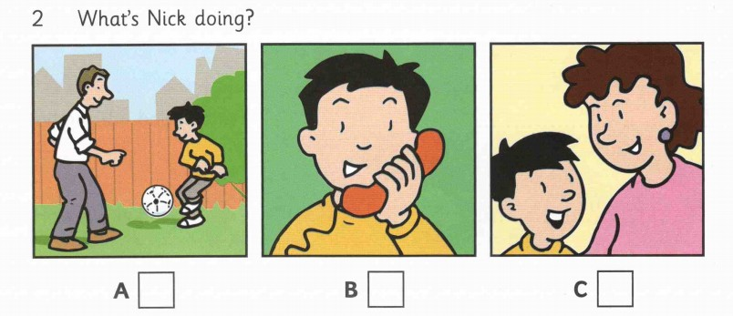 | 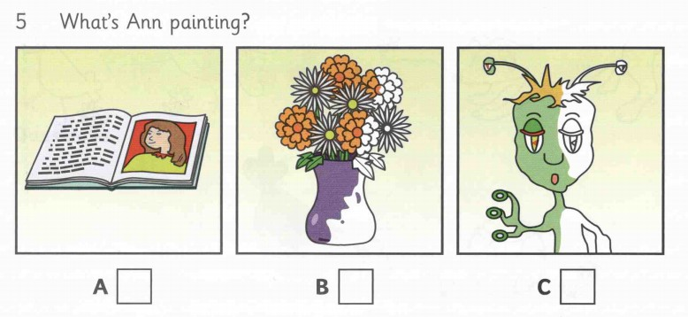
Part II. Listen to Sue talking to her friend, Jim, about the new sports centre. Then complete the sentences below. (no more three words) (1.0pt)
1. The bus to the sports centre is number__________
2. From Monday to Saturday, the sports centre is open from__________
3. If Sue goes swimming, she must take___________
4. At the sports centre, you can buy______________
5. Jim and Sue are going to go to the sports centre next__________
B- VOCABULARY & GRAMMAR
Question 1. Choose the option (A, B, C or D) that best completes each of the following sentences ( 3P ).
1. We don’t usually ______ homework on Saturday.
A. play | B. have | C.work | D. do
2. _________ does Jane have science?~ On Monday and Friday.
A. Where | B. What | C. When | D. What time
3. Long: “Should we eat more vegetables !” Minh: “………………..”
A.Good idea ! | B. It’s funny | C. No, we should | D. yes, I do
4. My room is so ________! Dirty clothes, toys, books are all over the floor!
A. messy | B. crazy | C. tidy | D. cozy
5. Don’t stand in front of the TV I’m trying to watch _____favorite programme.
A.his | B me | C. I | D. my
6.What color are her eyes? – They are .
A.thin | B.full | C.brown | D.tall
7. The kids are ______ their tricycles around the playground now.
A. playing | B. riding | C. taking | D. driving
8. . Man: “Excuse me, Can I sit here? Woman: “ …………._“
A. sorry | B. That’s very kind of you | C. good idea | D. Please
9. What color are the cups? - white.
A.They are | B.It is | C.Are they | D.We are
10.What’s the matter with you? - ____________
A. I’m fine, thanks | B. I’ve got a headache | C. Are you free? | D. All are correct.
11.In our dining room, ________ four chairs and a table. We have breakfast there every morning.
A. there are | B. there is | C. there isn’t | D. there aren’t
12. What time …………….your father go to work?
A. is play | B. do | C. does | D. are
13. Your cupboard is too old. Let's_____a new one.
A. buying | B. bought | C. to buy | D. buy
14. Are you at the moment ?
A. study | B. studying | C. studies | D. studied
15. .______________ you usually (write) ______________ to your pen pal?
A.Does -write | B. Do -write | C.Are _ write | D.Do _ writes
C. READING
Question 1. Read the following passage and decide whether each of the statements is TRUE or FALS( 1.5 P).
Minh lives with his parents in a lovely apartment in Ho Chi Minh City. His apartment is not very big but it is comfortable. There are five rooms in the apartment: a living room, two bedrooms, a kitchen and a bathroom. The living room is the biggest of all. It is beautiful furnished. The bath room is very beautiful. It has a sink, a tub and a shower. The kitchen is very modern and has everything: refrigerator, washing machine, dishwasher, gas cooker, electric stove, kitchen table... Minh's bedroom is not large, but it is very bright and its colors are nice. Minh likes his apartment a lot.
Statements | True/ False
1. There are five rooms in Minh's apartment. | …………..
2. The kitchen is modern because there is a washing machine there. | …………..
3. The sink is in the bath room. | …………..
4. His bedroom is large. | …………..
5. The living room is bigger than any other rooms in his apartment. | …………..
Question 2: Read the following passage and choose the best answer to each question (1, 5
My name is Quang. I am in class 6A1 at Nguyen Du School. It is a small school on Nguyen Du street. My classroom is on the second floor. There are 40 students in my class. My form teacher is Miss Mai. She teaches us English. All of my classmates are really kind and hard-working. We always finish all homework at home. Every day, we start classes at seven o’clock and have a 20-minute break at thirty-five past eight. My school has a small schoolyard so the students usually stay in class or sit in the canteen at break time. After that, we are back to our room and finish class at half past eleven.
Choose the best answer:
1. Which floor is Quang's classroom in?
A. The first floor B. The second floor C. The third floor
2. What subject does Quang's form teacher teach?
A. English B. Math C. Literature
3. What is NOT true?
A. Quang's in grade 6 B. Quang's classmate are all nice
C. Quang's school is big
4. What time does Quang have break time?
A. At 8.30 B. At 8.35 C. At 8.20
5. What do the students usually do at break time?
A. Sit in the canteen B. Stay in class C. A and
C. WRITING
Question 1. Complete the second sentence so that it has the same meaning as the first one. (1p) (Viết câu thứ hai sao cho ý nghĩa không thay đổi so với câu thứ nhất)
1. I don’t have a bookshelf in my bedroom.
→ There_______________________________________________________________
2. My brother often drives to work.
→ My brother often ________________________________________________
3. My mother works in the factory .
→ My mother is_______________________________________________________
4. The bookstore is to the left of the hospital.
→ The hospital ____________________________________________
5.. This exercise is very difficult and he can’t do it.
→ This exercise is too _________________________________________
Question 2: Complete these sentences to finish the description about a friend (1p)
1. Ha / friend / is / my/ best/, / she / a/ long hair / has/ and/ round brown eyes.
=>
2. she / helps/ often/ the / other/ ,/she / goes/ the / to /orphanage/ sometimes.
=>
3. She/ the children/ how/ cook/ teaches/ to.
=>
4. The children/ very happy / when she comes to see them/ are.
=>
5. I / her/ kindness/ admire/ so much .
=>
======= The end ========

Mã đề 6.1.17 | HƯỚNG DẪN CHẤM KIỂM TRA GIỮA HỌC KÌ I  NĂM HỌC 2022-2023  MÔN Tiếng Anh - LỚP 6  Hướng dẫn chấm gồm 01 trang
- Listening
- Part I. There are 5 questions in this part, for each question there are 3 pictures and a short recording.(1.0pt: 0.2ps for an item )
1. A | 2. B | 3. A | 4. A | 5. C
- Part II. Listen to Sue talking to her friend, Jim, about the new sports centre.Then answer the questions below (1.0pt: 0.2ps for an item )
1. 18 | 2. 6 a.m | 3. A towel | 4. sandwiches | 5. Thursday

- VOCABULARY - GRAMMAR – LANGUAGE FUNCTION (15 x 0.2 = 3 pts)
1. D | 2. C | 3. A | 4. A | 5. D
6. C | 7. B | 8. D | 9. A | 10. B
11. A | 12. C | 13. D | 14. B | 15. B
C. READING
Q 1.(5 x 0.3 = 1.5pt)
- T | 2.F | 3.T | 4.F | 5.T
Q 2. (5 x 0.3 = 1.5pt)
1.B | 2.A | 3.C | 4.B | 5.C
D. WRITING
Q 1: Complete the sentences using the words given (5 x 0.2 = 1.0pt)

1. There isn’t any (a) bookshelf in my bedroom.
2. My brother often goes to work by car.
3. My mother is a worker.
4. The hospital is to the right of the bookstore.
5. This exercise is too difficult for him to do.
Q 2 : Complete these sentences to finish the description about a friend(1.0pt):
1. Ha is my best friend, she has along hair and round brown eyes.
2. She often helps the other, She sometimes goes to the orphanage.
3. She teaches the children how to cook.
4. the children are very happy when she comes to see them.
5. I admire her kindness so much.
======= The end ========

