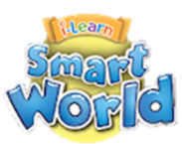
UNIT 5: FOOD AND DRINKS

A. VOCABULARY
Lesson 1
No | Words | Class | Transcription | Meaning
1 | flour | (n) | /ˈflaʊər/ | bột (mì, ngũ cốc)
2 | gram | (n) | /græm/ | gam
3 | lemon | (n) | /ˈlɛmən/ | quả chanh
4 | milliliter | (n) | /ˈmɪləˌlitər/ | mi-li-lít
5 | onion | (n) | /ˈʌnjən/ | củ hành
6 | spaghetti | (n) | /spəˈgɛti/ | mì ống
7 | tablespoon | (n) | /ˈteɪbəlˌspun/ | thìa (muỗng) canh thìa
8 | teaspoon | (n) | /ˈtiˌspun/ | (muỗng) cà phê
9 | tomato | (n) | /təˈmeɪˌtoʊ/ | cà chua

Lesson 2
No | Words | Class | Transcription | Meaning
10 | bag | (n) | /bæg/ | túi, giỏ
11 | bottle | (n) | /ˈbɑtəl/ | chai, lọ
12 | box | (n) | /bɑks/ | hộp, thùng
13 | bunch | (n) | /bʌnʧ/ | bó, buồng, chùm
14 | can | (n) | /kæn/ | lon, lọ
15 | carton | (n) | /ˈkɑrtən/ | hộp bằng bìa cứng
16 | container | (n) | /kənˈteɪnər/ | vật chứa
17 | groceries | (n) | /ˈgroʊsəriz/ | thực phẩm và đồ dùng gia đình
18 | stick | (n) | /stɪk/ | thanh, thỏi (kẹo, sô cô la)

Lesson 3
No | Words | Class | Transcription | Meaning
19 | barbecue | (n) | /ˈbɑrbɪˌkju/ | vỉ nướng, buổi nướng
20 | chef | (n) | /ʃɛf/ | đầu bếp
21 | crunchy | (a) | /ˈkrʌnʧi/ | giòn
22 | grill | (v) | /grɪl/ | nướng
23 | taste | (v) | /teɪst/ | có vị
24 | tasty | (a) | /ˈteɪsti/ | ngon
25 | worm | (n) | /wɜrm/ | con sâu
B. GRAMMAR
I. Much and many
Much: We can use much for uncountable nouns (things you can’t count, like milk and sugar…)
How much milk do you need?
How much sugar do you want?
How much water do you drink?
We need much milk for the child now.
We don’t have much cold water left in the fridge.
Many: We can use many for countable plural nouns (things you can count, like eggs and tomatoes…)
How many eggs do you need?
How many tomatoes do we want?
How many bananas do you eat?
She has many apples in her basket.
We don’t have many eggs left in the fridge.

II. Indefinite and definite articles
We use a/ an with singular nouns when we talk about something for the first time.
After that we use the.
We use an before nouns beginning with the vowel letters: a, e, i, o, u.
My mother bought a bag of rice. She put the bag of rice in the bucket.
I ate an apple. The apple was so sweet.

C. PRACTICE
Lesson 1
I. Look at the words in the box and write the suitable word for each picture. (Vocabulary)
spaghetti milliliters lemon chopsticks tablespoon grams onions teaspoon tomato
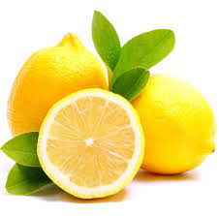 | 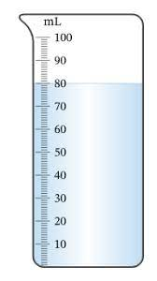 | 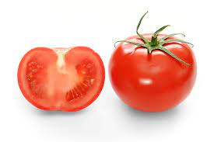
1. __________ | 2. __________ | 3. __________
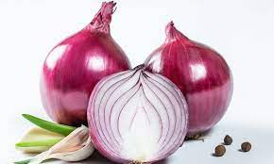 | 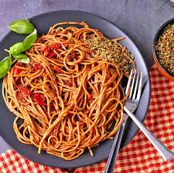 | 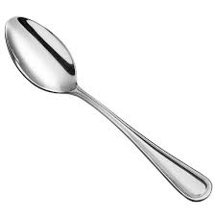
4. __________ | 5. __________ | 6. __________
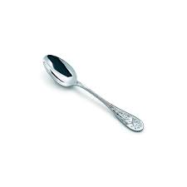 | 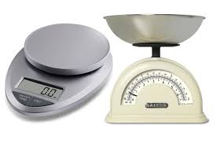 | 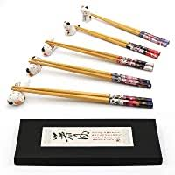
7. __________ | 8. __________ | 9. __________
II. Write the suitable word from its definition or each blank. (Vocabulary)
1. It’s a small measurement for liquid.
__________.
2. I take one__________ of sugar in my coffee.
3. It is a famous noodle dish from Italy.
__________.
- This vegetable make you cry.
__________.
5. It’s a small yellow fruit with a sour taste.
__________.
6. We need 20 __________ of salt to make the cake.
7. It’s red and juicy. We use it in salad.
__________.
8. It’s a large spoon.
__________.
9. Vietnamese usually use clean__________ to pick up food for others who sit near them in the meal.

III. Circle the correct word. (Grammar)
1. How much/ many apples do we need?
2. Do you have much/ many bananas left?
3. How much/ many tomatoes do you have?
4. How much/ many eggs this hen produced in this week?
5. How much/ many flour is there in this bag?
6. How much/ many onions do you need?
7. Don’t use too much/ many sugar every day.
8. How much/ many lemons does your mother want?
9. How much/ many butter do you need for making this cake?
10. Don’t use too much/ many spaghetti. We have some other food left.

Lesson 2
I. Look at the words in the box and write the suitable word for each picture. (Vocabulary)
bag bunch can bar bottle stick carton (x2) box
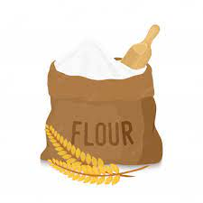 | 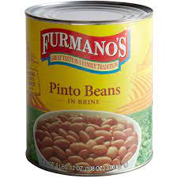 | 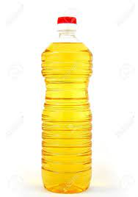
1. a______ of flour | 2. a______ of beans | 3. a______ of oil
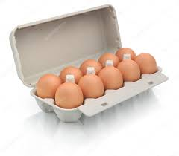 | 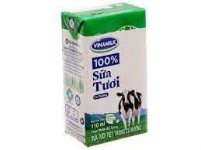 | 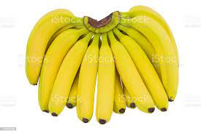
4. a______ of eggs | 5. a______ of milk | 6. a______ of bananas
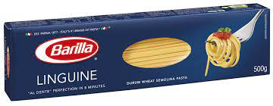 | 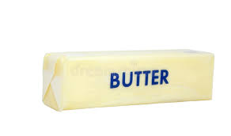 | 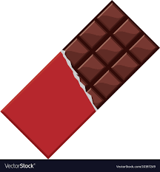
7. a______ of spaghetti | 8. a______ of butter | 9. a______ of chocolate

II. Fill in the blanks using the correct article “a/ an/ the”. (Vocabulary)
1. My mother bought me__________ interesting book about Geography.
2. There is__________ can of peas in the cupboard.
3. My little son likes eating__________ ice cream right now. __________ ice cream tastes strawberry.
4. There is__________ big bottle of milk in the fridge.
5. She bought some coffee for me.__________ coffee tasted chocolate.
6. There is__________ bag of rice under the table.
7. My father bought__________ carton of eggs. He put__________ carton in the fridge.
8. There is__________ bunch of bananas. My mom put__________ bunch of bananas on the table.
9. My daughter bought__________ can of beans. I put __________ can of beans in the cupboard.
10. I need__________ box of chocolate. __________ box of chocolate is black.

Lesson 3
TEST FOR UNIT 5

I. Choose the words whose underlined part is pronounced differently from that of the others in each group.
1. A. spaghetti B. gram C. can D. bag
2. A. box B. onion C. bottle D. shop
3. A. carton B. container C. grocery D. crunchy
4. A. chips B. chocolate C. bunch D. chef
5. A. really B. beans C. eating D. teaspoon
6. A. amount B. delicious C. found D. proud
7. A. ingredients B. pancakes C. potatoes D. grapes
8. A. tomatoes B. noodles C. groceries D. bunches
9. A. cooked B. needed C. tasted D. listed
10. A. picked B. added C. mixed D. hoped

II. Choose the word whose main stressed syllable is placed differently from that of the other in each group.
11. A. amount B. lemon C. teaspoon D. bottle
12. A. tasty B. crunchy C. famous D. correct
13. A. container B. measurement C. chocolate D. vegetables
14. A. barbecue B. groceries C. spaghetti D. coconut
15. A. environment B. supermarket C. instruction D. ingredient

III. Choose the best answer to complete each sentence.
16. __________ beef does she need?
A. How much B. How many C. How long D. How
17. I have__________ interesting book.__________ book is about “How to cook well?”
A. a/ The B. the/ A C. an/ The D. x/ The
18. __________ oranges does your mother want?
A. How much B. How many C. How long D. How
19. I think that this is__________ expensive restaurant because __________ restaurant has a lot of special food.
A. a/ the B. the/ a C. the/ an D. an/ the
20. There are__________ interesting things to enjoy in this city.
A. much B. many C. little D. a lot
21. Yesterday morning, my mother__________ shopping to get some groceries from the supermarket.
A. go B. to to C. going D. went
22. There aren’t__________ good restaurants in my neighborhood.
A. some B. any C. much D. few
23. She is very hungry now. Can you give her__________ apple?
A. an B. the C. a D. some
24. Don’t worry about the dinner. I have bought__________ sandwiches.
A. a B. much C. some D. any
25. Could you bring me__________ glass of orange juice, please?
A. a B. an C. the D. some
IV. Supply the correct forms of the given words to complete the sentences.
26. I really enjoy yellow sticky rice. It is very__________. (taste)
27. Chung cake (banh chung) is__________ Vietnamese rice cake. (tradition)
28. In Viet Nam, there are many__________ dishes to try. (interest)
29. Sally wants to try__________ food in Viet Nam, like sand worms, crickets, mice. (usual)
30. My father cooks very well. He is a good__________ in a big restaurant. (cook)

V. Choose the word which best fits each gap.
Pho might be Vietnam's (31)__________ famous dish, but bun cha is the top choice when it comes to lunchtime in Hanoi. It doesn't matter if you eat bun cha in a restaurant or a small cart on the street, you will be (32)__________ by a plate of vermicelli (bun), a bowl of broth with grilled pork and a (33)__________ of fresh herbs. The vermicelli and fresh herbs are pretty common in a Vietnamese restaurant. The broth and the pork are the ones that make this dish (34)__________ Bun cha sets often come with the delicious nem cua be fried - crab spring (35)__________ Still not convinced? It's what Obama ate during his night out with Bourdain.
31. A. most B. the most C. best D. the best
32. A. cooked B. made C. served D. tried
33. A. bottle B. pot C. bar D. basket
34. A. unique B. comfort C. specially D. simple
35. A. pieces B. rolls C. halves D. slices

VI. Read the text and choose the correct answer.
Our school has an organic garden. We learn about growing vegetables and looking after them in our food science lessons. In the holidays, we can volunteer to work in the garden. My family live in a flat so it's great for me to have a garden at school. Volunteers can take some vegetables home too, so my parents are very happy that I like working there.
My aunt and uncle live on a farm in the Red River Delta. It isn't very big but they have hens, pigs, and cows. We always go to stay with them in summer. It's a beautiful place and the food is amazing. All the vegetables are so fresh and, because the farm is organic, we know they are healthy, too.
We live in Ha Noi and my parents buy food at The Viet Fresh Farm Shop near our flat. It is very famous in our city and all the food they sell is from animals that live on the farm or vegetables that they grow. They organise a food festival once a year and we always go to eat the free food and watch cookery demonstrations. They are really interesting and you can learn a lot about cooking.
36. The students at the school
A. have to work in the school garden
B. get some free food for working in the garden
C. have food science lessons during the holidays
D. use the vegetables from the garden in cookery lessons
37. The student who wrote about the school garden
A. works there with her parents
B. also helps in her parents' garden
C. would like to work there in summer but she can't
D. doesn't have a garden at home
38. We know that the student who writes about the farm of her aunt and uncle certainly
A. goes there every year B. helps on the farm
C. likes eating meat from the farm D. eats only healthy food
39. The Viet Fresh Farm Shop
A. is the best farm shop in Ha Noi B. is famous all over Viet Nam
C. sells only vegetarian food D. only sells food from their farm
40. If you go to The Viet Fresh Farm food festival, you
A. have to pay for the food B. can watch how to cook different dishes
C. see animals from the farm D. have to take food to sell

VII. Rewrite the following sentences without changing the meaning.
41. Jenny wants to buy a box of chocolate, a bunch of bananas and a carton of eggs.
→ Jenny would____________________________________________________________
42. What kind of food do you like best?
→ What type______________________________________________________________
43. Mr. Thi can make this special food in some minutes.
→ This special food________________________________________________________
44. Pho bo (beef noodle) is my favorite food.
→ My___________________________________________________________________
45. In Viet Nam, enjoying banh chung (sticky rice cake) is very delicious.
→ It is___________________________________________________________________

VIII. Put the words in the correct order to make correct sentences.
46. My brother/ cooks/ in/ usually/ free time./ his/ some traditional food
_________________________________________________________________________
47. I/ going/ shopping/ my mother/ like/ the weekend./ on/ with
_________________________________________________________________________
48. What/ we/ need/ spaghetti?/ to make/ do
_________________________________________________________________________
49. Would/ like/ you/ go/ to/ restaurant/ to/ the/ with/ tonight?/ me
_________________________________________________________________________
50. There/ are/ strange/ food/ many/ his/ in/ village, like worms, mice and crickets.
_________________________________________________________________________

