## **Tiếng Anh 8 i-Learn Smart World - Luyện tập - Unit 7 Time allotted: 45**

**PART 1 PRONUNCIATION (4 questions)**

**Choose the word whose underlined part differs from the other three in pronunciation in the following question.**

1. A. break B. dream C. leader D. teacher

2. A. played B. lived C. talked D. solved

**Choose the word that differs from the other three in the position of the main stress in the following question.**

3. A. dentist B. attend C. florist D. mansion

4. A. engineer B. journalist C. article D. teenager

**PART 2 USE OF ENGLISH (13 questions)**

**Choose the option that best completes the following sentence.**

5. My dream is to be a ______________ because I love animals and want to help them.

|  |  |  |  |
| --- | --- | --- | --- |
| A. doctor | B. veterinarian | C. nurse | D. dentist |

6. I want to be a ______________ like my father. He works for the New York Times.

|  |  |  |  |
| --- | --- | --- | --- |
| A. florist | B. flight attendant | C. teacher | D. journalist |

7. A lot of celebrities have their own private ______________ so that they can fly faster and more comfortably.

|  |  |  |  |
| --- | --- | --- | --- |
| A. yachts | B. sports cars | C. jets | D. motorbikes |

8. My dream job is to be a ______________ and own a flower shop.

|  |  |  |  |
| --- | --- | --- | --- |
| A. florist | B. engineer | C. business person | D. dentist |

9. Nathan thinks it is interesting to be a ______________ as you can make delicious dishes.

|  |  |  |  |
| --- | --- | --- | --- |
| A. business person | B. chef | C. dentist | D. painter |

10. The rock star decided to buy a ______________ in order to explore beautiful islands and shores.

|  |  |  |  |
| --- | --- | --- | --- |
| A. bus | B. coach | C. trolley | D. yacht |

11. Flight attendants always take care ______________ passengers during the flight.

|  |  |  |  |
| --- | --- | --- | --- |
| A. to | B. for | C. of | D. with |

12. Can you see the helicopter over there? It's ______________.

|  |  |  |  |
| --- | --- | --- | --- |
| A. my | B. mine | C. me | D. me's |

13. Tommy: "Are you sure this car belongs to your mother?"   
William: "Yes, it's ______________."

|  |  |  |  |
| --- | --- | --- | --- |
| A. her | B. my | C. hers | D. mine |

14. Olivia told her friends that her mother ______________ a famous chef.

|  |  |  |  |
| --- | --- | --- | --- |
| A. was | B. were | C. has been | D. will be |

15. Their mansion has a home theater, but ______________ has a library.

|  |  |  |  |
| --- | --- | --- | --- |
| A. its | B. our | C. ours | D. her |

16. Aaron ______________ he wanted to be as rich as a millionaire.

|  |  |  |  |
| --- | --- | --- | --- |
| A. told | B. said | C. spoke | D. talked |

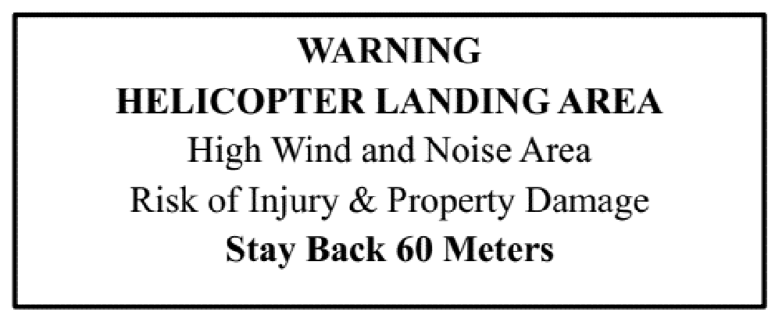

17. What does the notice want us to do?

A. You must stay 60 meters away from this area.

B. You should avoid being injured because of high wind in this area.

C. You need to travel by helicopter to this area.

D. You need to protect your property from helicopters in this area.

**PART 3 WORD FORMATION (6 questions)**

**Write the correct form of the given word.**

18. If you want to be a game ______________, you have to be creative. ***(DESIGN)***

19. Rylee can play the guitar really well. She hopes to be a famous ______________ one day. ***(MUSIC)***

20. We look forward to hearing two ______________ sharing about their films. ***(DIRECT)***

21. Many teenagers feel ______________ and tired because they have a lot of homework. ***(STRESS)***

22. One ______________ to this problem is to find other activities to do that don't involve your phone. ***(SOLVE)***

23. Lack of sleep can have several negative ______________ on teenagers' health. ***(AFFECT)***

**PART 4 ERROR RECOGNITION**

**Find the underlined part that needs correction in the following question.**

24. Mrs. Cooper said that her son spent too much time using his smartphone and didn't focus in his school work.

A. spent B. too much C. using D. focus in

**PART 5 READING (5 questions)**

**Read the website article. Choose the best word or phrase for each space. (5 questions)**

**Choose your career!**   
What do you want to do when you leave school? There are so many jobs in the world, but it is good to choose a job that you will be interested in.   
• Are you good with colors? Perhaps you could be a house (25)___________, or perhaps you could make paintings of people, like Leonardo Da Vinci or Rembrandt, but remember, very few people make money from art.   
• Do you like working with machines? Every town and city needs (26) ___________ to fix cars in garages.   
• Medicine is a good career. You will have a job for life. If you love animals, the work of a (27) ___________ may be perfect for you.   
• Working in a shop or a hotel can be fun, but perhaps the best job serving customers is … flight (28) ___________. See the world and get paid for it!   
• Would you like to be on television – not as an actor or someone reading the news, but as an (29) ___________ who talks to celebrities? The job is not easy, because you must think of good questions and then listen to the answers.

(25) A. painter B. drawer C. artist D. designer

(26) A. engineers B. explorers C. mechanics D. factory workers

(27) A. dentist B. doctor C. veterinarian D. nurse

(28) A. assistant B. attendant C. actor D. receptionist

(29) A. journalist B. announcer C. reporter D. interviewer

**PART 6 LISTENING (5 questions)**

**Listen to five short texts. Choose the correct picture for each question. (5 questions)**

30. (1) What job would the boy like to do?

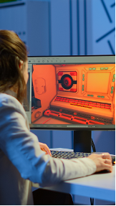  

**A. ☐** **B. ☐** **C. ☐**

31. (2) What job would the girl like to do?

 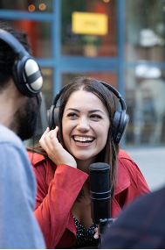 

**A. ☐** **B. ☐** **C. ☐**

32. (3) What type of musician is the boy?

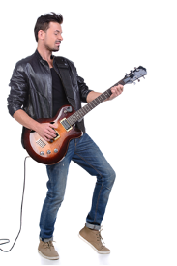 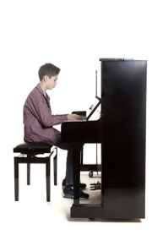 

**A. ☐** **B. ☐** **C. ☐**

33. (4) What type of doctor does the girl want to be?

  

**A. ☐** **B. ☐** **C. ☐**

34. (5) What is the boy’s dream for the future?

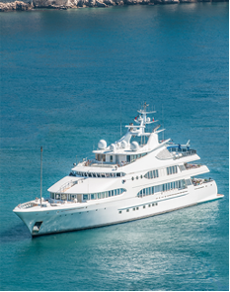 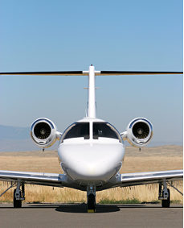 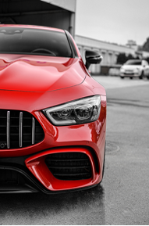

**A. ☐** **B. ☐** **C. ☐**

**PART 7 WRITING (6 questions)**

**Rewrite the following sentence using reported speech.**

35. "My sister is a singer and she earns a lot of money", said Isabella.

→ Isabella said ___________

36. "My father has a sports car, so we can go on fun road trips together", Robert said to us.

→ Robert told___________

37. "When I grow up, I want to live in a mansion with ten rooms", Nick said.

→ Nick said___________

38. "I don't have a home theater in my house", Mandy said.

→ Mandy told us___________

**Put the words in the correct order to make a correct sentence.**

39. Keywords: extra classes/with chores/and helped/./he attended/his parents/after school/Lucas said that

→ .......................................

40. Keywords: it with others/so I can/record my life/I've always/./and share/being a vlogger/dreamed of

→ .......................................

**---THE END---**