A SOLUTION TO IMPROVE TEACHING ENGLISH
I. THE MEASURE AND SCOPE.
- Name of measure: "Using Shadowing technique in Pre speaking
to help secondary school students love English speaking skills."
- Scope: Speaking lessons included in the 6th grade English textbook
(Global success)
II. CONTENT OF THE MEASURE.
1. The situation before applying the measure.
I have worked at Quang Trung Secondary since 2014. I have been being assigned by the school to teach English in grade 6 for 5 years, I have
noticed some advantages and disadvantages:
  - Advantages
- I was facilitated by school administrator to help me from which I had the
opportunity to develop a strong professional career. In addition,
I was regularly discussed innovative methods in day learning and shared the research materials which have helped me further
improve my professional qualifications as well as professional skills. by enthusiastic and experienced colleagues in the English team. Moreover, I have been helped by teachers of other subjects and school administrator.
2.2. Disadvantages
In the process of teaching 6th grade English, I often encountered difficulties:
* The students:
Many students are still afraid, inconfident when speaking English and not interested in speaking practice.
Grade 6 students are still confused with the method of learning at the
secondary level when they have just transferred.
Students do not have a language environment to regularly practice.
Students' English proficiency and background are uneven.
The large number of students in the classroom leads to difficulties
in organizing speaking activities.
At Quang Trung Secondary School, many students admitted
that they only focused on learning vocabulary and grammar in order to do exercises and paper tests well.
* Teachers:
Due to the large number of students at secondary school, teachers tend to use traditional teaching methods to save time as well as easily manage the class. Teachers spend a lot of time presenting vocabulary and grammar knowledge, they seldom organize speaking activities in pairs and groups
The current situation of the teaching speaking skills , most teachers focus on teaching language knowledge
* Textbooks:
English Book 6 has a rich system of topics that makes it difficult for teachers to access content and communicate it to students effectively
Textbooks are up to date, so this is also a difficulty for teachers in the teaching process
Through the practice of teaching, I recognize the importance of developing speaking skills in teaching communicative English as the goal of learning a foreign language. Therefore, I have explored, analyzed, and clarified what factors influence the development of English-speaking skills of 6th grades. I have applied the Shadowing technique to help improve the quality of teaching and learning English speaking skills to meet the 2018 general education program goals. This measure has been applied by me since 2020 and widely applied by my school colleagues in all grades.
2. The measure of improvement.
2.1. Detailed description of the nature of the measure:
Shadowing is a language learning technique where students repeat an audio just after they hear it. They’re acting like an “echo” or a “shadow” (hence the name “shadowing”). They listen to the words and then say them back out loud. I always remember that the students are not listening to the audio, stopping it, and then repeating it. They ’re repeating it as they’re listening.
According to researchers, shadowing is effective for
- Developing listening comprehension
- Developing the ability to produce speech
- Develop the ability to learn new words, and
- Develop metacognitive monitoring skills for language
2.2. The steps to teach:
Step1: Find/ Create an audio. English Learning for Curious Minds Podcast is a great option for audio. But I can really use any audio: Free Text To - Speech and Text- to MP3 For US English; Wave pad Sound editor
Step2: Listen to the audio first. Shadowing is most effective when the students understand the content before they repeat it. So give it a listen first, so they understand it. Check that the students understand all the key vocabulary.
Step 3: Shadow the audio with a transcript. This is the easier version of shadowing: speaking with the audio while also reading a transcript. This helps the students to see the words as they’re repeating them. The students in grade 6 ’re lower-intermediate English learner, this is a great option for them (Leonardo English even provides transcripts for all episodes to members).
Step 4: Shadow without a transcript. If the students’re a bit more advanced, they can skip straight to this step and do shadowing without the transcript. The focus here is on simply listening and then mimicking what they hear. Their focus is on mimicking the sounds; it’s not so much on what is being said.
*Here are some further tips for shadowing:
- Active learning. The best is if the students actually sit down and engage actively in the activity. The more they can focus the better.
- Short duration. This sort of activity is intense; they should do it for only a short period of time. A good length is about 3 to 5 minutes.
- Repeat a few times. There is some benefit from repeating the same passage or piece of audio a few times. But not too much. Repeating between 2 and 4 times is enough.
- Make sure the students like the audio. Find content that they’re curious about or that interests them.
- Students can practice shadowing anytime, anywhere.
2.3. Demo in the class:
Period 30: Unit 4 :Skills 1: Speaking skills - page 44 ( Textbook -English 6 - Global success)
Activity 3: Pre- speaking: Using Shadowing techniques
STAGE II: ASSESSMANT EVIDENCE.
Performance Tasks | Performance Products | Assessment Tools
5. Work in pairs. Ask and answer about what you like or dislike about your neighbourhood | Pair oral answer(dialogue) | T’s feedback
PROCEDURE:
STAGE III: TEACHING PROCEDURE/ LEARNING EXPERIENCES:
Activity 1: Listen to the audio and then say parody about the neighbourhood.
Step 1:T asks Ss to look at the transcript, and listen to the audio once first then say parody one sentence by one sentence twice
S1: Where do …………….?
S2: …… live…………………..
S1: What do you like………..?
S2: The weather……The people ………..and the food………….
S1: What do you dislike ……?
S2:……………….
Step 2 : Students practise the audio by working in pairs one by one for 2 minutes and then they practise saying parody with the audio for a minute
Step 3:T notes some common errors and discusses them with the whole class. Select some strong pairs to act out their dialogues in front of the class.
Step 4 :Then give feedback: comment on their strengths and correct a few errors in the target language.T helps if necessary to work in pairs. Then correct mistakes if have .
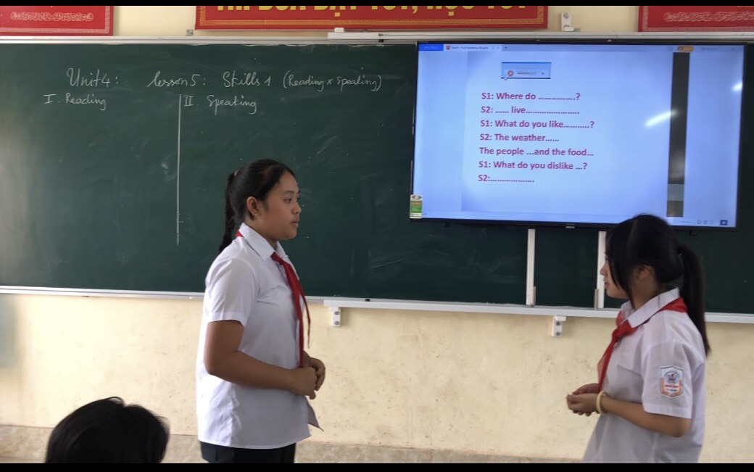

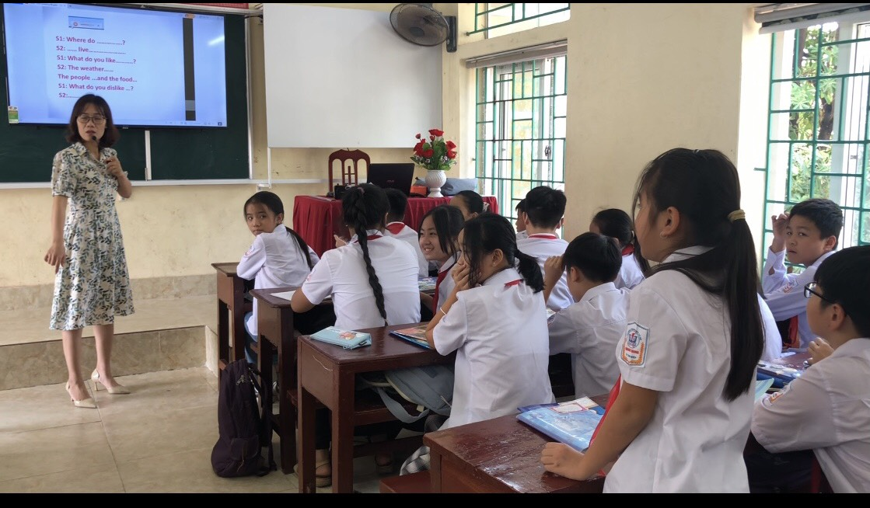
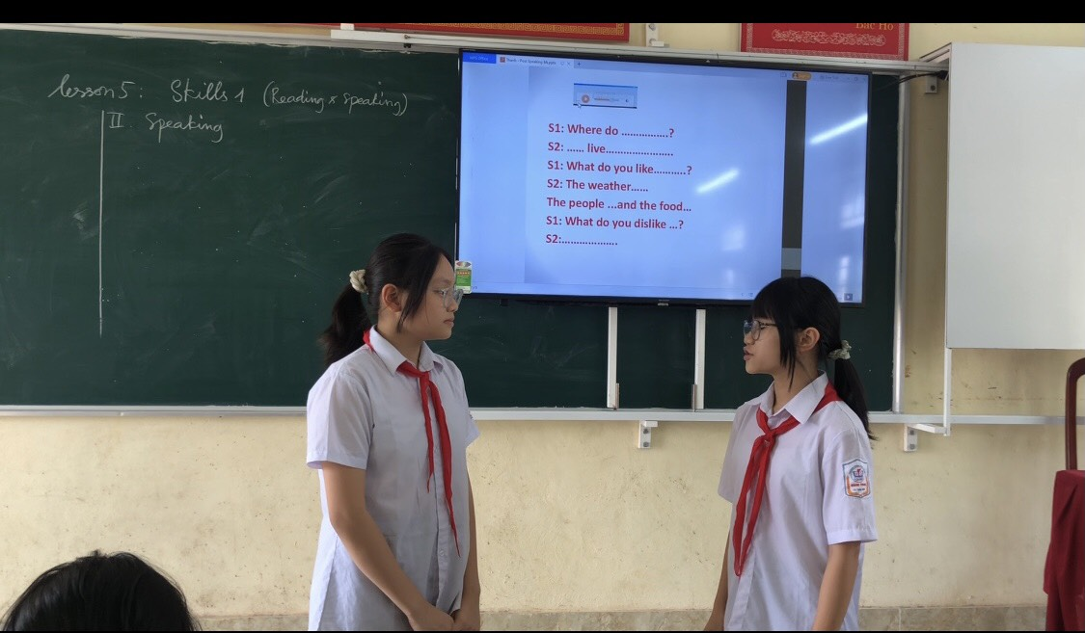
2.4. The novelty and creativity of the measure:
Problem | Solution
* Difficulties of Vietnamese students when pronouncing English  * Many students are afraid to speak English.  * Students pronounce words incorrectly.  . Students speak English without rhythm.  * Students do not know how to read the consonant sounds in sentences. | * I create audios of English 6 to teach by using some web-sides like:  - Free Text To -  Speech and Text- to MP3  For US English  - Wave pad  Sound editor  *I can create transcripts of English 6 to teach.
III. EFFECTIVENESS:
Shadowing helps the students develop all the physical aspects of fluency. These include things like pronunciation, stress and rhythm of English.

Improves English pronunciation
Pronunciation is how a word is articulated. It involves things like how open mouth is, the placement of the tongue, and so on.
Since learners use different muscles to pronounce English words than them do in other languages, part of learning to pronounce English words is to practice moving their mouths like we do when we speak English.
Shadowing is really great for helping learners’ practice developing muscle memory for their mouths so they can better pronounce English words.

Improves prosody and intonation
Prosody is like the “music” of a language. It’s how the pitches vary across a sentence or across a conversation. For example, in American English we often raise our pitch at the end of a sentence to signal a question. That’s an example of prosody.
Each language and accent have different ways that they do Prosody, which is why, for example, sometimes people say that the Irish sound like they’re singing when they’re speaking.
Prosody and intonation are often neglected in teaching English. That’s partly because it’s a bit difficult to teach, but it’s also partly because English teachers tend to put more value on learning isolated words and sentences.
Shadowing is an excellent way to practice the prosody of English because you mimic not just the words, but also the pitches. In this way they practice speaking similar to how native English-speakers speak.
Improves rhythm
Rhythm refers to the pacing and stress of a language. It is a product of stressing some words and not stressing others.
While mastering the rhythm for now native English speakers' talk is not essential for being understood, it can help learners sound much more natural or fluent when they’re speaking. Like prosody, rhythm tends to be undervalued when teaching English and learners who have a mother tongue that are phonemic or syllable-timed have particular difficulties with this in English.
Again, shadowing helps teach English because learners get to practice it together with audio from a native speaker. get a sense of which words are stressed and which are not by actually stressing them or not.
1. Before applying the above measure, I had students fill out a poll about their attitude to the "speaking skill" lesson, the results were as follows:
Class | TOTAL | Adore | Like | Dislike
6A | 44 | 10 (22,7%) | 8 ( 18,8%) | 26 (58,5%)
2. After applying the above measure, I had students fill out a poll about their attitude to the lesson “practise speaking English by Using Shadowing techniques” with the following results:
Class | Total | Adore | Like | Dislike
6A | 44 | 20 (45,5%) | 22 ( 50%) | 2 (4,5%)
They are more interested and work hard to learn more. Listening to parents feedback that their children like learning English. Some of them volunteered to join the England team. The number of students participating in the team has significantly increased.

Students in grade 8 join the excellent student team in the school year 2020-2021

Students in grade 8 join the excellent student team in the school year 2022-2023

Students in grade 7 join the excellent student team in the school year 2022-2023

Students in grade 6 join the excellent student team in the school year 2022-2023
Some students speak English well like these:
Bài của Hương Giang.mp4
A student's speaking skill in grade 8.mp4
CD CỦA HƯNG.m4a
Bài của Linh.mp4
IV. CONDITION AND SCOPE
. School facilities: computers with internet connection, multi-function projectors.
. Media: smartphone (when allowed by the teacher)
. Audience: This method can be widely applied to practice speaking as well as presentation ability of students: good, average, weak in grades at my school very effectively. And can be applied in some secondary schools
V. COMMITMENT
I pledge that this method was first used to register for the Contest and has not been used to review my personal achievements before.
Trung Son, November 11, 2022
CERTIFIED BY THE PRINCIPAL | Taken by  Do Thi Thanh

Table of contents
Content | Page | Note
- NAME OF THE MEASURE AND SCOPE | 2
II. CONTENTS OF MEASURE | 2
1. The situation before applying the measure | 2
- The measure of improvement | 3
2.1. Detailed description of the nature of the measure | 3
2.2. These steps to teach | 4
2.3. Demo in the class | 5
2.4. The novelty and creativity of the measure | 6
III. EFFECTIVENESS | 7
IV. CONDITION AND SCOPE | 10
V. COMMITMENT | 10

