UNIT 2. MY HOUSE
PART 1. THEORY
I. VOCABULARY
No. | English | Type | Pronunciation | Vietnamese
1 | apartment | n | /ə'pɑːtmənt/ | căn hộ chung cư
2 | attic | n | /'ætɪk/ | tầng gác mái
3 | aunt | n | /ɑːnt/ | cô, dì, thím, mợ
4 | basement | n | /'beismənt/ | tầng hầm
5 | bathroom | n | /'bɑːθ ru:m/ | phòng tắm
6 | bedroom | n | /'bedru:m/ | phòng ngủ
7 | brother | n | /'brʌðə(r)/ | anh/em trai
8 | children | n | /'tʃɪldrən/ | trẻ con
9 | cousin | n | /'kʌzn/ | anh, em họ
10 | dad | n | /dæd/ | bố
11 | daughter | n | /'dɔːtə (r)/ | con gái
12 | garage | n | /'gærɑːʒ/ | nhà xe
13 | grandma/ grandmother | n | /'grænmɑː/  /'grænmʌðə(r)/ | bà
14 | grandpa/  grandfather | n | /'grænpɑː/  /'grænfɑːðə(r)/ | ông
15 | grandparents | n | /'grænpeərənts/ | ông bà
16 | guest room | n | /gest ru:m/ | phòng ngủ dành cho khách
17 | hall | n | /hɔːl/ | đại sảnh
18 | kitchen | n | /’kɪtʃɪn/ | nhà bếp
19 | living room | n | /'lɪvɪη ru:m/ | phòng khách
20 | mum | n | /mʌm/ | mẹ
21 | palace | n | /'pæləs/ | cung điện
22 | parents | n | /'peərənts/ | bô mẹ
23 | sister | n | /'sɪstə(r)/ | chị, em gái
24 | son | n | /sʌn/ | con trai
25 | stilt house | n | /stɪlt haʊs/ | nhà sàn
26 | townhouse | n | /taʊn haʊs/ | nhà ở thành phố
27 | uncle | n | /'ʌηkl/ | chú, bác, cậu
28 | villa | n | /'vɪlə/ | biệt thự
29 | warehouse | ^{n} | /'weəhaʊs/ | nhà kho, kho chứa đồ

II. GRAMMAR

1. Possessive case (Sở hữu cách)

a. Định nghĩa sở hữu cách
Sở hữu cách được dùng để diễn tả sự sở hữu của một người hay một nhóm người đối với một vật hay nhiều đồ vật nào đó.

b. Công thức chung của sở hữu cách
Thông thường, ta thành lập dạng sở hữu cách bằng cách thêm 's vào sau một danh từ.
Ex. My father’s table = The table of my father: cái bàn của bố tôi
Tom's mother = The mother of Tom: mẹ của Tom
c. Một số trường hợp khác:
- Với danh từ số nhiều không tận cùng là s, ta thêm 's.
Ex. The children's toys = The toys of the children: Đo chơi của trẻ em
- Với danh từ là số nhiều có tận cùng là s, ta chỉ thêm dấu phẩy (’).
Ex. Students’ library = The library of students (Thư viện của sinh viên)
- Nếu có hai người cùng sở hữu một vật gì đó, ta chỉ thêm 's cho danh từ thứ hai.
Ex. Mai and Long’s car. (Xe hơi của Mai và Long)

2. Preposition of place (Giới từ chỉ vị trí)
- Giới từ chỉ vị trí là một trong những loại giới từ thường gặp nhất trong tiếng Anh. Nó dùng để chỉ vị trí của một người hoặc một vật so với vị trí của một người khác hoặc vật khác.
Ex. The cat is on the bed. (Con mèo ở trên giường.)
The birds are in the cage. (Những con chim ở trong cái lồng.)
- Một số giới từ chỉ vị trí thường gặp:
1. in: bên trong  Ex: My toys are in the box.  (Các đồ chơi của tôi ở trong hộp.) | 2. in front of: ở đằng trước  Ex: The bus stops in front of her house.  (Xe buýt dừng ngay trước nhà cô ấy.)
3. next to: bên cạnh, kế bên  Ex: My house is next to Linda's house.  (Nhà của tôi ở kế bên nhà Linda) | 4. on: bên trên một mặt phẳng (có tiếp xúc)  Ex: There are two apples on the table.  (Có 2 quả táo ở trên mặt bàn.)
5. near: gần (không cần chính xác khoảng cách và cũng không hẳn sát bên cạnh)  Ex: My house is near the park.  (Nhà tớ ở gần công viên.) | 6. opposite: đối diện  Ex: The bookstore is opposite our school.  (Hiệu sách nằm đối diện với trường học của chúng tôi.)
7. above: bên trên, phía trên  Ex: The helicopter was hovering above the building.  (Máy bay trực thăng đang bay trên tòa nhà.) | 8. between: ở giữa  Ex: I sat down between my mother and father.  (Tôi ngồi giữa mẹ và bố.)
9. behind: đằng sau  Ex: I hang my coat behind the door.  (Tôi treo áo khoác phía sau cánh cửa.) | 10. under: bên dưới  ExrThe dog is under the bed.  (Con chó đang ở dưới gậm giường.)

iii. PHONETICS

Cách phát âm âm đuôi s, es trong tiếng Anh.

Có 3 cách phát âm âm đuôi s và es như sau:
Cách 1. Phát âm là /s/ khi tận cùng từ là âm -p, -f, -k, -t.
Cách 2. Phát âm là /iz/ khi tận cùng từ là âm -s, -ss, -z, -o, -ge, -ce, -ch, -sh.
Cách 3. Phát âm là /z/ với các âm còn lại.

Cụ thể như sau:
Cách 1. Phát âm là /s/ khi từ có tận cùng là các âm /f/, /t/, /k/, /p/, /θ/. Và thường là các chữ cái: -f, -t, -k, -p và -th.
Từ vựng | Phiên âm | Nghĩa
laughs | /la:fs/ | cười
hats | /hæts/ | mũ
walks | /walks/ | đi bộ
maps | /mæps/ | bản đồ
months | /mʌnθs/ | tháng
Cách 2. Phát âm là /iz/ khi từ có tận cùng là các âm: /s/, /z/, /ʃ/, /tʃ/, /dʒ/, /ʒ/. Và thường là các chữ cái -sh, -ce, -s, -ss, -z, -ge, -ch, -c.
Từ vựng | Phiên âm | Nghĩa
kisses | /'kɪsɪz/ | hôn
prizes | /'praɪzɪz/ | giải thưởng
wishes | /'wɪʃɪz/ | mong ước
witches | /'wɪtʃɪz/ | phù thủy
garages | /'gærɑːʒɪz/ | nhà để xe
boxes | /'bɒksɪz/ | cái hộp
Cách 3. Phát âm là /z/ khi từ có tận cùng là một âm hữu thanh. Hay để dễ nhớ hơn thì ngoài 2 trường hợp bên trên, s đều phát âm là /z/.
Từ vựng | Phiên âm | Nghĩa
sees | /si:z/ | nhìn thấy
ends | /endz/ | kết thúc
bags | /bægz/ | cặp sách
dreams | /dri:mz/ | giấc mơ
pens | /penz/ | bút bi
gloves | /glʌvz/ | găng tay
says | /seɪz/ | nói

PART 2. LANGUAGE
I. VOCABULARY
Exercise 1. Find the word which does not belong to the group.
1. A. sofa B. chair C. toilet D. table
2. A. flat B. school C. town house D. villa
3. A. bed B. lamp C. fan D. Villa
4. A. aunt B. uncle C. grandmother D. teacher
5. A. cousin B. mother C. father D. Brother
Exercise 2. Look at the picture and write the correct word under each picture.
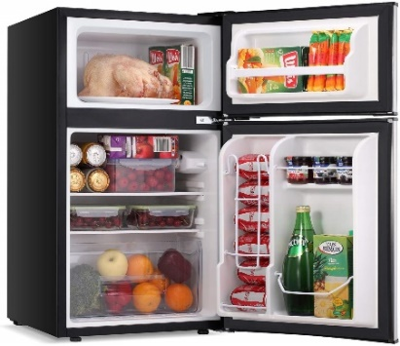 | 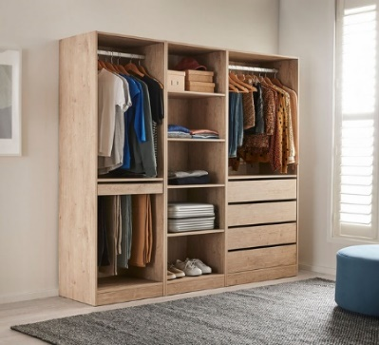 | 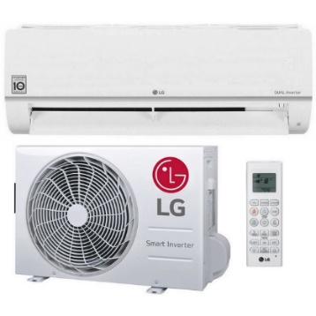
1. ____________ | 2. ____________ | 3. ____________
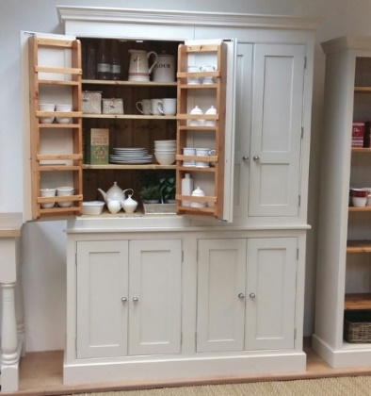 | 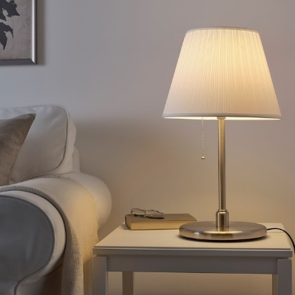 | 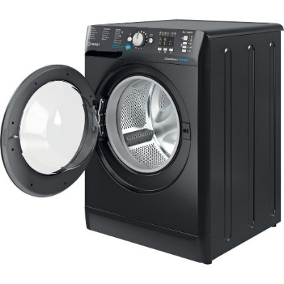
4. ____________ | 5. ____________ | 6. ____________
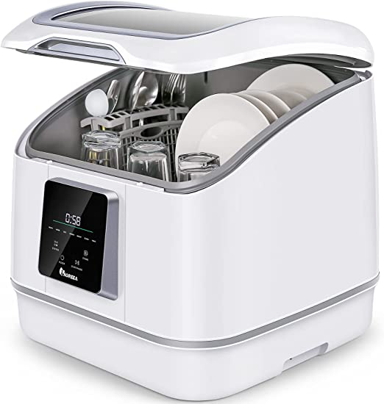 | 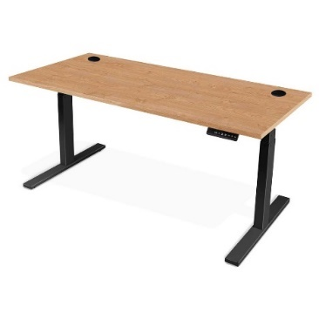 | 
7. ____________ | 8. ____________ | 9. ____________
Exercise 3. Look at the picture and write the family members.
 | 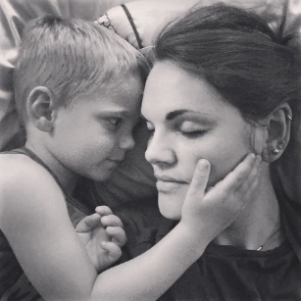 | 
1. ____________ | 2. ____________ | 3. ____________
 |  | 
4. ____________ | 5. ____________ | 6. ____________
Exercise 4. Put the words/ phrases into their correct explanation.
kitchen | utility room | guest room | toilet | garden
bathroom | garage | bedroom | staircase | living room

1. The room in a house or an apartment that is used for relaxing in and entertaining guests. | ____________
2. A room used for sleeping in. | ____________
3. A room where food is kept, prepared, and cooked and where the dishes are washed. | ____________
4. A room with a bath and/or shower and often a toilet | ____________
5. A building where a car is kept, built next to or as part of a house. | ____________
6. A piece of land next to and belonging to a house, where flowers and other plants are grown, and often containing an area of grass. | ____________
7. A bedroom in a house for visitors to sleep in. | ____________
8. A room, especially in a house, where large pieces of useful equipment such as a washing machine can be kept and where things can be stored. | ____________
9. This is the thing connecting the floor upstairs and floor downstairs. | ____________
10. Another name of this room is WC. | ____________
Exercise 5. Choose the best answer to complete each of the following sentences.
1. There ____________ a restaurant around the corner.
A. be B. are C. to be D. is
2. Your keys are ____________ the table.
A. from B. over C. on D. in
3. There ____________ two people waiting outside.
A. are B. is C. be D. isn’t
4. The men were standing ____________ the roof.
A. with B. on C. under D. in
5. There ____________ three Japanese students in my class.
A. be B. is C. are D. isn’t
6. I left keys ____________ the car.
A. my – in B. my – over C. mine – in D. mine – over
7. The cat the table.
A. are between B. is between C. are under D. is under
8. There ____________ a new café ____________ the centre of town.
A. is – in B. is – on C. are – in D. are – on
9. There ____________ two new buildings ____________ the school.
A. are - under B. is – under C. are - next to D. is - next to
10. I hung ____________ coat ____________ the door.
A. me-in B. my-in C. me-behind D. my-behind
11. Turn on the ____________, please. It’s so hot in here.
A. cupboard B. dishwasher C. air conditioner D. lamp
12. I ____________ an ____________ with three friends in Ha Noi.
A. share - apartment B. move – attic
C. share - furniture D. move - country house
13. I put my clothes in the ____________ at the corner of my bedroom.
A. chest of drawers B. hall C. kitchen D. wall
14. You must be ____________ to lend him your motorbike. He’s very careless.
A. crazy B. attic C. interesting D. care
15. - Where should we go to buy some clothes, fruits and food?
- In ____________.
A. a hall B. a living room
C. a department store D. a stilt house
16. Don't run the ____________ half empty. It wastes energy.
A. dishwasher B. kitchen C. wardrobe D. sink
17. Would you mind helping me hang this dress in the ____________?
A. sofa B. sink C. wardrobe D. vase
18. A ____________ is a piece of electrical equipment to store food and keep food cold or fresh.
A. fridge B. dishwasher C. microwave D. cooker
II. GRAMMAR
Exercise 1. Complete the sentences with the correct possessive form of the word in brackets.
1. ____________ mother is my teacher of English. (Mai)
2. Is it ____________ study room? (Nam)
3. My ____________ bedroom is my favourite room in our house. (grandmother)
4. My ____________ father is my uncle. (cousin)
5. Look! ____________ dog is running in the park. (Tom)
6. There is a cat behind my ____________ computer. (sister)
Exercise 2. Fill the gaps with the possessive case of nouns.
1. This is ____________ book. (Peter)
2. Let’s go to the ____________ (Smiths)
3. The ____________ room is upstairs. (children)
4. ____________ sister is twelve years old. (John)
5. ____________ and ____________ school is old. (Susan - Steve)
6. ____________ shoes are on the second floor. (men)
7. My ____________ car was not expensive. (parents)
8. ____________ CD player is new. (Henry)
9. This is the ____________ bike. (boy)
10. These are the ____________ pencils. (boys)
Exercise 3. Complete the sentence with the correct preposition in, on or at.
1. I’ve got a computer ____________ my bedroom.
2. Do you live ____________ a house or an apartment?
3. He is sitting ____________ a sofa ____________ the corner of the sitting room.
4. There is such a mess ____________ the kitchen!
5. The dog is sleeping ____________ the carpet.
6. We live ____________ the 3rd floor ____________ 53 Pine Street ____________ London.
7. Jane is waiting for a bus ____________ the bus stop.
8. Are there any pictures ____________ the walls ____________ the living room?
9. We are staying ____________ the Royal Hotel ____________ New York City.
10. My camera is ____________ a box ____________ a shelf ____________ the bedroom closet.
Exercise 4. Circle the correct preposition.
1. Don't sit in/ on/ under this stool. It’s broken.
2. My grandma is sitting in/ on/ at the armchair on/ next/ beside the fireplace.
3. Simon likes to stay in/ on/ at bed all Sunday morning.
4. We live on/ in/ at an apartment on/ at/ into a very busy road.
5. I put my book in/ on/ over the table in/ at/ on the dining room.
6. There is a clock under/ next to/ above the teacher’s desk.
7. He always hides the key on /at/ under the box.
8. Mary is sitting under/ between/ behind her parents. They are watching TV.
9. On a bus, passengers sit in front of/ behind/ between the driver.
10. You can see the children's books in/ on/ at the bookshelf to/ at/ in the corner.
Exercise 5. Choose the best preposition to complete the sentence.
1. I eat ____________ home with my family.
A. at B. in C. on D. beside
2. May ____________ comes April.
A. before B. after C. from D. against
3. There is a clock ____________ the wall in class.
A. near B. across C. on D. at
4. "Where is Susan?” - "She is sitting ____________ Jim."
A. on B. under C. Between D. next to
5. We’re studying ____________ Sai Gon University.
A. at B. in C. of D. from
6. There are 40 students ____________ the class.
A. inside B. in C. at D. over
7. My pen is ____________ the books and the computer.
A. among B. down C. up D. between
8. I saw a mouse ____________ the chair.
A. among B. between C. in D. behind
9. My house is ____________ to the hospital.
A. close B. near C. opposite D. across
10. We come ____________ Viet Nam.
A. in B. above C. from D. below
11. There are two students ____________ the class.
A. next B.in C. on D. Front
12. The oranges are not in the basket. They are ____________ the table.
A. in B. between C. next D. on
13. My pencil is ____________ the books and the notebooks.
A. between B. in C. on D. next
14. The red car is ____________ of the house.
A. behind B. in front C. next to D. under
15. There isn’t anything ____________ my pocket.
A. between B. next to C. in D.near
16. Some students are waiting in ____________ the classroom.
A. next to B. front of C. between D. under
17. Our house is ____________ to the supermarket.
A. in B. on C. behind D. next
18. Oh my God! I saw a mouse ____________ the sofa.
A. behind B. in C. next D. between
19. There is a big supermarket ____________ the park.
A. on B. near C. in front D. next
20. The children are playing ____________ the garden.
A. on B. between C. in D. to
III. PHONETICS
Exercise 1. Find the word which has a different sound in the part underlined. Then say the words aloud.
1. A. boys B. lessons C. cats D. pictures
2. A. places B. messages C. houses D. clothes
3. A. sinks B. bags C. laptops D. students
4. A. fridges B. kisses C. watches D. wardrobes
5. A. plates B. posters C. trees D. songs
Exercise 2. Add "s/es" after each verb then divide them into three columns.
work | push | reply |  | kick | teach |  | hope
fix | miss | sing |  | drink | crash |  | type
go | keep | give |  | roof | speak |  | meet
cry | drop | buzz |  | finish | ship |  | pass
sit | hold | catch |  | draw | brush |  | change
/s/ |  |  | /z/ |  |  | /iz/

PART 3. COMMUNICATION SKILLS
I. LISTENING
Listen and do the tasks followed.
Exercise 1. Listen and complete the sentences. Track 03
1. Many ____________ are very noisy.
2. The speaker ____________ hears her neighbors.
3. A lot of houses have a ____________ to enjoy the free time.
4. Most apartments are ____________ than houses.
5. You feel more relaxed when you live in a big ____________.
Exercise 2. Listen again and decide if each statement is True (T) or False (F). Track 04
1. Many people believe that it's better to live in a house than in an apartment.  2. The speaker shows five reasons for her choice.  3. If you live in an apartment, you may suffer from noise from the radio upstairs.  4. You still may have a yard when you live in an apartment.  5. Last weekend, the speaker played football with her little brother. | ___________  ___________  ___________  ___________  ___________
II. SPEAKING
Exercise 1. Complete the conversation with the verbs below and then practice it with your classmates.
watching | helping | going | doing | writing

Conversation 1
David: What are you doing on Saturday, Susan?
Mary: Nothing much. I’m (1) ____________ some old DVDs.
David: Aren’t you going to the cinema?
Mary: No, there's nothing new. What are you doing?
David: I'm (2) ____________ to the city centre with some friends.
Mary: Sounds good. Can I come?
David: Sure! Good idea!

Conversation 2
Peter: What are you (3) ____________ this evening?
Anna: I'm (4) ____________ my essay for English.
Peter: Really?
Anna: Why don't you do your essay too? We could help each other.
Peter: I'm sorry, I can’t. I'm (5) ____________ my dad with his new computer.
Exercise 2. Complete the conversation with available sentences.
A. It's about 80 years old
B. How many floors has it got
C. How many rooms has it got
D. Do you live in a big or a small house
E. Where is your house located
Bill: OK, Julia, we are going to talk about your house.
Julia: What would you like to know?
Bill: (1) ____________?
Julia: I live in a big detached house.
Bill: A big house. Really? (2) ____________?
Julia: About 12.
Bill: It's big indeed! Is it a new house or an old house?
Julia: (3) ____________
Bill: (4) ____________? In the country or in the city?
Julia: In a country village.

Bill: (5) ____________?
Julia: It has got two floors: the ground floor and the first floor. There's also an attic and a basement.
Bill: Do you like your house?
Julia: Yes. I do. My house is small but beautiful.
III. READING
Read and do the tasks followed.

HOUSES
There are houses all over the world. Some houses are large. Some are small. Some are made of wood. Some are made of rock. People usually build their houses with something that is easy to find. For example, there are many trees in a forest. So people who live there might build a house made of logs.
Some houses have one room. Some houses have many rooms. There is usually a bedroom for sleeping, a kitchen for cooking, a living room for sitting and talking. There is usually a bathroom. Some houses have attics. The attic is above the main part of the house. Most houses have a door so people can enter and exit the house. Most houses have windows so the people can look outside.
Houses look very different in different parts of the world. But, people who live in a house probably all agree that there is no place like home!
Exercise 1a. Choose the correct answer.
1. Why are many forest houses made of logs?
A. There are many logs in the forest.
B. Trees are easy to find in the forest.
C. There is a lot of wood in the forest.
D. All of the above
2. According to your opinion, where do you think there are rock houses?
A. Near the sea C. Near the mountain
B. Near the forest. D. Near the city
3. Why do houses have bedrooms?
A. For sleeping B. For cooking
C. For relaxing D. For building things
4. Where is the attic of a house?
A. Beside the house B. Above the house
C. Under the house D. None of the above
5. What do people do in the living room?
A. They sleep. B. They take a bath,
C. They talk. D. They do gardening.
Exercise 1b. Complete the sentence.
1. Houses have ____________ so people can enter and exit.
2. Houses have ____________ to let people look outside.
3. A ____________ is a room for cooking.
4. An attic is a room or space just ____________ the roof of a house.
5. If people ____________, they feel the same way about something.
Exercise 2. Read the text below and write one word in each blank to complete it.
I live in a semi detached house (1) ____________ a large front garden and extra large front garden with about fourteen trees. I have a front room (2) ____________ a large kitchen with a utility room which used to be (3) ____________ outhouse and coal house, a hall, separate toilet and bathroom and three bedrooms upstairs. I have lived here (4) ____________ twenty six years, and (5) ____________ we moved here, my neighbours had been here since the houses were built a few years before. They (6) ____________ in their eighties now and we have got on with them. They (7) ____________ buy my children presents at Christmas and now buy for my grandchildren. I have been so lucky to (8) ____________ such good neighbours like them.
Exercise 3. Read the article about unusual houses, and do the task followed.

A house? A boat? A houseboat!
Pete and Karen Clay are from Kentucky. They have an unusual house. It’s a houseboat named Fargo. Their houseboat has a living room, a dining room, a kitchen, and a bathroom, and three bedrooms. The Clay’s children, Andy and Kris, love it. "It’s a cool house and a fun boat,” says Kris.

Up in a tree!
Grant Stone is 12, and his sister, Jenna, 8. They're only kids, but they have a house. It's a tree house! It's in the country. It’s at their grandparents’ house in Kansas. Their tree house has one room. It's a living room with a table and a few chairs. It's small, but Grant and Jenna think it's great. Grant says, "It’s my favourite place! That's the name - My Place.”
Read the article again. Then complete the chart.
Name | Kind of house | Name of home | Number of rooms
The Clays
The Stones

IV. WRITING
Exercise 1. Make sentences from the given words or phrases.
1. There/a bed/corner/the room.
___________________________________________________________________.
2. Shelves/above/the closet.
___________________________________________________________________.
3. Wardrobe/the center/the room.
___________________________________________________________________.
4. Table/ between/ two chairs.
___________________________________________________________________.
5. Lamp/ next/ the bed.
___________________________________________________________________.
6. Table/ the right/ the wardrobe.
___________________________________________________________________.
7. There/ some pictures/ the wall.
___________________________________________________________________.
8. There/ a window/ the left-side/ the room.
___________________________________________________________________.
9. Bed/ opposite/ the door.
___________________________________________________________________.
10. There/ some bottles/ the shelf.
___________________________________________________________________.
Exercise 2. Answer the question about your house.
1. What kind of house is it?
___________________________________________________________________.
2. How many rooms are there?
___________________________________________________________________.
3. Where is your bedroom?
___________________________________________________________________.
4. What is there in your bedroom?
___________________________________________________________________.
5. What is there in the living room?
___________________________________________________________________.
6. Which room do you like?
___________________________________________________________________.
7. Why do you like that room?
___________________________________________________________________.
8. Why do you like your house?
___________________________________________________________________.
9. What do you want to add in your room?
___________________________________________________________________.
10. Why do you want to add that thing?
___________________________________________________________________.
Exercise 3. Write a paragraph (about 100 words) to describe your house. The questions and answers in Exercise 2 are cues for you.
___________________________________________________________________________
___________________________________________________________________________
___________________________________________________________________________
___________________________________________________________________________
___________________________________________________________________________
___________________________________________________________________________
___________________________________________________________________________
___________________________________________________________________________
___________________________________________________________________________
___________________________________________________________________________

