**SEMESTER 1 TEST**

**GRADE 3**

|  |  |  |  |
| --- | --- | --- | --- |
| Full name: …………………………………… | **Mark: /10** | | |
| School: ……………………………………… | **Listening** | **Reading** | **Writing** |
| Class: ………………………………………… | /3.0 | /3.0 | /3.0 |

**LISTENING**

**PART 1**

4 questions - 1.0 point

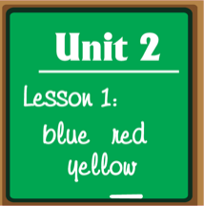**Listen and draw lines. There is one example.**



**Ex.**  ⚫ ⚫

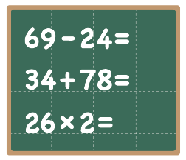



1. ⚫ ⚫





2. ⚫ ⚫





3. ⚫ ⚫



4. ⚫ ⚫

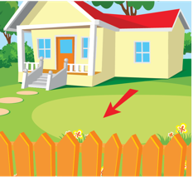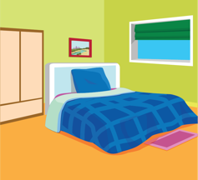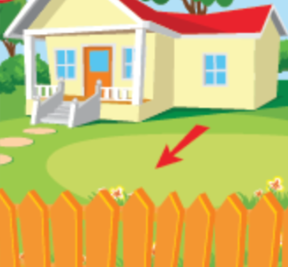**PART 2**

4 questions - 1.0 point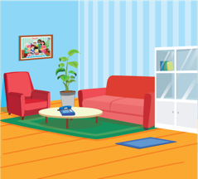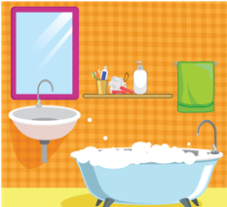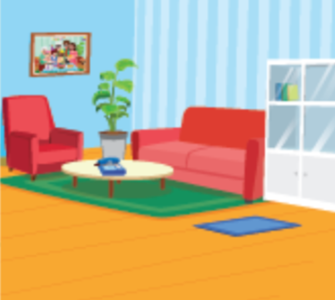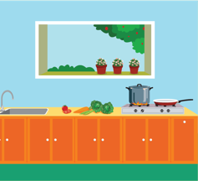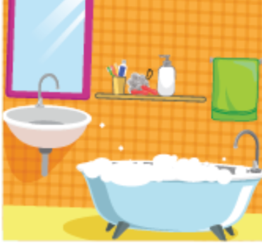

**Listen and put a tick (✓) in the box. There is one example.**

|  |  |  |  |  |
| --- | --- | --- | --- | --- |
| **Ex.** | 5. | 6. | 7. | 8. |
| a. 🗹  b. 🞎 | a. 🞎  b. 🗹 | a. 🞎  b. 🗹 | a. 🗹  b. 🞎 | a. 🗹  b. 🞎 |

**PART 3**

4 questions - 1.0 point

**Listen and write. There is one example.**

**MY FAMILY**

*Ayla*

**Ex.** Name:

9. Brothers: ***3 / three***

10. Cousins: ***7 / cousins***

11. Father’s name: ***DAVID***

12. Pet: a ***rabbit***

**READING**

**PART 1**

3 questions - 0.9 points

**Look, read and draw lines. There is one example.**

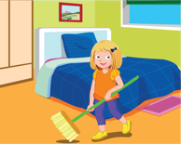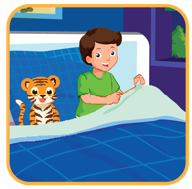

**⚫ ⚫ ⚫ ⚫**

**⚫ ⚫ ⚫ ⚫** Go to bed! Clean your room! Do your homework! Wake up!

**PART 2**

3 questions - 0.9 points

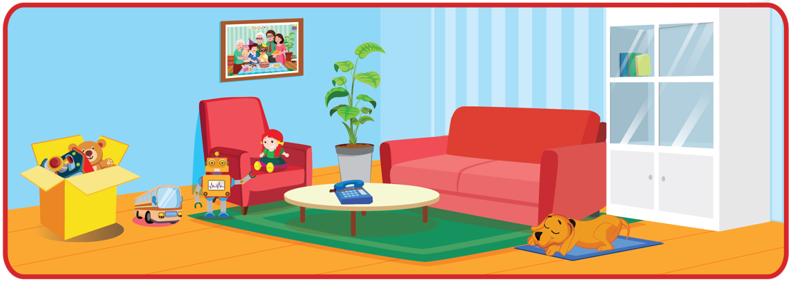**Look, read and tick (✓) Yes or No. There is one example.**

**YES NO**

**Ex.** This is the living room. 🗹 🞎

4. There is a dog in the living room. 🗹 🞎

5. There are two dolls in the living room. 🞎 🗹

6. There is a red sofa in the living room. 🗹 🞎

**PART 3**

4 questions - 1.2 points

**Look, read and circle. There is one example.**

|  |  |  |
| --- | --- | --- |
|  | *This is my / These are my…* |  |
| **Ex.** |  | a. yellow notebooks and blue pencils.  b. yellow notebooks and red erasers. |
| 7. |  | a. green rulers and pink pencil cases.  b. green rulers and red pencil cases. |
| 8. |  | a. red sofa and yellow box.  b. yellow sofa and red box. |
| 9. |  | a. brown chairs and blue notebooks.  b. blue chairs and brown notebooks. |
| 10. |  | a. white tables and black pencils.  b. blue pencils and white tables. |

**WRITING**

**PART 1**

3 questions - 1.5 points

*a u n t*

**Order the letters. There is one example.**

|  |  |  |  |
| --- | --- | --- | --- |
| **Ex.** |  | u a t n | ___ ___ ___ ___ |
| 1. |  | a a e f g r r d n h t | ***grandfather*** |
| 2. |  | i e s t s r | ***sister*** |
| 3. |  | e u c n l | ***uncle*** |

**PART 2**

3 questions - 1.5 points

**Look and write. There is one example.**

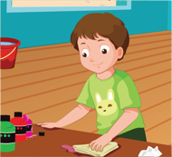***My family’s weekend***

*c l e a n i n g*

On Saturday, I help my mother (**Ex.**) __ __ __ __ __ __ __ __   
the house.

It’s 11 o’clock. My mom is in the kitchen. She is (4.) ***cooking*** lunch for my family.

My older brother, Sam, he is (5.) ***sleeping*** 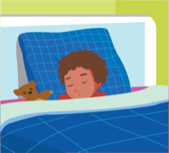 in his bedroom.



My younger sister, Anna, she is (6.) ***eating***  some cake.

**PART 3**

2 questions - 1.0 point

**Reorder the words to make a correct sentence**. **There is one example.**

Stand

up

, please.

**Ex.**

*Stand up, please.*

🡪

these

Are

your

pencil cases?

7.

🡪 ***Are these your pencil cases?***

dancing?

Do

like

friends

your

8.

🡪 ***Do your friends like dancing?***

**THE END.**