School: ……………………………………….. | Date: …………………………………..
Class: ……………………………..................... | Period: ………………………….........

UNIT 7: TRANSPORTATION
Lesson 2.1 – New words and Reading (page 55)

I. OBJECTIVES
By the end of the lesson, Ss will be able to:
1.1. Language knowledge and skills
- know some new words relating to means of transportation (frequent, eco-friendly, comfortable, convenient, public, ticket, reliable).
- describe different types of transportation.
- read a paragraph about Vietnam Travel Guide to understand general and specific information.
1.2. Competences
- improve communication, collaboration, analytical and critical thinking skills.
1.3. Attributes
- be careful and safe road users.
- love hometown and country.
- use public transport to protect the environment.

II. TEACHING AIDS AND LEARNING MATERIALS
1. Teacher’s aids: Student book and Teacher’s book, class CDs, Digital Book (DCR phần mềm tương tác SB, DHA (từ vựng/ cấu trúc) phần mềm trò chơi tương tác), projector/interactive whiteboard / TV (if any), PowerPoint slides, pictures.
2. Students’ aids: Student’s book, workbook, notebook.

III. ASSESSMENT EVIDENCE
Performance Tasks | Performance Products | Assessment Tools
- Fill in the blanks. | - Ss’ answers. | - T’s feedback/Peers’ feedback.
- Listen and repeat. | - Ss’ answers/ presentation. | - T’s observation / feedback.
- Use adjectives to describe different types of transportation. | - Ss’ answers. | - T’s feedback/Peers’ feedback.
- Read the travel guide and choose the best title. | - Ss’ answers. | - T’s feedback/Peers’ feedback.
- Read and fill in the blanks. | - Ss’ answers. | - T’s feedback/Peers’ feedback.
- Speak: What types of transportation are there in your neighborhood? | - Ss’ answers/ presentation. | - T’s feedback/Peers’ feedback.

IV. PROCEDURES
A. Warm up: (5’)
a) Objective: Introduce the new lesson and set the scene for Ss to acquire new language; get students' attention at the beginning of the class by enjoyable and short activities as well as to engage them in the follow-up steps.
b) Content: Review: Means of transport.
c) Expected outcomes: Ss have general ideas about the topic of the new lesson: Means of transport.
d) Organization of the activity:
TEACHER’S ACTIVITIES | STUDENTS’ ACTIVITIES
- Option 1: Cool pair matching  - Show pictures and words, have Ss look + read and find 6 pairs of means of transportation.  - Call Ss to give answers.  - Give feedback and show correct answers.  - Have Ss pronounce the words.  - Correct Ss’ pronunciation if necessary.  - Lead to the new lesson.  *Illustration:  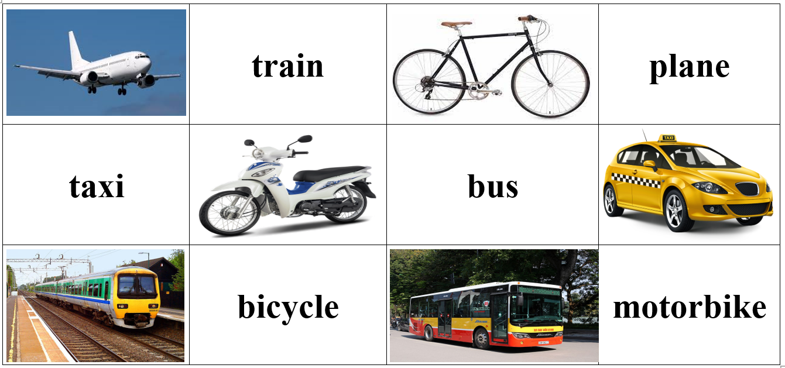  - Option 2: Matching  - Have Ss look at the map of Vietnam and match 5 busiest airports in Vietnam with the places in number (work in pairs).  - Call Ss to give answers.  - Give feedback.  - Introduce the new lesson: Plane is one of many popular means of transport in Vietnam.  *Illustration: Match 5 busiest airports in Vietnam with the places in number: Liên Khương Airport, Nội Bài Airport, Đà Nẵng Airport, Tân Sơn Nhất Airport, Vinh Airport  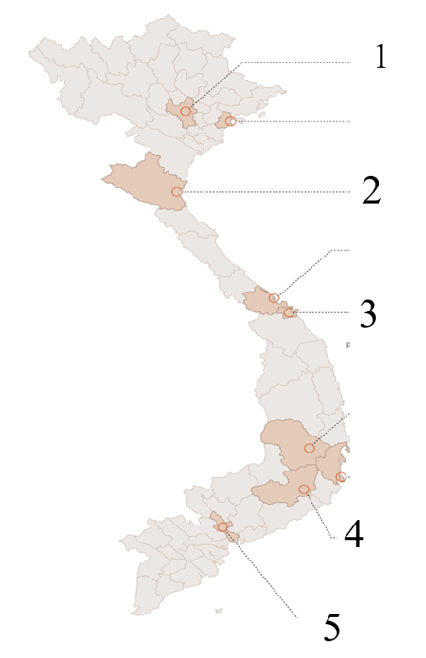 | - Look and find 6 pairs (a word+ a picture).  - Give answers.  - Read words.  - Listen.  Answer keys  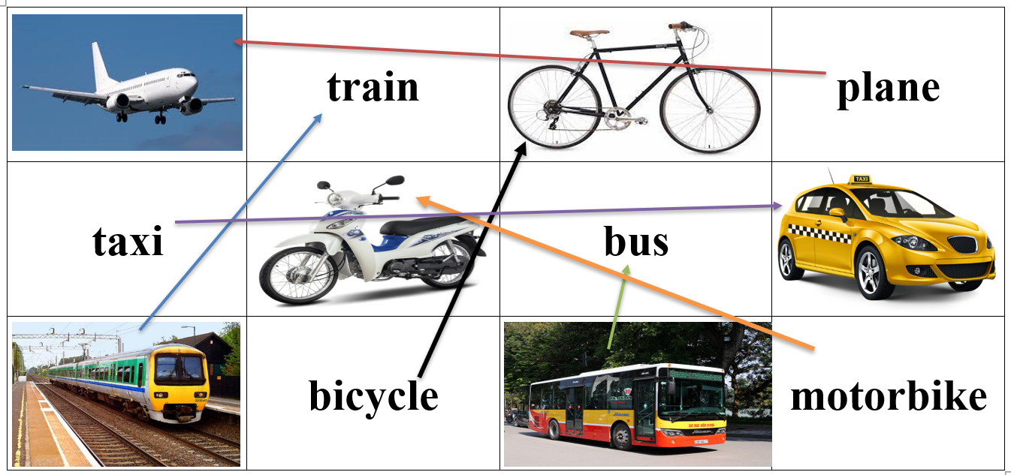  - Look and match (in pairs).  - Give answers.  Answer keys  1. Nội Bài Airport  2. Vinh Airport  3. Đà Nẵng Airport  4. Liên Khương Airport  5. Tân Sơn Nhất Airport

B. New lesson (35’)
- Activity 1: Pre-Reading (Vocabulary) (12’)
a) Objective: Ss know some words relating to means of transportation and their characteristics.
b) Content:
- Vocabulary study: frequent, eco-friendly, comfortable, convenient, public, ticket, reliable.
- Fill in the blanks. Listen and repeat.
- Speaking: Use adjectives to describe different types of transportation.
c) Expected outcomes: Ss know how to pronounce the new words correctly and use them in appropriate situations.
d) Organization of the activity:
TEACHER’S ACTIVITIES | STUDENTS’ ACTIVITIES
Task a. Fill in the blanks. Listen and repeat.  - Option 1  - Demonstrate the activity on DCR, using the example  - Have students fill in the blanks.  - Divide the class into pairs and have them check their answers with their partners.  - Call Ss to give answers (read or write).  - Check answers as a whole class using DCR.  - Play audio (CD1 – Track 75). Have Ss listen and repeat.  - Correct Ss’ pronunciation.  - Option 2: (for Ss with high level)  - Introduce new words by giving a matching exercise.  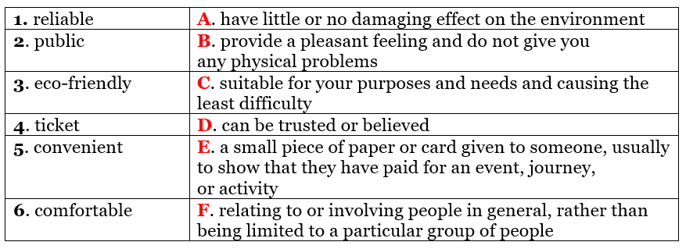  - Have Ss do the matching and give the meaning of the words in the first column.  - Call Ss to give answers (read or write).  - Check answers as a whole class.  - Call some Ss to read the words again.  - Play audio (CD1 – Track 75). Have Ss listen and repeat.  - Correct Ss’ pronunciation.  Task b. Use adjectives to describe different types of transportation.  - Have pairs use adjectives to describe different types of transportation.  - Have Ss share their answers in front of the class.  - Give feedback and evaluation. | - Look and listen.  - Work individually.  - Work in pairs.  - Give answers.  - Listen and repeat.  Answer keys  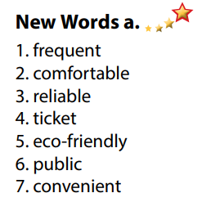  - Work in pairs.  - Give answers.  - Read.  - Listen.  Matching: Answer keys  1D 2F 3A 4E 5C 6B  - Work in pairs.  - Present.  Sample answers  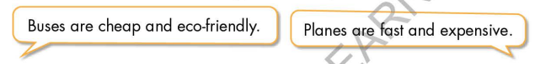
- Activity 2: While - Reading (18’)
a) Objective: Students can develop their reading skill.
b) Content:
- Read the travel guide and choose the best title.
- Read and fill in the blanks.
c) Expected outcomes: Students can read a paragraph and understand more about means of transport in Vietnam.
d) Organization of the activity:
TEACHER’S ACTIVITIES | STUDENTS’ ACTIVITIES
Task a. Read the travel guide and choose the best title.  - Ask Ss to scan the paragraph, then choose the best title.  - Remind Ss to underline or highlight the keywords or supporting ideas for their answers.  - Have some Ss share their answers with the class (read), explain for their answers.  - Give feedback.  - Give feedback and correct Ss’ answers if necessary.  Task b. Now, read the paragraph and fill in the blanks.  - Have Ss look at sentences and underline the key words.  - Have Ss work in pairs to fill in the blanks. Remind Ss to use short answers for each blank (1-2 words).  - Elicit answers from different pairs.  - Give feedback and evaluation. | - Work individually.  - Read answers, explain.  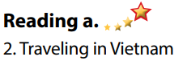  - Check answers.  Answer keys  - Work in pairs to circle the best answer.  - Read answers.  Answer keys  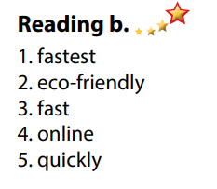

- Activity 3: Post - Reading (5’)
a) Objective: Students can use the vocabulary and ideas from the reading text to develop their speaking skill.
b) Content: Speaking: What types of transportation are there in your neighborhood?
c) Expected outcomes: Students can talk about their types of transportation in your neighborhood.
d) Organization of the activity:
TEACHER’S ACTIVITIES | STUDENTS’ ACTIVITIES
Task c. In pairs: What types of transportation are there in your neighborhood?  - Have Ss work in pairs to answer the questions.  - Go round and give help if necessary.  - Call some Ss to share their ideas with the whole class.  - Give feedback and evaluation. | - Discuss in pairs.  - Present.  - Listen.

C. Consolidation and homework assignments (5’)
* Consolidation:
- Words relating to means of transportation and their characteristics (frequent, eco-friendly, comfortable, convenient, public, ticket, reliable).
- Some adjectives to describe different types of transportation: expensive, cheap, eco-friendly, fast, slow, dangerous, safe, modern.
* Homework:
- Learn the new words by heart.
- Practice talking about your favorite means of transport.
- Do the exercises in WB: Unit 7 - Lesson 2 - New words + Reading (Page 40).
- Do the vocabulary exercise in Tiếng Anh 7 i-Learn Smart World Notebook (page 44).
- Play consolation games in Tiếng Anh 7 i-Learn Smart World DHA App on www.eduhome.com.vn
- Prepare: Unit 7 - Lesson 2.2 – Grammar (page 56 – SB).

D. Reflection
a. What I liked most about this lesson today:
…………………………………………………………………………………………
- What I learned from this lesson today:
…………………………………………………………………………………………
c. What I should improve for this lesson next time:
…………………………………………………………………………………………

