School: ……………………………………….. | Date:…………………………………..
Class: ……………………………..................... | Period: ………………………….........

UNIT 3: MUSIC AND ARTS
Lesson 3.1 - Listening and Reading (Page 26)

I. OBJECTIVES
By the end of the lesson, Ss will be able to:
1.1. Language knowledge and skills
- talk about a movie you like.
- talk about different types of movie.
- practice listening and understanding general and specific information about things relating to a film.
- read a film description.
1.2. Competences
- improve communication, collaboration, analytical and critical thinking skills.
1.3. Attributes
- love movies and appreciate the film industry.
- choose suitable movies to watch and relax.

II. TEACHING AIDS AND LEARNING MATERIALS
1. Teacher’s aids: Student book and Teacher’s book, class CDs, Digital Book (DCR phần mềm tương tác SB, DHA (từ vựng/ cấu trúc) phần mềm trò chơi tương tác), projector/interactive whiteboard / TV (if any), PowerPoint slides.
2. Students’ aids: Student’s book, workbook, notebook.

III. ASSESSMENT EVIDENCE
Performance Tasks | Performance Products | Assessment Tools
- Speaking: Name three movies you like and say why you like them. What are the different types of movie you can watch? | - Ss’ answers. | - T’s feedback.
- Fill in the blanks using the words in the box. Listen to an English teacher and check your answers. | - Ss’ answers. | - T’s feedback/Peers’ feedback.
- Listen again and circle the correct answer. | - Ss’ answers. | - T’s feedback/Peers’ feedback.
- Read the description and choose the best title. | - Ss’ answers. | - T’s feedback/Peers’ feedback.
- Read and fill in the blanks. | - Ss’ answers. | - T’s feedback/Peers’ feedback.
-Speaking: Would you like to watch this movie? Why (not)? | - Ss’ answers / presentation. | - T’s observation/ DCR and T’s feedback.

IV. PROCEDURES
A. Warm up: (5’)
a) Objective: Introduce the new lesson and set the scene for Ss to acquire new language; get students' attention at the beginning of the class by giving enjoyable and short activities as well as to engage them in the follow-up steps.
b) Content: Movies.
c) Expected outcomes: Ss have general ideas about the topic “movies”, which they are going to listen and read in the new lesson.
d) Organization of the activity:
TEACHER’S ACTIVITIES | STUDENTS’ ACTIVITIES
- Option 1: Let’s Talk!  - Use the “Let’s talk!” part in the textbook– page 26 for warm-up activity.  - Ask Ss to work in pairs to name three movies they like and say why they like them.  - Call Ss to share their answers with the whole class  - Give feedback and evaluation.  - Ask Ss: What are different types of movies can you watch?  - Call Ss to give answers, comment.  - Lead to the new lesson.  - Option 2: Matching  - Have Ss match each picture / poster with its name of the film.  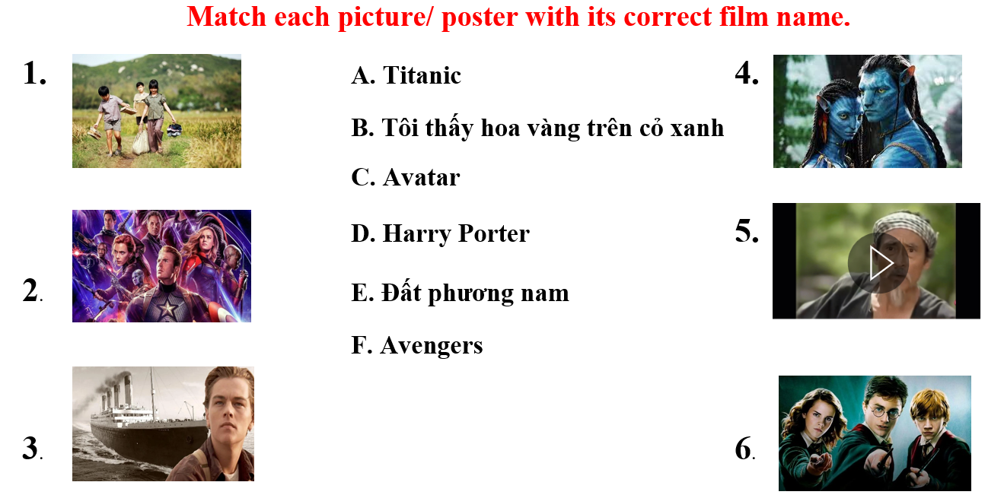  - Call Ss to give answers.  - Check and give correct answers.  - Extra question: What do you know about these films? (Ss can choose a film they know to talk about it.)  - Give feedback and evaluation.  - Lead to the new lesson. | - Work in pairs to discuss.  - Present.  - Discuss.  - Answer.  - Look and match.  - Give answers.  - Give answers.  - Listen.  Answer keys  1.B 2.F 3.A 4.C 5.E 6.D

B. New lesson (35’)
- Activity 1: Listening (17’)
a) Objective: Students can develop their listening skill.
b) Content: Listen to an English teacher talking about film description.
c) Expected outcomes: Students can practice listening and understanding general + specific information about film description.
d) Organization of the activity:

TEACHER’S ACTIVITIES | STUDENTS’ ACTIVITIES
Task a. Fill in the blanks using the words in the box. Listen to an English teacher and check your answers  - Briefly explain the meaning of the words in the box.  - Have Ss read the uncompleted sentences and guess the answers.  - Play audio (CD1 - Track 34) using DCR.  - Have Ss listen and fill in the blanks with the words in the box.  - Call Ss to give answer, explain.  - Play the audio again and check the answer as a whole class using DCR.  Task b. Now, listen and circle the correct answers  - Have Ss read through the content of Task b first.  - Play the audio again (CD1 - Track 34) using DCR.  - Have Ss listen and circle the correct answers.  - Have Ss check answers with their partners.  - Call Ss to give answers, explain.  - Check answers as a whole class using DCR. | - Listen and take notes.  - Read.  - Listen and fill in the blanks with the words in the box.  Answer keys  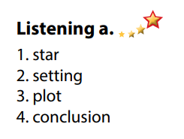  - Read.  - Listen and circle the correct answers.  - Exchange answers.  - Give answers.  Answer keys  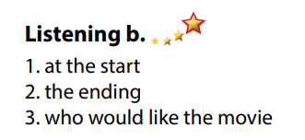

- Activity 3: Reading (18’)
a) Objective: Students can develop their reading skill.
b) Content:
- Read the description and choose the best title.
- Read and fill in the blanks.
c) Expected outcomes: Students can read a film description for gist and details, and they can talk about their favorite film.
d) Organization of the activity:
TEACHER’S ACTIVITIES | STUDENTS’ ACTIVITIES
Task a. Read the description and choose the best title.  - Have Ss read Task a and guess the answer.  - Ask Ss to read the description quickly and circle the correct answer.  - Call 1 S to give answer.  - Check answers as a whole class using DCR.  Task b. Now, read and fill in the blanks  - Have Ss read the content in Task b and underline the key words.  - Have Ss read the text again and fill in the blanks.  - Have Ss check their answers with a partner.  - Call Ss to give answers.  - Check answers as a whole class using DCR.  Task c. Speaking: In pairs: Would you like to watch this movie? Why / Why not?  - Have Ss discuss the questions in pairs.  - Call some Ss to share their answers with the whole class.  - Give feedback and evaluation.  - For class with high level students: Give Ss an extra task: Describe your favorite film.  - Call Ss some Ss to share their answers with the whole class.  - Give feedback and evaluation. | - Read and guess.  - Scan the text for general idea.  - Give answer.  Answer keys  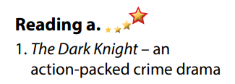  - Read and underline the key words.  - Read the text again for details.  - Exchange answers.  - Give answers.  Answer keys  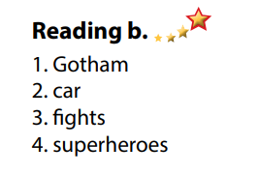  - Discuss in pairs.  - Present.  - Discuss in pairs.  - Present.

C. Consolidation and homework assignments (5’)
*Consolidation:
- Vocabulary: Film description: plot, conclusion, star, setting, characters, acting, dramatic.

*Homework
- Practice describing your favorite film.
- Do the exercises in WB: Lesson 3 – Listening and Reading (page 18).
- Do the vocabulary exercise in Tiếng Anh 7 i-Learn Smart World Notebook (page 20).
- Play consolation games in Tiếng Anh 7 i-Learn Smart World DHA App on www.eduhome.com.vn
- Prepare: Lesson 3 – Writing and Speaking (page 27 – SB).

D. Reflection
a. What I liked most about this lesson today:
…………………………………………………………………………………………
- What I learned from this lesson today:
…………………………………………………………………………………………
c. What I should improve for this lesson next time:
…………………………………………………………………………………………

