UNIT 4: MY NEIGHBOURHOOD
A - TRỌNG TÂM KIẾN THỨC
I. Từ vựng
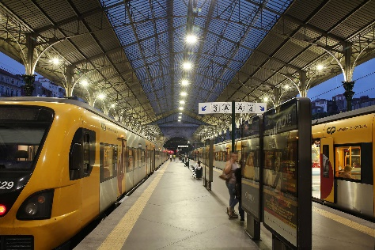 | 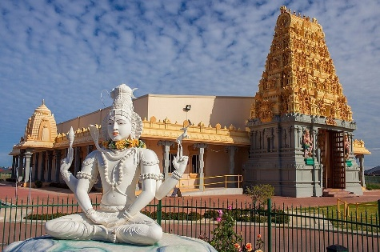 | 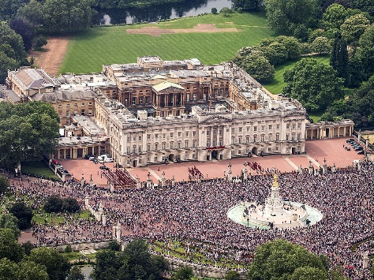
railway station  ga tàu | temple  đền, chùa | palace  cung điện
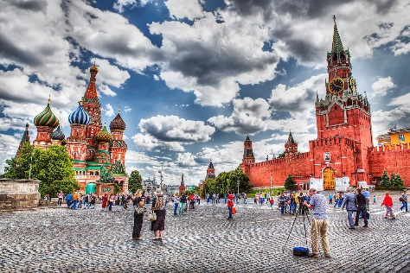 |  | 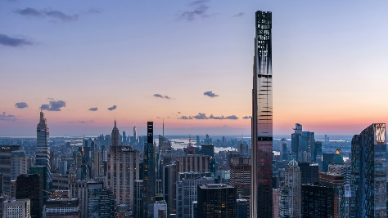
square  quảng trường | art gallery  triển làm nghệ thuật | skyscraper  tòa nhà chọc trời
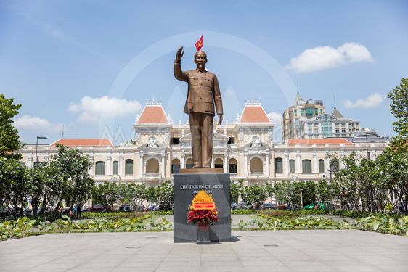 | 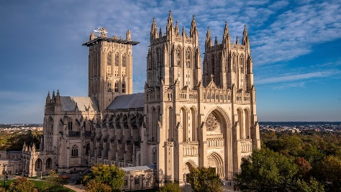 | 
memorial  đài tưởng niệm | cathedral  nhà thờ | statue  tượng

Words to describe a neighbourhood
(in)convenient | historic | polluted | peaceful | terrible | modern

II. Ngữ âm
1. Phát âm: /i:/ & /ɪ/
Âm | Độ dài hơi | Môi | Lưỡi | Minh họa
/i:/ | Dài | Môi mở rộng sang hai bên như đang mỉm cười | Lưỡi nâng cao lên. | 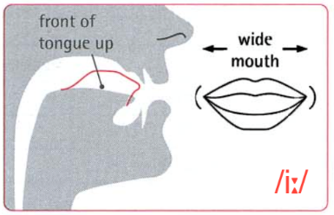
/ɪ/ | Ngắn | Môi hơi mở rộng sang hai bên | Lưỡi hạ thấp | 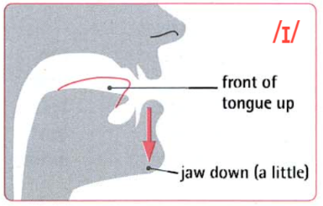
• Âm /i:/ có thể được nhận diện trong các từ có chứa các nhóm chữ cái sau:
- ee | see | agree | cheese
- ea | eat | seat | team
- ie | field | piece
- e | these | secret | equal
- i | ski | pizza | police
• Âm /ɪ/ có thể được nhận diện bằng chữ cái “i”:
if | listen | miss | dinner
swim | in | six | picture
2. Trọng âm của từ với đuôi -ic, -ical
Trọng âm của từ thường rơi vào âm tiết đứng trước hậu tố -ic và -ical.
electric | /ɪˈlektrɪk/ | musical | /'mju:zɪkl/
characteristic | /ˌkærəktəˈrɪstɪk/ | historical | /hɪˈstɒrɪkl/
fantastic | /fæn’tæstɪk/ | magical | /ˈmædʒɪkl/
III. Ngữ pháp
1. Cấu trúc so sánh hơn
Ta sử dụng so sánh hơn của tính từ để so sánh giữa người (hoặc vật) này với người (hoặc vật) kháC. Trong câu so sánh hơn, tính từ sẽ được chia làm hai loại là tính từ dài và tính từ ngắn, trong đỏ:
- Tính từ ngắn là những tính từ có 1 âm tiết. Ví dụ: tall, high, big, ...
- Tính từ dài là những tính từ có từ 2 âm tiết trở lên.
Đối với tính từ ngắn | Đối với tính từ/ dài
S + to be + adj-er + than + sb/sth/ clause  E.g. Peter is stronger than me. | S + to be + more + adj + than + sb/sth/ clause  E.g. This dress is more expensive than I think.
Để nhấn mạnh so sánh, ta có thể thêm một số từ chỉ mức độ (intensifiers) vào trước tính từ hoặc trạng từ như sau:
much | a lot | far | a bit | a little | slightly
- I was sick yesterday, but I feel much better now.
- I think that dress is a lot more expensive than its worth.
- I can’t make out what you ’re saying. Could you speak a bit louder?
2. Cách sử dụng tính từ trong câu so sánh hơn.
a. Cách thêm đuôi -er vào tính từ ngắn
Tính từ kết thúc bởi 1 phụ âm thêm đuôi -er | old - older  near - nearer
Tính từ kết thúc bởi nguyên âm ‘e’ chỉ cần thêm đuôi ‘r’ | nice - nicer
Tính từ kết thúc bởi 1 nguyên âm (u, e, o, a, i) + 1 phụ âm gấp đôi phụ âm cuối và thêm đuôi -er | big - bigger  hot - hotter
Tính từ kết thúc bởi ‘y’, dù có 2 âm tiết vẫn là tính từ ngắn bỏ ‘y’ và thêm đuôi ‘ier’ | happy - happier  pretty - prettier
• Lưu ý: Một số tính từ có hai âm tiết kết thúc bằng -et, -ow, -le, -er, -y thì áp dụng quy tắc thêm đuôi -er như tính từ ngắn.
Ví dụ: quiet quieter; clever cleverer; simple simpler, narrow narrower
b. Một vài tính từ đặc biệt
Với một số tính từ sau, dạng so sánh hơn của chúng không theo quy tẳc trên.
Tính từ | Dạng so sánh hou
good | better
bad | worse
far | farther/further
much/many | more
little | less
old | older/elder
3. Một số cấu trúc so sánh thường gặp
a. Cấu trúc any/no + tính từ so sánh
Cấu trúc any/no + tính từ so sánh thường được sử dụng để diễn đạt một thông tin mang tính phủ định, không còn duy trì tình trạng trước đây.
- I've waited for hours. I will not wait for them any longer.
- That apartment is in the centre, but it's no more expensive than ours in the suburbs.
- You were sick yesterday. Do you feel any better now?
b. Cấu trúc so sánh lặp
Cấu trúc so sánh lặp (better and better, ...) có thể được sử dụng để nói về những sự thay đổi có tính tiếp diễn.
- Your English is improving. It's getting better and better.
- More and more tourists are visiting this part of the country.
- Due to industrialisation, the climate is getting warmer and warmer.
c. Cấu trúc so sánh kép
Cấu trúc so sánh kép (the.. .the...) có thể được sử dụng để nói về những sự việc xảy ra có tính phụ thuộc, hành động này khéo theo hành động kia.
- The sooner we leave, the earlier we 'll arrive.
- People think that the more expensive the hotel is, the better the service is.
- Producers expect that the more advertisements they display, the more customers they will attract.

B - BÀI TẬP VẬN DỤNG
I. Từ vựng
Exercise 1: Match the word in column A with its antonym in column B.
Column A |  | Column B
1. narrow | ______________ | a. chaotic
2. cheap | ______________ | b. modern
3. exciting | ______________ | c. inconvenient
4. noisy | ______________ | d. smart
5. light | ______________ | e. boring
6. friendly | ______________ | f. quiet
7. sleepy | ______________ | g. fantastic
8. peaceful | ______________ | h. awake
9. historical | ______________ | i. expensive
10. convenient | ______________ | j. broad
 |  | k. heavy
 |  | l. rude
Exercise 2: Fill in the blank with the correct form of the word given in capital.
1. ______________: important in history; likely to be thought of as important at some time in the future
2. ______________: the official home of a king, queen, etc.
3. ______________: a very large, usually stone, building for Christian worship. It is the largest and most important church of a diocese
4. ______________: quiet and calm; not worried or upset in any way
5. ______________: affected by pollution
6. ______________: a statue, stone, etc. that is built in order to remind people of an important past event or of a famous person who has died
7. ______________: an open area in a town, usually with four sides, surrounded by buildings
8. ______________: without any order; in a completely confused state
9. ______________: a building used for religious worship, especially in religions such as Buddhist/Hindu
10. ______________: a very tall building in a city
Exercise 3: Complete the following sentences using the words given.
polluted | inconvenient | modern | terrible | peaceful
fantastic | historic | hectic | narrow | ancient
1. Tourists usually visit cultural heritage attractions such as ______________ buildings and other attractions.
2. Living in the countryside is ______________ due to fewer hospitals, schools, and other modem facilities compared to in big cities.
3. Many beautiful beaches in Vietnam are getting more and more ______________ because of waste from tourist activities.
4. The traffic in cities is far more ______________ than on the outskirts. People have to face heavy traffic even when it is not rush hour.
5. I prefer ______________ apartments with advanced technology and smart furniture to villas in a quiet neighbourhood.
6. The area is quiet and has become a haven for people tired of the ______________ pace of city life.
7. Hoi An ______________ town is recognized as an exceptionally well-preserved example of a Southeast Asian trading port.
8. Not only tourists but also residents can get confused by ______________ roads in Vietnam’s neighbourhoods.
9. It is ______________ to take an evening stroll and explore the lantern-lit streets in Hoi An Old Town.
10. They want to find an accommodation in a ______________ part of the town, and don’t have to worry about crime or robbery.
II. Ngữ âm
Exercise 1: Choose the word whose underlined part is pronounced differently from the others.
1. A. beat | B. eat | C. chip | D. piece
2. A. green | B. piss | C. it | D. fit
3. A. hip | B. ill | C. sit | D. scene
4. A. deep | B. eel | C. each | D. dip
5. A. feel | B. cheap | C. fill | D. beach
6. A. tick | B. leak | C. heap | D. teach
7. A. live | B. meat | C. business | D. grin
8. A. itch | B. heat | C. heal | D. jeans
9. A. increase | B. peach | C. leave | D. begin
10. A. city | B. keep | C. little | D. with
11. A. will | B. in | C. sea | D. did
12. A. create | B. leaf | C. feature | Đ. cream
13. A. deal | B. leader | C. six | D. steal
14. A. team | B. this | C. will | D. with
15.A. easy | B. cheat | C. clean | D. busy
Exercise 2: Choose the word whose main stress is different from the others.
1. A. athletic | B. poetic | C. comedic | D. periodic
2. A. idiotic | B. patriotic | C. biological | D. magnetic
3. A. synthetic | B. chaotic | C. civic | D. acoustic
4. A. economic | B. economical | C. geometrical | D. graphic
5. A. linguistic | B. phonic | C. kinetic | D. aesthetic
6. A. nomadic | B. melodic | C. episodic | D. parodic
7. A. periodic | B. economical | C. biological | D. gymnastic
8. A. optical | B. political | C. statistical | D. mechanical
9. A. logistical | B. logical | C. critical | D. cynical
10. A. medical | B. topical | C. sceptical | D. academic
11. A. geological | B. ecological | C. zoological | D. logical
12. A. magical | B. clinical | C. clerical | D. historical
13. A. epithetic | B. apathetic | C. sympathetic | D. hysterical
14. A. physical | B. political | C. logistics | D. theatrical
15. A. symbiotic | B. fibrotic | C. hypnotic | D. neurotic
Exercise 3: Put the words into the suitable columns.
his | this | creature | will |  | lead | pen | dream |  | think | pink | rich
achieve | police | sheep | complete |  | sea | pick | weapon |  | wheat | heavy | spread
still | steady | theme | finger |  | people | measure | bring |  | threat | echo | deaf
/ɪ/ |  |  |  | /i:/ |  |  |  | /e/
III. Ngữ pháp
Exercise 1: Complete the sentence with the comparative form of the adjective given.
1. Russia is far (large) ______________ than Vietnam.
2. Ho Chi Minh City is (busy) ______________ than Hanoi.
3. Sarah is (competitive) ______________ than her classmates.
4. My garden is a lot (colourful) ______________ than my neighbour’s.
5. Peter is (quiet) ______________ than his sister.
6. My English class is (interesting) ______________ than my Chinese class.
7. In Vietnam, the streets are generally (narrow) ______________ than in the UK.
8. Anna’s house is a bit (comfortable) ______________ than a hotel.
9. My sister is (tall) ______________ than me.
10. Dogs are (intelligent) ______________ than pigs.
Exercise 2: Use the words in brackets to complete the sentences. Use much/a bit etc. + a comparative form. Use than where necessary.
1. The problem is ______________ we thought at first. (much/ serious)
2. This apartment is too expensive. We can only afford somewhere ______________. (much/cheap)
3. I liked Minion: The Rise of Gru although it was an animation. It was ______________ I expected. (far/ interesting)
4. It was blistering yesterday. Today it’s ______________. (a bit/ cool)
5. I’m afraid the crime rate in this neighbourhood is ______________ it seems. (much/ high)
6. You’re driving too fast. Can you drive ______________? (a bit/slowly)
7. I thought he was younger than me, but in fact he’s ______________. (slightly/old)
8. I think Hanoi offers cuisine ______________ any other part of the country. (a lot/ delicious)
9. We have enough money to stay at a three-star hotel. Can you suggest somewhere that is ______________ with better reputation? (slight/ expensive)
10. I find reading ______________ watching movie adaptions. I would like to let my imagination run wild. (a bit/ interesting)
Exercise 3: Complete the following sentences using the comparative and the clue given.
1. Anna/ much/ happy/ than/ Sarah.
___________________________________________________________________________________
2. Peter’s presentation/ far/ professional/ Daniel’s.
___________________________________________________________________________________
3. Sarah/ talk/ a lot/ loud/ Tom.
___________________________________________________________________________________
4. It is raining/ much/ heavy/ yesterday.
___________________________________________________________________________________
5. Ruby/ live/ a lot/ far/ the station/ anyone else/ in my class.
___________________________________________________________________________________
6. Maths/ much/ difficult/ Literature.
___________________________________________________________________________________
7. A Mercedes/ much/ expensive/ a Toyota.
___________________________________________________________________________________
8. The clown with the blue nose/ a lot/ funny/ the other clown.
___________________________________________________________________________________
9. We/ look for/ much/ small/ apartment/ the one/ we/ stay/ now.
___________________________________________________________________________________
10. Angelina/ a lot/ beautiful/ Veronica.
___________________________________________________________________________________
Exercise 4: Complete the sentence using ‘no + comparative’ using the word in bracket.
1. This table is (big) ______________ than I thought.
2. This shirt is (expensive) ______________ than that one.
3. My sister is (tall) ______________ than me.
4. Sarah is (intelligent) ______________ than Anna.
5. Today is (sunny) ______________ than yesterday.
6. I speak Chinese (good) ______________ than she does.
7. This road is (convenient) ______________ than that one.
8. The turtle is (fast) ______________ than the rabbit.
9. This phone is (cheap) ______________ than that one.
10. This blue skirt is (long) ______________ than the black one.
Exercise 5: Complete the sentence using ‘(not) + any + comparative’ using the adjective in bracket.
1. She is (short) ______________ than me.
2. Peter does not work (hard) ______________ than Sarah.
3. Is it (hot) ______________ today than yesterday?
4. Does Anna sing (good) ______________ than you?
5. These shoes are (dark) ______________ than the others.
6. Are you staying (long) ______________ than last time?
7. We are (smart) ______________ than they are.
8. This room is (large) ______________ than that one.
9. Her wedding dress is (pretty) ______________ than mine.
10. Online shopping is (cheap) ______________ than buying from a store.
Exercise 6: Use repeated comparatives (e.g. better and better) to complete the sentence.
1. The buildings in our city are becoming (tall) ______________.
2. My Maths exercises get (hard) ______________ every year.
3. Your English is getting (good) ______________. I’m so proud of you.
4. My eyesight is getting (bad) ______________. I can barely see a thing.
5. She gets (rich) ______________ every month.
6. My dog is growing (big) ______________.
7. The Earth’s temperature is becoming (high) ______________ due to global warming.
8. Taylor Swift is getting (pretty) ______________ over the years.
9. Our grandparents are getting (old) ______________ every year.
10. The light is getting (dark) ______________. I think we need to check it up.
Exercise 7: Use the structure ‘more and more + adjective’ to complete the sentence.
1. The food price is getting (expensive) ______________.
2. This movie gets (interesting) ______________ with every episode.
3. The lecture became (complicated) ______________. I couldn’t understand a thing.
4. The market for phones is becoming (competitive) ______________.
5. Sarah becomes (intelligent) ______________. She is the smartest person in our class.
6. The world is getting (modern) ______________.
7. Using solar energy is becoming (economical) ______________.
8. My sister grows (beautiful) ______________. She looks like an angel.
9. My garden is getting (colourful) ______________.
10. Our exams are becoming (challenging) ______________.
Exercise 8: Use the structure ‘the..., the...’ to complete the sentence.
1. ______________ (old) he gets, ______________ (few) work opportunities he has.
2. ______________ (few) mistakes you make, ______________ (good) your exam score is.
3. ______________ (good) I know him, ______________ (much) I understand him.
4. ______________ (fast) you drive, ______________ (dangerous) it becomes.
5. ______________ (much) I work, ______________ (experienced) I become.
6. ______________ (long) I wait, ______________ (furious) I get.
7. ______________ (much) you pay, ______________ (good) the quality is.
8. ______________ (many) candidates there are, ______________ (competitive) it will be.
9. ______________ (angry) you become, ______________ (loud) you speak.
10. ______________ (busy) I am, ______________ (little) time I spend with my children.

C - BÀI TẬP LUYỆN TẬP
Exercise 1: Choose the word whose underlined part is pronounced differently from others.
1. A. peace | B. hit | C. kill | D. fit
2. A. sit | B. sleep | C. sick | D. ship
3. A. called | B. played | C. bored | D. danced
4. A. cycled | B. stayed | C. decided | D. loved
5. A. thread | B. head | C. beam | D. threat
Exercise 2: Choose the word whose main stress is different from the others.
1. A. airport | B. around | C. station | D. movie
2. A. information | B. destination | C. oceanic | D. physical
3. A. botanical | B. parodic | C. rhapsodic | D. episodic
4. A. depart | B. departure | C. prefer | D. water
5. A. canoe | B. hotel | C. husband | D. include
Exercise 3: Fill in the blank with the given words to complete the following sentences.
pagoda | palace | skyscrapers | statue
memorial | square | railway | art gallery
1. An ______________ will be held this weekends to showcase the artworks of local artists.
2. Do you know that Buckingham ______________ is not only a royal residence nut also the administrative headquarters of UK monarch?
3. It is commonly believed that Times ______________ is New York's most famous landmark and is the liveliest area in the city.
4. One Pillar ______________ is a historic site in the central Ba Đình district, Hanoi.
5. The ______________ of Liberty, a historical landmark, was given to the United States by France.
6. The local authority decided to put up a ______________ to the brave soldiers who sacrificed for the country’s independence.
7. Tourists can take the ______________ to travel from the North to the South of Vietnam to enjoy the coutry’s beautiful landscape.
8. With the increasing modernization, there are more and more ______________ in the urban areas served as office buildings and accommodation.
Exercise 4: Fill in the blank with the correct form of the word given.
1. The government has announced plans to solve noise ______________. POLLUTE
2. Plans to ______________ the railway system is being carried out. MODERN
3. It's so ______________ out here in my neighborhood. PEACE
4. What I don’t like about living in the city is the ______________ streets. CROWD
5. There is a ______________ monument in this area to commemorate the national heroes. HISTORY
6. I can’t put up with all the ______________ from the construction site. NOISY
7. I really enjoy the ______________ of my hometown. QUIET
8. My neighbors are ______________ than I thought at first. FRIEND
Exercise 5: Choose the correct answer.
1. The yellow dress is ______________ than the red one.
A. beautiful B. as beautiful as C. beautiful as D. far more beautiful
2. My dog is ______________ than yours.
A. more big B. bigger C. as big D. much big
3. This test is one ______________ in the whole semester.
A. difficult B. more difficult C. the most difficult D. as much difficult
4. His stomachache was bad yesterday. Today it has become even ______________.
A. worse B. bad C. worst D. as bad
5. Yesterday I was really sick, but today I feel ______________.
A. good B. best C. better D. as good
6. His speech is getting ______________ as he keeps speaking.
A. more and more B. more and more complicated
C. best and best D. good and good
7. The teacher is ______________ today than she was yesterday.
A. more happy B. happy C. happiest D. much happier
8. It is ______________ than I thought it is.
A. not as big as B. as big as C. no bigger D. more bigger
9. The eagle is ______________ than the pigeon.
A. small B. smaller C. more little D. littler
10. My kitchen is ______________ than yours.
A. cleaner B. more clean C. most clean D. as clean
11. Your English is ______________ mine.
A. not good as B. not as good as C. better D. better as
12. She is ______________ student in my class.
A. the smartest B. smartest C. the smarter D. smarter
13. Peter does not speak English ______________ than I do.
A. any better B. gooder C. good D. better as
14. She is ______________ prettier than me.
A. no any B. none C. not D. any
15. ______________ you practice, ______________ you can speak English.
A. the more – more B. the more - the better
C. more - more D. the more - better
Exercise 6: Identify the mistake in each of the following sentences and correct it.
1. _____________ Mary looks pretty in the blue dress than in the green one.
2. _____________ Of the two students, Peter appears to be the most hardworking.
3. _____________ The more attention you pay to the lesson, the best you can learn.
4. _____________ This area of the city is farther more convenient than the others.
5. _____________ Donkeys run slower than horses.
Exercise 7: Choose the best answer to complete the following passage.
The Railway System
The railway system (1) _____________ in England in the 1820s and became one of the (2) _____________ successful methods of transportation. The railway was practical and connected (3) _____________ of Europe for transport of people and products for over 100 years. They replaced the wagons drawn (4) _____________ horses, and as time passed, the companies and inventors responsible for the railways improved the trains and the (5) _____________. For the growing United States, the railways presented the only option to connect the already established Eastern coast with the settler and budding towns in the Midwest and West.
(Source: https://www.historyforkids.net/)
1. A. began | B. begin | C. beguns | D. beginning
2. A. more | B. most | C. least | D. so
3. A. much | B. few | C. little | D. some
4. A. for | B. by | C. of | D. on
5. A. tracks | B. roads | C. paths | D. ways
Exercise 8: Read the passage and answer the following questions.
Statue of Liberty
By Peter Winkler
On July 4, 1884 France presented the United States with an incredible birthday gift: The Statue of Liberty! Without its pedestal it’s as tall as a 15-story building. She represents the United States. But the world-famous Statue of Liberty standing in New York Harbor was built in France. The statue was presented to the U.S., taken apart, shipped across the Atlantic Ocean in crates, and rebuilt in the U.S. It was France’s gift to the American people.
It all started at dinner one night near Paris in 1865. A group of Frenchmen were discussing their dictator-like emperor and the democratic government of the U.S. They decided to build a monument to American freedom - and perhaps even strengthen French demands for democracy in their own country. At that dinner was the sculptor Frederic-Auguste Bartholdi. He imagined a statue of a woman holding a torch burning with the light of freedom.
Turning Bartholdi’s idea into reality took 21 years. French supporters raised money to build the statue, and Americans paid for the pedestal it would stand on. Finally, in 1886, the statue was dedicated.
(Source: https://kids.nationalgeographiC.com/)
1. When was the Statue of Liberty given to the US?
___________________________________________________________________________________
2. What is the height of the Statue of Liberty?
___________________________________________________________________________________
3. How was the Statue of Liberty transported to the US?
___________________________________________________________________________________
4. Who came up with the idea for the Statue of Liberty?
___________________________________________________________________________________
5. How long did it take to complete the Statue of Liberty?
___________________________________________________________________________________
Exercise 9: Rewrite the sentence using comparatives.
1. No one in my class is taller than Hang.
Hang ____________________________________________________________________________.
2. Nothing in the shop is cheaper than this headphone.
This headphone ___________________________________________________________________.
3. No one can swim faster than he does.
________________________________________________________________________ swimmer.
4. I like chocolate ice cream best.
I don’t ___________________________________________________________________________.
5. No one in his family can read faster than Peter.
Peter reads in his family _____________________________________________________________.

