

Tiết thứ ...
UNIT 8: FILMS
Lesson 4: Communication
Class | Date of teaching | Attendence
7A | ..../09/2022
7B | ..../09/2022
7C | ..../09/2022

I. OBJECTIVE: By the end of the lesson, Ss will be able to know
1. Knowledge:
- how to do survey on favourite actors/actress and films through listening and speaking practice. To teach some new words .
+ Vocabulary: Using the words related to films.
+ Language: use of that’s a great idea/ I’d love to,…; talking about accepting and declining suggestions.
2. Competence:
a) General competencies:
Students will be able to learn how to use some new words. Know how to use some action verbs go with Nouns to describe hobbies. Ss may add more nouns that can go with these action verbs.
- Develop communication skills and creativity.
- Be collaborative and supportive in pair work and teamwork.
- Actively join in class activities.
b) Specific competencies:
- Group work and independent working, pair work, linguistic competence, cooperative learning and communicative competence.
- Ability of using Present Simple Tense, some popular verbs of liking.
- Sts can introduce themselves or one another fluently.
3. Qualities: Love talking about their hobbies; having benefits of their hobbies in daily life. Develop self-study skills.
II. PREPARATIONS
Teacher: Grade 7 text book, laptop, TV, pictures and realia, Computer connected to the Internet. Sach mem.vn
Students: Text books, pencils, pics, blank papers, realia,….
III. PROCEDURE:
In each activity, each step will be represented as following:
* Deliver the task.
** Implement the task.
*** Discuss.
* Give comments or feedback.

1. WARM-UP (5’- GW/PW/IW)
+ Aim:
- To create an active atmosphere in the class before the lesson
- To lead into the new lesson.
+ Content: Listening and talking about a film.
+ Products: Having a chance to speak English and focus on the topic of the lesson.
+ Implementation: Teacher’s instructions…
Teacher’s & Student’s activities | Content
+ Greeting  1. Listen and read the conversations. Pay attention to the highlighted sentences.  * Ask ss to pay much attention to the conversation  - Play the recording  - Listen and read the conversations.  - Check and correct pronunciation | + Greeting  Tom: How about going to the cinema tonight?  Anna: That’s a great idea  Minh: Let’s go to see A Nightmare at Sao Mai Cinema tonight.  Mi: I’d love to, but that’s too far for me to travel.
ACTIVITY 2: KNOWLEDGE FORMATION (15'- PW/IW)
+ Aim : make suggestions; accept/ decline suggestions.
+ Content: Suggestions – Accepting and Declining suggestions.
+ Products: Make similar conversations .
+ Implementation:
Teacher’s & Student’s activities | Content
2. Work in pairs. Make similar conversations with the following situation.  * Modals:  - Teacher asks ss give rhe form  - Ss gies form  - Teacher gives some cues and asks ss apply it for their situations.  - Ss copy down and practice. | 2. Work in pairs. Make similar conversations with the following situation.  * Modals:  How about + V-ing?  Let’s + Vo!  Cues:  (+) It sound good/ interesting/ great to me/ I’m up for it./ I’m on it./ I can’t agree more./ Sure, let’s do it.  (-) No, thanks./ Thanks but I can’t…/ That’s not my type/ cup of tea/ interest/ thing/ favourite…/ I would rather/ had better not/ am busy/ am not interested…
ACTIVITY 3. PRACTICE (15’-IW, PW, GW)
+ Aim: to recall ss’ knowlegde about the concept of a survey and prepare needed language material for the next task; To let ss have some time to brainstorm the ideas and do the survey.
+ Content: Listen to the conversation and fill in the blanks with the words you hear.
+ Products: Ss can listen the word related to the film.
+ Implementation:
Teacher’s Student’s activities | Content
3. Listen to the conservation and fill in the blanks with the words you hear.  - Play the recording and ask ss to listen only  - Play the recording again and allow ss to write down the answer as they listen.  - Ask ss to share their answers in pairs, before playing the recording a final time to allow the pairs to check their answers. | 3. Listen to the conversation and fill in the blanks with the words you hear.  1. best 2. comedies 3. favourite  4. stars 5. Funny
4. Work in groups. Do the survey about your group members’ favourite films.  - Have some Ss to work in groups and ask their group members about their favourite films.  - Remind them to write the names of the people they interview and note the answers in the table.  - Have ss make notes of their survey results, using the suggestions in the ss’ book.  - When they have finished the survey, T may have ss practice reporting the results of their surveys in pairs or in groups. | 4. Work in groups. Do the survey about your group members’ favourite films.  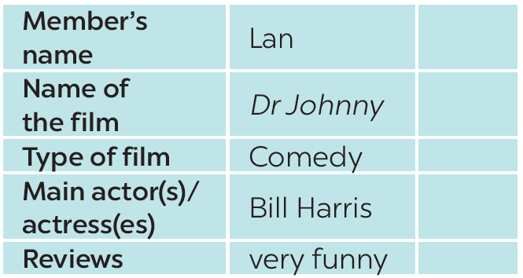
ACTIVITY 4: APPLICATION (5' - IW)
1. Aim: To help ss pratice reporting the results of their surveys.
2. Content:
Practise talking about others’ favourite films.
3. Products:
Ss talking about others’ favourite films.
4. Implementation: Teacher’s instructions…
5. Report your results to the class.  - Choose some ss to report the results of their surveys in front of the whole class.  - After each ss has finished his/her report, invite some comments from other ss.  - T comment and correct any common errors. | 5. Report your results to the class.  EX: In our survey we interviewed three members: Lan,… and… Lan likes comedies best. Her favourite comedy is……

V. FEEDBACK:
With 7A ……………………………………………………………………………..…
With 7B …………………………...……………………………………..……………
With 7C ………………………………………………………………………….……

