Full name: .............................................................

School: ..................................................................

Class: .....................................................................

Mark:

**Speaking Test – Unit 6**

Now let's talk about your Tet holiday in Vietnam. Are you ready?

**TASK 1**

1. What do you usually do before Tet?
2. What do you like to do during Tet?
3. Do you like to stay at home or travel during Tet holiday?
4. Is Tet your favourite holiday? Why/ Why not?

Each of you will now receive a card. On the card there is a picture and clues for five questions. You should use the words to make questions and ask your friends. Your friend will answer the questions based on the picture he/ she has.

**Task 2**



*Now, your friends will ask you questions about your picture. Answer his/ her questions.*

**Card A**

*Use the words given below to make questions. Ask your friend about his/ her picture and listen to the answers.*

1. What/ holiday?
2. What/ on/ table?
3. What/ outside the window?
4. How/ they/ feel?
5. Who/ you/ like/ celebrate Tet/ with? Why?

68

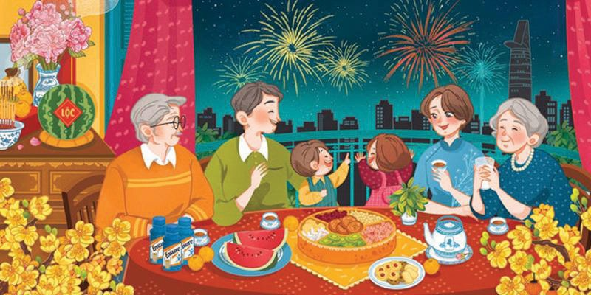

*Now, your friends will ask you questions about your picture. Answer his/ her questions.*

**Card B**

*Use the words given below to make questions. Ask your friend about his/ her picture and listen to the answers.*

1. What/ holiday?
2. How many/ people/ in/ picture?
3. What/ they/ doing?
4. How/ they/ feel?
5. you/ like/ clean your house/ before Tet? Why/ Why not?

69