READING
PART 1
Look at the picture. Read the words. Which words go with the picture? Fill in the correct circles on your answer sheet.
1.

(A) The boy is drawing a picture. | (B) The boy is taking a photo. | (C) The boy is talking on the phone
The answer is “B”. Fill in “B” on your answer sheet.
2.

What does the arrow show?
The boy with the arrow is ahead of the other boy.
(A) Ahead | (B) Beside | (C) Under
The answer is “A”. Fill in “A” on your answer sheet.

3.

(A) Cake | (B) Candy | (C) Sugar
4.
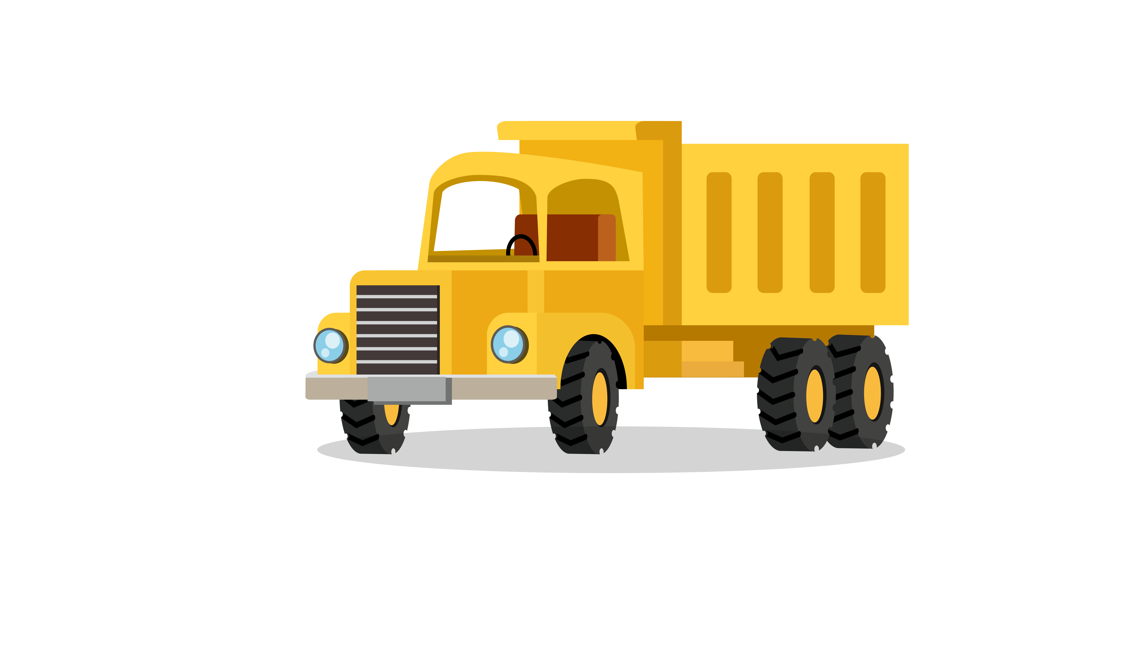
(A) Truck | (B) Bike | (C) Train
5.

(A) Hippo | (B) Lion | (C) Zebra
6.

(A) Swimming pool | (B) Supermarket | (C) Post office
7.

(A) Sad | (B) Happy | (C) Tired
8.
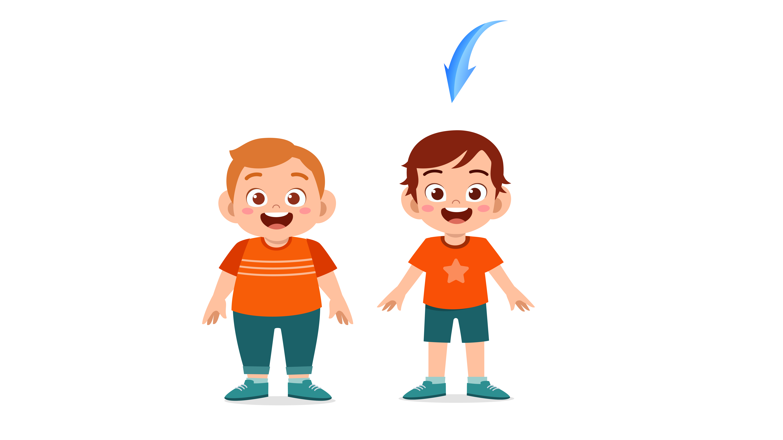
(A) Tall | (B) Thin | (C) Fat
9.

(A) Different | (B) Alone | (C) Same
10.

(A) They are skipping ropes. | (B) They are writing on the notebook. | (C) They are reading books.
11.
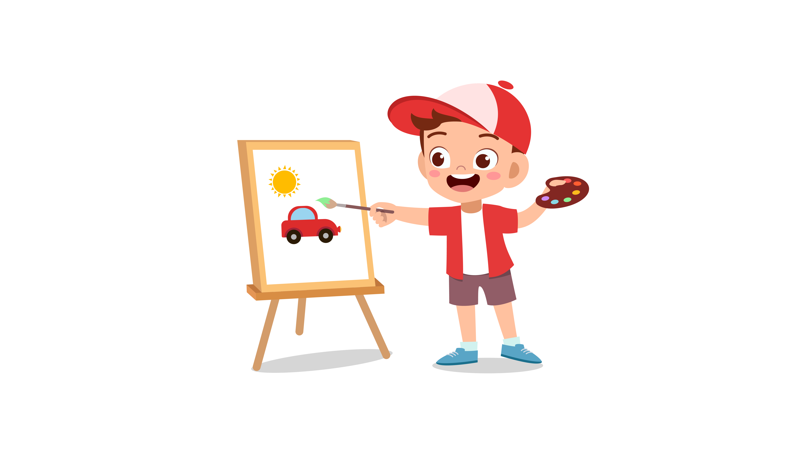
(A) The boy is playing baseball. | (B) The boy is flying a kite. | (C) The boy is drawing a picture.
12.

(A) The girls are in the Math class. | (B) The girls are in the History class. | (C) The girls are in the P.E class.
13.

(A) They are standing in the classroom.  14. | (B) There are more girls than boys.   | (C) They are waiting for food.
(A) The boy is doing a crossword puzzle. | (B) The boy is sitting quietly. | (C) The boy is answering a question.
15.

(A) They rode their bikes. | (B) They drove cars. | (C) They walked to school.
16.
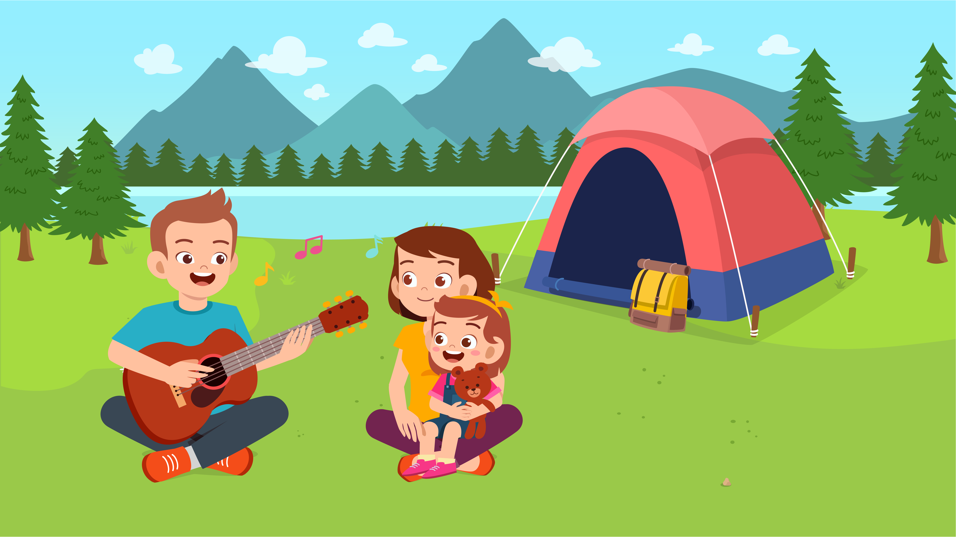
(A) The family is going camping. | (B) The family is buying a tent. | (C) The family is moving their house.
17.

(A) The cat is more beautiful than the tiger. | (B) The tiger is taller than the cat. | (C) The cat is smaller than the tiger.

PART 2
Read and find the answer.
Fill in the correct circles on your answer sheet.
Let’s do an example.
- Students go to class here. Teachers work here. It has many desks. What is it?
  - (A) A house
  - (B) A school
  - (C) A bank
The correct answer is a school. Fill in "B" on your answer sheet.

- It is a big place. Doctors work here. They cure diseases.
Where is it?
(A) A farm
(B) A factory
(C) A hospital

- This is a long, thin school object. It is used for writing with ink.
What is it?
(A) A pen
(B) A pencil sharpener
(C) A pencil case

- This takes you from one place to another. You go to the airport to catch it. This has wings.
(A) A bike
(B) A bus
(C) A plane

- You feel sick. Your body temperature is higher than usual. You have a _________.
(A) sore throat
(B) fever
(C) stomachache

- You are going to be late for school. To get there on time, you have to _________.
(A) walk
(B) run
(C) jump

- In the zoo, you can see many kangaroos. You watch them use their feet to push themselves off the ground. They are _________.
(A) swinging
(B) jumping
(C) flying

- Library is a ______________ place because people do not speak loudly.
(A) noisy
(B) quiet
(C) calm

PART 3
Read the sign. Answer questions 26 to 29.
Fill in the correct circles on your answer sheet.
Peter, Alex, Eden, Kelly and Ana go to the shopping mall. They read this sign at the mall.

Guide to the Shopping mall
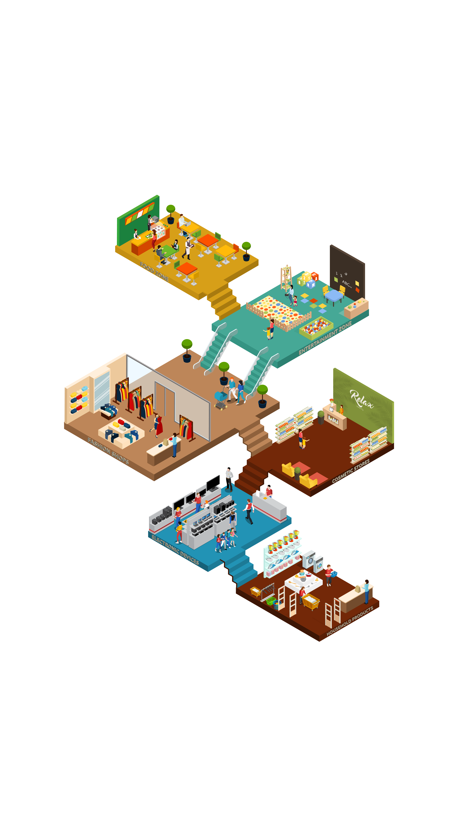

- Peter wants to buy a computer. He goes to the ____________.
(A) ground floor
(B) 1st floor
(C) 3rd floor

- Ana likes to try on clothes. She goes to the ____________.
(A) 1st floor
(B) 2nd floor
(C) 3rd floor

- Eden wants to watch a movie. She goes to the____________.
(A) 2nd floor
(B) 4th floor
(C) 5th floor

29. Alex is hungry. He goes to the____________.
(A) 3rd floor
(B) 4th floor
(C) 5th floor

Read about how family members help with the housework. Answer questions 30 to 33.
 | Tuesday | Wednesday | Saturday
Clean the windows | Dad | Mom | Brother
Wash dishes | Mom | Brother | Sister
Empty the trash | Sister | Sister | Mom
30. What does dad do on Tuesday?
(A) Wash dishes
(B) Clean the windows
(C) Empty the trash

31. When does Mom clean the windows?
(A) Tuesday
(B) Wednesday
(C) Saturday

32. Who empties the trash on Wednesday?
(A) Brother
(B) Sister
(C) Mom

33. When does brother wash dishes?
(A) Tuesday
(B) Wednesday
(C) Saturday

Read the letter. Answer questions 34 to 35.

Dear Rhea,
I hope you are doing all good. It feels like a really long time since I have spoken with you but very soon. I will be there in your city and we are certainly going to have a lot of talks together.
Just wanted to tell you that I am visiting New York on May 1st, 2020 for an interview in your city which is scheduled on May 4th, 2020. I have planned a week-long trip so that I can spend some quality time with my childhood friend and also take the interview. So make sure that you take some time out for me and show me the city around.
I am really very excited to meet you after so many years. It will surely be a week to remember. Cannot wait to meet you. Will share my flight and hotel details with you soon.
Regards,
Andrew

34. Why does Andrew write to Rhea?
(A) To inform her of his upcoming trip
(B) To get some help with his hotel booking
(C) To ask her about New York
35. What does Andrew say about his schedule?
(A) He has little time for visiting New York.
(B) He will go to New York before the interview date.
(C) He can spend one week with Rhea.

Read the email. Answer questions 36 to 37.
Hi Liam,

How are you? My name's Juan and l am from Rio de Janeiro in Brazil. I’m eleven years old. How old are you?

I’m tall, I’ve got black hair and brown eyes. I’ve got one sister and two brothers.
I’ ve got a dog called Pedro. Have you got any pets? I like football, beach volleyball and music. What do you like?
I speak Portuguese (the language in Brazil) and English. What languages do you speak?
lt’s sunny and hot in Rio. What’s the weather like where you live in Canada?

Please write soon.
Best wishes,
Juan
36. Why does Juan write to Liam?
(A) To introduce himself and tell about his life
(B) To know about the languages in Canada
(C) To tell Liam about his pets

37. What is probably true about Juan?
(A) He has three siblings.
(B) He plays three sports.
(C) He can speak three languages.

Read the letter. Answer questions 38 to 39.
Dear Lisa,

How are you doing? Sorry it took me too long to write back. How has summer been? What have you been doing during the summer? On my part, I have been traveling around the country with my family. I made new friends and new memories.
I miss you. I cannot wait to go back to school and see you again. I also want to tell you about all my travel experiences when we are back in school. I will send you some of my pictures.

I hope all is well with you. Send your family my love. See you soon.
Love,
Sabrina.
38. Why does Sabrina write to Lisa?
(A) To tell about what she did during the trip
(B) To tell Lisa what she has been doing during the summer
(C) To know about Lisa’s summer
39. What does Lisa say about her summer?
(A) She goes to another country.
(B) She has a trip with friends.
(C) It brings her new memories.

You finished the reading test.

LISTENING
PART 1
Listen to the words. Look at the pictures.
Fill in the correct circles on your answer sheet.
1.
 | 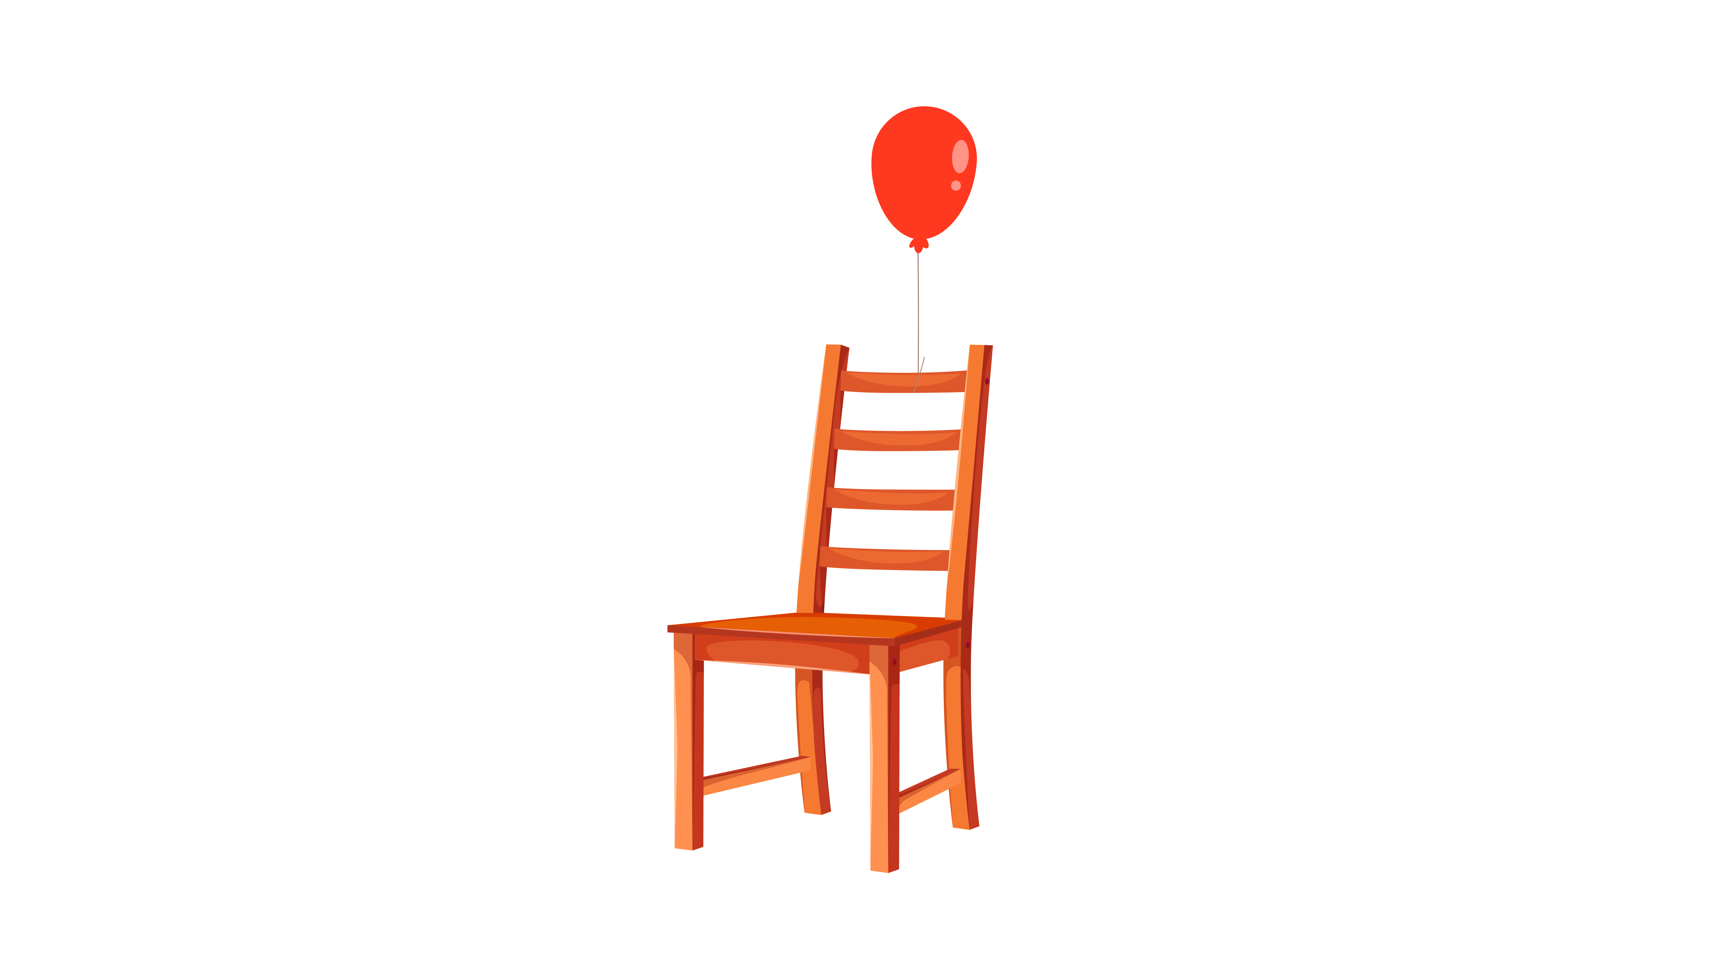 | 
(A) | (B) | (C)
2.
 |  | 
(A) | (B) | (C)
3.
 |  | 
(A) | (B) | (C)
4.
 |  | 
(A) | (B) | (C)
5.
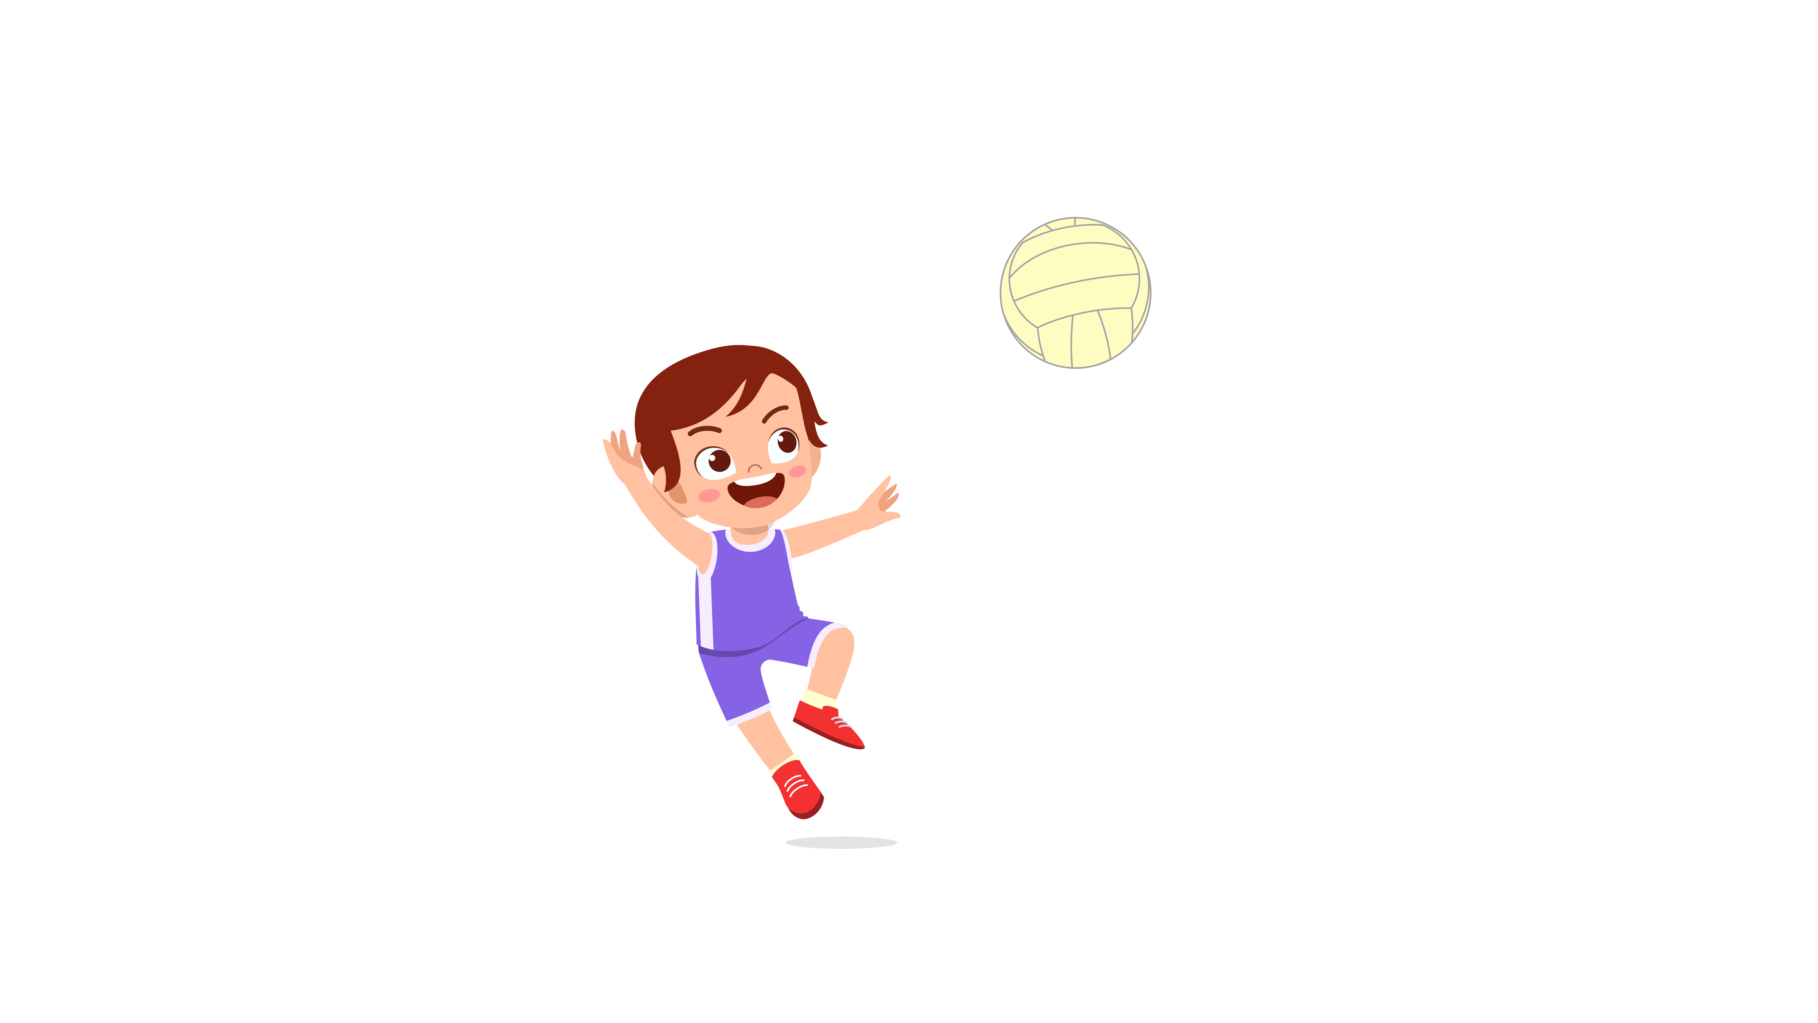 |  | 
(A) | (B) | (C)
6.
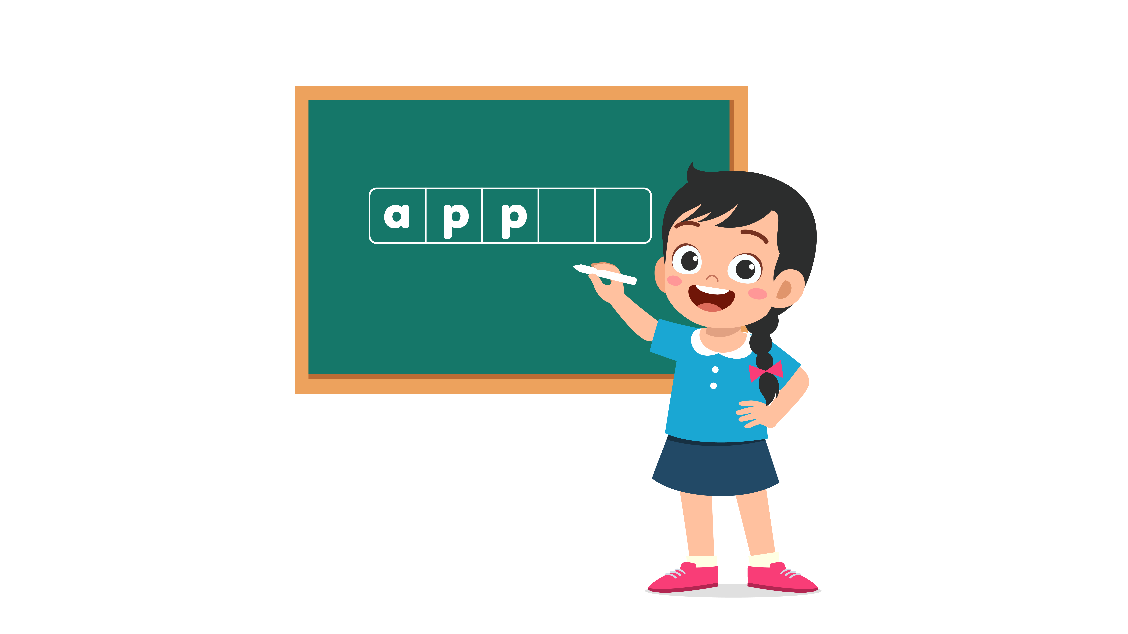 | 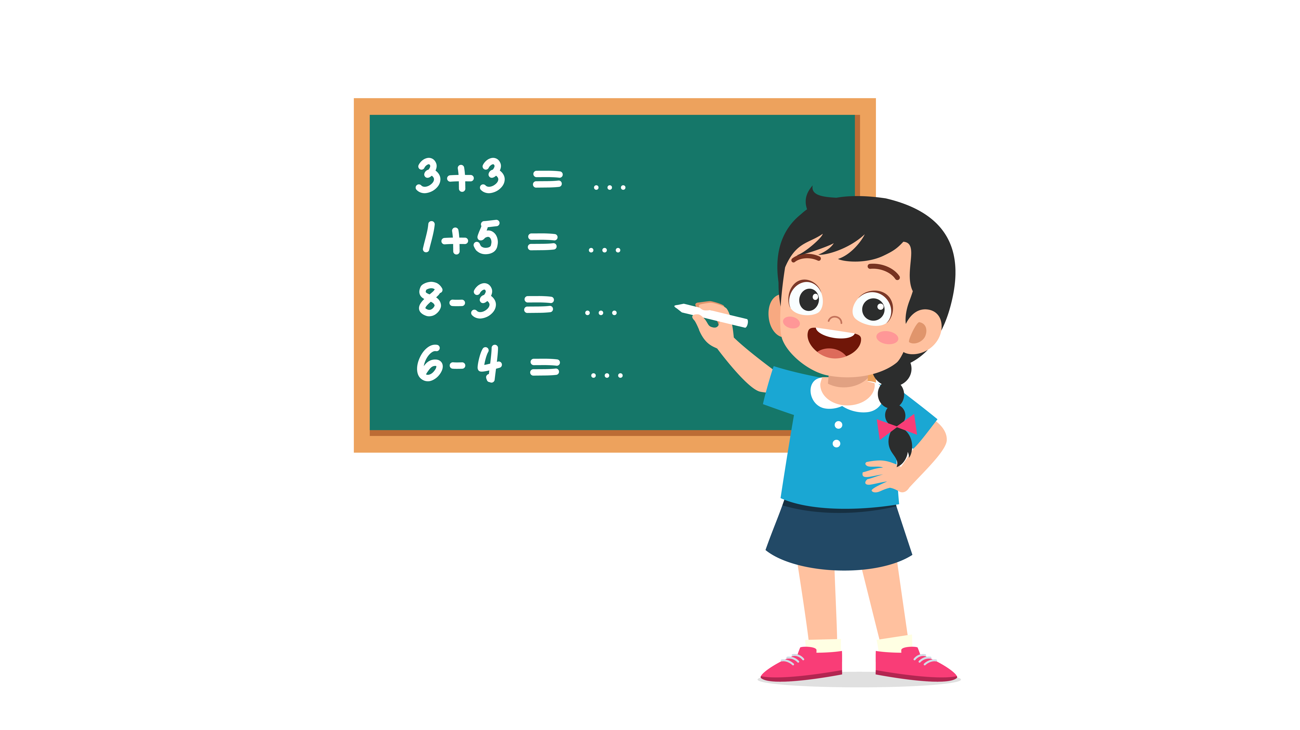 | 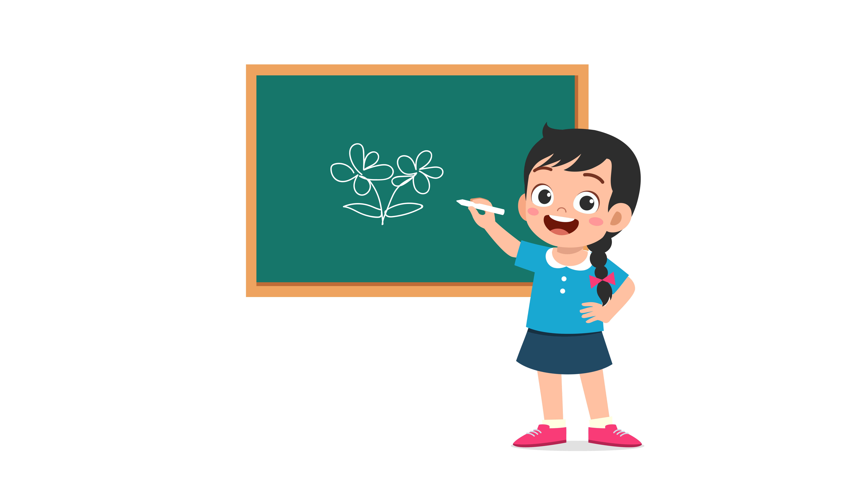
(A) | (B) | (C)
7.
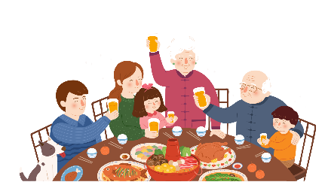 |  | 
(A) | (B) | (C)
8.
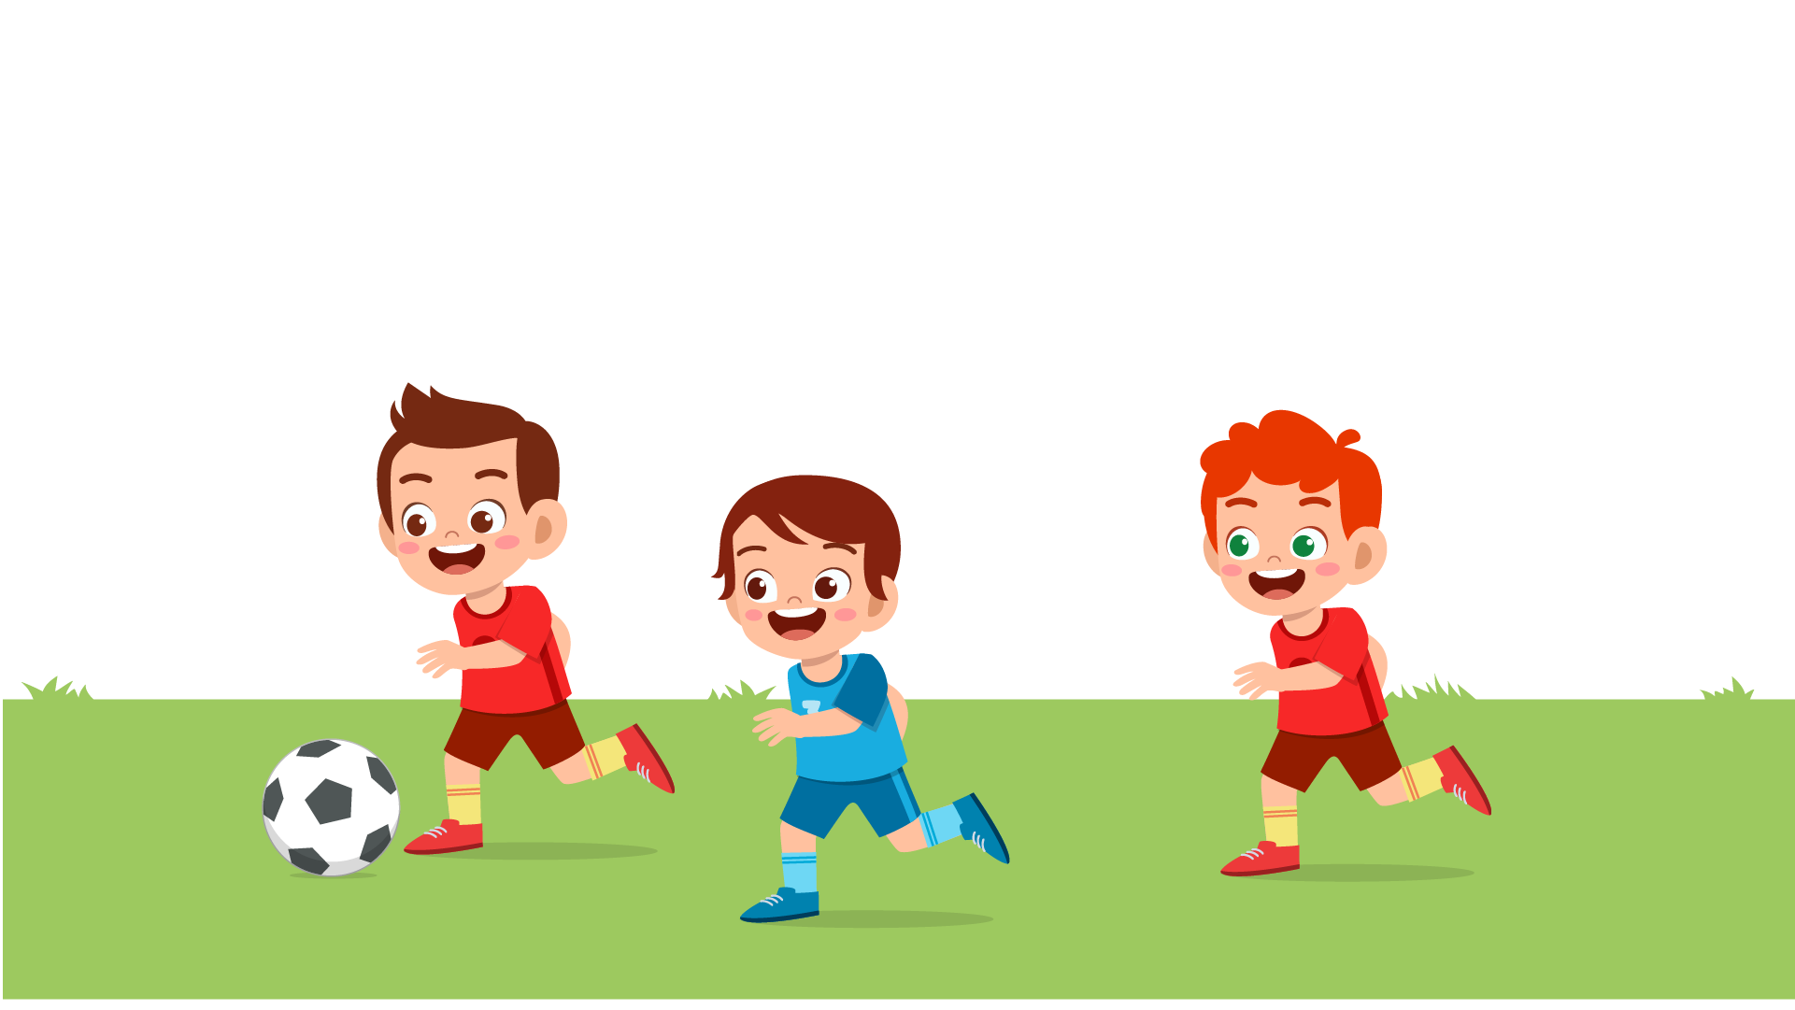 |  | 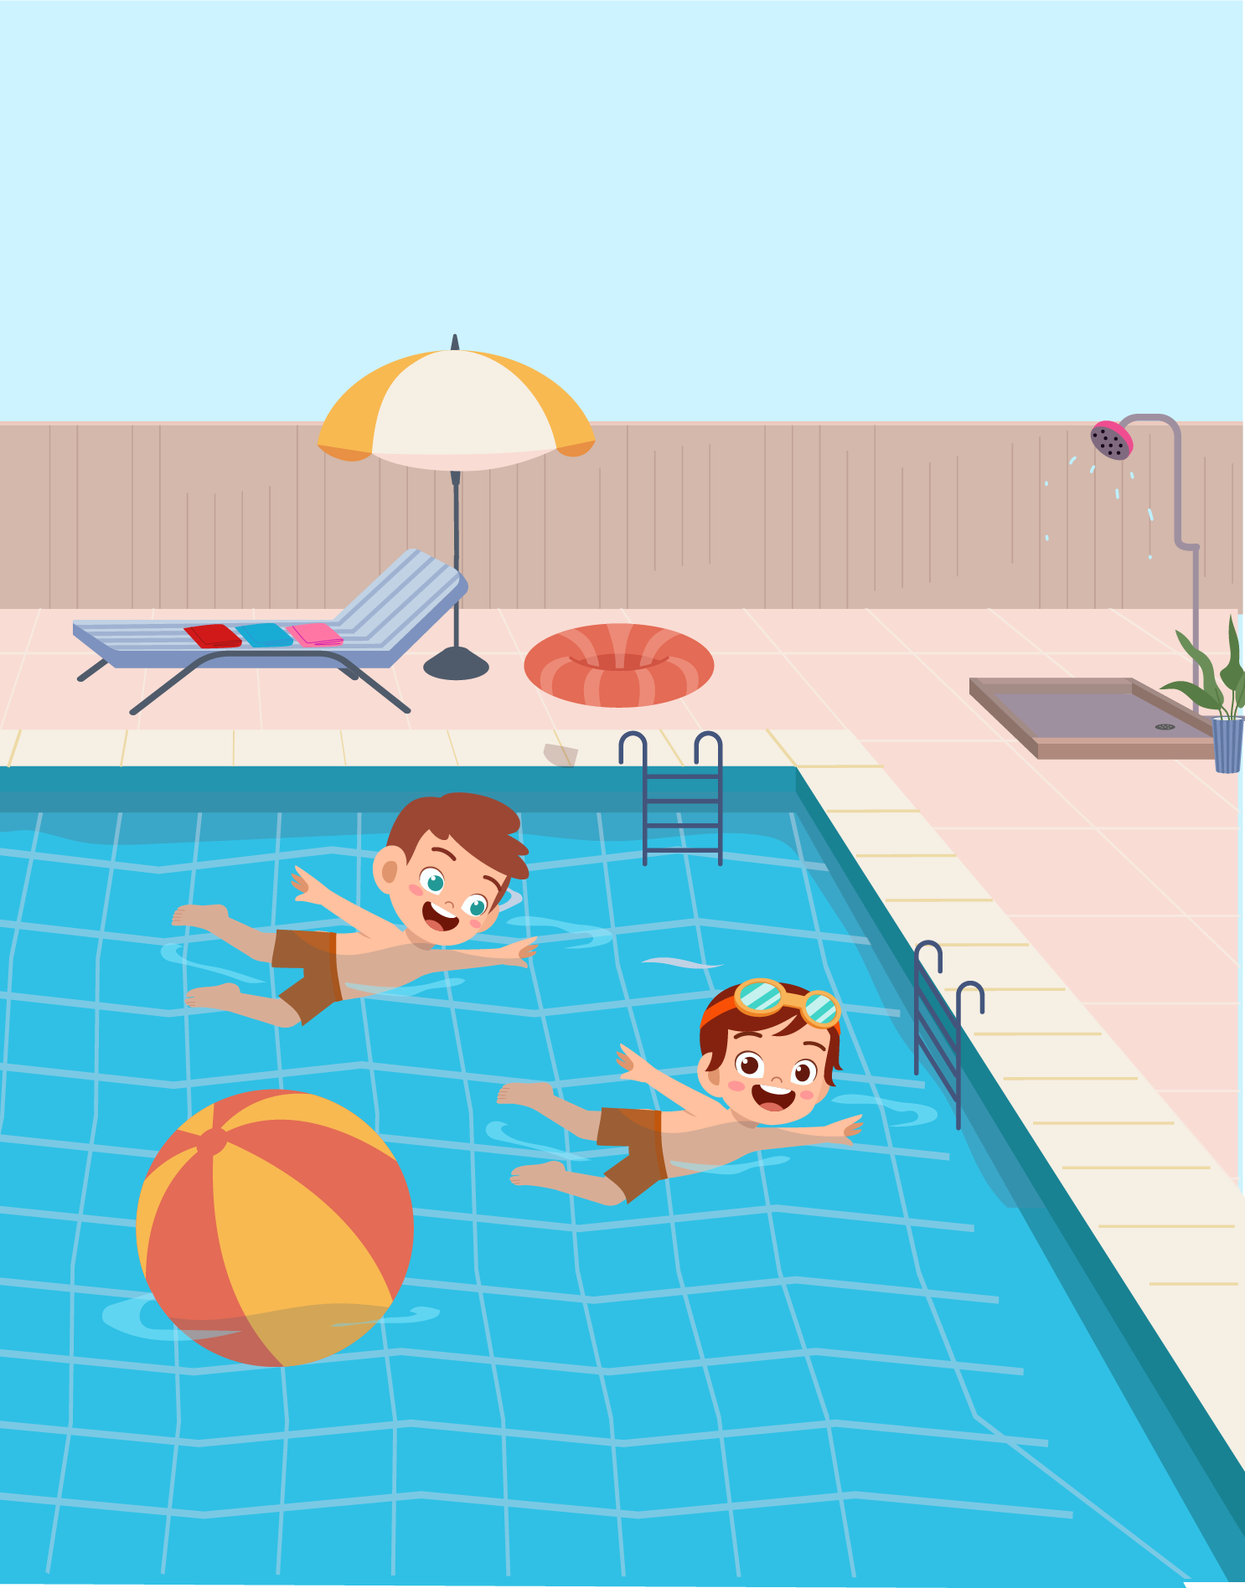
(A) | (B) | (C)

PART 2
Fill in the correct circles on your answer sheet.
9.
 |  | 
(A) | (B) | (C)
10.
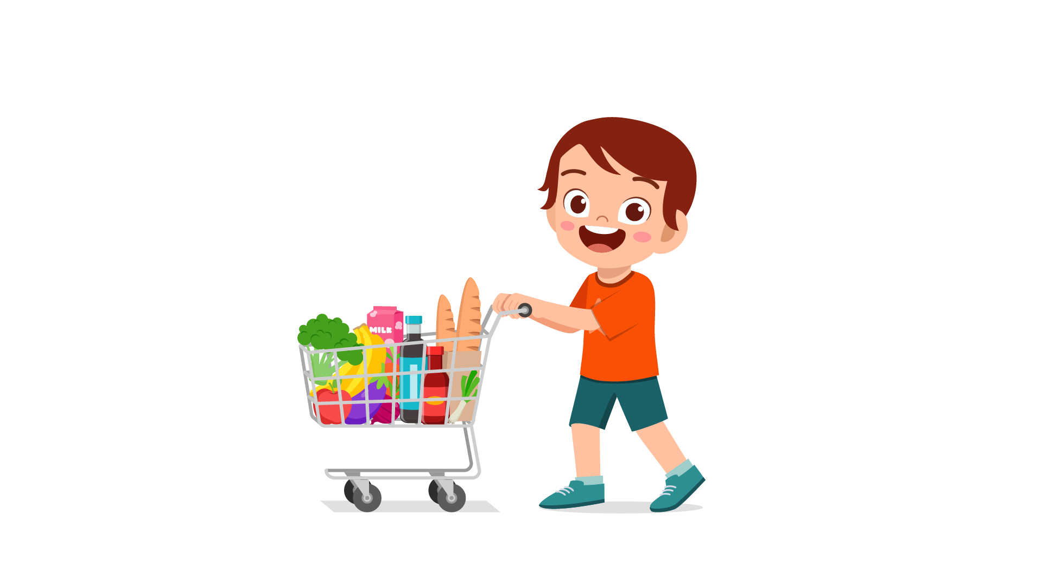 |  | 
(A) | (B) | (C)
11.
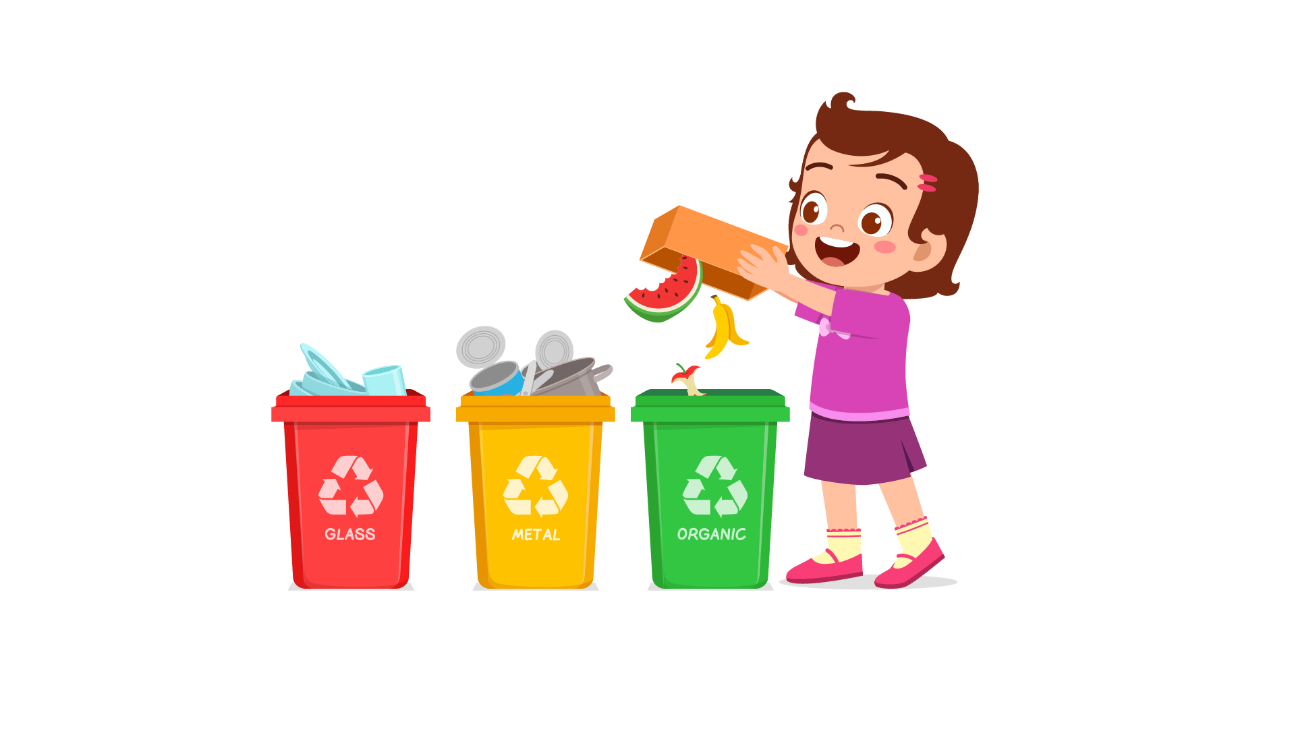 | 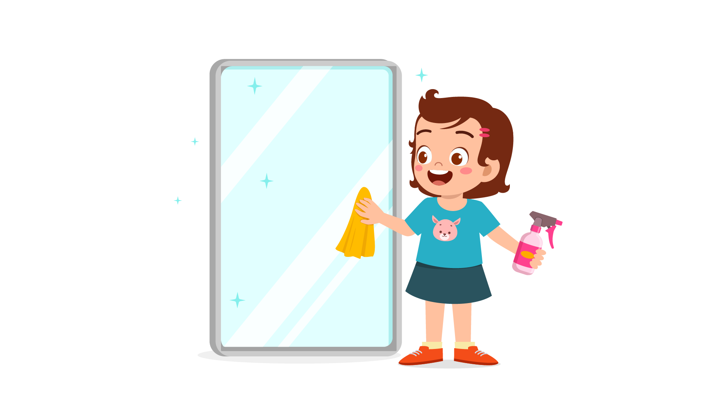 | 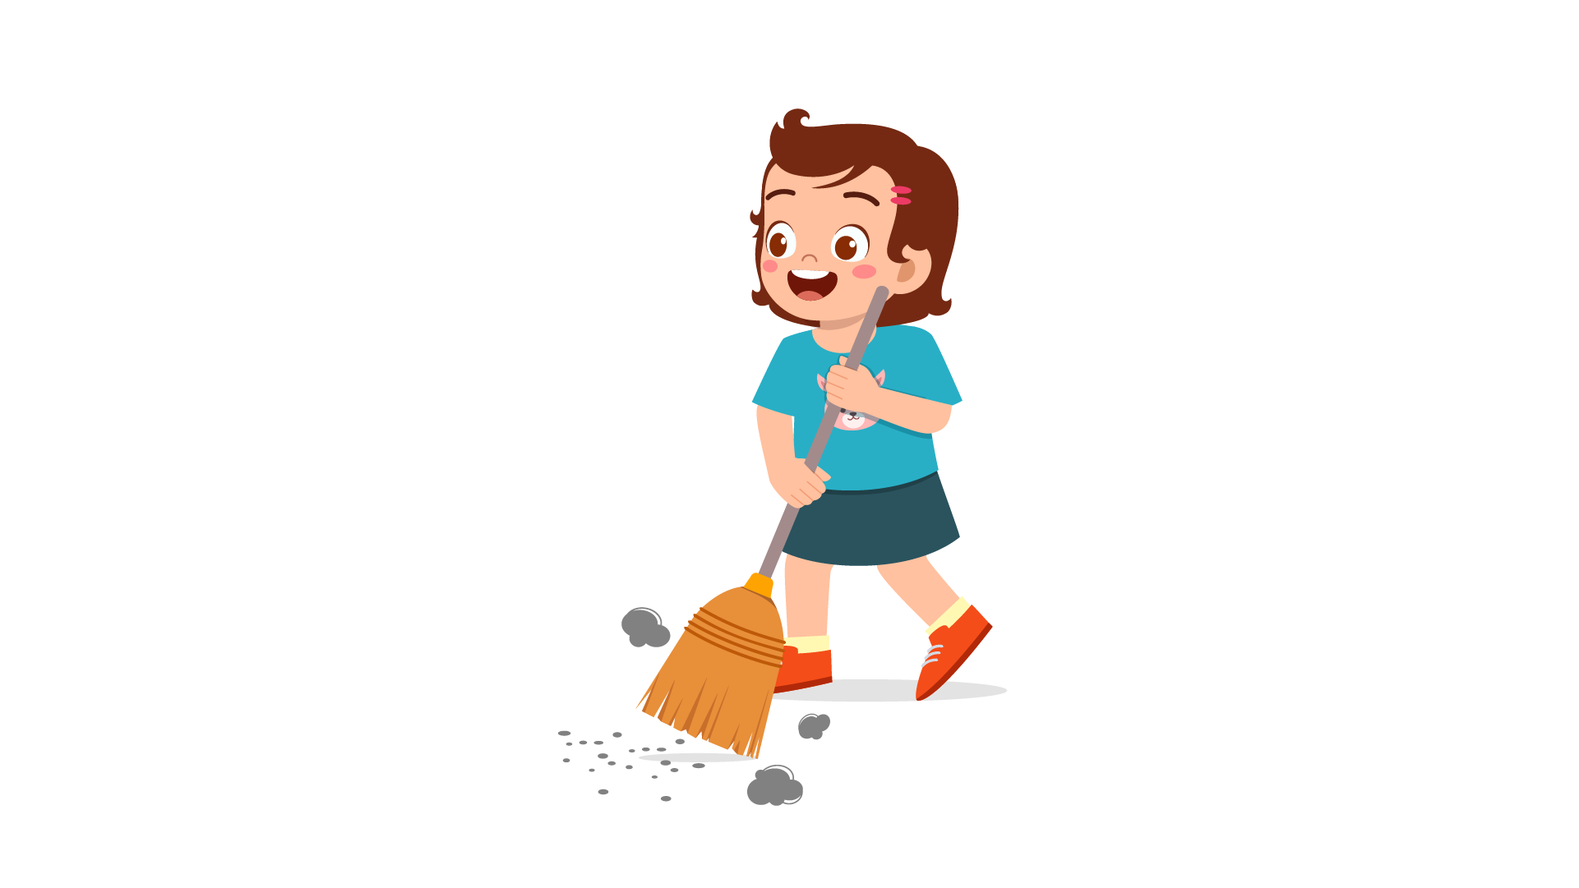
(A) | (B) | (C)
12.
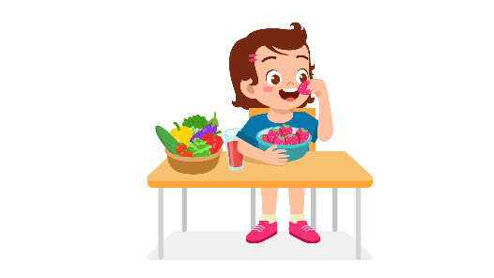 |  | 
(A) | (B) | (C)
13.
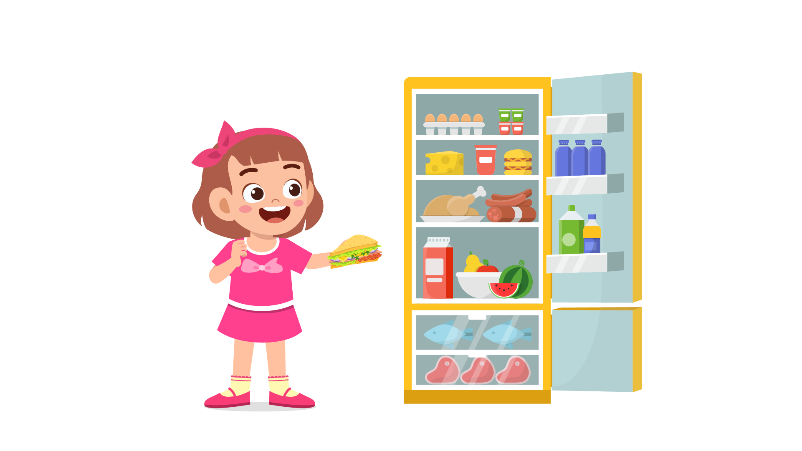 | 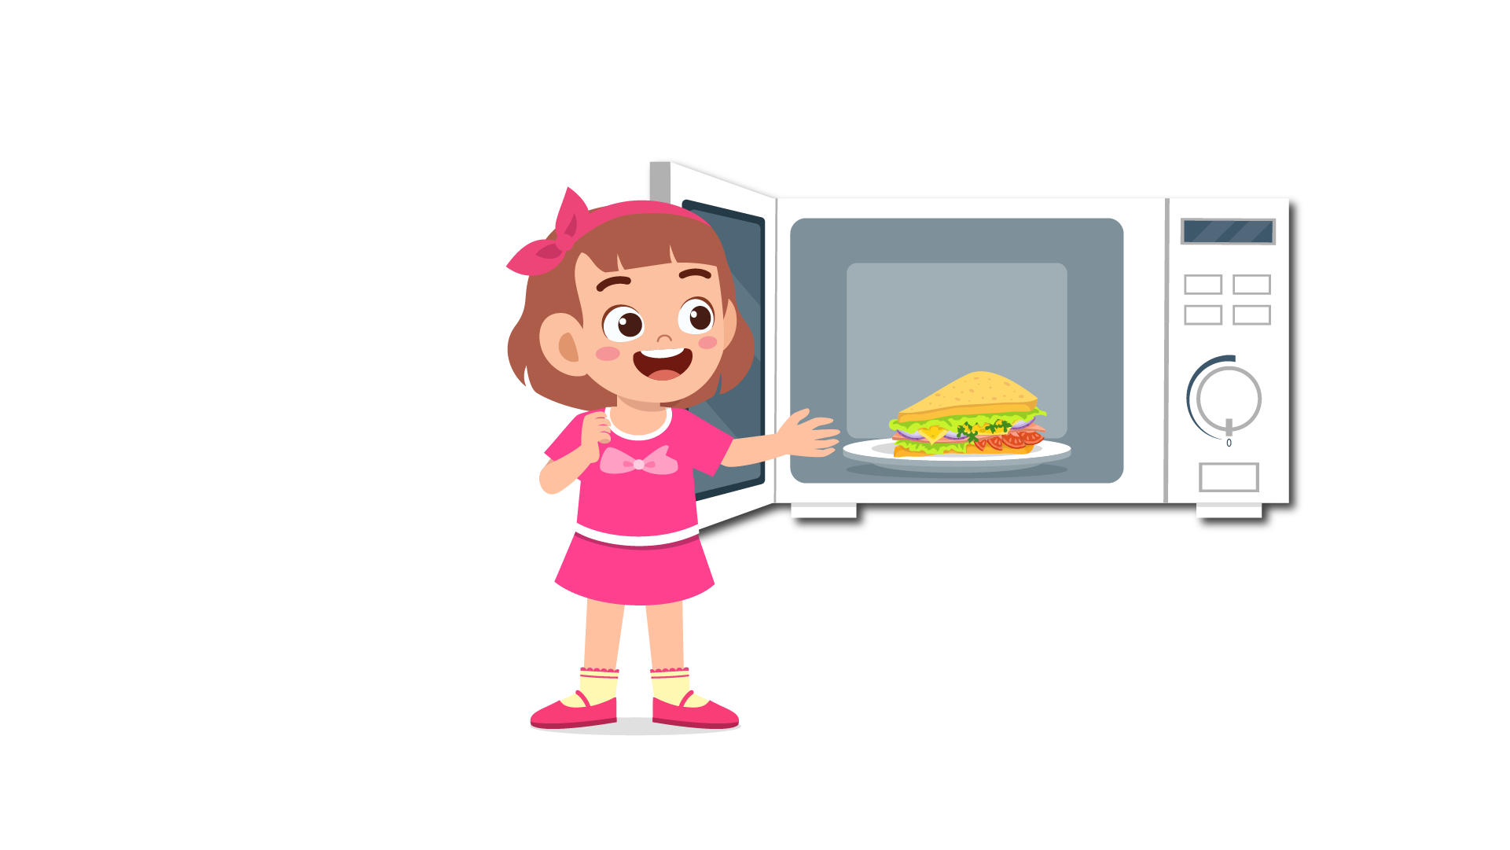 | 
(A) | (B) | (C)
14.
 |  | 
(A) | (B) | (C)
15.
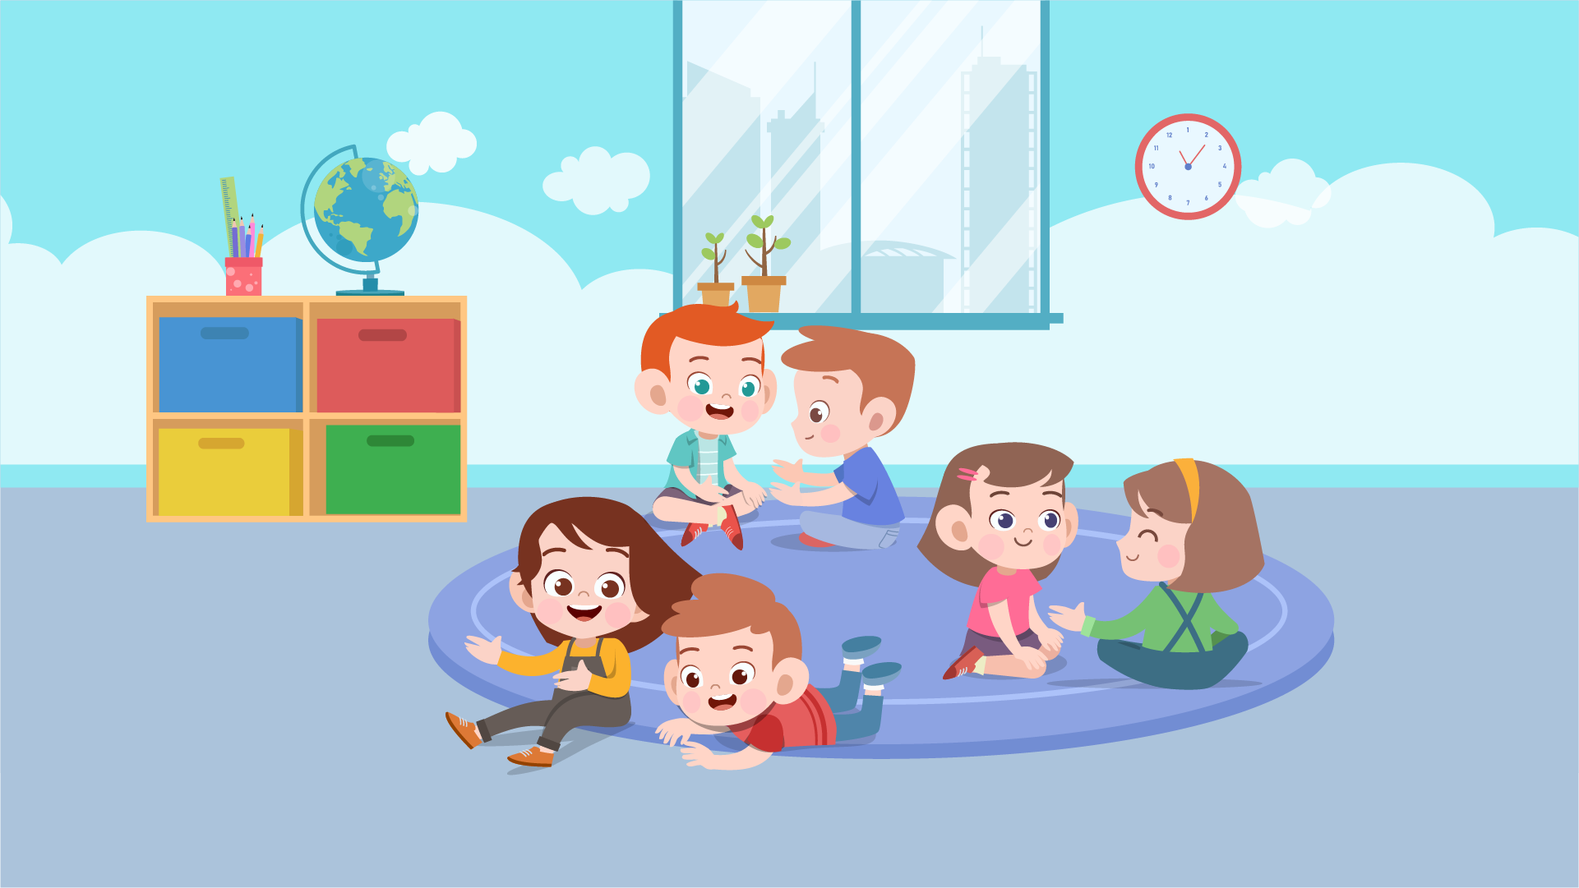 | 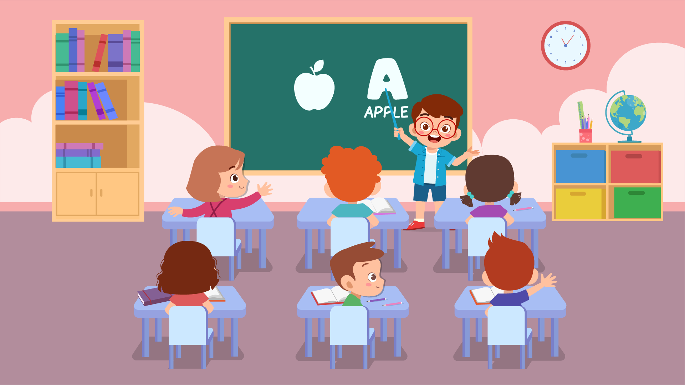 | 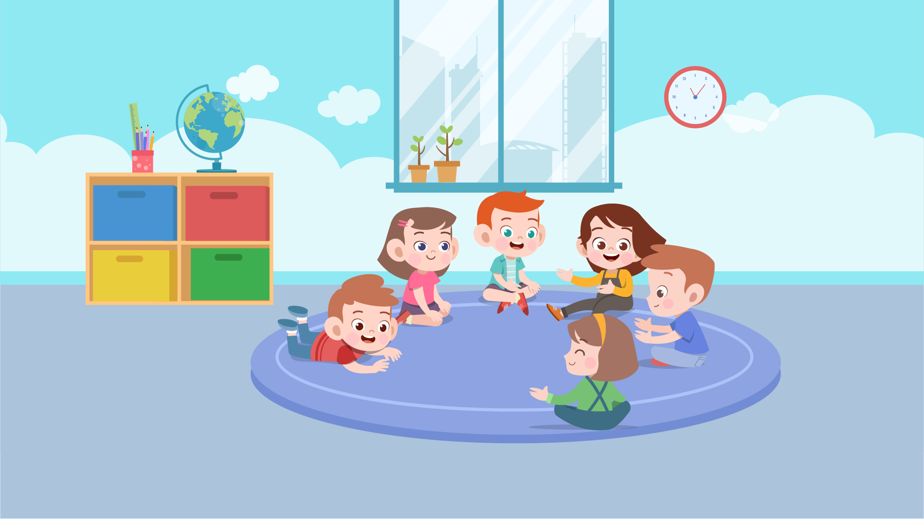
(A) | (B) | (C)
16.
 |  | 
(A) | (B) | (C)
17.
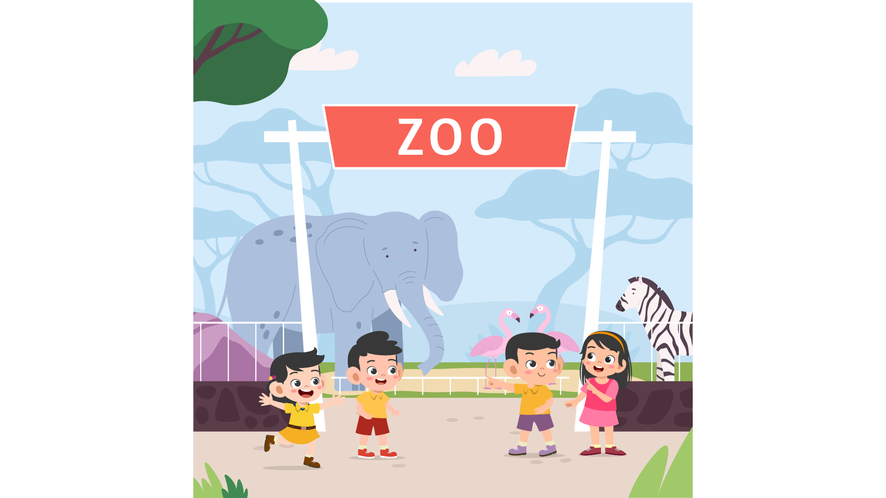 | 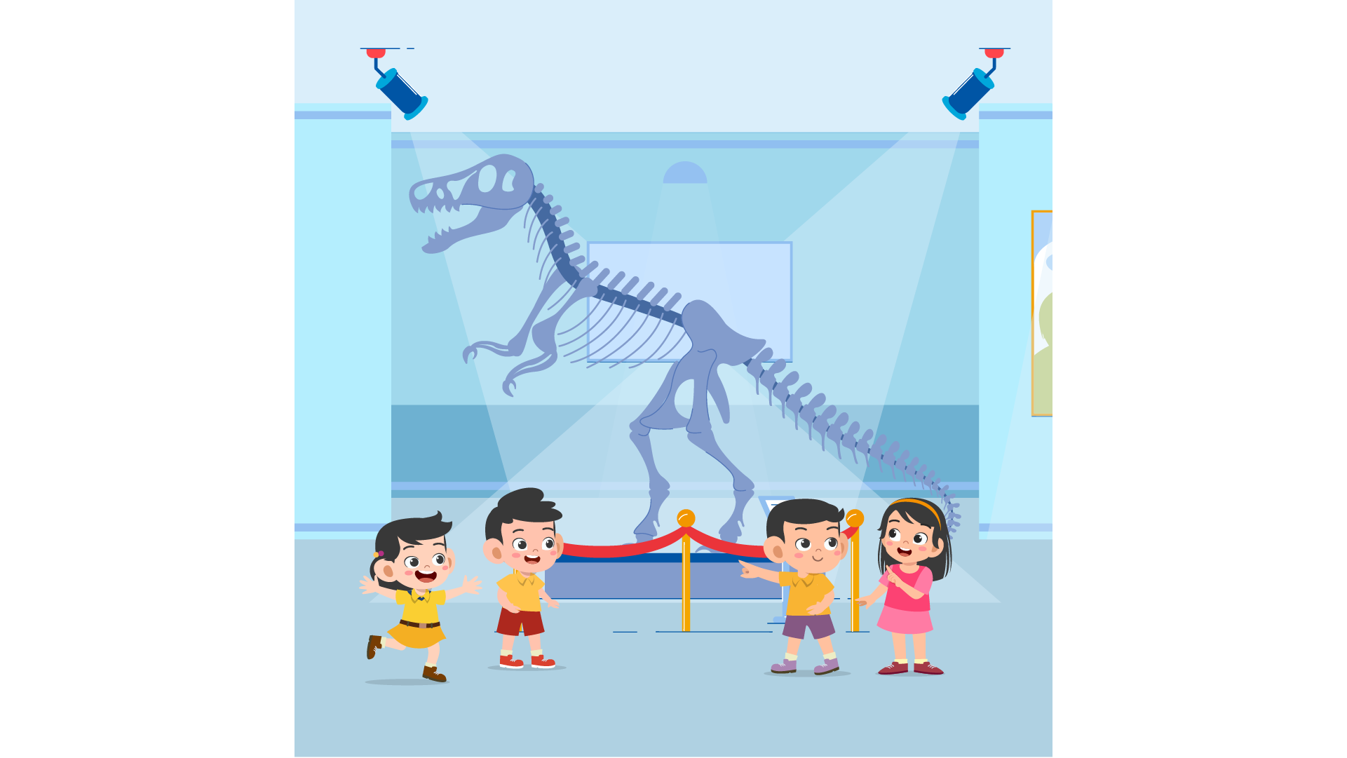 | 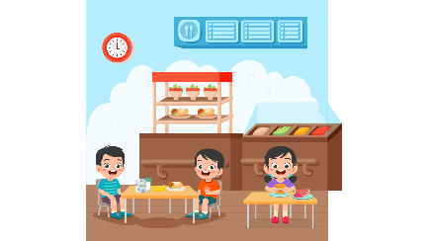
(A) | (B) | (C)
PART 3
Fill in the correct circles on your answer sheet.
Look at your answer sheet. Listen to a conversation. Which conversation sounds correct?
Let’s do an example.
(Narrator): A
(Boy): Hello. What’s your name?
(Girl): I’m fine, thanks.
(Narrator): B
(Boy): How are you today?
(Girl): I’m six years old.
(Narrator): C
(Boy): Nice to meet you!
(Girl): Nice to meet you, too!
The answer is "C." Fill in "C" on your answer sheet. Now, you do it.
18.
(A) | (B) | (C)
19.
(A) | (B) | (C)
20.
(A) | (B) | (C)
21.
(A) | (B) | (C)
22.
(A) | (B) | (C)
23.
(A) | (B) | (C)
24.
(A) | (B) | (C)
25.
(A) | (B) | (C)
26.
(A) | (B) | (C)
27.
(A) | (B) | (C)

PART 4
Listen to a conversation and answer the question. Fill in the correct circle on your answer sheet.
Let’s do an example.
28. When is the girl's party?
(A) Tonight
(B) Next week
(C) This weekend
The answer is "C." Fill in "C" on your answer sheet. Now, you do it.
29. What did the boy do last weekend?
(A) Go to the cinema
(B) Play tennis
(C) Go to the post office
30. What do they want to buy?
(A) Some bananas
(B) Some pears
(C) Some oranges
31. What will the girl do this summer holiday?
(A) visit their grandparents
(B) go to the beach
(C) go abroad

32. What does the teacher tell the boy to do?
(A) come late for the science class
(B) complete his homework
(C) bring books
33. What is the girl trying to do?
(A) ask to go to the birthday party
(B) prepare for the party
(C) have party at school
34. What do the friends want to do?
(A) eat something in the canteen
(B) go to a local food store
(C) prepare their own food

PART 5
Listen and answer the question.
Fill in the correct circle on your answer sheet.
Let’s do an example.
- What did Mike call about?
(A) Homework
(B) A movie
(C) A library book
The answer is "B." Fill in "B" on your answer sheet. Now, you do it.

36. Why did Kate’s mother call?
(A) To tell her she will be home late
(B) To tell her to have a piano class
(C) To ask her to be ready for the meal
37. Why did Jessie call?
(A) To talk about drinking water
(B) To remind Daisy about what to prepare for the field trip
(C) To borrow a watter bottle
38. Why did Cathy call?
(A) To choose a film
(B) To suggest another option
(C) To ask Mike to go to the cinema

39. Why did the teacher call?
(A) To invite Lucy to join a speaking club
(B) To make a speech
(C) To ask Lucy about the topic of her presentation
40. Why did the shop assistant call?
(A) To tell Dan to come and get notebooks
(B) To talk about the supermarket’s promotion
(C) To give directions to the supermarket
41. Why did Laura call?
(A) To share information about a country
(B) To ask Kimmie about related books
(C) To ask for some online material

