Full name: ……………………………………………….  School: ………………………………………………….  Class: ……………………………………………………. | Mark:

SPEAKING TEST 3 (UNITS 5 & 6)

TASK 1 |  |  | Let’s talk about your school.  The following questions may help you.
 | 1. | Where is your school? How do you go to school every day?
 | 2. | How many students and teachers are there in your school?
 | 3. | Can you tell me more about the students and teachers in your school?
 | 4. | What facilities are there in your school?
 | 5. | Which school facility do you like best? Why?

TASK 2 | Work in pairs. Each of you receives a card. Use the clues on your card to make questions about your friend’s picture. Use the picture on your card to answer your friend’s questions.

CARD A
Ask your friends about his / her picture. Listen to his / her answers

1. | What / are / names / dishes?
2. | Which country / these dishes / popular? | 
3. | What ingredients / need / prepare them?
4. | How / prepare (boil / bake / stew)?
5. | How long / take / prepare?
 |  | Answer your friend’s questions about this picture.

CARD B
Ask your friends about his / her picture. Listen to his / her answers.

1. | What / are / kinds / pizza?
2. | Which country / these pizzas / popular? | 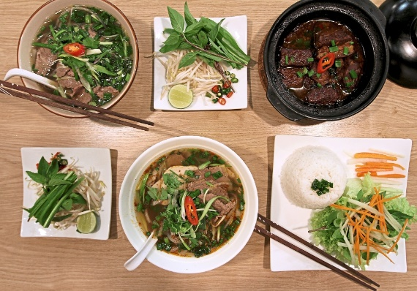
3. | What ingredients / need / prepare them?
4. | How / prepare (boil/ bake/ stew)?
5. | How much / cost / at restaurants?
 |  | Answer your friend’s questions about this picture.

