Đề thi Tiếng Anh lớp 3 giữa học kì 2 Global Success
Choose the odd one out
- A. school | - living room | - kitchen | - bedroom
- A. father | - mother | - aunt | - teacher
- A. between | - in | - on | - upstairs
Look at the picture and write
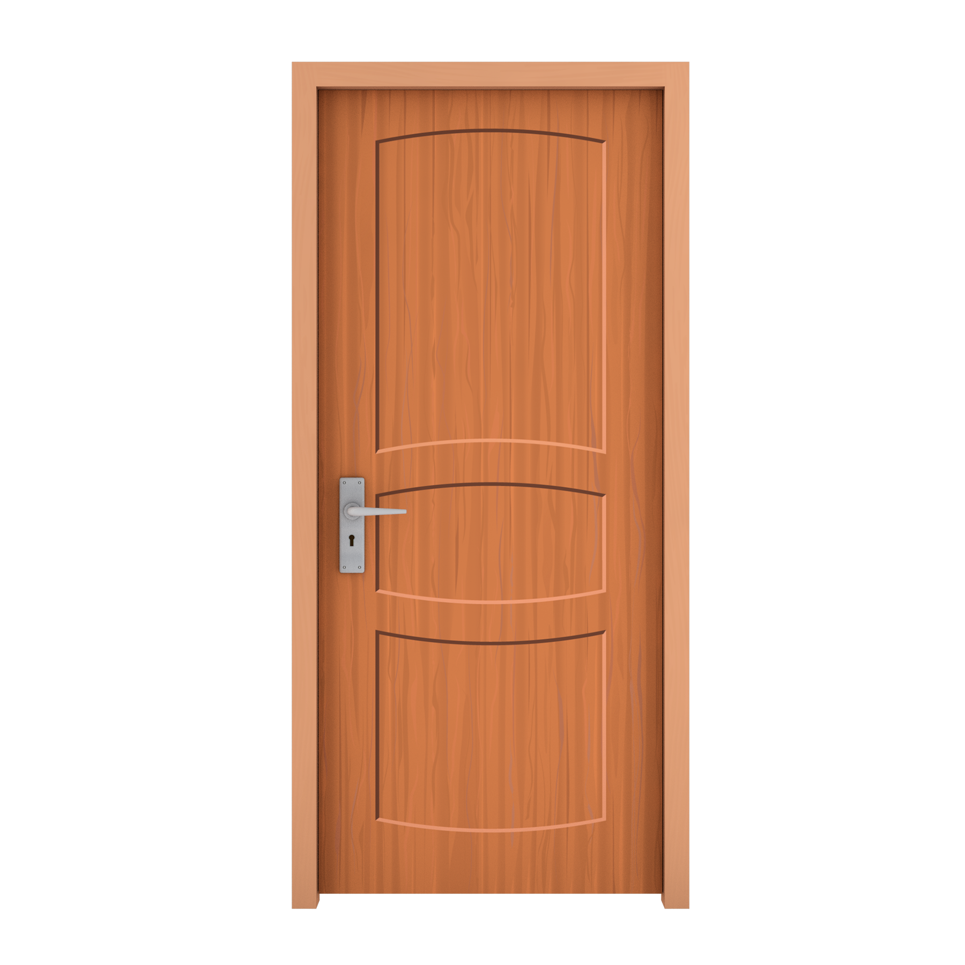 | 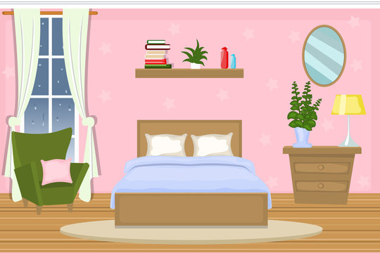 | 
- _______________ | - _______________ | - _______________
Choose the best answer
- The coat is ………………. on the desk. It’s on the chair.
- not
- aren’t
- isn’t
- ….……….. you like some milk? - No, thanks.
- What
- Where
- Would
- Would you like some …………?
No, thanks. I’d like some drink.
- drink
- food
- thing
- A: Is there a fence around your house?
B: No, there …………..
- is
- aren’t
- isn’t
- How ………….. books are there on the table?
There are three books
- much
- very
- many
Under and corrrect the mistakes
- He doesn’t have a balloon. He have a car.
….…………………………………………………………….
- Does they have books?
….…………………………………………………………….
Read the text and answer the questions
I am Robert. This is a photo of my family. This is my father. He is forty-two years old. He likes reading news. This is my mother. She is thirty-five years old. She is a housewife. She likes cooking. This is my brother. His name is Jack. Jack is only two years old. This is my sister. Her name is Ann. She is eight years old. I am eleven years old. I love my family.
- How old is Robet’s father?
….…………………………………………………………….
- What does his mother like doing?
….…………………………………………………………….
- What is his mother’s job?
….…………………………………………………………….
- How old is Jack?
….…………………………………………………………….
- How old is Robert?
….…………………………………………………………….
Reorder the words to make meaningful sentences
- old/ his/ How/ is/ sister/?/
….…………………………………………………………….
- years/ father/ Her/is/old/ forty -three /./
….…………………………………………………………….
- brother/ a/ Is/ worker/ your/? /
….…………………………………………………………….
- dining room/ is/ Where /your/?/
….…………………………………………………………….
- brown/ like/ house/ don’t / I/a/./
….…………………………………………………………….
Listen and fill in the missing word
- Would you like some …………..
- Her favourite drink is …………..
- I have egg and ………….. for dinner.
- My family has a big …………..
- My daughter likes chicken …………..
-The end-
Đáp án đề thi Tiếng Anh lớp 3 giữa học kì 2 Global Success
Choose the odd one out
- A | - D | - D
Look at the picture and write
- door | - bedroom | - rice
Choose the best answer
- A | - C | - B | - C | - C
Under and corrrect the mistakes
- have => has
He doesn’t have a balloon. He has a car
- Does => Do
Do they have books?
Read the text and answer the questions
- He is forty-two years old.
- She likes cooking.
- She is a housewife.
- Jack is only two years old.
- He is eleven years old.
Reorder the words to make meaningful sentences
- How old is his sister?
- Her father is forty-three years old.
- Is your brother a worker?
- Where is your dining room?
- I don’t like a brown house.
Listen and fill in the missing word
- Would you like some ……pork ……..
- Her favourite drink is ……milk……..
- I have egg and …… noodles…….. for dinner.
- My family has a big ……lunch……..
- My daughter likes chicken ……soup……..
