Tiếng Anh 8 i-Learn Smart World - Luyện tập - Unit 6 - BS
Time allotted: 60

PART 1 PRONUNCIATION (5 questions)
Choose the word that has the underlined part pronounced differently from the others.
1. A. A. called B. B. visited C. C. followed D. D. believed
2. A. A. appeared B. B. started C. C. decided D. D. succeeded
3. A. A. finished B. B. stopped C. C. agreed D. D. laughed
4. A. A. traveled B. B. opened C. C. learned D. D. passed
5. A. A. caused B. B. asked C. C. promised D. D. practiced

PART 2 VOCABULARY (10 questions)
1. Match the descriptions to the words from Lesson Summary. (5 questions)
6. This is the place where people and animals live. | a. Earth
7. This shows how hot or cold a place or thing is. | b. temperature
8. It is the fourth planet from the Sun by distance. | c. gravity
9. The survival of both people and animals depends on this gas. | d. Mars
10. Researchers use this large spacecraft as a place to live and work in space. | e. Venus
 | f. space station
 | g. oxygen
2. Complete the sentences using the words in the boxes. (5 questions)
- temperature - gravity - space station - oxygen -Venus
-> Like humans, plants and animals live on (11) ___________.
-> The (12) ___________ can fall below zero degrees Celsius in winter.
-> Venus has the same (13) ___________ as Earth.
-> Every 225 Earth days, (14)___________ completes one orbit around the Sun.
-> Astronauts stay in a (15)___________ when they are in space.

PART 3 LISTENING (10 questions)
- Listen to a report on a sighting of a strange animal. Fill in each gap with NO MORE THAN TWO WORDS. (5 questions)
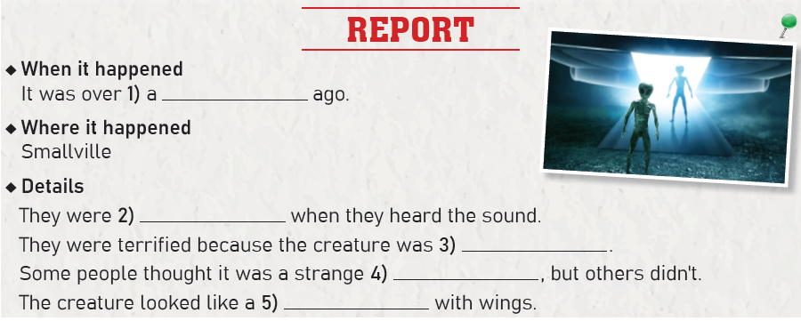
(16)___________________
(17)___________________
(18)___________________
(19)___________________
(20)___________________
2. Listen to a radio show about UFO and alien sightings. Choose True or False. (5 questions)

Answers | True | False
21. In the radio talk, Andrew was a guest. | ◯ | ◯
22. Andrew’s parents saw the aliens in 1980. | ◯ | ◯
23. There were only Andrew’s parents at the campsite. | ◯ | ◯
24. The strangers had big eyes and green skin. | ◯ | ◯
25. Andrew’s parents are still scared when thinking about it. | ◯ | ◯

PART 4 GRAMMAR (10 questions)
Choose the correct options. (5 questions)
26. ______________ believe there will be life on Venus in the future?
A. A. Will you B. B. Did you C. C. Do you D. D. Can you
27. ______________ we live on Venus in the future?
A. A. Do B. B. Will C. C. Did D. D. Are
28. What will we do when Earth ______________ overcrowded?
A. A. is B. B. are C. C. were D. D. will be
29. It ______________ safe for humans to live on the moon because there is not enough oxygen.
A. A. was B. B. wasn't C. C. aren’t D. D. won’t be
30. Researchers ______________ still in search of life on Mars. They hope they will find evidence of life there.
A. A. is B. B. are C. C. was D. D. were
Put the verbs in brackets in the correct forms of the Future Simple.
31. ______________ a trip to space in the future? (you/take)
32. I think there ______________ life on Mars in two hundred years. (be)
33. In the near future, researchers ______________ more space stations. (build)
34. Do you think other planets ______________ houses and buildings in the future? (have)
35. I think people ______________ on Earth because they will live on Venus soon. (not/live)

PART 5 READING (10 questions)
Read the text about past explanations for UFOs. Choose True, False or NI (doesn’t say). (5 questions)
PAST EXPLANATIONS for UFOs
An unidentified flying object, or UFO, is anything in the sky that the person who sees it cannot explain. Some people believe UFOs are alien spacecraft. However, most scientists believe that it can be easier to explain UFOs. A UFO has different descriptions. It can take the form of a disk, triangle or even an egg. After a sighting of a disk-shaped UFO in the 1940s, the term "flying saucer" became popular. It soon became fashionable to call all UFOs flying saucers. Nowadays, there are records of thousands of UFO sightings. These are photographs of UFOs and conversations with the people who saw UFOs. In the 1950s, a government asked a group of scientists to study hundreds of sightings. However, most sightings were just space objects like stars, planets or meteors. A lot of other sightings were only aircraft, birds or hot gases. However, such things didn't stop people from reporting UFOs. By the mid-1960s, there were even more sightings of UFOs than ever. People also found that most UFO or alien sightings happened in bad weather. But governments around the world still believed that UFOs were unreal. Other scientists agreed. But it was hard to explain why UFOs still appeared. Nowadays, researchers believe that UFOs might be visitors from space.

Answers | True | False | Not given
36. It is easy for a person to describe a UFO when he or she sees it. | ◯ | ◯ | ◯
37. Most researchers believe that explaining UFOs will be easier. | ◯ | ◯ | ◯
38. A UFO can be a disk-shaped or egg-shaped object. | ◯ | ◯ | ◯
39. The term “flying saucer” was popular in 1940s. | ◯ | ◯ | ◯
40. There are thousands of UFO sightings these days. | ◯ | ◯ | ◯
Read the text again. Write NO MORE THAN THREE WORDS AND/OR A NUMBER. (5 questions)
PAST EXPLANATIONS for UFOs
An unidentified flying object, or UFO, is anything in the sky that the person who sees it cannot explain. Some people believe UFOs are alien spacecraft. However, most scientists believe that it can be easier to explain UFOs. A UFO has different descriptions. It can take the form of a disk, triangle or even an egg. After a sighting of a disk-shaped UFO in the 1940s, the term "flying saucer" became popular. It soon became fashionable to call all UFOs flying saucers. Nowadays, there are records of thousands of UFO sightings. These are photographs of UFOs and conversations with the people who saw UFOs. In the 1950s, a government asked a group of scientists to study hundreds of sightings. However, most sightings were just space objects like stars, planets or meteors. A lot of other sightings were only aircraft, birds or hot gases. However, such things didn't stop people from reporting UFOs. By the mid-1960s, there were even more sightings of UFOs than ever. People also found that most UFO or alien sightings happened in bad weather. But governments around the world still believed that UFOs were unreal. Other scientists agreed. But it was hard to explain why UFOs still appeared. Nowadays, researchers believe that UFOs might be visitors from space.
-> When did the researchers start to study UFO sightings? (41)___________
-> In what kind of weather did UFOs or aliens often appear? (42)___________
-> When were there even more reports on UFOs than before? (43)___________
-> How did some governments describe UFOs in the past? (44)___________
-> How do scientists describe UFOs these days? (45) ___________

PART 6 SPEAKING (5 questions)
Complete the conversation using the sentences in the box. (5 questions)
A. It looked like a saucer.
B. They had big eyes, and they were green.
C. I don’t know, but they looked very strange.
D. I watched a movie on a scientific channel last night.
E. It showed some evidence of UFO and alien sightings.
Emma: Do you think UFOs are real?
Liam: I have no idea. Why?
Emma: (46)___________
Liam: What was the movie about?
Emma: (47)___________
Liam: Do you think UFOs and aliens were real in the movie?
Emma: (48)___________
Liam: So what did a UFO look like in the movie?
Emma: (49)___________
Liam: How about the aliens?
Emma: (50)___________
Liam How interesting!

PART 7 WRITING (5 questions)
Complete the passage using the phrases in the box. (5 questions)
A. when he talked
B. I told other people about that
C. I was twelve years old
D. I saw an alien on an island in Oceania
E. We were walking along a footpath
I still remember the day (51) ___________. When I saw that strange creature,
(52)___________. My classmates and I were on a summer trip to an Oceanian island. We were excited when we arrived. It was still fifteen minutes earlier until the event started. So, we decided to get to know the area. The scenery was beautiful. (53) ___________ when we saw an old man. He looked very strange. He had green skin and very big eyes. He made strange sounds (54) ___________. We were terrified. We screamed and ran. (55) ___________, but they think it was just an animal with an unusual look.
---THE END---

