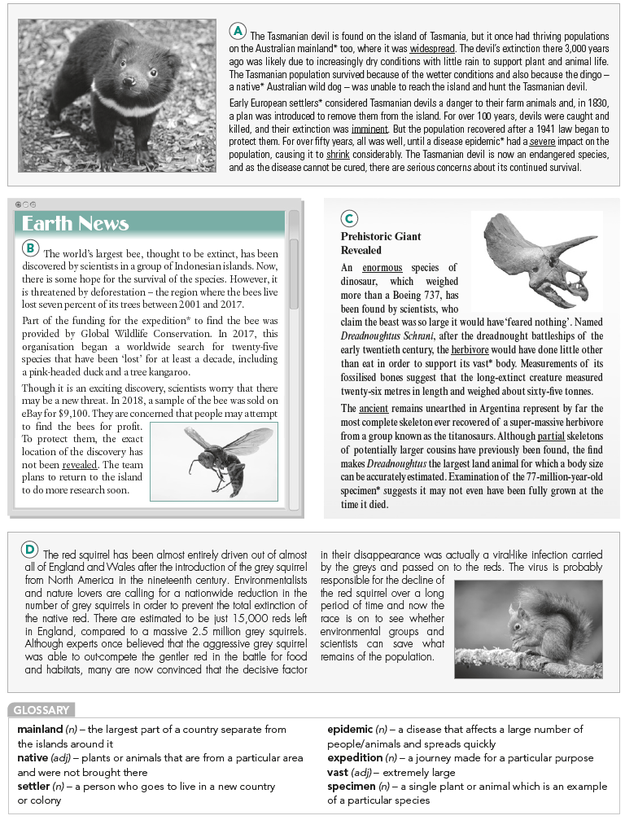

**Exercise 1: Read the texts. What is the common topic of all four?**

a. Population

b. Extinction

c. Large creatures.

**Exercise 2: Match the statements with texts A–D. You can choose each text more than once.**

1. reports the discovery of a record-breaking extinct species.

2. gives an example of a link between climate and extinction.

3. talks about the man-made destruction of a natural habitat.

4. explains what has happened to two groups of the same species.

5. talks about a misconception concerning a threatened species.

6. explains the meaning of a species' name.

7. explains that a rival species is responsible for the problem in question.

8. talks about a species that has faced extinction twice.

9. reports on a selfish reason to find a particular species.

**Exercise 3: Read the article again. Are the statements True or False?**

1. Wild dogs are currently threatening the Tasmanian devil.

2. It is unlikely that the Tasmanian devil will survive.

3. The bee's natural home in Indonesia has been almost completely destroyed.

4. For the survival of the bee, people shouldn't find out where it lives.

5. The Dreadnoughtus dinosaur probably ate very little considering its enormous size.

6. Other Dreadnoughtus dinosaurs might have been bigger than the one discovered in Argentina.

7. The red squirrel has no hope of surviving.

8. The grey squirrel does not die from the illness it carries.

**ANSWER KEY**

Exercise 1:

1-d 2-e 3-b 4-f

Exercise 2:

1. C

2. A

3. B

4. D

5. D

6. C

7. D

8. A

9. B

Exercise 3:

1. F

2. T

3. F

4. T

5. F

6. T

7. F

8. T