SPEAKING TEST ENGLISH 7
UNIT 1: HOBBIES
Part 1. Introduction - 0.4 pt (~3 ideas):
Part 2. Cue pictures (Vocabulary) – 1.0 pt (~5 questions):
  1 | 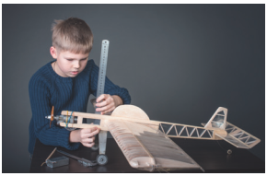  2 |   3 |   4
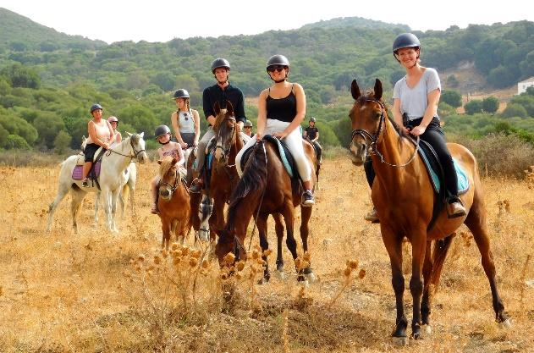 | 1. What is her/his hobby? 1-2-6-7-11-12  12  2. What do you need to make a dollhouse? 3-8  - What does/ do (she /he/they) like doing? 5-10-11-12  - It’s an activity that helps your hands and eyes work well together. 2  - It is an activity that helps you learn about flowers, fruits, vegetables and insects. 9  - It is a noun that means ‘the duty of taking care of something’ 4 |  |   5
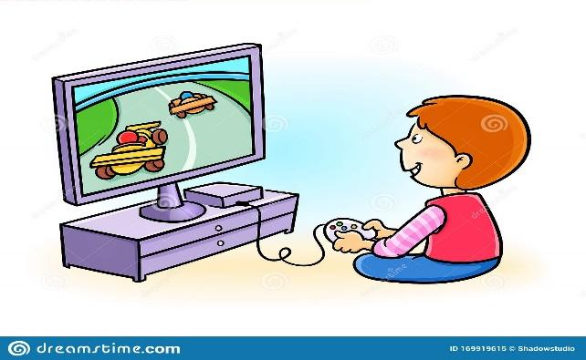  11 |  |  | 6  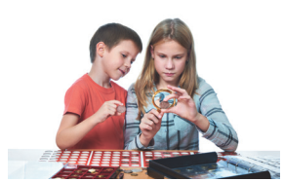
  10 | 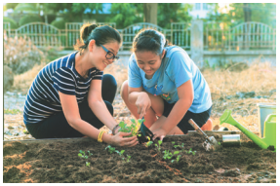  9 | 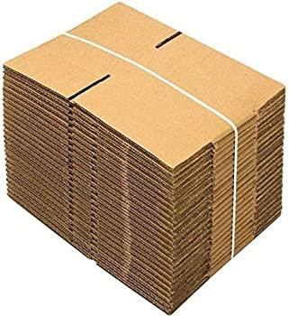  8 | 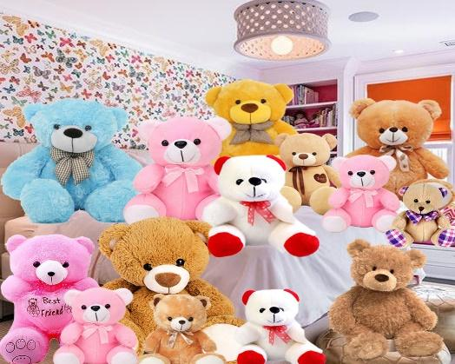  7

Answer key (for pictures part II)
- building dollhouses | - making models | - glue | - responsibility | - doing judo | - collecting coins
7. collecting teddy bears | 8. cardboard | 9. gardening | 10. doing yoga | 11. computer games | 12. riding a horse

Part 3. Role-play – 0.6 pt (~3 questions/ 1 student)

2/3/ …hours a day
How much free time do you have a day?

1

My favourite hobby is ……………………..
What is your favourite hobby?
2

I started this hobby (2)/……..years ago.
When did you start this hobby?
3

I share my hobby with my (mom/sister/……..
Who do you share your hobby with?
4

- …………………………………………………….……….
What do you need for this hobby?
5

What is its benefit? What benefit do you get from this hobby?
- …………………………………………………….……….

6

ROLE PLAY

