UNIT 5: NATURAL WONDERS OF VIET NAM

Lesson 1: Getting started – Geography Club!

I. Objectives
By the end of this lesson, students will be able to:

1. Knowledge
- Get an overview about the topic Natural wonders of Viet Nam
- Use vocabulary and structures to describe wonders of Viet Nam

2. Core competence
- Develop communication skills and creativity
- Be collaborative and supportive in pair work and teamwork
- Actively join in class activities

3. Personal qualities
- Develop self-study skills
- Develop their love for nature and some natural wonders of the country

II. Materials
- Grade 6 textbook, Unit 5, Getting started
- Computer connected to the internet
- Projector/ TV/ pictures and cards
- hoclieu.vn

Language analysis
Form | Meaning | Pronunciation
1. scenery (noun) | the natural features of an area | /ˈsiːnəri/
2. natural (adj) | not made by human | /ˈnætʃərəl/
3. wonder (noun) | something that fills you with surprise and admiration | /ˈwʌndə/
4. amazing (adj) | very good | /əˈmeɪzɪŋ/
5. island (noun) | a piece of land that is completely surrounded by water | /ˈaɪlənd/

Anticipated difficulty | Solution
Students may not have travelled and have no idea of any natural wonders of Viet Nam. | Prepare some short videos of Ha Long Bay, Ganh Da Dia, Son Doong Cave and other wonders of Viet Nam to show them.  *Suggested video link:  https://youtu.be/og_1u8RFmuI
Board Plan

Date of teaching

UNIT 5: NATURAL WONDERS OF VIET NAM

Lesson 1: Getting started

* Warm-up

I. Vocabulary:
- scenery (noun): [picture]
- natural (adj): [antonym] man-made
- wonders (noun): [picture]
- amazing (adj): [synonym] very good
- island (noun): [picture]
II. Practice:
Task 1: Listen and read. (p. 48)
Task 2: Complete the following sentences with the words from the box. (p. 49)
Task 3: Listen and repeat the words, then label the pictures. (p. 49)
Task 4: QUIZ: Work in groups. Choose the correct answer to each of the questions. (p. 49)
* Homework

Procedure:

Stage | Stage aim | Procedure | Interaction | Time
Warm-up | - To set the context for the listening and reading text.  - To introduce the topic of natural wonders of Viet Nam. | Guess what's behind the boxes.  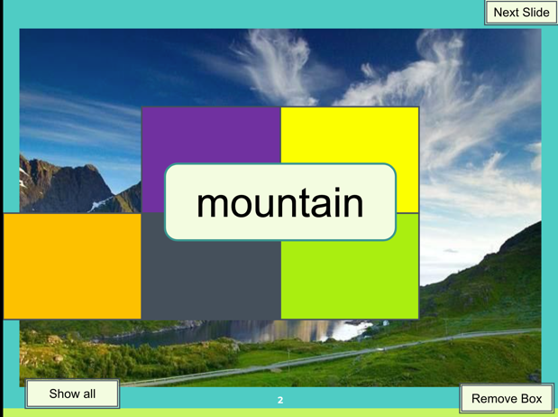  - Teacher shows the colourful boxes on the screen, asks students to look closely, raise their hands to say aloud what they can see  behind the boxes.  - Teacher removes the boxes one by one and asks  students to guess what is  behind the boxes after each box has been removed until students can tell the teacher what it is. | T-Ss | 5 mins
Lead-in | To lead in the topic of natural wonders of Viet Nam. | - Teacher draws students’ attention to the picture in the textbook and asks them questions about the picture.  Who are they?  What are they looking at?  What are they talking about?  Suggested answers:  They are Alice, Elena and Nick.  They are looking at some photos/ pictures.  They are talking about  attractive places in Viet Nam. | T-Ss | 2 mins
Presentation  (Vocab  pre-teaching) | To present the word meanings, ways of pronouncing them and forms. | VOCABULARY:  - Teacher introduces the vocabulary by:  showing the pictures illustrating the words;  providing the synonyms or antonyms of the words;  providing the definitions of the words.  scenery (noun): [picture]  natural (adj): [antonym] man-made  wonder (noun): [picture]  amazing (adj): [synonym] very good  island (noun): [picture]    scenery  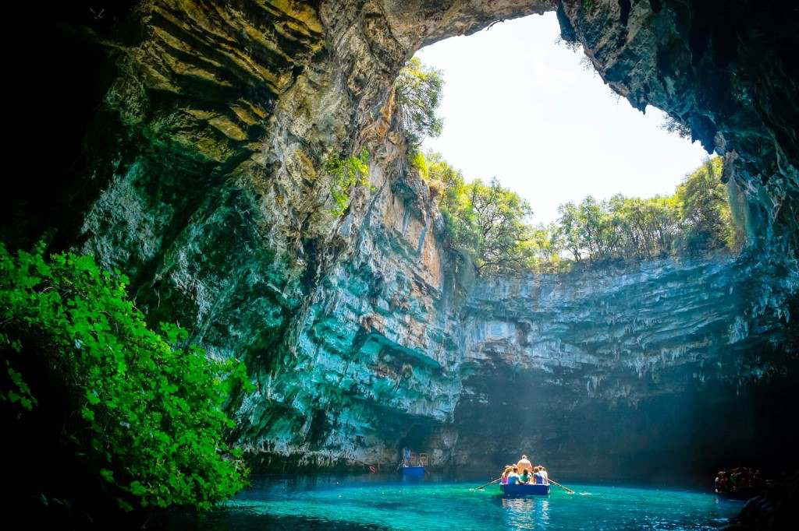  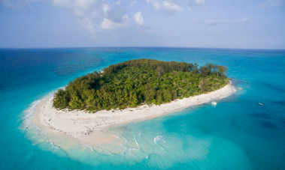  wonder  island | T-Ss | 5 mins
Practice | To practise using the targeted language and the background knowledge of natural wonders.  To help  students  identify the  location of the places  mentioned in the  conversation.  To help  students  focus on the use of  lexical items to describe the places.  To help students  visualize some lexical items related to the topic. | Task 1: Listen and read. (p.48)  - Teacher sets the context for the listening and reading text by asking students some questions:  What places can you see in the photos on the table?  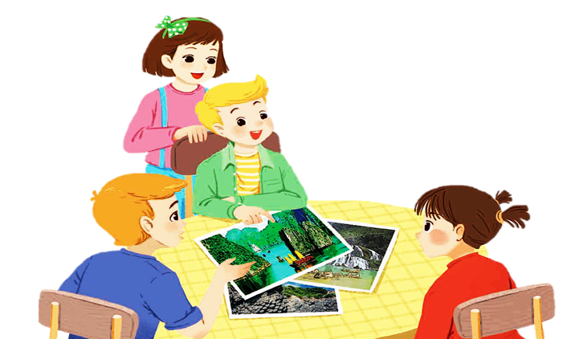  Why are they attractive?  etc.  - Teacher encourages students to give their answers, but do not tell them whether their answers are correct or in correct.  - Teacher plays the recording, asks students underline the words they have learnt in the vocabulary part.  - Teacher plays the recording more than once if necessary. Students listen and read.  - Teacher nominates some pairs of students to read the dialogue aloud.  - Teacher has students say the words in the text that they have underlined.  Task 2: Complete the following sentences with the words from the box. (p. 49)  - Teacher tells students to read the text again in order to find the words to complete the sentences independently.  - Teacher allows students to share their answers before discussing as a class.  - Teacher nominates students to give answers and corrects them if necessary.  Answer key:  1. amazing  2. islands  3. scenery  4. natural  5. wonders  Task 3: Listen and repeat the words, then label the pictures. (p. 49)  - Teacher asks students to look at the words in the box, listen and repeat.  - Teacher has students match the pictures with the  appropriate words independently.  - Teacher allows students to share their answers before discussing as a class.  - Teacher asks students to give answers and corrects them if necessary.  Answer key:  a. 6. desert  b. 8. island  c. 5. cave  d. 2. river  e. 3. waterfall  f. 1. mountain  g. 4. forest  h. 7. beach | T-Ss  T-Ss  T-Ss  Ss  T-Ss  T-Ss | 5 mins
Production | To give students a fun time revising what they have learnt so far in the lesson and  responding the questions about natural wonders. | Task 4: QUIZ Work in groups. Choose the correct answer to each of the questions. (p. 49)  - Teacher divides the class into groups of four or five and provides each group with a set of A and B signs.  - Teacher gives students time to read the quiz  carefully and choose the correct answers.  - Then, teacher lets students randomly select a number on the screen to choose the question.  - Students raise the correct signs of A or B for answering and say the answer aloud. The quickest group gets 5 points for each correct answer. At the end of the activity, 3 groups having the highest points are the winners. | T-Ss  Group work | 5 mins
Consolidation | To consolidate what students have learnt in the lesson. | Teacher asks students to talk about what they have learnt in the lesson. | T-Ss | 2 mins
Homework | To review and use the  language of lexical items related to  natural wonders. | Go to the internet and search for the information on your favourite natural wonder in Viet Nam and prepare a small talk between 1-2 minutes about it. | T-Ss | 1 min

UNIT 5: NATURAL WONDERS OF VIET NAM

Lesson 2: A closer look 1

I. Objectives
By the end of this lesson, students will be able to:

1. Knowledge
- Use lexical items related to the topic of natural wonders of Viet Nam
- Use the vocabularies and structures to talk about famous natural places
- Identify and pronounce the sounds /t/ and /d/

2. Core competence
- Develop communication skills and creativity
- Be collaborative and supportive in pair work and team work
- Actively join in class activities

3. Personal qualities
- Be ready to make share ideas among classmates
- Develop self-study skills

II. Materials
- Grade 6 textbook, Unit 5, A closer look 1
- Computer connected to the internet
- Projector/ TV/ pictures and posters.
- hoclieu.vn

Language analysis
Form | Meaning | Pronunciation
1. plaster (n) | a small piece of sticky cloth or plastic used to cover a cut in the skin | /ˈplɑːstər/
2. sleeping bag (nph) | a large bag for sleeping in outside | /ˈsliːpɪŋ bæɡ/
3. backpack (n) | a large bag used to carry things on your back when going camping or walking | /ˈbækpæk/
4. compass (n) | a device for finding direction with a needle that can move easily | /ˈkʌmpəs/
5. suncream (n) | ​ a substance that is put on the skin to protect it from being burned by the Sun | /ˈsʌn kriːm/
6. scissors (n) | a device used for cutting materials such as paper, cloth, and hair, consisting of two sharp blades that are joined in the middle, and two handles with holes to put fingers through | /ˈsɪzəz/

Anticipated difficulties | Solutions
1. Students may lack knowledge about some lexical items. | Provide students with the meaning and pronunciation of some lexical items.
2. Students may have underdeveloped listening, speaking and co-operating skills. | Play the recording as many times necessary.  Encourage students to work in pairs, in groups so that they can help each other.  Provide feedback and help if necessary.
3. Some students will excessively talk in the class. | Define expectations in explicit detail.  Have excessively talkative students practise.  Continue to define expectations in small chunks (before every activity).

Board Plan
Date of teaching
UNIT 5: NATURAL WONDERS OF VIET NAM
Lesson 2: A closer look 1
* Warm-up
Name the travel items
I. Vocabulary:
1. plaster (n)
2. sleeping bag (nph)
3. backpack (n)
4. compass (n)
5. suncream (n)
6. scissors (n)
Task 1: Write a word under each picture. Practise saying the word.
Task 2: Complete the following sentences. Use the words in 1.
Task 3: Now put the items in order of usefulness. Number 1 is the most useful, number 6 is the least useful on holiday.
II. Pronunciation:
Task 4: Listen and repeat the words.
Task 5: Listen and repeat. Pay attention to the bold-typed parts of the words.
III. Production:
* Whispering game
* Homework

Procedure

Stage | Stage aim | Procedure | Interaction | Time
Warm-up | To activate students’ prior knowledge and  vocabulary related to the topic, the targeted  vocabulary and its  pronunciation. | * Name the things needed for going camping:  - Teacher asks students to work in groups of 6.  - Teacher sets the context: “Next week, we are going camping in the forest. What should we bring?”  - Teacher give all groups 3 minutes to write down as many things as possible.  - Teacher goes around the class to provide help (if necessary).  - The group with the most correct answers will be the winner.  Suggested answer:  - tent  - sleeping bag  - compass  - suncream  - mobile phone  - food  - water  … | T-Ss  Ss-Ss | 5 mins
Lead in | To lead in the lesson about vocabulary and pronunciation. | Teacher leads students into the lesson by telling them that: “In today lesson, we are going to learn more travel items and two sounds /t/ and /d/.” | T-Ss | 2 mins
Presentation  (Vocab  pre-teaching) | To introduce six travel items using pictures. | VOCABULARY  Teacher introduces the vocabulary by providing the pictures of the words:  - plaster (n): [picture]  - sleeping bag (nph): [picture]  - backpack (n): [picture]  - compass (n): [picture]  - suncream (n): [picture]  - scissors (n): [picture]  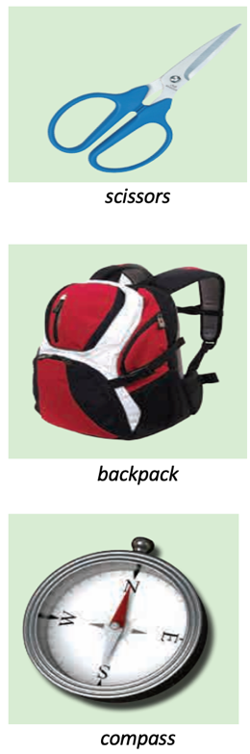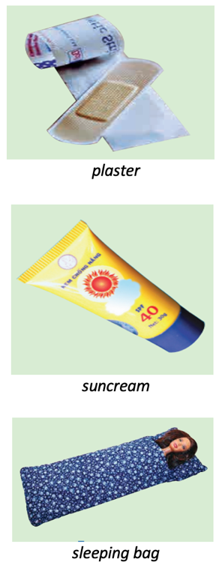 | T-Ss | 5 mins
Practice | To manipulate forms  (spelling and pronunciation) of six travel items.  To provide restricted practice in using travel items in context.  To give students authentic practice in using six travel items. | Task 1: Write a word under each picture. Practise saying the words. (p. 50)  - Teacher asks students to write the suitable word under each picture in 2 minutes.  - Students do the task.  - Teacher calls some students to give their answers.  - Teacher gives feedback and corrections (if necessary).  Answer key:  - plaster  - suncream  - sleeping bag  - scissors  - backpack  - compass  Task 2: Complete the following sentences. Use the words in 1. (p. 50)  - Teacher asks students to work in pairs and use the words in task 1 to complete the sentences. Students work in pairs and do the task.  - Teacher calls some pairs to share their answers with the whole class. Teacher gives feedback and corrections (if necessary).  Answer key:  - compass  - suncream  - sleeping bag  - backpack  - plaster  Task 3: Now put the items in order of usefulness. Number 1 is the most useful, number 6 is the least useful on holiday. (p. 50)  - Teacher asks students to work in groups of three.  - Teacher gives students 3 minutes to discuss and put the item in the order of usefulness.  - Teacher asks students to share their answers as a whole class. Teacher gives corrections (if necessary). | T-Ss  S  T-Ss  Pair work  T-Ss  Group work  T-Ss | 15 mins
Presentation  (Pre-teach the sounds  /t/ and  /d/) | To help students to identify how to pronounce the sounds /t/ and /d/. | PRONUNCIATION  - Teacher introduces two sounds /t/ and /d/ to students and lets them watch a video about how to pronounce these two sounds.  - Teacher asks students to give some words they know containing these sounds.  Suggested answers:  /t/: plaster, tower, letter, desert, want  /d/: need, island, guide, holiday, pagoda | T-Ss | 5 mins
Practice | To help students identify and practise the /t/ and /d/ sounds.  To help students  practise the sounds /t/ and /d/ in sentences. | Task 4: Listen and repeat the words. (p. 51)  - Teacher asks students to listen to the recording for the first time.  - Teacher asks students to listen and repeat the words for the second time.  Task 5: Listen and repeat. Pay attention to the bold-typed parts of the words. (p. 51)  - Teacher plays the recording for students to listen and asks students to repeat the sentences after they listen (with attention to the bold-typed parts of the words).  - Teacher calls some students randomly to read the sentences and gives correction (if necessary). | T-Ss  T-Ss  T-Ss | 5 mins
Production | To give students chance to apply what they have learnt. | * Game: Whispering  - Teacher divides the class into 4 big groups and asks students to stand in four lines.  - The member in the last place will make a sentence containing at least a word and a sound they have learnt; then, whisper the sentence to the next member of the group.  - They will continue until the member in the first place and this member will say the sentence aloud.  - The fastest group with the correct sentence will win the game.  Suggested sentences:  - I must bring a plaster when going camping.  - I want to visit a famous desert in the world.  - He lives in a quiet island. | Group work | 5 mins
Consolidation | To consolidate what students have learnt in the lesson. | Teacher asks students to talk about what they have learnt in the lesson. | T-Ss | 2 mins
Homework | To revise what they have learnt. | Find 5 more words with the sound /t/ and 5 more words with the sound /d/. Write them down and  practise pronouncing the words. | T-Ss | 1 min

UNIT 5: NATURAL WONDERS OF VIET NAM

Lesson 3: A closer look 2

Countable & uncountable nouns

Modal verbs: must and musn’t

I. Objectives
By the end of this lesson, students will be able to:

1. Knowledge
- Use countable nouns and uncountable nouns
- Use quantifiers some, many, much, a few, a little with countable nouns and
uncountable nouns
- Use “must” and “mustn’t” to make classroom rules

2. Core competence
- Develop communication skills and creativity
- Be collaborative and supportive in pair work and teamwork
- Actively join in class activities

3. Personal qualities
- Develop self-study skills

II. Materials
- Grade 6 textbook, Unit 5, A closer look 2
- Computer connected to the internet
- Projector/ TV/ pictures and set of word cards
- hoclieu.vn

Language analysis
Form | Meaning
- some, many, a few + countable noun  - some, much, a little + uncoutable nouns | - Countable nouns are for the people and things we can count using numbers. Countable nouns can be  singular: a rock, an island ..., or plural: rocks, islands ...  - Uncountable nouns are for the things that we cannot count with numbers. They usually do not have a plural form: cream, chocolate ...
- subject + must + base form  - subject + mustn’t + base form | We use must to say that something is very necessary or very important.  E.g. I must walk the dog when I get home.  E.g. You must answer all of the questions.  We use mustn't to say that doing something is not  allowed.  E.g. Students mustn't take mobile phones into the exam room.

Anticipated difficulties | Solutions
1. Students may be confused because some English uncountable nouns are countable in  Vietnamese, and vice versa. | Show and explain by illustrating with pictures or short videos when native people using uncountable nouns.  *Suggested video link  https://www.youtube.com/watch?v=tjPoypKI11g
2. Some students will excessively talk in the class. | - Define expectation in explicit detail.  - Have excessively talkative students practise.  - Continue to define expectations in small chunks (before every activity).

Board Plan

Date of teaching

Unit 5: NATURAL WONDERS OF VIET NAM

Lesson 3: A closer look 2
* Warm-up
Game: Unscrambled words
I. Grammar:
1. uncountable nouns don't have a plural form: cream, chocolate...
countable nouns can be singular: a rock, an island..., or plural: rocks,
islands...
2. some/ many/ a few + countable nouns
some/ much/ a little + uncountable nouns
3. subject + must + base form
subject + mustn’t + base form
II. Practice:
Task 1: Is the underlined noun countable or uncountable?
Task 2: Choose the correct option for each sentence.
Task 3: Fill each blank with must or mustn’t.
Task 4: Making classroom rules.
* Homework:
Exercise 3 (p. 52)

Procedure

Stage | Stage aim | Procedure | Interaction | Time
Warm-up | To put students into English mode:  attentive, interested and ready to participate; and to  prepare the class for a new topic. | * Game: Unscrambled words  - Teacher divides the class into groups of 3-6 students.  - Teacher delivers a set of unscrambled words of which some are countable nouns and some are uncountable nouns to each group.  - Students will have to work in groups to solve the quiz.  - The group with more correct words will be the winner.  Answer key:  1. cream 2. rock 3. island 4. rice 5. juice 6. butter 7. backpack 8. plaster | T-Ss  Group work | 4 mins
Lead-in | To get students  interested and find out what they have  already known. | - Teacher writes on the board 2 words: “Countable” and “Uncountable”.  - Teacher draws students’ attention to the words finished in the game and ask them whether they know the types of these words.  - Teacher gives them the word cards and requires students to identify the category of each word.  - Teacher provides or confirms the answers and lead in the grammar focus of the lesson:  “The words “cream, rice, juice, butter” are uncountable nouns.  The words “rock, island, backpack,  plaster” are countable nouns.  Today we are going to learn more about countable and uncountable nouns.” | T-Ss | 3 mins
Presentation 1 | To elicit/ show the students when and how uncountable and countable nouns are used in sentences as well as when and how the quantifiers are used. | 1. Countable and Uncountable Nouns:  Task 1: Is the underlined noun  countable or uncountable? Write C (countable) or U (uncountable). (p. 51)  - Teacher has students complete the underlining activity individually.  - Teacher then asks students to swap their textbooks to check their  classmates’ answers.  Answer key:  1 – C  2 – U  3 – U  4 – C  5 – U  - Teacher draws students’ attention to the underlined words and confirm the use of countable and uncountable nouns “Countable nouns are for the people and things we can count using numbers. Countable nouns can be  singular. Uncountable nouns are for the things that we cannot count with numbers. They usually do not have a plural form.”  - Teacher then asks students to give some more examples of uncountable nouns that they know.  - Teacher reminds students of the definition of countable nouns.  “Countable nouns are for the people and things we can count using numbers”. Some English uncountable nouns are countable in Vietnamese. (E.g. advice, furniture…)  2. Some, many, much, a few, a little:  - Teacher gives students handouts of quantifiers and their usages.  - Teacher has students work in groups of 4 to match the the quantifiers with their usages.  Answer key:  QUANTIFIERS USE  1. many countable nouns, usually in negative statements and questions  2. much uncountable nouns, usually in negative statements and questions  3. a few countable nouns, means ‘some’  4. a little uncountable nouns, means ‘some’  5. some countable nouns, uncountable nouns  - Teacher then asks students to exchange their handout to check their classmates’ answers. | T-Ss  Ss-Ss  T-Ss  T-Ss  T-Ss  Ss-Ss | 6 mins  5 mins
Controlled Practice 1 | To check if students can use countable, uncountable nouns and quantifiers correctly. | Task 2: Choose the correct option for each sentence. (p. 52)  - Teacher has students work on the exercise individually before they compare the answers with each other.  - Teacher gives feedback as a class discussion.  Answer key:  - A  - B  - A  - B  - A | T-Ss | 5 mins
Presentation 2 | To elicit/ show the students when must and mustn't are used and how to make a  sentence with these modals. | - Students are asked to watch a video concerning school rules and answer the question “What school rules are there in the video?  *Video link: http://learnenglishkids.britishcouncil.org/grammar-videos/school-rules  - Teacher provides each pair of students with a copy of the script and the students watch the video a second time checking on the script and  highlighting the word(s) before each school rule.  - After watching the video, teacher elicits and discusses what rules students could understand in the video.  - This will allow the students to begin to identify the language item without a grammar explanation.  - After gathering answers from  students, teacher briefly summarizes the language item:  “We use must to say that something is very necessary or very important.”  “We use mustn’t to say that doing something is not allowed.”  - Teacher asks students to write the form of this targeted grammar into their notebook and make up from 1 to 2 sentences according to their  understading.  - Teacher calls out 1 – 2 students to read aloud their answers and check immediately in class. | T-Ss  Ss-Ss  T-Ss  T-Ss | 5 mins  2 mins
Controlled Practice 2 | To give written  consolidation of the  grammar and to use the grammar  correctly. | Task 4: Fill each blank with must or mustn’t. (p. 52)  - Teacher has students work on the exercise individually before they compare answers with each other.  - Teacher gives feedback as a class discussion.  Answer key:  - must  - musn’t  - must  - mustn’t  - must | T-Ss | 5 mins
Freer Practice 2 | To give students speaking practice to use must and mustn’t correctly to make a set of rules in school. | Task 5. Write some more rules for you and your classmates at school. (p. 52)  - Teacher divides the class into groups of 6 students.  - Teacher assigns the roles for each member by asking quetions:  + Who's leader?  + Who are rules makers / idea thinkers?  + Who's a note taker?  + Who's a presenter?  - Teacher asks students to work in group and make at least 3 classroom rules in 3 minutes.  - After that, the presenter of each team goes to the board and present their rules.  - The other teams listen and give comments on their friends’ ideas.  - Teacher gives complement or good mark to the group with suitable rules after getting suggestions/ comments from the class. | T-Ss  Ss-Ss | 8 mins
Recap | To consolidate what  students have learnt in the lesson. | Teacher asks students to talk about what they have learnt in the lesson. | T-Ss | 1 min
Homework | To reactivate the knowledge that  students have gained. | Teacher shows the QR code and link of Kahoot and asks students play the games as many times as they can to remember the words/ phrases and modal verbs they have learned in the lessons. | T-Ss | 1 min

UNIT 5: NATURAL WONDERS OF VIET NAM

Lesson 4: Communication

I. Objectives
By the end of this lesson, students will be able to gain:

1. Knowledge
- Make and accept appointments
- Have knowledge about a travel guide
- Use must and mustn’t to talk about what to prepare for a trip

2. Core competence
- Develop communication skills and creativity
- Be collaborative and supportive in pair work and team work
- Actively join in class activities

3. Personal qualities
- Be ready to make and share ideas among classmates
- Develop self-study skills

II. Materials
- Grade 6 textbook, Unit 5, Communication
- Computer connected to the internet
- Projector/ TV/ pictures and cards
- hoclieu.vn

Anticipated difficulties | Solutions
1. Students may lack knowledge about the necessary things they must bring and what to prepare for a trip. | Provide students with information they do not know.
2. Students may have underdeveloped reading, speaking and co-operating skills. | - Encourage students to work in pairs, in groups so that they can help each other.  - Provide feedback and help if necessary.
3. Some students will excessively talk in the class. | - Define expectation in explicit detail.  - Have excessively talkative students practise.  - Continue to define expectations in small chunks (before every activity).

Board Plan

Date of teaching

UNIT 5: NATURAL WONDERS OF VIET NAM

Lesson 4: Communication
* Warm-up

GAME: Pass the ball
I. Everyday English:
Task 1: Listen and read the conversation, paying attention to the highlighted parts.
Making and accepting appointments
  - Making appointments:
Let’s + V.
How about …?
  - Accepting appointments:
That’s fine.
Sure.
Task 2: Work in pairs. Make a short conversation, following the example.
II. A tour guide:
Task 3: Read the travel guide entry.
Task 4: Make a list of the things you must bring to the Himalayas. Then add things you mustn’t bring.
Task 5: Role-play. Tell what to prepare for the trip to the Himalayas and give
reasons.
* Homework

Procedure

Stage | Stage aim | Procedure | Interaction | Time
Warm-up | To review must and mustn’t. | GAME: Pass the ball  Teacher plays the music. When music’s on, students pass the ball as fast as they can. When music’s off, the student holding the ball has to make a sentence with must/ mustn’t. | T-Ss  Ss-Ss | 3 mins
Lead-in | To lead in the lesson about vocabulary and pronunciation. | - Teacher sets the scene.  “They are Duong and Steven. Steven wants Duong to go picnic with him this Sunday.  What structures can he use?  If Duong agrees, what does he say?”  - Students give their answers.  - Teacher leads students into the lesson by telling about what they are going to learn: “We are going to learn how to make and accept  appointments”. | T-Ss | 2 mins
* EVERYDAY ENGLISH
Presentation | To introduce how to make and accept  appointments. | * Making and accepting appointments  Task 1: Listen and read the short conversation, paying attention to the highlighted parts.  - Teacher asks students to listen and read the short conversation, paying attention to the highlighted parts.  - Teacher writes down highlighted parts on the board and asks students which is used to make appointments and which is used to accepting appointments.  - Teacher calls some students to share their opinions.  Teacher gives more explanations and elicit the form.  - Making appointments:  Let’s + V.  How about …?  - Accepting appointments:  That’s fine.  Sure. | T-Ss | 10 mins
Practice | To practise making and accepting appointments. | Task 2: Work in pairs. Make a short conversation, following the example in Task 1. (p. 53)  - Teacher asks students to work in pairs and make a short conversation, following the example.  - Teacher models with a volunteer.  - Students do the task in pairs.  Teacher calls some pairs to make a conversation in front of the class.  - Teacher gives feedback and corrections (if necessary) | Pair work  T-S  Ss  T-Ss | 7 mins
* A TOUR GUIDE
Pre-Reading | To help students set the scene. |   - Teacher shows the picture and ask students some questions:  “Next week, I am going mountain climbing. Can you guess where I am going to? (Himalayas)  Before we go, what should we read? (A tour guide)  What information can you read in a tour guide?” | T-Ss | 3 mins
While-  Reading | To help students have knowledge about a travel guide. | Task 3: Read the travel guide entry. (p. 53)  Teacher asks students to read the travel guide entry to check their guess and sets the time limit for reading task for 2 minutes.  Task 4: Make a list of the things you must bring to the Himalayas. Then add things you mustn’t bring. (p. 53)  In group of 3, students write as many things they must and mustn’t bring to the Himalayas as they can in 2 minutes.  Teacher calls some groups to give their answers and checks. | T-Ss  Group work | 7 mins
Post-Reading | To help students talk about what to prepare for a trip. | Task 5: Role-play being a tour guide and a tourist. Tell your partner what to prepare for their trip to the Himalayas, and give reasons.  - Teacher divide the class into 2 main group. One is a tour guide and one is a tourist.  - The tourist prepares the questions and the tour guide prepare the information in 2 minutes.  - Students work in pairs. Make a conversation.  - Teacher calls some pairs to talk in front of the class.  - Teacher asks students to peer check and then gives feedback. | Group work  T-Ss | 10 mins
Consolidation | To consolidate what students have learnt in the lesson. | Teacher asks students to talk about what they have learnt in the lesson. | T-Ss | 2 mins
Homework | To prepare for the next lesson: Skills 1. | Choose a natural attraction in your city and find out the information about it (interesting things about the place as well as what they must and mustn’t do there). | T-Ss | 1 min

UNIT 5: NATURAL WONDERS OF VIET NAM

Lesson 5: Skills 1

I. Objectives
By the end of this lesson, students will be able to gain:

1. Knowledge
- Develop reading skill for general and specific information about the topic
- Use the lexical items related to the topic ‘things in nature’ and ‘travel items’
- Use what they have learnt to talk about a famous place, and what people must/ mustn’t do there

2. Core competence
- Develop communication skills and creativity
- Be collaborative and supportive in pair work and teamwork
- Actively join in class activities

3. Personal qualities
- Be ready to make and share ideas among classmates
- Develop self-study skills

II. Materials
- Grade 6 textbook, Unit 5, Communication
- Computer connected to the internet
- Projector/ TV/ pictures and cards
- hoclieu.vn

Language analysis

Form | Meaning | Pronunciation
1. tourist attraction (n) | a place that people visit for pleasure and interest, usually while they are on holiday | /ˈtʊə.rɪst əˈtrækʃən/
2. wonder (n) | kỳ quan | /ˈwʌndər/
3. popular (adj) | liked, enjoyed, or supported by many people | /ˈpɒpjələr/
4. landscape (n) | everything you can see when you look across a large area of land, especially in the country | /ˈlændskeɪp/
5. slope (n) | a surface that rises at an angle, esp. a hill or mountain, or the angle at which something rises | /sləʊp/
6. sand dune (n) | a hill of sand made by the wind on the coast or in a desert | /ˈsænd ˌdjuːn/

Anticipated difficulties | Solutions
1. Students may lack knowledge about some lexical items. | Provide students with the meaning and pronunciation of words.
2. Students may have underdeveloped reading, speaking and co-operating skills. | - Let students read the text again (if needed).  - Create a comfortable and encouraging environment for students to speak.  - Encourage students to work in pairs, in groups so that they can help each other.  - Provide feedback and help if necessary.
3. Some students will excessively talk in the class. | - Define expectation in explicit detail.  - Have excessively talkative students practise.  - Continue to define expectations in small chunks (before every activity).

Board Plan

Date of teaching

UNIT 5: NATURAL WONDERS OF VIET NAM

Lesson 5: Skills 1

* Warm-up

Discussion

Task 1: Look at the pictures and make predictions about the reading. Then read and check your ideas.
I. Reading:
* Vocabulary:
- tourist attraction (n)
- wonder (n)
- popular (adj)
- landscape (n)
- slope (n)
- sand dune (n)
Task 2: Complete the sentences, using the words from the box.
Task 3: Read the text and answer the following questions.
II. Speaking:
Task 4: Work in pairs. Make notes. Add your own ideas. Tell your partner about the place.
Task 5: Some foreign visitors are visiting your city/ town/ area. Tell them some
interesting things about the place; what they must do or mustn’t do there.
* Homework

Procedure

Stage | Stage aim | Procedure | Interaction | Time
Warm-up | To introduce the topic of reading. | * Set the scene  - Teacher sets the scene: “Next month, I am going travelling. Guess where I will visit.”  - Let’s students guess the places by opening the boxes one by one. The pictures are hidden behind the boxes.    - Teacher shows the pictures on the screen.  - Teacher leads in the lesson by asking questions:  Have you ever been to these places?  Today, let’s see what they have.  * Discussing:  Task 1: Look at the pictures and make predictions about the reading. Then read and check your ideas. (p. 54)  - Teacher asks students to close the book.  - Teacher shows the pictures of the places and asks students to answer the questions:  1. What are the places?  2. What do you know about these places?    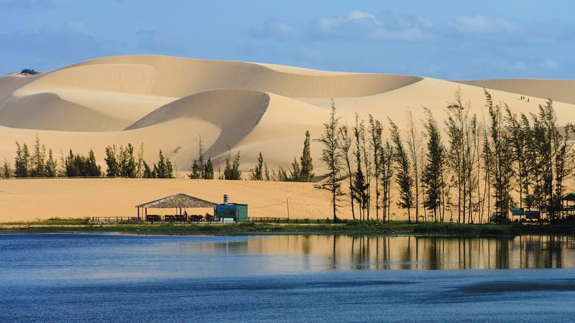  - Teacher invites some students to share their discussion in front of the class.  - Teacher asks students to open the book. Read the text and check their ideas. | T-Ss  Ss  T-Ss  T-Ss | 2 mins  3 mins
Pre-Reading  (Vocab  pre-teaching) | To provide students with some lexical items before reading the text.  To check  students  understanding of using  correct lexical items about the topic. | * VOCABULARY  Teacher introduces the vocabulary by:  - providing the synonyms or  antonyms of the words.  - providing the pictures of the words.  - providing the definition of the words.  - providing the meaning by  translating.  1. tourist attraction (n): a place that people visit for pleasure and interest, usually while they are on holiday  2. wonder (n): [meaning] kỳ quan  3. popular (adj): [synonym] well-known, common  4. landscape (n): [picture]  5. slope (n): [picture]  6. sand dune (nph): [picture]  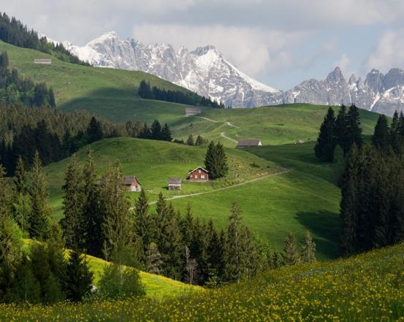  landscape  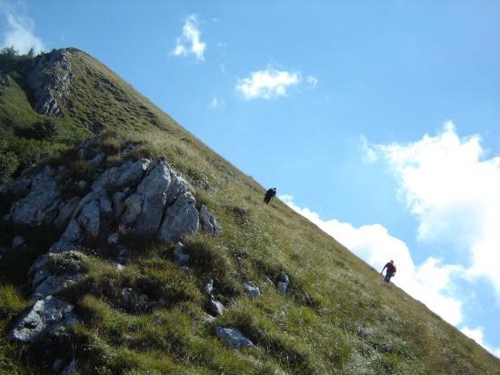  slope  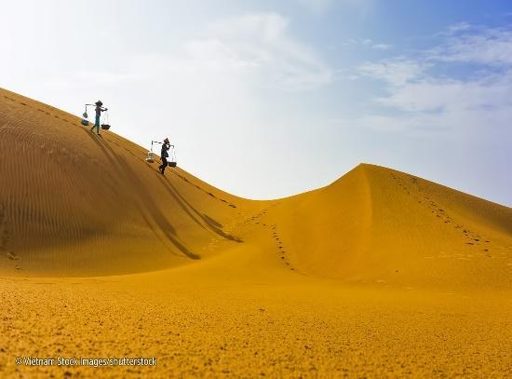  sand dune  Task 2. Complete the sentences, using the words from the box.  (p. 54)  - Teacher asks students to do Exercise 2 individually, in 3 minutes.  - After 3 minutes, teacher lets students swap their answers with their partners.  - Check the answers.  Answer key:  1. islands  2. wonder  3. desert  4. Remember  5. visit | T-Ss  S  Ss-Ss | 5 mins  2 mins
While-  Reading | To develop reading skill for general and specific information. | Task 3: Read the text and answer the following questions. (p. 54)  - Teacher asks students to go through the questions (1 – 5) to make sure that they understand them and know what information is being asked.  - Students underline the key word(s) in each question to locate the answer in the reading text.  - Teacher asks students to work individually to answer the questions. Teacher checks the answers.  Answer key:  - Ha Long Bay is in Quang Ninh.  - You can enjoy great seafood and join in exciting activities.  - No, there isn’t. It’s like a desert, not a real desert.  - You can have a picnic in Mui Ne by the beach.  - The best time to visit the Mui Ne Sand Dunes is early morning or late afternoon. | T-Ss  Ss  T-Ss | 7 mins
Post-  Reading | To check students’  reading comprehension and prepare for the next part. | Task 4: Work in pairs. Make notes about one of the places in the reading. You can add your own ideas. (p. 54)  - Teacher asks students to work in groups of 3 and make notes about one place in the reading.  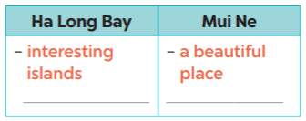  - Compare the notes with other groups.  - Teacher asks students to tell their partner about the place by looking at the notes.  Example:  Ha Long Bay has a lot of interesting islands. It ….  - Teacher goes around and offers help if needed.  - Students share their ideas with the whole class. | S-S | 4 mins
Pre-Speaking | To help students form the ideas for their speaking. | Task 5: Some foreign visitors are visiting your city/ town/ area. You are their tour guide. Tell them some interesting things about the place as well as what they must and mustn’t do there.  - Teacher asks students to work in groups of 6.  + Leader?  + Idea thinkers?  + Presenters?  + Drawers?  - Teacher asks students to choose a famous place in their city or area.  - Teacher asks students to discuss and make notes of the information they want to share with the class.  - Teacher asks students to refer to the questions as suggestions for their notes or they can do it in their own way.  + Where is it?  + What does it have?  + Are there any interesting things here?  + What must they do or mustn’t do there?  - Teacher goes around and offers help if needed. | Group work | 5 mins
While-Speaking | To help students use what they have learnt so far to talk about a  famous place. | - Teacher asks students to practise presenting in their groups.  - Teacher makes sure that students speak in full sentences.  - Then, teacher invites some groups to go to the board and share their preparation with the whole class. | T-Ss | 10 mins
Post-  Speaking | To help students  improve next time. | - Teacher allows students to give comments for their friends and vote for the most interesting and informative presentation.  - Teacher gives feedback and comments. | T-Ss  Ss-Ss | 4 mins
Consolidation | To consolidate what students have learnt in the lesson. | Teacher asks students to talk about what they have learnt in the lesson. | T-Ss | 2 mins
Homework | To prepare for the next lesson: Skills 2. | Teacher asks students to search for information about Phu Quoc Island. | T-Ss | 1 min

UNIT 5: NATURAL WONDERS OF VIET NAM

Lesson 6: Skills 2

I. Objectives
By the end of this lesson, students will be able to:

1. Knowledge
- Listen for specific information about a natural wonder
- Write a paragraph about a natural wonder.

2. Core competence
- Develop communication skills and creativity
- Be collaborative and supportive in pair work and teamwork
- Actively join in class activities

3. Personal qualities
- Develop self-study skills

II. Materials
- Grade 6 textbook, Unit 5, Skills 2
- Computer connected to the internet
- Projector/ TV/ pictures and jumbled word cards
- hoclieu.vn

Anticipated difficulties | Solutions
1. Students may lack knowledge and experiences about the topic. | Prepare some hand-outs in which key language of describing tourist attractions.
2. Students may have underdeveloped listening, writing and co-operating skills. | - Play the recording many times if any necessary.  - Encourage students to work in pairs, in groups so that they can help each other.  - Provide feedback and help if necessary.
3. Some students will excessively talk in the class. | - Define expectation in explicit detail.  - Have excessively talkative students practise.  - Continue to define expectations in small chunks (before every activity).

Board Plan

Date of teaching

UNIT 5: NATURAL WONDERS OF VIET NAM

Lesson 6: Skills 2

Warm-up:
* Game: Hidden picture
I. Listening:
Task 1: Work in groups. Discuss and answer the question.
Task 2: Listen and tick True or False.
II. Writing:
Task 3: Fill each blank in the network with the information about a travel
attraction you know.
Work in pairs. Talk about a travel attraction you know, using the filled network in task 3.
Task 4: Write a paragraph of about 50 words about a travel attraction you know. Use the information in Task 3.
* Homework:
Rewrite the paragraph in your notebook.

Procedure

Stage | Stage aim | Procedure | Interaction | Time
Warm-up | To introduce about the destination in the talk. | * Game: Hidden picture  - Teacher shows the slide with the picture that was hidden.  - Teacher gradually unhides the picture while having the class guess the name of the destination.    Suggested answers:  Phu Quoc Island | T-Ss | 2 mins
Lead-in | To lead in the listening task. | Teacher draws students’ attention to Phu Quoc island.  “Today we are going to listen to a talk about a famous natural wonder of Viet Nam. It’s Phu Quoc Island.” | T-Ss | 1 min
Pre-  Listening | To help students brainstorm about the  destination in the talk. | Task 1: Work in groups. Discuss and answer the question. (p. 55)  1. Teacher asks students to work in groups of four to answer the question:  “What do you know about Phu Quoc Island?”  2. Teacher asks students to talk in  Vietnamese (sometimes) if they do not have enough vocabulary in English.  3. Teacher asks students to share what they have discussed to see what they know about Phu Quoc Island.  Suggested answers:  - Phu Quoc is a beautiful island in Viet Nam.  - Tourists can enjoy many entertaining activities such as  visiting the night market, sightseeing, visiting the Safari,...  - The food in here is delicious and unique. | T-Ss  Group work | 4 mins
While-  Listening | To help students develop listening skill for specific  information (T / F). | Task 2: Listen and tick True or False. (p. 55)  * True – False prediction:  - Teacher asks students to go through the statements (1 – 5) to make sure that they understand and know what information they have to catch for the answers.  - Students underline the keyword(s) in each statement and guess whether they are True or False  individually.  * Listen and decide True or False:  - Teacher plays the recording once or twice. Teacher asks students to listen and tick the answers.  - Teacher asks students to compare their answers with the prediction made previously.  - Teacher calls on some students to read aloud their answers and correct the false one(s). Teacher checks students answers as a class.  Answer key:  1. T  2. F (It has beautiful beaches and green forest.)  3. T  4. F (Sailing and fishing are popular water sports.)  5. T | T-Ss  S  T-Ss  Ss-Ss  T-Ss | 10 mins
Pre-  Writing | To help students talk about a travel  attraction they know and collect information for their later writing. | Task 3: Fill each blank in the  network with the information about a travel attraction you know. (p. 55)  - Teacher models the task by summarizing the information of the talk with a student using the questions in the network below:  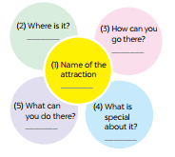  Suggested answers:  Teacher: What is the name of the  attraction?  Student: It’s Phu Quoc island.  Teacher: Where is it?  Student: It’s in Kien Giang.  Teacher: How can you go there?  Student: You can fly to the island because it has an international airport.  Teacher: What can you do there?  Student: I can visit the fishing villages, the national parks, beautiful beaches, temples, pagodas, etc. I can enjoy some water sports like sailing and fishing or buy interesting things at the night market.  Teacher: What is special about it?  Student: It’s one of the most famous natural wonders of Viet Nam and thousands of tourists visit it every year.  - Teacher asks students to choose a travel attraction they know and individually brainstorm about that place using the network in Task 3. (p. 55)  - Teacher goes round and help if needed.  - Teacher asks students to work in groups of four to introduce about their chosen places using the filled network.  - Teacher asks 1-2 students to stand up and talk about their chosen place then give them comments. | T-Ss  T-Ss  Group work  T-Ss | 10 mins
While-Writing | To teach students how to write a  paragraph of about 50 words about a travel  attraction they know. | Task 4: Write a paragraph of about 50 words about a travel attraction you know. Use the information in Task 3.  (p. 55)  - Teacher shows the picture in Task 4 and explains to students that they should begin the paragraph with a topic sentence.  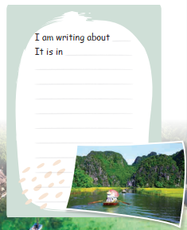  What are you writing about?  Other  information  - Teacher asks students to use ideas they have brainstormed to write a paragraph of about 50 words about a travel attraction they know.  - Teacher asks students to refer to the Reading passages in Skills 1 if needed.  - Teacher goes round and help if needed. | T-Ss  S | 12 mins
Post-Writing | To peer check, cross check and final check students’ writing. | - Teacher asks students to exchange their notebooks to check their friends’ writing.  - Teacher then gives feedback as a class discussion. | Ss-Ss  T-Ss | 3 mins
Consolidation | To consolidate what students have learnt in the lesson. | Teacher asks students to talk about what they have learnt in the lesson. | T-Ss | 2 mins
Homework | To allow students  finalize their  paragraph after being checked by friends and the teacher. | Rewrite the paraghraph in your notebook. | T-Ss | 1 min

UNIT 5: NATURAL WONDERS OF VIET NAM

Lesson 7: Looking back & Project

I. Objectives
By the end of this lesson, students will be able to:

1. Knowledge
- review language use and skills student have learned in Unit 5;
- apply what they have learnt (vocabulary and grammar) into practice through a project.

2. Core competence
- Develop communication skills and creativity
- Be collaborative and supportive in pair work and team work
- Actively join in class activities

3. Personal qualities
- Develop self-study skills

II. Materials
- Grade 6 textbook, Unit 3, Skills 2
- Computer connected to the internet
- Projector/ TV/ pictures and jumbled word cards
- hoclieu.vn

Anticipated difficulties | Solutions
1. Students may have underdeveloped speaking, writing and co-operating skills when doing project. | - Encourage students to work in pairs, in groups so that they can help each other.  - Provide feedback and help if necessary.
2. Some students will excessively talk in the class. | - Define expectation in explicit detail.  - Have excessive talking students practise.  - Continue to define expectations in small chunks (before every activity).

Board Plan

Date of teaching

UNIT 5: NATURAL WONDERS OF VIET NAM

Lesson 7: Looking back & Project

* Warm-up:
Brainstorming: things in nature and travel items
I. Looking back:
Task 1: Write the name for each picture.
Task 2: Matching.
Task 3: Write the words.
Task 4: Find the mistakes.
Task 5: Complete the dialogue, using must/ mustn’t.
II. Project:
Dream destination
* Homework

Procedure

Stage | Stage aim | Procedure | Interaction | Time
Warm-up | To revise the vocabulary related to the topic and lead in the next part of the lesson. | * Brainstorming:  - Teacher divides the class into 2 big teams A and B.  - Then, teacher asks students to work in groups of 6.  - Write 2 main phrases on the board.  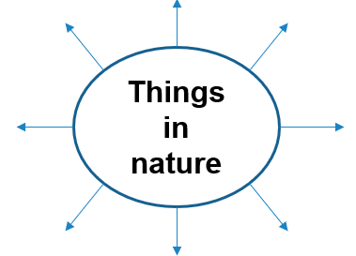  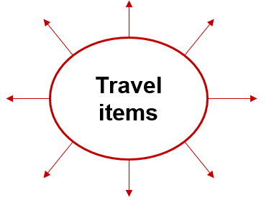  - One team (team A) finds all the words related to things in nature. Another team (team B) finds all the travel items they know.  - Teacher asks students to make a web map in 2 minutes, try to add as many words as possible.  - The fastest group with the most correct answers is the winner.  Suggested answers:  - Things in nature: desert, forest,  mountain, lake, river, valley, cave,  island, beach…  - Travel items: lighter, scissors, sleeping bag, compass, plastic, backpack… | T-Ss  Group work | 5 mins
Looking back | To help students  revise the vocabulary items they have learnt in the unit.  To help students revise the use of must/ mustn’t in context. | Task 1: Write the name for each picture. (p. 56)  - Teacher encourages students to complete the task individually.  - Teacher asks students to swap their books with their partners.  - Teacher shows the answer and check.  Answer key:  1. waterfall  2. cave  3. desert  4. river  5. beach  6. island  Task 2: Match the name of a natural  wonder on column A with a word  indicating it in column B.  - Teacher asks students to work in pairs.  - Teacher monitors the activity and lets them do it in 2 minutes.  - Teacher lets each pair answer.  Teacher checks the answers with the whole class.  Answer key:  1. d  2. c  3. a  4. e  5. f  6. b  Task 3: Write the words under the  pictures. (p. 56)  - Teacher asks students to do this exercise  individually.  - Teacher lets students compare their  answers in pairs before checking as a class.  Answer key:  1. scissors  2. sleeping bag  3. compass  4. backpack  5. plaster  Task 4: Find the mistake in each sentence and correct it. (p. 56)  - Teacher asks students to work  independently.  - Teacher asks students to read the sentences carefully and correct the mistakes.  - Students complete the task and discuss the answers.  - Teacher gives feedback as a class discussion.  Answer key  1. is 🡪 are  2. are 🡪 is  3. instrument 🡪 instruments  4. are 🡪 is  5. luggages 🡪 luggage  Task 5: Complete the dialogue, using must/ mustn’t. (p. 56)  - Teacher lets students to work in pairs and complete the activity.  - Teacher asks students to stand up and make a role play.  - Teacher checks the answers with the whole class.  Answer key:  1. must  2. must  3. mustn’t  4. must  5. mustn’t | S  Ss-Ss  T-Ss  T-Ss  T-Ss  S-S  T-Ss  T-Ss  S-S  T-Ss  S-S  T-Ss | 16 mins
Project | To allow students to apply what they have learnt  (vocabulary and  grammar) into  practice through  a project. | * DREAM DESTINATION:  (Making a poster/ travel brochure)  - Teacher sets the context:  + Teacher will be a tourist who is looking for a dream destination to go on holiday.  + Students will be the travel agents who have to suggest the tourist by providing their travel brochure (poster).  - Teacher divides the class into groups of 6. Each group will act as a travel agency.  - Teacher asks “the travel agencies” to  discuss and choose an interesting place they would like to visit (in Viet Nam or in the world).  - Teacher asks them to look for necessary  information for the visit, basically by discussing the suggested questions.  What is the natural wonder?  Where is it?  How can you go there?  What is it special about?  What can you do there?  …  - Students summarise the information and design A0 posters about the places they would like to promote.  - Teacher asks the class to listen to the reports and ask questions if they would like to.  - Students will critically evaluate all the posters, then give 1 vote for the most attractive poster/ place.  - Teacher gives comments and feedback to all groups and awards special prize to the group who has the most votes. | T-Ss  Group work  T-Ss | 20 mins
Consolidation | To consolidate what  students have learnt in the lesson. | Teacher asks students to talk about what they have learnt in the lesson and how they feel about their project. | T-Ss | 3 mins
Homework | To prepare for the next lesson. | Prepare for the next lesson: Unit 6 –  Getting started. | T-Ss | 1 min
* Source of pictures: Internet

