|  |  |
| --- | --- |
| **Tiếng Anh 8 Friends Plus** | **FP 8 - UNIT 1 - TEST 1**  **Test for Unit**  *Thời gian làm bài: 40 phút (Không kể thời gian giao đề)*  *-------------------------* |

**I. Listening: Listen and decide whether the statements are true or false.**

**Question 1.** The friends are shopping for summer clothes,

**A.** False  **B.** True

**Question 2.** The friends start their shopping at a boutique,

**A.** False  **B.** True

**Question 3.** The friends only try on a t-shirt.

**A.** False  **B.** True

**Question 4.** The friend likes the shirt and decides to buy it.

**A.** True  **B.** False

**Question 5.** The friends only shop at one store.

**A.** False  **B.** True

**Question 6.** What are the friends shopping for?

**A.** Wedding clothes  **B.** Work clothes

**C.** Winter clothes  **D.** Summer clothes

**Question 7.** Where do the friends start their shopping?

**A.** A department store  **B.** A grocery store

**C.** A new boutique  **D.** A sporting goods store

**Question 8.** What item does the friend try on first?

**A.** Shorts  **B.** A shirt  **C.** A dress  **D.** A jacket

**Question 9.** Does the friend like the shirt they try on?

**A.** No  **B.** Yes

**Question 10.** Do the friends shop at only one store?

**A.** Yes  **B.** No

**II. Pronunciation**

**Question 11.** Which word has the underlined part pronounced differently from that of the others?

**A.** food  **B.** suit  **C.** put  **D.** rule

**Question 12.** Which word has the underlined part pronounced differently from that of the others?

**A.** group  **B.** book  **C.** look  **D.** cook

**Question 13.** Which word has a different stress pattern from that of the others?

**A.** simultaneous  **B.** tournament

**C.** media  **D.** patterned

**Question 14.** Which word has a different stress pattern from that of the others?

**A.** generally  **B.** obviously

**C.** apparently  **D.** gadget

**III. Choose the answer (A, B, C or D) that best fits the space in each question.**

**Question 15.** Jean really loves wearing silk, especially **_______** silk.

**A.** obvious  **B.** absolute  **C.** apparent  **D.** patterned

**Question 16.** **_______** has changed the way people communicate and consume information.

**A.** TV  **B.** Life

**C.** Craze  **D.** Social media

**Question 17.** I **_______** my friends in Sapa this time last year. The weather was really cold.

**A.** to visit  **B.** visit

**C.** visited  **D.** was visiting

**Question 18.** They saw a robbery while they were shopping **_______** the market.

**A.** in  **B.** on  **C.** for  **D.** at

**Question 19.** What do you think of these trousers? – “ **_______**”

**A.** I hope to get a new one.  **B.** They are not really my styles.

**C.** I think I’ll take the shirts.  **D.** You can find a lot of these in this shop.

**Question 20.** When Simson **_______** home, everyone was singing and dancing happily.

**A.** come  **B.** came  **C.** comes  **D.** coming

**Question 21.** I’m going to a wedding party next week, but I don’t know what to wear. – “**_______**”

**A.** Let’s meet at a new clothing store on Sunday. We can find what suits you.

**B.** You can call me next week.

**C.** I’ll buy my sister a new dress.

**D.** Don’t worry. I’ll go on holiday that day.

**Question 22.** I always **_______** new clothes before buying them.

**A.** try in  **B.** try on  **C.** try as  **D.** try to

**Question 23.** We **_______** football together every Sunday, but now we don’t anymore.

**A.** played  **B.** play

**C.** used to play  **D.** use to play

**Question 24.** High-tech **_______** are everywhere in our modern world.

**A.** utensils  **B.** fad  **C.** pole  **D.** gadgets

**IV. Look at the signs. Choose the best answer (A, B, C or D).**

**Question 25.**

What does this sign mean?

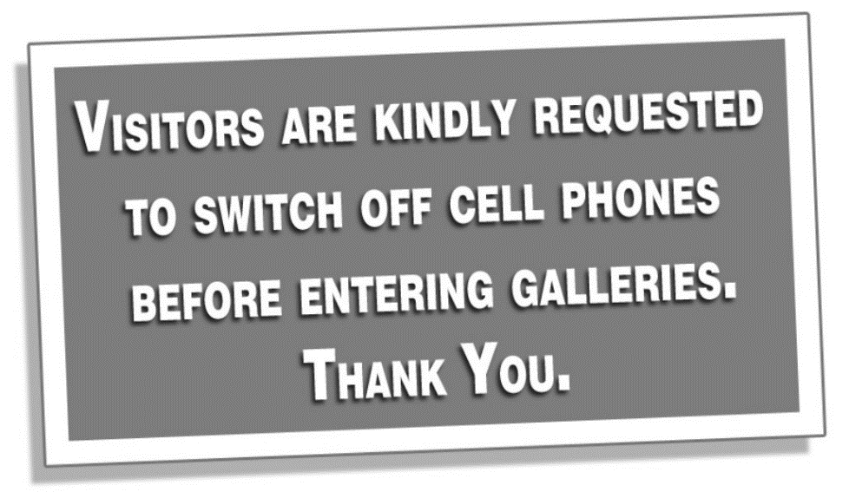

**A.** Visitors should turn off their cell phones when they are in the galleries.

**B.** Visitors are allowed in the galleries with a cell phone.

**C.** Visitors should turn off cell phones after visiting the galleries.

**D.** Visitors should use their cell phones in the galleries.

**Question 26.**

What does this sign mean?

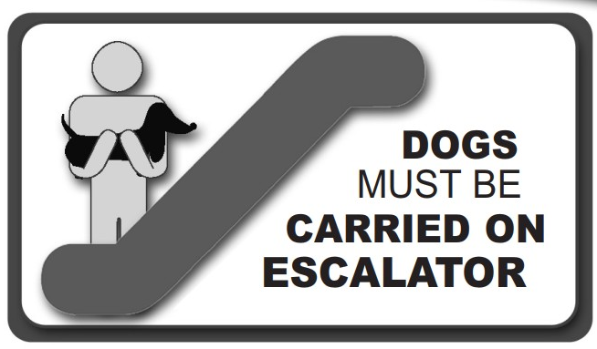

**A.** You don’t have to carry your dog on the escalator.

**B.** If you want, you can ride the escalator with your dog.

**C.** When using the escalator, you should carry your dog in your arms.

**D.** If you have a dog, you can't use the escalator.

**V. Read the following passage. Decide if the statements from 27 to 30 are True or False, and choose the correct answers (A, B, C or D) for questions 31 and 32.**

TikTok has become a popular platform among teenagers in recent years. TikTok is a social media app that allows users to create and share short, lip-sync, comedy, and talent videos. The app provides a fun and creative outlet for teenagers to express themselves and showcase their interests and talents. TikTok has also become a source of entertainment, with its endless stream of funny and relatable content.

However, it is important for teenagers to use TikTok responsibly and be aware of the potential risks. They should be mindful of the content they post and ensure it is appropriate and respectful to others. They should also be cautious of cyberbullying and be aware of their privacy settings.

Despite these concerns, TikTok remains a popular platform for teenagers to connect with others and express their creativity. By using TikTok wisely, teenagers can enjoy its many benefits while avoiding its potential drawbacks.

**Question 27.** TikTok is a platform for teenagers to showcase their talents and interests.

**A.** True  **B.** False

**Question 28.** TikTok is a source of entertainment with its endless stream of funny and relatable content.

**A.** True  **B.** False

**Question 29.** Teenagers should be mindful of the content they post and ensure it is appropriate.

**A.** True  **B.** False

**Question 30.** TikTok has no potential drawbacks for teenagers.

**A.** False  **B.** True

**Question 31.** What is TikTok?

**A.** A platform for cooking tutorials  **B.** An online shopping website

**C.** A social media app for teenagers  **D.** A virtual reality platform

**Question 32.** What is the importance of using TikTok wisely for teenagers?

**A.** To avoid cyberbullying  **B.** To increase their exposure

**C.** To become famous  **D.** To improve their popularity

**VI. Choose the word (A, B, C or D) that best fits the blank space in the following passage.**

Clothing is a big part of how a teen **___33____** himself or herself and shows his or her style. Teenagers often use what they wear to show who they are and what they like. With the rise of **___34____** and online shopping, teenagers have access to a wide range of fashion options, from trendy and fashionable to vintage and eclectic.

Teenagers choose what to wear **___35____** on both their personal style and how comfortable it is. Teenagers are wearing more and more clothes that are comfortable and useful, like athletic wear. Conscious consumers are also becoming more interested in brands that put an emphasis on sustainability and ethical production methods.

Teenagers can also be **___36____** by the pressure to fit in with certain beauty standards and fashion trends. Teenagers should know that their worth and value are not based on what they wear or how they look. Instead, they should dress in a way that makes them feel **___37____** and comfortable.

Overall, clothing is a big part of a teenager's life and a way for them to show who they are and what they like. Teenagers can make good decisions about what to wear by embracing their uniqueness and putting comfort and **____38___** values first.

**Question 33.**

**A.** expresses  **B.** communicates

**C.** thinks  **D.** believes

**Question 34.**

**A.** TV  **B.** social media

**C.** clothes  **D.** social life

**Question 35.**

**A.** played  **B.** made  **C.** based  **D.** found

**Question 36.**

**A.** thought  **B.** touched

**C.** influenced  **D.** impressed

**Question 37.**

**A.** self-confidence  **B.** confidence

**C.** confidently  **D.** confident

**Question 38.**

**A.** familiar  **B.** different  **C.** similar  **D.** personal

**VII. Supply the correct form of the word given in each sentence.**

**Question 39.** Seafood is a **____________** on this coastal village. (special)

**Question 40.** I like travelling because I can try **____________** food in different countries. (taste)

**Question 41.** Try to stay away from **____________** things because they will slow you down. (importance)

**Question 42.** They were **____________** by a knock at the door. (interruption)

**Question 43.** I love football because it is easy and **____________** to play. (expense)

**Question 44.** The sunset was **____________** beautiful. (amaze)

**VIII. Rearrange the groups of words in a correct order to make complete sentences.**

**Question 45.** With cell phones, / instantly upload / we can / images or game results /online.

________________________________________________________________________

**Question 46.** someone when we / We naturally / see them / want to join /enjoying themselves.

________________________________________________________________________

**IX. Rewrite each of the following sentences in another way so that it means almost the same as the sentence printed before it.**

**Question 47.** Many teenagers like posting photos and videos on social media.

Many teenagers are ______________________________________________

**Question 48.** Why don’t we go to this department store next Sunday?

How about ______________________________________________

**Question 49.** These red trainers are more expensive than the blue ones.

These blue ______________________________________________

**Question 50.** Max enjoyed surfing the internet, but now he doesn’t.

Max used ______________________________________________

**----HẾT---**