
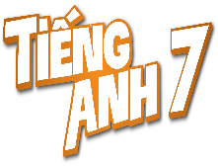
Tiết thứ ......
UNIT 4: MUSIC AND ARTS
Lesson 5: Skills 1
Class | Date of teaching | Attendence
7A | ..../09/2022
7B | ..../09/2022
7C | ..../09/2022
I. OBJECTIVES: By the end of this unit, students will be able to gain the following things:
1. Knowledge:
- Read for specific information about traditional art.
- Talk about a musical performance at their school.
+ Vocabulary: - Use the vocabulary to talk about Music and arts:
+ Grammar:
2. Competence:
a) General competencies:
- Develop communication skills
- Be collaborative and supportive in pair work and team work
- Actively join in class activities
b) Specific competencies:
- Develop communication skills.
- Be cooperative and supportive in pair work and teamwork.
- Actively join in class activities.
3. Qualities:
- To educate the love of music and art.
- Be ready to know the words about music and arts.
- Develop self-study skills.
II. PREPARATIONS
- Teacher: Grade 7 text book, laptop, projector / TV/ pictures and cards.....
- Students : Text books, studying equipment….
III. PROCEDURE:
Notes: In each activity, each step will be represented as following:
* Deliver the task.
* Implement the task.
* Discuss.
* Give comments or feedback.
Activity 1. WARM UP (5’-IW, GW)
* Aim:
To introduce the topic of reading.
To lead in the lesson.
* Content: Playing a game: FACE TO FACE
* Product: Having a chance to speak English and focus on the topic of the lesson..
* Implementation: Teacher’s instructions…
Teacher’s & Student’s activities | Content
GAME: FACE TO FACE  TRADITIONAL PERFORMANCES  * Teacher writes on the board “Traditional performances”, then divides the class into 2 teams and asks them to think of the words and list as many words as possible.  ** Students work in groups and have 1 minute to think of the words related to the topic.  *** Each member from each team takes turns to says one word.   Teacher confirms the correct answers. The team which has more than right will be the winner.  Teacher leads students into the lesson by telling what they are going to learn: “In the lesson today, we are going to read and find some information about one of the most famous traditional performances in Viet Nam.” | Suggested answers: Quan Ho singing, Xoan singing, Ca Tru singing, Nha nhac, Bai Choi Folk Singing, Cultural Space of Gong, A O show, Don Ca Tai Tu, water puppet show, …
Activity 2. KNOWLEDGE FORMATION (15'- PW, IW)
* Aim:
To provide students with some lexical items before reading the text.
To activate students’ knowledge of the topic of the reading text (a traditional art form).
* Content: Teach some new words.
* Product: Knowing more new words. Understanding the conversation; topic of the lesson, grammar points…
* Implementation: Teacher’s instructions…
Teacher’s & Student’s activities | Content
* Vocabulary  - Teacher introduces the vocabulary by:  + providing the synonym or antonym of the words;  + providing the pictures of the words;  + providing the definition of the words.  Concept check: Rub out and Remember technique  * DISCUSSION: LOOK AT THE PICTURES. DISCUSS THE QUESTIONS BELOW WITH A PARTNER.  * Teacher asks students to work in pairs to look at some pictures in Ex. 1 on page 46 to discuss with their partners.  ** Students work in pairs to do the task.  *** Teacher calls some students to check what they have discussed.   Teacher listens and does not need to care about whether they know or don’t know about these traditional art forms, whether they like them or not. | * Vocabulary  a. puppetry (n): [visual + explanation]  b. string (n): [visual + explanation]  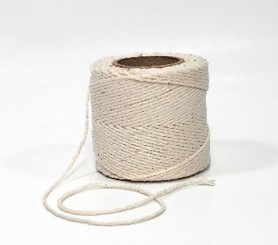  c. control (v): [ explanation]  Concept check: Rub out and Remember technique  * DISCUSSION: LOOK AT THE PICTURES. DISCUSS THE QUESTIONS BELOW WITH A PARTNER.  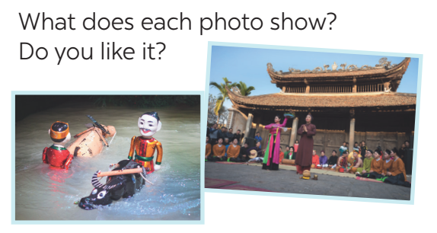
Activity 3. PRACTICE (15’-IW, PW, GW)
* Aim:
- To help students read to find some words in context, and their meaning.
- To help students further develop their reading skill for specific information (scanning).
- To give students some understanding of water puppetry – a traditional art form of north Viet Nam.
- To help Ss read for specific information about a traditional art form;
- To give Ss some understanding of water puppetry – a traditional art form of north Viet Nam.
- To help students ask and answer questions about a school musical performance.
* Product: Ss can learn how to do the excersises.
* Implementation: Teacher’s instructions…
Teacher’s Student’s activities | Content
1. Read the email and match the highlighted words with their meanings. (Ex 2, p. 46)  * Teacher has students read the text very quickly and focus on the four phrases given and the four highlighted words in passage.  ** Students do the task independently.  *** Teacher tells students to compare their answers in pairs before calling some of them to check.   Teacher confirms the correct answer and explains if needed.  2. Read the passage again and decide these statements are true or false.  * Teacher asks students to read the passage in detail to find the information to finish the task.  ** Students do the task independently.  *** Teachers has students compare their answers in pairs and call some students to give their ideas.   Teacher checks and confirms the correct answers. | 1. Read the email and match the highlighted words with their meanings. (Ex 2, p. 46)  Answer key:  1. performed  2. traditional  3. fantastic  4. festival  2. Read the passage again and decide these statements are true or false.  Statements True False  1. Mary went to see a puppet show in an art museum in the centre of Ha Noi. √  2. The show was presented by the artists who stood behind a screen in a pool. √  3. These shows are normally about everyday life in the countryside and in the city of Viet Nam. √  4. Tourists coming to Viet Nam love to see it because it is a special traditional art form. √
3. Read the email again and answer the questions. (Ex 3, p. 46)  * Teacher asks students to read the email again, work in pairs to ask and answer the questions.  ** Students work in pairs.  *** Teacher uses the game “Lucky numbers” to check their comprehension.  - Teacher divides the class into 2 teams.  - Each team, turn by turn, chooses one number: If the number is a question, they must answer it correctly to get 1 point. If the number is a lucky one, they will get 2 points without having to answer any questions.  - The team who gets more points will be the winner.   Teacher corrects the answers. | 3. Read the email again and answer the questions. (Ex 3, p. 46)   Teacher corrects the answers.  Answer key:  Lucky numbers: 1, 4, 8  Number 2: Question 1: Mary did.  Number 3: Question 2: In a pool.  Number 5: Question 3: The artists did.  Number 6: Question 4: (They are) about everyday life in the countryside of Viet Nam.  Number 7: Question 5: Yes, it is.
4. Work in pairs. Ask and answer about mark’s school musical performance last year. (Ex 4, p. 46)  * Teacher asks students to read about Mark’s school musical performance last year, then let them work in pairs to ask and answer questions about the performance.  ** Students work in pairs to do the task. Teacher goes around and corrects mistakes or gives help when necessary. Encourage students to ask more questions.  *** Teacher calls on some pairs to perform the task in front of the class.   Teacher and other students listen and comment. | 4. Work in pairs. Ask and answer about mark’s school musical performance last year. (Ex 4, p. 46)  * Suggested answer:  A: When was the performance?  B: On Saturday night.  A: How long did it last?  B: It lasted three hours.  A: Where did it take place?  B: In the schoolyard.  A: What did they perform?  B: They performed some plays, danced, sang songs, …  …
Activity 4. APPLICATION (7’-IW, PW, GW)
* Aim:
- To help students talk about how students in Viet Nam study music and arts.
- To help them compare their school and schools in other countries.
* Content: Students talk about how students in Viet Nam study music and arts.
* Product: Students’s dialogues.
* Implementation: Teacher’s instructions
5. Make a plan and talk. (Ex 5, p. 46)  Your school is going to have a musical performance to celebrate Teacher’s Day. Work in groups. Make a plan for the performance and talk about the items you will contribute.  * Teacher has students work in groups and asks them to give their ideas about the items they’d like to contribute  ** Students work in groups to do the task. Teacher goes around, listens and gives help if needed.  *** Teacher asks students to talk about the item they have agreed on, and how they will prepare for it.   Teacher comments.  * Home assignment  - Do exercises in the workbook.  - Prepare for the next lesson: Skills 2. | 5. Make a plan and talk. (Ex 5, p. 46)  Your school is going to have a musical performance to celebrate Teacher’s Day. Work in groups. Make a plan for the performance and talk about the items you will contribute.  Suggested answers:  A: I think we will perform a play.  B: A play takes a long time to prepare. I think we will sing in a choir.  C: Quang can sing solo. He has a nice voice for singing.  …  * Home assignment  - Do exercises in the workbook.  - Prepare for the next lesson: Skills 2.
V. FEEDBACK:
With 7A ……………………………………………………………………………..…
With 7B …………………………...……………………………………..……………
With 7C ………………………………………………………………………….……

