

Tiết thứ 11
UNIT 2: HEALTHY LIVING
Lesson 3: A closer look 2
Class | Date of teaching | Attendence
7A | ..../09/2022
7B | ..../09/2022
7C | ..../09/2022

I. OBJECTIVES: * By the end of this unit, students will be able to gain the following things:
1. Knowledge:
- To recognize and teach Simple sentences.
+ use the lexical items related to the topic Healthy living.
+ Know how to recognize and write simple sentences.
Types of simple sentences | Examples
1. Having a subject and a verb | I read.
2. Having an object | I read science books.
3. Having an adverb | I read science books every weekend.
+ Vocabulary: Use the words about healthy activities and health problems.
+ Pronounciation: the sounds /f/ and /v/ correctly;
+ Grammar: - Simple sentences;
2. Competence:
a) General competencies:
Students will be able to know more words and phrases about healthy activities and health problems; Develop communication skills and creativity; Actively join in class activities.
b) Specific competencies:
- Group work and independent working, pair work, linguistic competence, cooperative learning and communicative competence.
- Ability of using Present Simple Tense, some popular verbs of liking.
- Sts can introduce themselves or one another fluently.
3. Qualities: The love of living things; The awareness about importance of healthy living; Be ready to talk about Healthy living; Know some daily activities whether good or bad for health.
II. PREPARATIONS
Teacher: Grade 7 text book, laptop, TV, pictures and realia, Computer connected to the Internet. Sach mem.vn
Students: Text books, pencils, pics, blank papers, realia,….
III. PROCEDURE:
In each activity, each step will be represented as following:
* Task delivering
** Task performance
*** Report and discussion
 Judgement

Activity 1. WARM UP (5’-IW, GW)
* Aims:
- To activate students’ prior knowledge and vocabulary related to the targeted grammar.
- To lead into the new lesson.
* Content: Review the previous lesson or have some warm-up activities to create a friendly and relaxed atmosphere to inspire Ss to warm up to the new lesson.
* Product:Having a chance to speak English and focus on the topic of the lesson..
* Implementation:Teacher’s instructions…
Teacher’s & Student’s activities | Content
* JUMBLED SENTENCES  * Teacher gives instructions.  ** In groups, Ss:  - discuss to rearrange the words to make meaningful and completed sentences.  *** The group which can finish all the sentences first and has all correct answers will be the winner  ****Teacher checks and corrects Ss’ answer. | * JUMBLED SENTENCES  1. books / I / science / read /.  2. games / children / love / outdoor /.  3. their / every day / they / clean / house /.  4. night / watched / I / T.V / last /.  5. learn / words / every day / You / should / the / new /.
Activity 2. KNOWLEDGE FORMATION (15'- PW, IW)
* Aim: To help Ss identify simple sentences.
* Content: Identify simple sentences.
* Product:Ss learn how to use the use of simple sentences .
Teacher’s & Student’s activities | Content
Grammar  * Teacher draws students’ attention to the sentences in the answers from the Warm-up and writes 1 more example, then underlines the main parts of each sentence.  ** Ss look at the board and listen to the teacher’s questions to identify each part of a sentences.  *** Ss answer the teacher’s questions, then read REMEMBER box in Ss’ book.  ****Teacher tells Ss that a simple sentence has only one subject and one verb, some simple sentences also have an object, some simple sentences also have an adverb. | Simple sentences  a) I read.  S V  b) I science books.  S V O  c) I read science books every weekend.  S V O A  * Simple sentences  - Some simple sentences have a subject and a verb.  Example: I read.  - Some simple sentences also have an object.  Example: I read science books.  - Some simple sentences also have an adverb.  - I read science books every weekend.
Activity 3. PRACTICE (20’-IW, PW, GW)
* Aim: To help students identify the correct form of simple sentences; To help students identify the subject and the verb in a simple sentence; To help student identify different parts of a simple sentence and put them in the correct order to form a simple sentence; To give Ss further practice on writing out simple sentences from the prompts given; To allow Ss more advanced practice in forming a simple sentence from two separate ones.
* Content: Write S if subject is missing. V if the verb is.
* Product:Ss understand more using simple sentences correctly; Ss can do exercises correctly. Further practice with the present simple.
* Implementation:
Teacher’s & Student’s activities | Content
1. Tick (√) the simple sentences. (Ex 1, P₂₁)  * Teacher asks students to do the exercise individually and then compare their answers with a classmate.  ** Ss do the task individually.  *** Some Ss explain their choices.  ****Teacher confirms the correct answers. | 1. Tick (√) the simple sentences.  - Simple sentences: 1,2,4
2. Write S if the subject is missing from the sentence and V if the verb is.  * Teacher has students do this exercise individually by reading each sentence carefully to look for the two main parts.  ** Ss do the task individually.  *** Ss give and explain their answers.   Teacher confirms the correct answers. | 2. Write S if the subject is missing from the sentence and V if the verb is. (Ex 2, P₂₁)  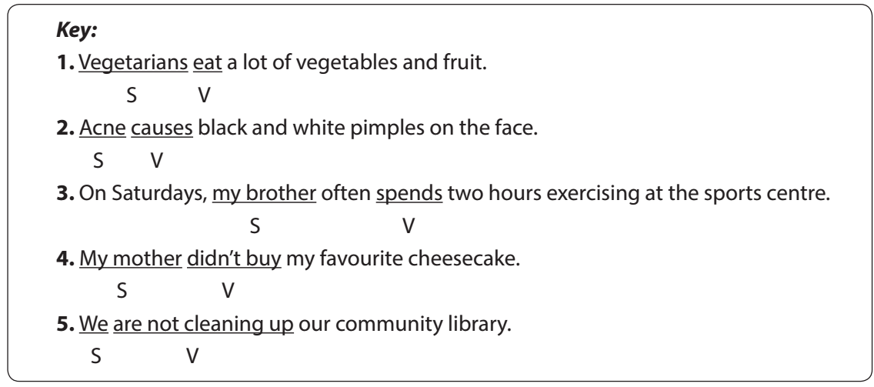
3. Rearrange the words and phrases to make simple sentences. (Ex 3, P₂₁)  * Teacher asks Ss to work in pairs.  ** Ss work in pairs to do the task.  *** Teacher calls on Ss to read aloud the complete sentences.   Teacher confirms the correct answers. | 3. Rearrange the words and phrases to make simple sentences.  1. My sister never drinks soft drinks.  2. Acne affects 80% of young people.  3. He has bread and eggs for breakfast.  4. We don't eat much fast food.  5. Fruit and vegetables have a lot of vitamins.
4. Write complete sentences from the prompts. You may have to change the words or add some. (Ex 4, P₂₁)  * Teacher asks Ss to look at the prompts of each sentence and decide the two main parts of the sentence.  ** Ss do the task individually.  *** Call on some students to read out their answers.   Teacher confirms the correct answers.  - Choose some typical errors and correct as a whole class without nominating the students’ names. | 4. Write complete sentences from the prompts. You may have to change the words or add some.  1. Tofu is healthy.  2. Many Vietnamese drink green tea.  3. She does not use suncream.  4. My father does not exercise every morning.  5. Most children have chapped lips and skin in winter.
5. Work in pairs. Discuss and write a simple sentence from the two given sentences. (Ex 5, P₂₁)  * Teacher asks Ss to work in pairs to read the two separate sentences, discuss and determine the two main parts for the new sentence.  ** Ss work in pairs.  *** Call on some Ss to write the sentences on the board.   Teacher corrects the answers.  - Choose some typical errors and correct as a whole class without nominating the students’ names. | 5. Work in pairs. Discuss and write a simple sentence from the two given sentences. (Ex 5, P₂₁)  1. We avoid sweetened food and soft drinks.  2. My dad and I love outdoor activities.  3. You should wear a hat and suncream.  4. My mother read and downloaded the health tips.
Activity 4. APPLICATION (5’-IW, PW, GW)
* Aim: To help Ss pronounce sounds /f/ and /v/ correctly in sentences.
* Content: Pratice saying the words pay attention to the underlined parts; Home assigment.
* Product:Ss learn how to pronounce the words , the underlined parts correctly; Take note Home assigment.
* Implementation: Teacher’s instructions
* Home assignment  - T assigns the homework.  - Ss copy their homework.  - T explains it carefully | Make more simple sentences.  - Do more exercises in workbook.  - Prepare new lesson. Communication
V. FEEDBACK:
With 7A ……………………………………………………………………………..…
With 7B …………………………...……………………………………..……………
With 7C ………………………………………………………………………….……

