School: ……………………………………….. | Date:…………………………………..
Class: ……………………………..................... | Period: …………………………..........

UNIT 8: TRADITIONS OF ETHNIC GROUPS IN VIETNAM
Review 1 (Page 104)

I. OBJECTIVES
By the end of the lesson, Ss will be able to:
1.1. Language knowledge and skills
- review words and phrases about the culture of ethnic groups in Vietnam (skirt, headscarf, embroidery, silver, folk games, traditional food, traditional music, corn, sticky rice, ethnic group, cloth)
- practice listening and reading skills.
- practice test taking skills.
1.2. Competences
- improve listening, reading skills.
- improve the use of English.
1.3. Attributes
- have positive attitude in English language learning so that they actively participate in all classroom activities.
- review the old lesson and have good preparation for the test.
II. TEACHING AIDS AND LEARNING MATERIALS
1. Teacher’s aids: Student book and Teacher’s book, class CDs, Digital Book (DCR phần mềm tương tác SB, DHA (từ vựng/ cấu trúc) phần mềm trò chơi tương tác), projector/interactive whiteboard / TV (if any), PowerPoint slides, handouts.
2. Students’ aids: Student’s book, workbook, notebook.
III. ASSESSMENT EVIDENCE
Performance Tasks | Performance Products | Assessment Tools
- Solve the crossword puzzle.  - Listening: Listen to five conversation and circle the correct answer (A, B, or C).  - Reading: Read the passage and write one word in each blank.  - Ask and answer the quiz. | - Ss’ answers.  - Ss’ answers.  - Ss’ answers.  - Ss’ answers. | - T’s feedback/Peers’ feedback.  - T’s feedback/Peers’ feedback.  - T’s feedback/Peers’ feedback.  - T’s feedback/Peers’ feedback.

IV. PROCEDURES
A. Warm up: (10’)
a) Objective: Introduce the new lesson and set the scene for Ss to acquire new language; get students' attention at the beginning of the class by enjoyable and short activities as well as to engage them in the follow-up steps.
b) Content: Review vocabulary words. Ss work in groups to do crossword puzzle.
c) Expected outcomes: Ss fill in the blanks with correct sentence to make meaningful sentences and do crossword well.
d) Organization of the activity:
TEACHER’S ACTIVITIES | STUDENTS’ ACTIVITIES
Crossword puzzle  - Have Ss solve the crossword puzzle.  - Tell Ss that the red word is the keyword of the new lesson.  - Divide the class into 6 teams. Each team takes turn to solve the puzzle.  - Ask Ss to read and fill in the blanks with correct words to make meaningful sentences.  - The games is finished when a student guesses the red word correctly.  Suggested sentences used for the corssword puzzle:  1. I think I’ll wear a nice, blue _______ and a pants to the party.  2. Many people in my ethnic village celebrate the festival from the old village ________.  3. My mom uses a _________ to clean the table.  4. My grandma makes ________ cake for Tết holiday.  5. I have a ________ necklace. It’s very beautiful and flashy.  6. Pu Péo is wearing a long skirt, two different vest, and a _______ on their head.  Answer keys  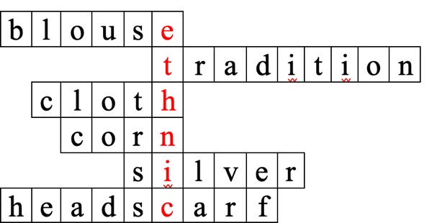 | - Look at the puzzle.  - Listen to T’ instruction.  - Sit in teams and ready to solve the crossword puzzle.  - Read and do the task.  - Raise hand to tell the red keyword to be the winner.

B. New lesson (30’)
- Activity 1: Listening (10’)
a) Objective: Help Ss improve their listening skill.
b) Content:
- Listen to five short conversation. Circle the correct answer (A, B, or C).
c) Expected outcomes: Ss listen in details and get familiar with the listening test format.
d) Organization of the activity:
TEACHER’S ACTIVITIES | STUDENTS’ ACTIVITIES
You will hear five short conversations. You will hear each conversation twice. There is one question for each conversation. For each question, choose the correct answer (A, B, or C).  - Use DCR to show the task.  - Have Ss read through the listening questions.  - Demonstrate the activity by using the example.  - Play the audio (CD 2 – Track 45).  - Have Ss check answers with pairs and then give answers.  - Check answers as a whole class. | - Read in silence.  - Listen and then give answers.  Answer keys  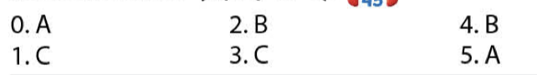
- Activity 2: Reading (10’)
a) Objective: Students can improve their reading skill.
b) Content:
- Read the article about the festival. Write one word in each blank.
c) Expected outcomes: Ss read for comprehension and get familiar with the reading test format.
d) Organization of the activity:
TEACHER’S ACTIVITIES | STUDENTS’ ACTIVITIES
Read about the festival. Write one word for each blank.  - Use DCR to show the task.  - Demonstrate the activity by using the example.  - Have Ss read the article and write one word in each blank. Underline the supporting ideas for their answers.  - Call Ss to give answers, explain.  - Give feedback and evaluation. | - Observe and listen.  - Work individually.  - Give answers, explain.  Answer keys  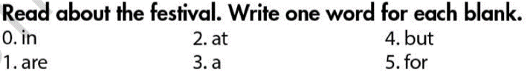

- Activity 3: Quick Quiz (10’)
a) Objective: Establish a conversation to answer different question about the ethnic group in Vietnam.
b) Content: Ss work in pairs to ask and answer the quick quiz.
c) Expected outcomes: Ss can comprehend the language adn vocabulary within the unit and develop listening, reading, and speaking skills.
d) Organization of the activity:
TEACHER’S ACTIVITIES | STUDENTS’ ACTIVITIES
Fill in the blanks with the words from the box.  - Have Ss work in pairs to ask and answer the questions.  - Have Ss read the passage in reading exercise (page 104) again and answer quick quiz.  - Have Ss ask and answer then swap roles.  - Call some pairs to talk in front of the class.  Quick Quiz  1. Where do the Thái live?  2. Do the Thái have their own language?  3. Where do Thái people often build villages?  4.What are Thái’s main crops?  5. What do Thái women wear?  6. What do Thái men wear?  7. Why do Thái men and women wash their hair on the last day of lunar new year?  8. What do Thái people do after finish washing their hair on the last day of Lunar new year? | - Work in pairs.  - Read the passage on page 104.  - Ask and answer then swap roles.  - Role play in front of the class.

C. Consolidation and homework assignments (5’)
* Consolidation:
- Asks ss to recall the main content of the lesson they have learnt.
- Consolidate more for ss to remember.
* Homework:
- Learn by heart all the new words.
- Do the review listening exercise part 1 (page 57) in the Workbook.
- Prepare: review 2 in the SB (page 105) – Vocabulary, Grammar, Pronunication, Writing.

V. Reflection
a. What I liked most about this lesson today:
…………………………………………………………………………………………
- What I learned from this lesson today:
…………………………………………………………………………………………
c. What I should improve for this lesson next time:
…………………………………………………………………………………………

