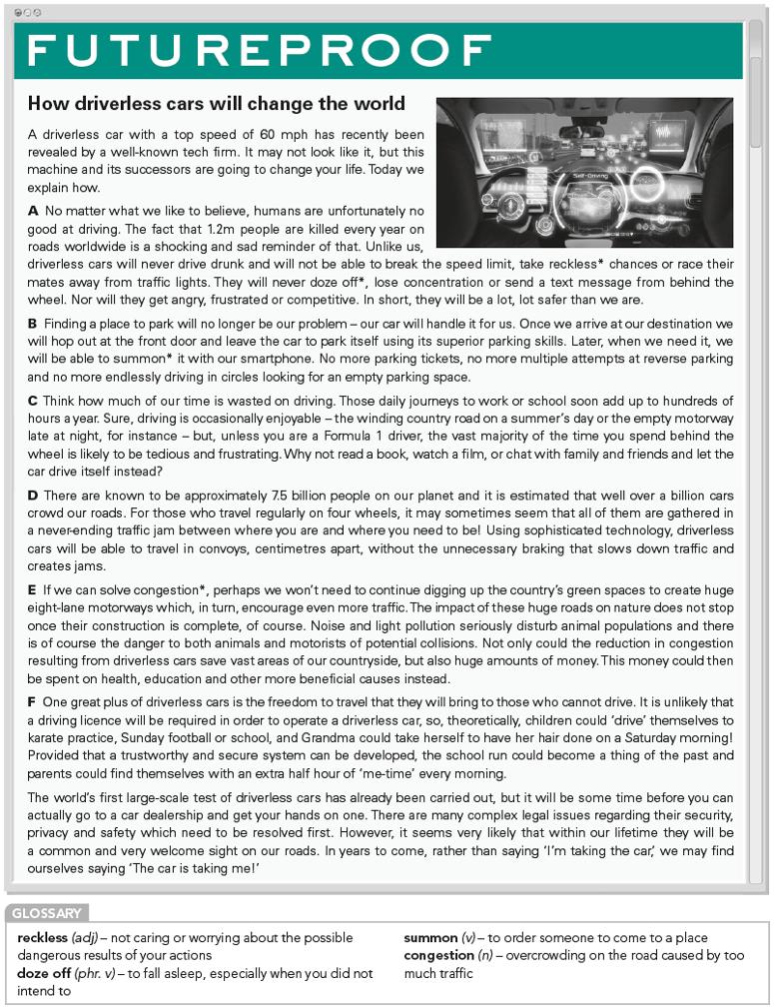

**Exercise 1: Read the text and label paragraphs A–F with the headings below. There is one extra heading.**

Cost

Free time

Traffic

Parking

Environment

Safety

Freedom

**Exercise 2: Read the text again and answer the questions.**

1 What causes of traffic accidents could be eliminated thanks to driverless cars?

2 What technology would car owners use to get their vehicles back after parking?

3 What activities could people spend time on instead of driving?

4 How can driverless cars reduce traffic congestion?

5 What impact could driverless cars have on green areas?

6 Which groups of people could benefit most from these cars?

7 What issues need to be solved before driverless cars become commonly available?

**Exercise 3: Complete the collocations to do with driving with words from the article.**

1. drive after consuming alcohol – drive _______/ _______ driving
2. drive faster than the law permits – _______ the speed limit
3. driving a motor vehicle – _______ the wheel
4. reversing into a parking space – _______ parking
5. driving round and round because you are lost or looking for a parking space - driving in _______
6. small countryside roads with lots of bends – _______ country roads
7. very wide roads used to travel long distances – _______ motorways
8. a place where cars are sold – a car _______
9. a document that states you are legally qualified to drive – a driving _______
10. a regular car journey to take children to school or bring them home – the school _______

**ANSWER KEY**

Exercise 1:

Free time - Paragraph C

Traffic - Paragraph D

Parking - Paragraph B

Environment - Paragraph E

Safety - Paragraph A

Freedom – Paragraph F

Exercise 2:

1 What causes of traffic accidents could be eliminated thanks to driverless cars?

**[Unlike us, driverless cars will never drink drunk…Nor they will get angry, frustrated or competitive.]**

2 What technology would car owners use to get their vehicles back after parking?

**smartphone**

3 What activities could people spend time on instead of driving?

**Read a book, watch a film, or chat with family and friends**

4 How can driverless cars reduce traffic congestion?

**[Using sophisticated technology … slows down traffic and creates jams.]**

5 What impact could driverless cars have on green areas?

**It can save a vast of green areas.**

6 Which groups of people could benefit most from these cars?

**People cannot drive**

7 What issues need to be solved before driverless cars become commonly available?

**Their security, privacy and safety**

Exercise 3:

1-drunk 2-break 3-behind 4-reverse 5-circles

6-winding 7- eight-lane 8-dealership 9-licence 10-run