School: ……………………………………….. | Date:……………………………………..
Class: ……………………………..................... | Period: 8

UNIT 1: FREE TIME
Lesson 3.1 – Reading & Writing, pages 12 & 13
1. Objectives
By the end of this lesson, students will be able to…
1.1. Language knowledge/ skills
- practice reading for gist and for detail
- learn how to write a descriptive passage
1.2. Competences
- improve Ss’ communication, collaboration, analytical, critical thinking skills.
1.3. Attributes
- have healthy lifestyles.
- spend free time in a good way.
2. Teaching aids and materials
- Teacher’s aids: Teacher’s aids: Student’s book and Teacher’s book, class CDs, DCR– Phần mềm tương tác trực quan, DHA – Ứng dụng trò chơi tương tác, projector / interactive whiteboard /TV (if any), PowerPoint slides.
- Students’ aids: Student’s book, Workbook, Notebook.
3. Assessment Evidence
Performance Tasks | Performance Products | Assessment Tools
- Read a passage and choose the best beginning sentence.  - Read and answer the questions.  - Unscramble the sentences and then number them. | - Ss’ answers.  - Ss’ answers.  - Ss’ answers. | - Observation.  - Observation.  - Observation.
4. Procedures
A. Warm up: 5’
a. Objective: to introduce the topic.
b. Content: Let’s talk.
c. Expected outcomes: Ss can talk about popular hobbies in their country.
d. Organization
Teacher’s activities | Students’ activities
Let’s talk! In pairs: What hobbies can you see in the pictures? What are some popular hobbies in your country?  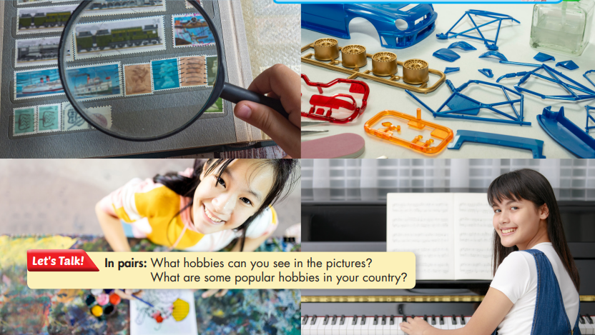  - Ask Ss to work in pairs, look at the picture and answer the questions:  What hobbies can you see in the pictures?  What are some popular hobbies in your country?  - Call some pairs to give their answers.  - Give feedback. | - Work in pairs, look at the picture and answer the questions.  Answer Keys  Collecting stamps, building models, make craft, practice the piano.  Ss’ own answers:
B. New lesson (35’)
1. Reading: 20’
a. Objectives: to help Ss improve their reading skills.
b. Content: tasks a, b, c and d.
c. Expected outcomes: Ss can read for specific details and have general idea about the text.
d. Organization
Teacher’s activities | Students’ activities
Pre-reading:  - Ask Ss to look at the picture and guess Linh’s hobby: trying new cakes or baking.  - Pick some Ss to give their answers.  - Write their guesses on the board.  Task a: Read Linh's passage and choose the best beginning sentence.  1. I love trying new cakes.  2. I have many hobbies, but I like baking best.  - Remind the Ss of the function of the beginning sentence (topic sentence): state the main idea of the passage.  - Ask Ss to read the passage and choose the best beginning sentence.  - Let Ss check the answer with their partners.  - Pick some Ss to give their answers.  - Check the answer.  Vocabulary:  - recipe (n) /ˈresəpi/ công thức nấu ăn  - prepare (v) /prɪˈper/ chuẩn bị  - mess (n) /mes/ tình trạng hỗn độn  - relax (v) /rɪˈlæks/ thư giãn  - Ask Ss to read the text and underline the words above.  - Get Ss to try to guess their meanings in the context first.  - Explain the meanings of the words.  - Ask Ss to listen and repeat chorally and individually.  - Check Ss’ remembering.  While-reading  Task b: Read and answer the questions.  1.When did Linh start her favorite hobby?  When she was ten.  2. What does the word them in paragraph 2 refer to? A. chocolate cookies B. recipes C. hobbies  3. Where does Linh do it?_________________  4. When does Linh usually bake? ___________  5. What does baking help Linh do? __________  - Use DCR to show the task. Ask Ss to read the questions carefully and underline the key words in each question.  - Get Ss to scan the text to find the key words.  - Ask Ss to answer the questions.  - Set the time and monitor the class.  - Check Ss’ answers (using the DCR).  Task c: Listen and read.  - Play the CD and ask Ss to listen and read.  - Pick some Ss to read the passage and correct their pronunciation if necessary. | - Read the passage and choose the best beginning sentence.  - Check the answer with their partners.  - Give their answers  Answer Keys:  2. I have many hobbies, but I like baking best.  - Read the text and underline the words.  - Try to guess their meanings in the context.  - Listen to the teacher and take notes the meanings of those words.  - Listen and repeat chorally and individually  - Answer the teacher.  - Read the questions carefully and underline the key words in each question.  - Scan the text to find the key words.  - Read the text again and answer the questions  Answer Keys:  1. When she was ten.  2.B  3. in her kitchen.  4. on the weekends.  5. It helps her relax.  -Listen and read.
Post – reading  Task d: In pairs: What's your favorite hobby? What do you like best about it?  - Ask Ss to work in pairs, answering the questions.  - Monitor the class and help them if necessary.  - Pick some Ss to share their ideas. | - Work in pairs to answer the questions.  - Share their ideas.
2. Writing: 15’
a. Objective: to help Ss know the structure of a descriptive passage and what to write in each part.
b. Content: tasks a and b.
c. Expected outcomes: Ss can order sentences to make a complete descriptive passage.
d. Organization
Teacher’s activities | Students’ activities
Task a: Read about writing basic descriptive passages. Then, read Linh's passage again and underline the topic sentence, five supporting ideas, and the concluding sentence.  Writing skill  Writing basic descriptive passages  To write a basic descriptive passage, you should:  1. Start with a topic sentence: tell the readers what your passage is about.  I have a lot of hobbies, but my favorite hobby is taking pictures.  2. Write about 3–5 supporting ideas to explain your topic. You can answer questions what, when, where, who, how, etc. about the topic to think of ideas to write about.  I started taking pictures when I was eight years old. I usually take lots of pictures with my friends and family. I take pictures at the park. I do it on the weekends.  3. End with a concluding sentence: say your main topic again in different words.  I think taking pictures is lots of fun, and I love it.  - Ask Ss to read about writing basic descriptive passages and answer the questions below in pairs:  a) How many parts are there in a basic descriptive passage?  b) What is the function of each part?  - Pick some Ss to give their answers.  - Check the answer.  - Ask Ss to read Linh's passage again and underline the topic sentence, five supporting ideas, and the concluding sentence.  - Let Ss check with their partners.  - Pick some Ss to give their answers.  - Check the answer.  Task b: Unscramble the sentences and then number them (1–5). Use the Writing skill box to help you.  A. my/with/swimming/dad./always/go/I  B. best./hobbies,/I/many/like/swimming/but/have/I  C. I/great/think/swimming/a/is/hobby.  D. five/started/old./when/I/years/I/swimming/was  E. swimming/on/the/go/my/pool/near/We/  weekends./house/the/at  - Ask Ss to Unscramble the sentences and then number them (1–5).  - Set the time and go around to help.  - Let Ss check with their partners.  - Pick some Ss to write their answers on the board.  - Check the answers. | - Read about writing basic descriptive passages and answer the questions in pairs.  - Give their answers  Answer Keys:  a) There are three parts: a topic sentence, supporting ideas, and a concluding sentence.  b) The topic sentence: tell the readers what your passage is about.  Supporting ideas: explain the topic by answering questions what, when, where, who, how, etc. about the topic.  The concluding sentence: say your main topic again in different words.  - Read Linh's passage again and underline the topic sentence, five supporting ideas, and the concluding sentence.  - Check with their partners.  - Give their answers.  Answer keys:  The topic sentence:  I have many hobbies, but I like baking best.  Supporting ideas:  I started this hobby when I was ten years old.  Now, I bake with my little sister.  We always bake in our lovely kitchen at home.  We usually bake on the weekends.  Baking also helps me relax after a busy week with lots of homework.  The concluding sentence:  Baking is a great hobby, and I really love baking!  - Unscramble the sentences and then number them (1–5).  - Check with their partners.  - Write their answers on the board.  Answer keys:  A. I always go swimming with my dad. 3  B. I have many hobbies, but I like swimming best. 1  C. I think swimming is a great hobby. 5  D. I started swimming when I was five years old. 2  E. We go swimming at the pool near my house on the weekends. 4
C. Consolidation and homework assignments: 5 minutes
- Vocabulary: recipe, prepare, mess, relax
- Do exercises in workbook on page 6.
- Prepare the next lesson: Lesson 3.2 – Speaking & Writing, page 13.
- Do the exercises in Tiếng Anh 8 i-Learn Smart World notebook (page 10).
5. Reflection

a. What I liked most about this lesson today:
…………………………………………………………………………………………
b. What I learned from this lesson today:
…………………………………………………………………………………………
c. What I should improve for this lesson next time:
…………………………………………………………………………………………

