

ENGLISH | TYPE | PRONUNCIATION | VIETNAMESE
avalanche | (n) | /ˈævəlæntʃ/ | tuyết lở
blizzard | (n) | /ˈblɪzərd/ | trận bão tuyết
disaster | (n) | /dɪˈzæstər/ | thảm họa
disastrous | (adj) | /dɪˈzæstrəs/ | thảm khốc
drought | (n): | /draʊt/ | hạn hán
earthquake | (n): | /ˈɜ:rθkweɪk/ | động đất
flood | (n): | /flʌd/ | lũ lụt
flooded | (adj): | /ˈflʌdɪd/ | bị ngập, úng
heat wave | (n): | /ˈhi:t weɪv/ | đợt nóng
landslide | (n): | /ˈlændslaɪd/ | sạt lở đất
tsunami | (n): | /tsu:ˈnɑ:mi/ | sóng thần
typhoon | (n): | /taɪˈfu:n/ | bão nhiệt đới
wildfire | (n): | /ˈwaɪldfaɪər/ | cháy rừng
battery | (n): | /ˈbætəri/ | pin
board up | (phr v): | /bɔ:rd ˈʌp/ | bịt kín (cửa, cửa sổ,…) bằng gỗ
fire extinguisher | (n): | /ˈfaɪər ɪkˌstɪŋɡwɪʃə/ | bình cứu hỏa
emergency service | (n): | /ɪˈmɜ:rdʒənsi ˌsɜ:rvɪs/ | dịch vụ cấp cứu, cứu hộ
escape plan | (n): | /ɪˈskeɪp plæn/ | sơ đồ thoát hiểm
stock up | (phr) | /stɑ:k ʌp/ | dự trữ
first aid kit | (n) | /ˌfɜ:rst ˈeɪd kɪt/ | bộ sơ cứu
flashlight | (n) | /ˈflæʃlaɪt/ | đèn pin
supply | (n) | /səˈplaɪ/ | sự cung cấp
supply | (v) | /səˈplaɪ/ | cung cấp
supplier | (n) | /səˈplaɪə/ | nhà cung cấp
task | (n) | /tæsk/ | nhiệm vụ
supplies | (n, pl) | /səˈplaɪz/ | nhu yếu phẩm
expect | (v) | /ɪkˈspekt/ | dự báo, cho là, kỳ vọng
expectation | (n) | /ˌekspekˈteɪʃən/ | sự kỳ vọng
immediate | (adj) | /ɪˈmi:diət/ | tức thời
immediately | (adv): | /ɪˈmi:diətli/ | ngay lập tức
inform | (v) | /ɪnˈfɔ:rm/ | thông báo
informative | (adj) | /ɪnˈfɔrmətɪv/ | cung cấp nhiều
information | (n) | /ˌɪnfərˈmeɪʃən/ | thông tin
warn | (v) | /wɔ:rn/ | cảnh báo
warning | (n) | /ˈwɔ:rnɪŋ/ | sự cảnh báo

earthquake | landslide | flashlight | avalanche
volcanic eruption | fire extinguisher | tropical storm | thunder
supplies | tsunami | typhoon | first aid kit

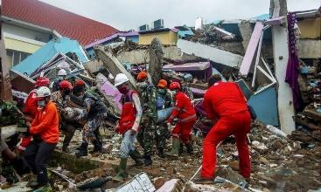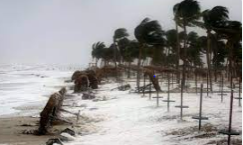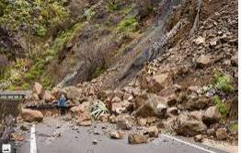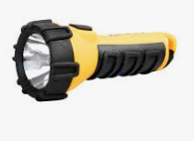

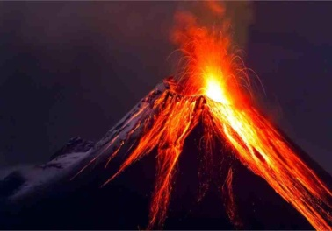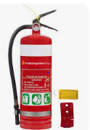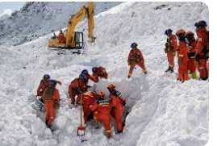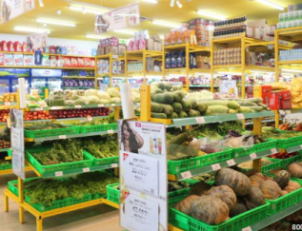

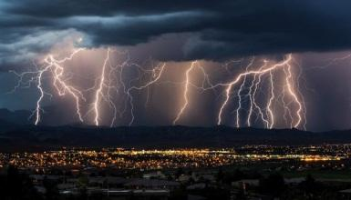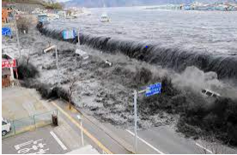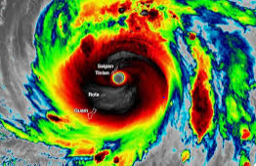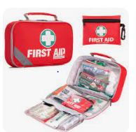

- flood | 1- | - shaking of the surface of earth, caused by sudden movement in the Earth’s crust.
- drought | 2- | - a storm in which the air moves very quickly in a circle.
- Wildfire | 3- | - a fire in an area of combustible vegetation that occurs in the countryside or rural area.
- Typhoon | 4- | - Natural occurrences where an area or land that is become submerged in water.
- Tsunami | 5- | - Period of time when an area experiences below normal precipitation
- Landslide | 6- | - molten rock, ash and steam pour through a vent in the earth’s crust
- Earthquake | 7- | - a series of waves in a water body caused by the displacement of a large volume of water
- Volcanic eruption | 8- | - a lot of rocks and earth fall down a hill.
- tornado | 9- | - A mass of snow, ice, and rock that falls down the side of a mountain
- avalanche | 10- | - A large amount of wet earth that suddenly falls down a hill.
- mudslide | 11- | - A very strong wind that goes quickly round in a circle or funnel.
- blizzard | 12- | - a snowstorm with powerful wind

1. | The waves of the_________ were so huge that it destroyed everything on the beach.
A. tornado |  | B. hurricane | C. tsunami | D. earthquake
2. | Five skiers are missing after the_________ in the Alps.
A. drought |  | B. landslide | C. flood | D. avalanche
3. | After the_________ all the houses were left under water.
A. flood |  | B. tornado | C. typhoon | D. mudslide
4. | It took firefighters five days to put out the_________.
A. hurricane |  | B. forest fire | C. tsunami | D. drought
5. | A period of 3- 4 months without rain will cause a severe_________.
A. typhoon |  | B. earthquake | C. drought | D. flood

- The_________ picked up the car and threw it 100 meters into the air. That’s an incredibly strong wind!

A. tornado B. volcanic eruption C. landslide D. typhoon

- The_________ shook parts of the region around Tokyo on Saturday. It was 5 on the Richter Scale.

A. hurricane B. flood C. earthquake D. tornado

- _________ occur when a large amount of water causes the rapid erosion of soil on a steep slope.

A. Tsunamis | B. Tornados | C. Avalanches | D. Mudslides
9. A big storm in the Pacific is known as a_________.
A. avalanche | B. typhoon | C. tsunami | D. tornado
10. Mount Merapi in Indonesia is a famous_________.
A. landslide | B. typhoon | C. volcano | D. tornado

debris | tornadoes | disasters | accommodation | havoc
victims | mudslide | property | supplies | flood

1. The_________ was overwhelming and the City was soon drowned.
- The_________ was overwhelming and the City was soon drowned.

- Teams of people are still clearing the_________ from damaged trees and houses after the tornado.

- Temporary housing can be provided to victims when natural______ strike.

- The storm wreaked_________ in the garden, uprooting trees and blowing a fence down.

- _________can destroy buildings, flip cars, and create deadly flying debris.

6. Four people were reported killed when a buried their house.
- Many people lost their homes due to the earthquake and are staying in temporary

_________ until their houses are rebuilt.

- Food, clean water and medical_________ arrived three days after the typhoon.

- A natural disaster can cause loss of life or damage to_________.

- The government is sending aid to flood_________.

- Earthquakes cause the ground to move and shake_________. (violent)
- Rescue experts can identify_________ victims with modern methods. (bury)
- Mount Mayon volcano caused a major_________ in the Philippines. (erupt)
- Volcanic tremor is the rhythmic ground_________. (shake)
- Despite all the modern technology available to us, we’re still_________ against earthquakes. (help)
- The remove of_________ debris can be rapidly finished by machines. (scatter)
- Indonesia orders immediate_________ as highest alert issued for Bali volcano.(evacuate)
- We assisted them with the_________ of food and clothing. (provide)
- Linda was the most_________ typhoon to ever hit Southern Vietnam. (destroy)
- Medical_________ were sent to the earthquake victims yesterday. (supply)



◆ Wh-questions (Câu hỏi với từ để hỏi bắt đầu bằng Wh-)
– Chúng ta sử dụng câu hỏi với từ để hỏi Wh- khi muốn hỏi về thông tin chi tiết của một hành động hoặc sự việc.
Từ để hỏi | Cách dùng | Ví dụ
What | Hỏi về sự vật, sự việc | What was the biggest earthquake? – It was the Great Chilean Earthquake.
Where | Hỏi về nơi chốn | Where were the biggest wirefires? – They were in Siberia, Russia.
When | Hỏi về thời gian | When was the worst avalanche? – It was in 1970.
How wide | Hỏi về chiều rộng | How wide was the typhoon? – It was 200 miles wide.
How tall | Hỏi về chiều cao | How tall was the tsunami? – It was 50 meters tall.
How long | Hỏi về chiều dài/khoảng thời gian | How long was the drought? – It lasted two years.
How many | Hỏi về số lượng (với danh từ đếm được) | How many houses did the typhoon damage? – 20,000 houses.
How much | Hỏi về lượng (với danh từ không đếm được) | How much damage did the flood cause?

◆ Prepositions of place (Giới từ chỉ vị trí)
Giới từ chỉ vị trí được dùng để nói về vị trí của một đồ vật hoặc một người.
in front of /ɪnˈfrʌntəf/: phía trước | Let’s meet in front of the movie theater.
behind /bɪˈhaɪnd/: phía sau | Shall we meet behind the market?
next to /ˈnekstə/: bên cạnh | The water park is next to the supermarket.
near /nɪər/: gần | Keep your phone near you at all times.
opposite /ˈɑ:pəzɪt/: đối diện | The bowling alley is opposite the ice rink.
under /ˈʌndər/: ngay bên dưới | The cats are under the bridge.
below /bɪˈloʊ/: ở vị trí thấp hơn | The kitchen is below her bedroom.
above /əˈbʌv/: ở vị trí cao hơn | The new room is above the garage.
inside /ɪnˈsaɪd/: bên trong | Keep children and pets inside the house.
outside /aʊtˈsaɪd/: bên ngoài | You shouldn’t go outside of your house.
*Ôn lại cách sử dụng 3 giới từ in, on at
*Lưu ý:
Sự khác biệt giữa in front of và opposite:
– Dùng in front of để miêu tả vị trí trước, sau của hai sự vật.
– Dùng opposite khi hai sự vật được nói đến bị phân cách bởi một sự vật khác ở giữa.
Cách đọc giới từ to
– Trước phụ âm /tə/, e.g. next to me /ˈnekstəˌmi/
– Trước nguyên âm /tu/, e.g. next to us /ˈnekstuˌ_{(w)}ʌs/
◆ Prepositions of movement (Giới từ chỉ sự chuyển động)
Giới từ chỉ sự chuyển động được dùng để nói sự di chuyển từ nơi này sang nơi khác.
to /tə/: đến, về hướng | Move to higher ground.
into /ˈɪntə/: vào trong | Don’t drive or walk into flood water.
onto /ˈɑ:ntə/: lên trên | The dog jumped onto the chair.
across /əˈkrɔ:s/: từ bên này sang bên kia (đường) | She walked across the road.
along /əˈlɔ:ŋ/: dọc theo | We walked along the beach collecting small crabs in a bucket.
out of /ˈautəv/: ra khỏi | They got out of the car and come into the house.
over /ˈoʊvə/: bên trên, bên kia (cầu, sông…) | She climbed over the wall.
through /θru:/: xuyên qua | They walked slowly through the woods.

1. Go_______ ___the house! The winds are getting stronger.
2. You shouldn't go__________ ____on a stormy day.
3. If your house was on fire, you should get out of the house really fast and move__________safe place.
4. During an earthquake, try to get_____ _____things such as a table, a desk or a bed.
5. People climbed_____ ____ the hill to avoid the tsunami.
6. You should seek shelter____ _____ a strong table or desk until the shaking stops.
7. People should work from home instead of going__ ______ work on a stormy day.
8. Run___ ___ the hill before the tsunami arrives.
9. Due to the road conditions, the authority warned people not to drive__ _____ flood water.
10. Stay__ ____ your house during a blizzard.
11. During an earthquake, you should get ______ a desk because something could fall on you
12. People living near the beach should move _____ a safe place before a typhoon hits.

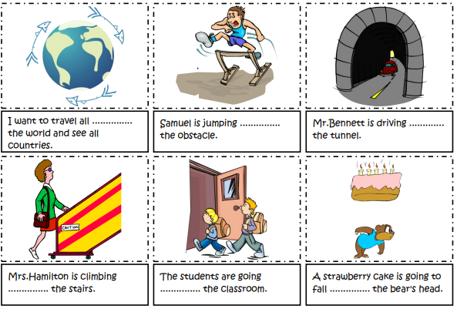

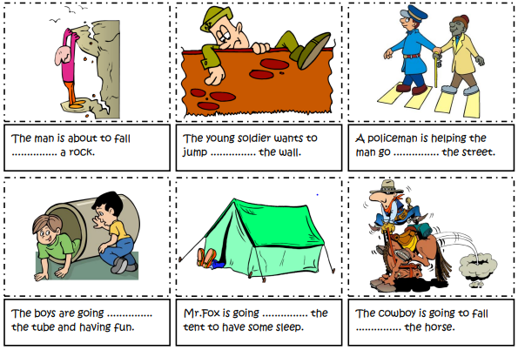

- Kate: ________ did th tsumina destroy?- Jack: The whole village.
- Where | - Which | - What | - Why
- Jim:________ was the wave? – Ann: About 10 meters tall.
- How much | - How many | - How long | - How tall
- Alex: __________ did the earthquake hit the city?- Tom: At midnight
- When | - What | - Where | - How
- Kim: ___________ was the biggest wildlife?- Ted: In Western Montana, the US.
- Which | - Where | - What | - How
5. Ben: _________did the blizzard cause across the city?- Roisie: A powerful cut.
A. Which | B. How | C. What | D Why
- ________was the biggest earthquake? – It was the Great Chilean Earthquake
A. When | B. How | C. What | D Why

- _________were the biggest wirefires? – They were in Siberia, Russia.
A. Which | B. How | C. What | D Where

- _____________ was the worst avalanche? – It was in 1970.
A. Which | B. When | C. What | D Why

- _____________was the typhoon? – It was 200 miles wide.
A. How wide | B. How tall | C. How long | D. How heavy

10. ______________ was the tsunami? – It was 50 meters tall.
A. How wide | B. How tall | C. How long | D. How heavy

11._______________ was the drought? – It lasted two years.
A. How wide | B. How tall | C. How long | D. How heavy

12.____________ houses did the typhoon damage? – 20,000 houses.

A. How wide | B. How much | C. How long | D. How many

13.______________ damage did the flood cause?
A. How wide | B. How much | C. How long | D. How many

1. We should keep fire extinguishers on a safe place.
A B C D
2. Stay inside a building when it is on fire.
A B C D
3. You should move up a safe place during a heavy flood.
A B C D
4. Stock in on emergency items such as first aid kits and supplies.
A B C D
5. Stay on a table to protect yourself when an earthquake happens.
A B C D
6. How much damage did the avalanche caused?
A B C D
7. How much people got hurt in the tsunami?
A B C D
8. What was you doing when the earthquake hit the city?
A B C D
9. Ann: "How tall was the wave?" - Ted: "It was over 20 meters long."
A B C D
10. Andy: "How many did it takes to stop the fire?" - Ben: "About 3 hours.
A B C D
11. How many people have to leave their houses because of the earthquake last week?
A B C D
12. If there's an earthquake, remember to get in the desk to stay away from fallen things.
A B C D
13.If you are in danger, calling the emergency service, they can help you.
A B C D


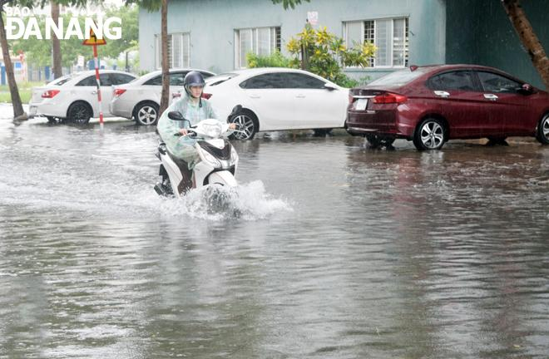 | 1. A flood is land ...................... by water that is not usually covered by water.  2. A flood which causes severely ...................... damage or loss of life to ...................... or livestock is considered a significant flood.  3. Floods are among the most ...................... of natural disasters.  4. Flood often results in ………………and cause emotional trauma  5. Even if people have not been directly affected by the loss of life, …………….., houses, or land can cause physiological damage.

1.

  - A flood is land covered by water that is not usually covered by water. _______
  - Unless a flood causes some kind of financial damage or loss of life to humans or livestock, it’s not considered a significant flood. _____
  - Floods is the most catastrophic of natural disasters. _______
  - Flood often cause loss of life and cause emotional trauma. _______
  - Floods affect not only human life but also destroy property. _______


1. Which natural disaster can produce the fastest winds on earth? | 1- | A.On September 28, 2018
2. In what country did the strongest earthquake  on record occur? | 2- | B. 53 people are dead, thousands are still missing and many buildings were destroyed.
3.How high were the tsunami waves that touched Indonesia in 2011? | 3- | C.Chile
4.When did the earthquake strike the Indonesian island of Sulawesi? | 4- | D.Human activities and deforestation
5.How many people died in Nigeria floods? | 5- | E.30 meters
6.How strong was the Papua New Guinea earthquake? | 6- | F. Tornado
7.What caused the Amazon rainforest wildfires in Brazil? | 7- | G. 7.2 on the Richter scale
8.What are the effects of Hurricane Dorian in the Bahamas? | 8- | H. More than 100
9.Where do most tsunamis occur? | 9- | I. Wind Speed
10. What determines the category number of a hurricane? | 10- | J. In the Pacific and Indian Oceans in the Ring Of Fire.

- __________________________________________________________________

If I knew a tornado was Corning, I would immediately and safe shelter.

- __________________________________________________________________

Earthquakes are becoming more frequent these days because of excess use of underground materials.

- __________________________________________________________________

Dozens of people were buried under a massive landslide in Natonin town.

- __________________________________________________________________

Rescue crews have helped people from flooded homes and cars.

- __________________________________________________________________

A 6.9 magnitude earthquake struck the Indonesian island of Lombok on August 5.

- __________________________________________________________________

Hurricane Dorian is currently hurtling towards Florida.

- __________________________________________________________________

These eruptions have lasted from a few hours to 145 days.

- __________________________________________________________________

Tornadoes generally travel at an average speed of 30 miles per hour.

- __________________________________________________________________

The Amazon is on fire as a result of illegal forest clearing to make more farms.

- __________________________________________________________________

When it rains for a long time, floods could happen.


Vietnam usually has a dozen storms every year from June through the end of November. November 2nd, 1997, however, was an unexpected day when the major storm Linda raged in the South. Linda was the worst typhoon in Southern Vietnam over 100 years. Formed in the sea of the Philippines, Linda strengthened as it moved westward. Later, it struck extreme Southern Vietnam with winds of 100 kilometres an hour. Over 3000 people were reported lost and died. Ca Mau province, suffered a direct hit by the storm, had the most damage. Gusts and heavy rainfalls caused flooding, destroyed crops, damaged about 200,000 houses and left about 383,000 people homeless. Linda later struck Thailand, causing flash flooding and at least 164 deaths. The storm also affected Myanmar, Indonesia, Malaysia, and Cambodia to a lesser degree.

different | most | common | against | small
ago | region | storms | social | has
As South Texas continues to battle (1) _____________ Harvey's record rainfall, the people of Louisiana are marking a tragic anniversary. Twelve years (2) _____________, on August 29, 2005, Hurricane Katrina made landfall near New Orleans. It was one of the (3) _____________ devastating natural disasters to ever hit the United States, and the (4) _____________still bears its scars.
Hurricane Harvey and Hurricane Katrina are (5) _____________ beasts, to be sure. Harvey's lingering wrath is very different than Katrina's swift and destructive turn, and the (6) _____________ and infrastructural collapses that followed. So far, Harvey (7) _____________ claimed a number of lives, but it is a (8) _____________ fraction of Katrina's 1,800+ victims.
From a meteorological perspective, though, how do these (9) _____________compare? Other than timing - an interesting but easily explained coincidence - do they have anything in (10)_____________ other than adjacent chambers in the nation's memory?
(Source: http://www. http://edition.cnn.com

A tornado is a violently rotating column of air that extends from a thunderstorm to the ground and is often - although not always - visible as a funnel cloud. Lightening and hail are common in thunderstorms that produce tornadoes. Tornadoes cause extensive damage to structures and disrupt transportation, power, water, gas, communications, and other services in its direct path and in neighbouring areas. Related thunderstorms can cause heavy rains, flash flooding, and hail.
About 1,200 tornadoes hit the United States every year and every state is at risk. Most tornadoes in the United States occur east of the Rocky Mountains with concentrations in the central and southern plains, the Gulf Coast and Florida.
Tornadoes can strike in any season, but occur most often in the spring and summer months. They can occur at all hours of the day and night, but are most likely to occur between 3 p.m. and 9 p.m.
(Source: https://www.rendy.gov)
a. Answer the following questions.
1. What is a tornado?
________________________________________________________________
2. What is common in thunderstorms that produce tornadoes?
________________________________________________________________
3. What can related thunderstorms cause?
________________________________________________________________
4. How many tornadoes hit the United States every year?
________________________________________________________________
5. Which seasons can tornadoes strike?
________________________________________________________________
b. Put True (T) or False (F) at the beginning of the statements below.
6. _____________ A tornado extends from thunderstorm to the ground.
7. _____________ Tornadoes cause slight damage to structures.
8. _____________ Every state in the US is at risk of being hit by tornadoes.
9. _____________No tornadoes in the United States occur east of the Rocky Mountains, the Gulf Coast and Florida.
10. _____________ Tornadoes occur between 3 p.m. and 9 p.m. only.

Hi Luke,
Did you watch that program about natural disasters last night? It was excellent! I was a bit bored at the beginning, because the first disaster was snow coming down a mountainside. I’m not sure that (1) ____________ are really disasters, but they are horrible for skiers.
After the first break, there was a sad story about a (2) ____________ in a part of India. It didn’t rain for nine months, and there was no water in any of the lakes or rivers. All the food plants died, and people brought things into the area by truck every day.
Next, we had a story about a kind of storm. It turns very fast over water and sometimes causes a lot of damage when it goes over land. It’s called a (3) ____________.
There’s another program next week about other natural disasters, but this program ended with some advice. The presenter said people need to be ready, but that is strange, because he also said there is often no (4) ____________ that a natural disaster will happen.
Next week, we will learn about the (5) ____________ of natural disasters, which will be very interesting. Do you want to come and watch it with me?
Best wishes,
Chris

1. | - blizzards | - avalanches | - landslides | - earthquakes
2. | - heat wave | - drought | - wildfire | - fire
3. | - typhoon | - tsunami | - wave | - wind
4. | - extinguisher | - kit | - plan | - warning
5. | - expects | - informs | - causes | - supplies


- the/ dangerous/ flood/ disasters/ in/ most/ world/ of/ the/ is/ one.

________________________________________________________________

- many/ shelter/ had/ 9 o’clock/ their homes/ by/ people/ camps/ fled/ to/ already/ seek/ in.

________________________________________________________________

- be/ with/ people/ homeless/ will/ temporary/ provided/ accommodation.

________________________________________________________________

- a/ Friday/ by/ 6.9/ Indonesia/ magnitude/ was/ earthquake/ powerful/ on/ struck.

________________________________________________________________

- the earthquake/ hundreds/ completely/ of/ destroyed/ homes/ hit/ the City/ were/ when.

________________________________________________________________

- natural/ typhoons and floods/ the/ in/ most/ are/ frequent/ Vietnam/ disasters?

________________________________________________________________

- escape/ before/ people/ had/ to/ fire crews/ the fire/ arrived/ four/ managed.

________________________________________________________________

- property/ people’s/ disasters/ devastate/ destroy/ their/ lives/ natural/ and.

________________________________________________________________
- a safe place / An escape plan / you know / how to / will help / get outside / and go to / .
________________________________________________________________
- earthquake / tsunami / undersea / A large / started a /.
________________________________________________________________

1. When will you do the work?

2. How many days did she spend to finish the work?

3. How do you spend this amount of money?

4. What books are people reading this year?

5. How did the police find the lost man?

6. Who looked after the children for you?

7. How long have they waited for the doctor?

8. What time can the boys hand in their papers?

9. Why didn’t they help him?

- Who are they keeping in the kitchen?
……………………………………………………………………………..

- What type of natural disaster is it?
- When/ where did it occur?
- What were the effects of it?
- What was/ has been done to help the

victims of the disasters

TEST FOR UNIT

Choose the word whose underlined part is pronounced differently from the other three in each question.
- A. world B. worst C. work D. doctor
- A. tsunami B. tooth C. without D. typhoon
- A. extinguisher B. emergency C. disaster D. number
Choose the word which has a different stress pattern from the other three in each question.
4. A. biology B. psychology C. photography D. climatography
5. A. volcano B. eruption C. tropical D. apology
Choose the word or phrase that best completes each sentence below.
6. Last year, a terrible storm the rural area of Son La province.
A. struck B. did C. made D. deployed
7.The family succeeded in running out of the house before the walls
A. damaged B. erupted C. collapsed D. felt
8. The mudslide_________the entire farm while the farmers were still working on the farm.
A. collapsed B. buried C. broke D. killed
9. The local people had to move to public shelters after the volcano ____________.
A. erosion B. break C. eruption D. damage
10. The rescue workers set up a camp to aid for the flood victims.
A. provide B. call C. bring D. invest
11. They in a cave when the storm happened.
A. had shelter B. had shelters C. took shelters D. took shelter
12. Many villagers were to public shelters to avoid the volcanic eruption.
A. evacuated B. given C. brought D. provided
13. There was a heavy rain which supported to the forest fire.
A. put up B. put out C. give out D. give up
14. After the flood, many people in that village were homeless.
A. put B. felt C. given D. left
15. Despite all the modem technology available to us, we’re still helpless ________natural disasters.
A. against B. to C. with D. for
Choose the word or phrase that is CLOSEST in meaning to the underlined part in each of the following sentences.
16. Volunteers have given out food and blankets to homeless people in the flooded area.
A. properties B. aid C. helping D. technology -
17. After the earthquake, his building was used exclusively for the accommodation of the victims.
A. workplace B. houses C. markets D. office
18. By the next morning, several villages around Mount Sinabung were buried in ash and debris.
A. damaged B. carried C. covered D. collapsed
Choose the word or phrase that is OPPOSITE in meaning to the underlined part in each of the following sentences.
19. The winds were so strong that trees, cars and even houses were picked lip and carried for miles.
A. stood still B. damaged C. put out D. made up
20. We cannot prevent natural disasters, but we can prepare for them.
A. avoid B. stop C. allow D. predict
Choose the word or phrase that best completes each sentence below.
21. If the area is hit by the storm, a lot of damage will be .
A. causing B. cause C. caused D. causes
22. Whenever I watch the news on TV, I see places that are ________ or________ by drought.
A. flood – affect B. flooded - affected
C. flooded – affecting D. flooding – affected
23. _____________to deal with natural disasters?
A. Are we prepared C. Are we be prepared
B. Are we prepare D. Are we be prepare
24. Many things have been to help the victims of the disaster.
A. done B. do C. doing D. be done
25. People left homeless have been taken to sale areas, where temporary accommodation ____________ to house them.
A. will built B. will be build C. will be building D. will be built
26. Thousands of lives were ______________ thanks to the timely warning.
A. stored B. saved C. reserved D. limited
27. You __________ open the windows when there is a storm.
A. shouldn’t B. don’t have to C. should D. must
28. I very pleased because I had received a nice present.
A. had been B. am C. was D. have been
29. It was the third time she Canada.
A. has been to B. was to C. had been to D. goes to
30. The rescue workers were very tired because they________ the villagers to thesafe places.
A. evacuated B. had evacuated C. evacuating D. evacuate
Choose the underlined part that needs correcting in each sentence below.
31. I think recent earthquakes(A) and tsunamis (B) just show how unprepare(C) we are to deal with (D) them.
32. It is also (A) important that (B) you put each other(C) an emergency supply kit (D).
33. Although Japan has (A) the most advanced warning system, there had been(B)no early(C) warning for this one and people were not preparing (D).
34. There wasn't(A) any damage about(B) property in Cua Lo, a coastal (C) town in (D) Nghe An.
35. By the (A) time we arrived (B) at the canyon, it stopped (C) snowing (D).
Read the passage and then decide whether the sentences are True (T) or False(F).
WHAT IS A TSUNAMI
A tsunami is a string of large ocean waves. Some people call it a “wave train" or a "tidal wave." Tsunamis, unlike nonnal ocean waves, are not caused by tides. The word tsunami comes from the Japanese. Tsunamis are caused by a sudden, large motion on the ocean floor. They can be caused by an earthquake under the ocean. Sometimes an underwater landslide or volcano is the cause. When one of these things happens, the energy passes through the ocean water. Just like the ripples from a rock being thrown into a pond, the energy released by one of these motions spreads out in all directions.
The energy can travel many miles away. Tsunamis move at high speeds. Most tsunamis happen in the Pacific Ocean. In the deep waters, a tsunami may travel 450 miles per hour. Out in the ocean, a tsunami may be hard to see. As it comes close to shore, its speed slows down. The height of the wave builds. The tsunami may suddenly rise into a wave ten to one hundred feet high. These large waves are a disaster for coastal regions and people living there. Tsunami warning networks alert people living along coastlines in the Pacific Ocean. When a warning is sounded, people can move away from the coast to higher ground. The wavelength can be as long as 150 miles. This means the time (wave period) between the giant waves is long, too. Giant waves on shore can last for hours or even days after the earthquake or other disturbance.
(Adapted from Edhelper)
 |  | T | F
36. | “Wave train” or “tidal wave” is another term for tsunami.
37. | Tsunamis often come from Japan.
38. | A tsunami may be hard to see because it may travel 450 miles per hour.
39. | Only people living along coastlines in the Pacific Ocean are alerted with tsunami warning networks.
40. | Big waves on shore can last very long after the earthquake.
Read the following passage and choose the option (A, B, C or D) that best answers each of the questions below.
At the top of the list of the costliest natural disasters in the history of the United States is Hurricane Katrina. Hurricane Katrina was the third strongest hurricane ever to hit the U. S. It affected 90,000 square miles in Louisiana, Mississippi, Florida, and Alabama.
The hurricane formed over the Bahamas and turned into a Category 1 hurricane by the time it hit the southeastern tip of Florida. It got stronger as it traveled across the Gulf of Mexico. It made its second landfall off the coast of southeast Louisiana on Monday, August 29, 2005. It had become a category 4 hurricane by then. The storm surge that followed caused destruction from central Florida to Texas. New Orleans, Louisiana, experienced even more damage because its levees were breeched, letting water flood a large portion of the city.
The National Weather Service warned people of the tropical monster that was heading towards the southern coast. Residents were told to expect power outages. They were told they might lose their rooftops and to expect water shortages. The National Hurricane Director was very concerned. He personally called the governors of Louisiana and Mississippi. He even called President Bush at his ranch in Texas. He spoke directly with New Orleans mayor Ray Nagin. Nagin issued an evacuation order for his city. Most people left. About eighty percent of the population evacuated. The estimate was that around 100,000 people remained in
the metro area. Some were stranded tourists; others did not own a car and had no way out. Those who were not able to leave were instructed to go to the New Orleans Convention Center and the Superdome.
- What is the passage mainly about?
A. The history of the United States hurricanes.
B. A hurricane in the history of the United States.
C. Hurricanes in the world, especially in the United States.
D. What the United States does to prevent hurricanes.
- According to the passage, what is NOT true about Hurricane Katrina?
A. It is the costliest natural disaster in the history of the United States.
B. It is the third strongest hurricane ever to hit the US.
C. It affected 90,000 square miles in Louisiana, Mississippi, Florida, and Alabama.
D. It formed over the Bahamas.
43. What can be true from the passage about Hurricane Katrina when it hit the southeastern tip of Florida?
A. It was very weak. B. It was very strong.
C. It was not as weak as it started. D. It was not as strong as it started.
44.What is NOT true about the National Hurricane Director?
A. He called the governors of Mississippi.
B. He called President Bush at his ranch in Texas.
C. He spoke directly with the New Orleans mayor.
D. He was very unconcerned.
45. According to the passage, how many people were evacuated?
A. About 80,000 people. B. About 80% of the population.
C. Around 100,000 people. D. Around 20% of the population.

Choose the sentence (A, B, C or O) that is closest in meaning to the root sentence or best combines the two given sentences.
46. Many people had been homeless before they were rescued by the volunteers.
- After they were rescued by the volunteers, many people had been homeless.
- After they had been rescued by the volunteers, many people were homeless.
- After they had been rescued by the volunteers, many people weren’t homeless.
- After they were rescued by the volunteers, many people hadn’t been homeless.
47. People had already left the flooded villages when rescue workers arrived.
- People had already left the flooded villages by the time rescue workers arrived.
- People had already left the flooded villages as soon as rescue workers arrived.
- People had already left the flooded villages at the time rescue workers arrived.
- People had already left the flooded villages after rescue workers arrived.
48. A garden party is going to be organised to raise money for the victims of the flood.
- They are going to organise a garden party to raise money for the victims of the flood.
- They are going to organised a garden party to raise money for the victims of the flood.
- They are going to organising a garden party to raise money for the victims of the flood.
- They are going to be organised a garden party to raise money for the victims of the flood.
49. Is she making a big cake for the party?
A. Is a big cake being made for the party?
B. Is a big cake make for the party?
C. Is a big cake being make for the party?
D. Is a big cake be made for the party?
50. Many people believe that natural disasters are very dangerous.
- Natural disasters are believed very dangerous.
- Natural disasters are believed to be very dangerous.
- Natural disasters are believed to being very dangerous.
- Natural disasters are believed that very dangerous.
_____The end_____

