SỞ GIÁO DỤC VÀ ĐÀO TẠO  NINH THUẬN  ĐỀ CHÍNH THỨC | KỲ THI TUYỂN SINH VÀO LỚP 10 THPT  NĂM HỌC 2023-2024  Môn thi: Tiếng Anh  Ngày thi: 03.06.2023  Thời gian làm bài: 90 phút (Không kể thời gian giao đề)
SECTION 1: USE OF ENGLISH (3.0 points)
Choose the correct answer (A, B, C or D) in each sentence.
1. Choose the word whose underlined part is pronounced differently from that of the others.
A. talked B. agreed C. played D. cleaned
2. Choose the word whose main stress pattern is placed differently from the others.
A. he’llo B. ‘loyal C. ‘classroom D. ‘careful
3. Choose the word(s) CLOSEST in meaning to the underlined word(s) in each of the following questions.
The Ao Dai is the traditional dress of Vietnamese women.
A. unfamiliar B. strange C. customary D. occasional
4. Choose the word(s) OPPOSITE in meaning to the underlined word(s) in each of the following questions.
Teens are under a lot of pressure due to tile high expectation from their parents and teachers nowadays.
A. relaxation B. nervousness C. emotion D. stress
5. A new hospital will _____________ in this town next year.
A. build B. be built C. been built D. Building
6. How many _____________ took part in the 32nd Sea Games in Cambodia?
A. competitors B. competitive C. competes D. Competitions
7. - Viet: I don’t like ice- cream!” - - Nam: “_____________.”
A. Neither do I B. I don’t, neither C. So do I D. I do, too
8. Tet is a festival which _____________ us a chance to have family reunions.
A. makes B. turns C. gives D. causes
9. The paintings _____________ Mrs. Brown has in her house are worth around £200,000.
A. which B whose C. what D. who
10. I _____________ an accident outside while I was having dinner in the restaurant.
A. see B. was seeing C. have seen D. saw
11. He asked _____________ it was too early to apply for the course.
A. if B. for C. when D. that
12. If Nam had a lot of money, he _____________ to the United Kingdom to improve his English.
A. will go B. had gone C. should have gone D. would go
Choose the underlined word or phrase that needs correcting.
13. Lan studied very well although her difficult living conditions.
A. studied B. well C. although D. conditions
14. Our brother suggested to go camping in the forest on the weekends.
A. Our B. to go C. in D. weekends
15. Ann’s brother isn’t enough tall to take part'in a basketball team.
A. Aim's brother B. enough tall C. take part in D. basketball team
SECTION 2: READING (4.0 points)
Part 1. Read the following passage and select the letter A, B, C, or D to indicate the correct word that best fits each of the numbered blanks. (2.0 points)
CAMELS
Camels are one of (16) _____________ only large animals that can live happily in the Sahara Desert. The hot weather and strong winds are not a (17) _____________ for them. Also, they do not need to eat or drink every day, and this (18) _____________ them very useful to the people (19) _____________ live there.
Camels begin working (20) _____________ the age of about four years old and don’t stop until they are around 25 to 30. They can carry people or things on a very long (21) _____________, and because of this, they are sometimes (22) _____________ the ‘ships of the desert’.
These days, there are roads across some (23) _____________. of the Sahara, so buses and lorries are often (24) _____________. (25) _____________, in places where there are no roads, camels are still the only type of transport.
16. A. a B. the C. an D.0
17. A. problem B. trouble C. issue D. mistake
18. A. gets B. causes C. makes D. has
19. A. whom B. which C. who D. whose
20. A. in B. at C. on D. for
21. A. way B. path C. road D. line
22. A. described B. called C. said D. known
23. A. things B. examples C. parts D. items
24. A. put B. done C. used D. carried
25. A. Therefore B. However C. Moreover D. Thus
Part 2. Read the following passage and choose the correct answer to each of the following questions. (1.0 points)
Ostriches arc the largest and heaviest birds on earth. They can grow to be as tall as 9 feet and can weigh as much as 250 pounds. Even though they have wings, they cannot fly. Instead, ostriches have long, powerful legs that help them to run very fast when they feel threatened. Ostriches use their wings to move themselves forward and to help them change direction.
Ostriches are native to Africa, where they still live in desert areas and dry, open grasslands called savannah. Ostriches can also be found in zoos all over the world. Humans have domesticated ostriches, so now ostriches live on farms in over a dozen countries, including the United States, China, India, Japan, Brazil and Costa Rica. They are raised for their meat, skin, and feathers.
Ostriches like to live in small groups called herds. The male ostrich is called a rooster; the female, a hen. Baby ostriches are called chicks. The female ostrich lays the eggs, but both the male and the female take turns sitting on the eggs to keep them warm.
26. What is the passage mainly about?
A. the male and female ostriches B. the reproduction habit of ostriches
C. distribution and habitat of ostriches D. facts about ostriches and their habits
27. The word “threatened” in paragraph 1 is CLOSEST in meaning to _____________.
A. happy B. bored C. safe D. scared
28. The word “them” in paragraph 3 refers to _____________.
A. chicks B. eggs C. ostriches D. herds
29. According to the passage, ostriches use their wings to _____________.
A. fly faster than most other birds B. move forward and change direction
C. keep their eggs warm in the nest D. scare potential predators away
30. Which of the following is NOT true about ostriches?
A. No birds on the earth are as large as ostriches
B. Ostriches are raised for different purposes
C. They have wings to fly like other birds
D. They live in many different places now
Part 3. For each question, choose the correct answer (A, B or C)
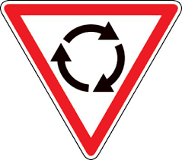 | 31. When you set this sign, it means:  A. There’s wind ahead.  B. There’s a comer ahead.  C. There’s a roundabout ahead.
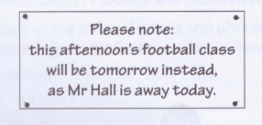 | 32.  A. There is no football class today.  B. Mr. Hall can’t come to the football class tomorrow.  C. You can choose to go to the football class today or tomorrow.
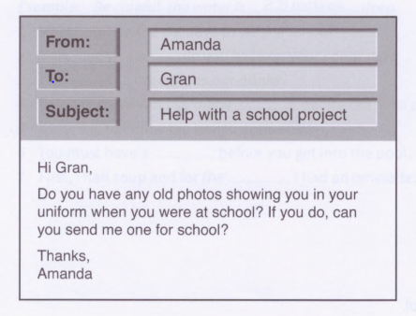 | 33. Amanda wants her grandmother to  A. let her have a picture.  B. lend her some clothes.  C. describe her old uniform.
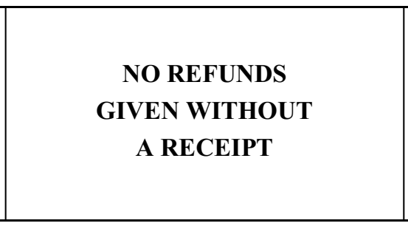 | 34.  A. This place never gives people their money back.  B. This place will sometimes give refunds.  C. This place only gives receipts for some items.
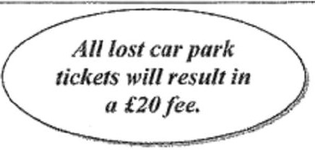 | 35.  A. It always costs £20 to park here.  B. You will be fined £20 if you park here.  C. You must pay £20 if you lose your tickets.
SECTION 3: WRITING (3.0 points)
Part 1. Complete the second sentence so that it has a similar meaning to the first sentence, using the word(s) in brackets. (1.0 point)
36. I can’t understand him because he speaks so quickly. (IF)
IF he didn’t speak so quickly, he could understand him.
37. They will catch all the prisoners again tonight. (CAUGHT)
All the prisoners will be CAUGHT again tonight.
38. Those pictures are beautiful. (HOW)
HOW beautiful those pictures are!
39. I don't find it difficult to get up early in the morning. (AM USED TO)
I AM USED TO getting up early in the morning.
40. The water was so cold that the children couldn’t swim in it. (ENOUGH)
The water was hot ENOUGH for the children swim in it.
Part 2. Complete the second sentence so that it has a similar meaning to the first one. (1.0 point)
41. "Do you go to school on Sunday, Anna?" my friend asked.
My friend asked Anna if she went school on Sunday.
42. Why don’t you plant some trees around your house to get more fresh air?
How about planting some trees around your house to get more fresh air?
43. I don’t have enough money to buy that electric bike.
I wish I had enough money to buy that electric bike.
44. Nga spends two hours a day practicing English with her friends.
It takes Nga two hours a day to practice English with her friends.
45. Nguyen Thi Oanh ran excellently in the 32nd Sea Games.
Nguyen Thi Oanh was an excellent runner in the 32nd Sea Games.
Part 3. (1.0 point) You want to borrow a bike from your English friend, Mike. Write an email to Mike (about 80 words or more). In your email:
ask Mike if you can borrow his bike
explain why you need it
say when you will give it back.
(DO NOT write your name or your personal information).

HẾT

Tài liệu được chia sẻ bởi Website VnTeach.Com

https://www.vnteach.com
Thí sinh không được sử dụng tàỉ liệu. Cán bộ coi thi không giải thích gì thêm.

